Citizen Oversight Committee Bio: Susan Hodgers, Real Estate/Member
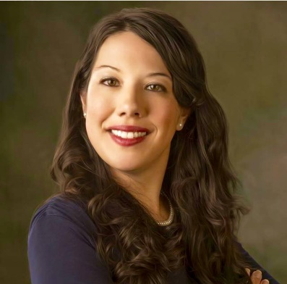
Susan Hodgers grew up in Brevard County enjoying the water by windsurfing, sailing, and rowing on the crew team. She also enjoys snorkeling and diving in the Keys. She graduated from Satellite High School in 1995. Since 2009, she has had her Florida and Georgia Real Estate license and even obtained her GRI certification by gaining in depth market knowledge. She has an interest in investing, renovating, and managing rental properties. In addition, she understands the home insurance industry as well and understands the flood zones which affect homeowners living on the water. Not only is she active in the community, but she has stayed active by serving on County Advisory Boards such as the Planning and Zoning Board and Redistricting Committee. She interacts regularly and participates with Space Coast Association of Realtor events and continues to educate the community how impactful a healthy lagoon is to the economy. Susan lives in Viera with her husband and children.

