Citizen Oversight Committee Bio: Melissa Martin, Education/Alternate
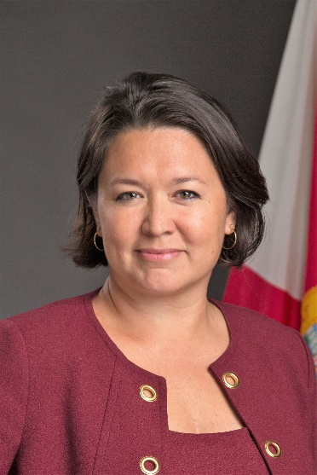
Melissa (Mel) Martin is a Florida native, originally from Longwood, just outside Wekiwa Springs State Park. She grew up learning how to fish, crab and cast-net in the Banana River. She attended the US Naval Academy and served as a Marine Corps (Judge Advocate) officer until retiring in December 2014. She, her husband and three sons moved to Cocoa in January 2015, hoping to provide a similar nature-filled childhood for the kids. She soon decided to engage in community service efforts, establishing and leading a local chapter of the national, nonpartisan organization against corruption, Represent Us, and later, serving as the Area Captain for the statewide coalition, Floridians Against Fracking. After the fish kill in 2016, she had the honor of helping to re-establish and serve in the Brevard Indian River Lagoon Coalition as President. After seeing the passage of the half-cent sales tax creating the Save Our Lagoon Trust Fund, Mel continued to advocate for the lagoon and clean water in Florida by running for state office in 2018. In addition to her duties as an alternate member for the Save Our Indian River Lagoon Citizen Oversight Committee, Mel currently serves on the City of Cocoa's Sustainability Advisory Committee and has recently joined Barry University School of Law, teaching Water Pollution Law as an adjunct law professor.

