Citizen Oversight Committee Bio: Dennis Basile, Real Estate/Alternate
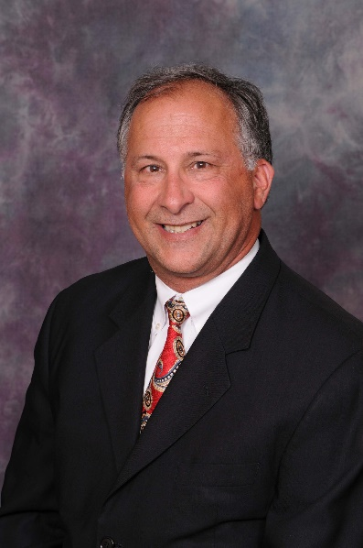
Presently, Dennis Basile, CCIM, is engaged in Real Estate Brokerage in Brevard County, Florida. He specialized in the sale, leasing and management of residential, commercial and industrial land and improvements, condominium projects, shopping centers, office buildings, subdivisions, and other large or unusual real estate assignments. He has six years of experience in one to four family dwelling units and thirty nine years of experience in commercial, industrial, multi-family, land and special purpose properties.

