Save Our Indian River Lagoon
Project Plan 2022 Update
for
Brevard County, Florida
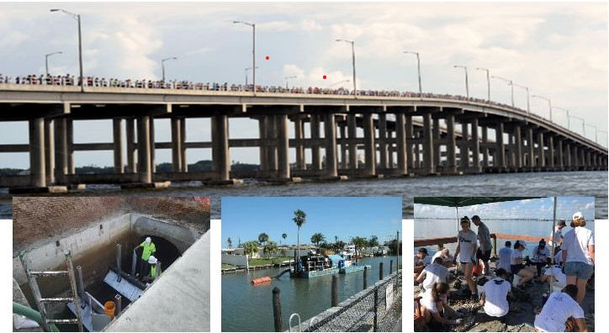
Prepared by:
Tetra Tech, Inc.
Prepared for:
Brevard County, Natural Resources Management Department
February 22, 2022
Table of Contents
Save Our Indian River Lagoon Project Plan 2022 Update for Brevard County, Florida 1
Acknowledgements vii
Executive Summary xi
Section 1. Background 1
1.1. Return on Investment and Economic Value 3
1.1.1 Areas of Economic Value at Risk 4
1.2. Maximizing Benefits and Managing Risk 5
1.2.1 Project Selection to Maximize Return on Investment 6
Section 2. Approach, Outputs, and Outcomes 8
2.1. Plan Focus Area 8
2.2. Plan Outputs and Outcomes 10
Section 3. Pollutant Sources in the IRL Watershed 12
Section 4. Project Options 15
4.1. Projects to Reduce Pollutants 15
4.1.1 Public Outreach and Education 16
4.1.2 Wastewater Treatment Facility Upgrades 24
4.1.3 Sprayfield and Rapid Infiltration Basin Upgrades 27
4.1.4 Package Plant Connections 27
4.1.5 Sewer Laterals Rehabilitation 28
4.1.6 Septic System Removal and Upgrades 32
4.1.7 Stormwater Treatment 61
4.1.8 Vegetation Harvesting 77
4.2. Projects to Remove Pollutants 79
4.2.1 Muck Removal 79
4.2.2 Treatment of Muck Interstitial Water 86
4.2.3 Spoil Management Areas 88
4.2.4 Surface Water Remediation System 89
4.2.5 Enhanced Circulation 90
4.3. Projects to Restore the Lagoon 95
4.3.1 Oyster Restoration 95
4.3.2 Planted Shorelines 99
4.3.3 Clam Restoration and Aquaculture 103
4.3.4 Seagrass Planting 104
4.4. Projects to Respond to New Information 106
4.4.1 Adaptive Management to Report, Reassess, and Respond 107
4.4.2 Cost-share for Substitute Projects 108
4.4.3 Additional Project Benefits 108
4.4.4 Responding to Implemented Projects 109
4.4.5 Research Needs 130
4.5. Unfunded Projects 131
Section 5. Project Funding 137
5.1. Project Funding, Schedule, and Scope Adjustments 137
5.1.1 Contingency Fund Reserve 137
5.1.2 Schedule Acceleration 138
5.1.3 Scope Reduction 138
5.2. Revenue Projection Update 138
5.3. Project Funding Allocations 139
Section 6. Summary of the Plan through the 2022 Update 141
6.1. Progress Toward the Local Targets for Maximum Total Loads 141
6.2. Plan Summary 145
Appendix A: Funding Needs and Leveraging Opportunities 162
Appendix B: References 164
Appendix C: Seagrasses 180
Loss of Seagrass 180
Nutrient Content of Seagrass 182
Draft Evaluation Criteria for Planting Seagrass 183
References 183
Appendix D: Withdrawn Projects 186
Appendix E: Long Descriptions of Figures 198
Figure 1-1: Decline of Commercial Fishing in Brevard County 198
Figure 2-2. Summary of the Save Our Indian River Lagoon Outputs and Outcomes 198
Figure 4-1: Grass Clippings Example for a Typical Lot 199
Figure 4-2: Septic System Removal Projects in Banana River Lagoon 199
Figure 4-3: Septic System Removal Projects in Banana River Lagoon, continued 199
Figure 4-4: Septic System Removal Projects in Banana River Lagoon, continued 199
Figure 4-5: Septic System Removal Projects in North IRL 200
Figure 4-6: Septic System Removal Projects in North IRL, continued 200
Figure 4-7: Septic System Removal Projects in North IRL, continued 200
Figure 4-8: Septic System Removal Projects in North IRL, continued 201
Figure 4-9: Septic System Removal Projects in North IRL, continued 201
Figure 4-10: Septic System Removal Projects in North IRL, continued 201
Figure 4-11: Septic System Removal Projects in Central IRL 202
Figure 4-12: Septic System Removal Projects in Central IRL, continued 202
Figure 4-13: Septic System Removal Projects in Central IRL, continued 202
Figure 4-14: Septic System Removal Projects in Central IRL, continued 203
Figure 4-15: Quick Connection Septic System Removal Locations in North Brevard County 203
Figure 4-16: Quick Connection Septic System Removal Locations in Central Brevard County 203
Figure 4-17: Quick Connection Septic System Removal Locations in South Brevard County 203
Figure 4-18: Example In-Ground Nitrogen-Reducing Biofilter Septic System 204
Figure 4-19: Septic System Upgrades in North Brevard County 204
Figure 4-20: Septic System Upgrades in Central Brevard County 204
Figure 4-21: Septic System Upgrades in South Brevard County 204
Figure 4-22: Stormwater Projects in North Brevard County 205
Figure 4-23: Stormwater Projects in Central Brevard County 205
Figure 4-24: Stormwater Projects in South Brevard County 205
Figure 4-25: Location of Muck Removal Projects in the Northern Banana River Lagoon 205
Figure 4-26: Location of Muck Removal Projects in the Southern Banana River Lagoon 206
Figure 4-27: Location of Muck Removal Projects in North IRL 206
Figure 4-28: Location of Muck Removal Projects in Central IRL 206
Figure 4-29: Phase I Potential Enhanced Circulation Project Locations 206
Figure 4-30: Shoreline Survey to Identify Locations Appropriate for Oyster Bars and Planted Shorelines 207
Figure 4-31: Estimated Economic Value of Some Seagrass Services 207
Figure 4-32: Completed Projects in North Brevard County 207
Figure 4-33: Completed Projects in Central Brevard County 208
Figure 4-34: Completed Projects in South Brevard County 208
Figure 4-36. Distribution of Oyster Sizes, Age, and Average Number of Measured Oysters Per Unit 208
Figure 4-35. Countywide Groundwater Nutrient Concentrations for TN (top) and TP (bottom) 209
Figure 5-2: Evolution of Project Funding Allocations 209
Figure C-1: Mean Areal Extent of Seagrass and Mean Length of Transects 210
Figure C-2: Mean Chlorophyll-a Concentrations 210
Photographs on cover:
Top from http://spacecoastdaily.com/2013/09/hands-across-lagoon-set-for-sept-28/
Bottom left from the Central Boulevard baffle box upgrade in the City of Cape Canaveral
Bottom middle from the muck dredging project in the City of Cocoa Beach
Bottom right from the Bomalaski oyster bar project in Merritt Island
List of Tables
Table ES-1: Summary of Project Types, Costs, and Nutrient Reductions in the 2022 Update of the Save Our Indian River Lagoon Project Plan xiv
Table 1-1: Economic Impact Scenarios Based Upon the Condition of the IRL 3
Table 2-1: Summary of Load Reductions and Projects in Central IRL Zone SEB 8
Table 3-1: Loading from Different Sources in Each Sub-lagoon 13
Table 4-1: Estimated TN and TP Not Attenuated in Fiscal Year 2014–2015 16
Table 4-2: Reductions from Fertilizer Ordinance Compliance as of Fiscal Year 2014–2015 17
Table 4-3: Project for Additional Fertilizer Ordinance Compliance 17
Table 4-4: Project for Grass Clippings Campaign 19
Table 4-5: Estimated TN Reductions and Costs from Reducing Excess Irrigation 20
Table 4-6: Estimated TN and TP Reductions and Costs from Stormwater Best Management Practice Maintenance 21
Table 4-7: Project for Septic System Maintenance Program 22
Table 4-8: Project for Oyster Gardening Program 24
Table 4-9: TN Concentrations in Wastewater Treatment Facility Reclaimed Water 25
Table 4-10: Projects for Wastewater Treatment Facility Upgrades to Improve Reclaimed Water 26
Table 4-11: Projects for Sprayfield or Rapid Infiltration Basin Upgrades for Public Facilities 27
Table 4-12: Projects for Sprayfield or Rapid Infiltration Basin Upgrades for Private Facilities 27
Table 4-13: Projects for Package Plant Connection 28
Table 4-14: Projects for Sewer Laterals Rehabilitation 31
Table 4-15: Original Estimate of TN Loading and Cost to Connect for Septic Systems 32
Table 4-16: Updated Estimate of TN Loading based on ArcGIS-Based Nitrate Load Estimation Toolkit and Updated Cost to Connect for Septic Systems 33
Table 4-17: Septic Systems by Soil Hydraulic Conductance Class within 55 Yards of IRL 33
Table 4-18: Septic Systems in Very High and High Hydraulic Conductance Soils Distributed by Distance to Surface Waters 33
Table 4-19: Projects for Septic System Removal 35
Table 4-20: Projects for Septic System Removal by Sewer Connection 51
Table 4-21: Projects for Septic System Upgrades 57
Table 4-22: Traditional Stormwater Best Management Practices with TN and TP Removal Efficiencies 62
Table 4-23: Low Impact Development and Green Infrastructure Best Management Practices and TN and TP Removal Efficiencies 63
Table 4-24: TN and TP Removal Efficiencies for Biosorption Activated Media 64
Table 4-25: Projects for Stormwater Treatment 65
Table 4-26: Estimated Costs and Nutrient Reductions for Vegetation Harvesting 77
Table 4-27: Projects for Vegetation Harvesting 78
Table 4-28: Muck Acreages in the IRL System 80
Table 4-29: Estimated Costs and Nutrient Reductions for Muck Removal Project Areas 80
Table 4-30: Projects for Muck Removal 81
Table 4-31: Projects for Treatment of Interstitial Water 87
Table 4-32: Summary of Annual Benefits and Ten-Year Costs of a Surface Water Remediation System 90
Table 4-33: Phase I Top Ranked Potential Enhanced Circulation Project Locations 91
Table 4-34: Computed Hydraulics for Connections at Select Locations 93
Table 4-35: Projects for Oyster Restoration 97
Table 4-36: Pollutant Load Reductions for Shoreline Management Practices 99
Table 4-37: Projects for Planted Shorelines 102
Table 4-38: Projects for Clam Restoration 104
Table 4-39: Average Nutrients in Seagrass from 1996–2009 105
Table 4-40: Average Seagrass Lost and Nutrients Made Available to Other Primary Producers in 2015 105
Table 4-41: Cost-share Offered for Project Requests Submitted for the 2022 Update 108
Table 4-42: Pollutants Removed by Different Project Types 109
Table 4-43: Save Our Indian River Lagoon Tax Funds Expended on Completed Construction Projects (as of October 31, 2021) 110
Table 4-44: Save Our Indian River Lagoon Tax Funds Contracted or Expended on Projects Underway (as of October 31, 2021) 114
Table 4-45: Unfunded Public Outreach and Education Projects 132
Table 4-46: Unfunded Wastewater Treatment Facility Reclaimed Water Upgrade Projects 132
Table 4-47: Unfunded Package Plant Connection Projects 132
Table 4-48: Unfunded Sprayfield or Rapid Infiltration Basin Upgrade Projects 133
Table 4-49: Unfunded Septic-to Sewer-Projects 133
Table 4-50: Unfunded Muck Dredging and Interstitial Treatment Projects 135
Table 6-1: Banana River Lagoon Project Reductions to Meet Five-Month Total Maximum Daily Load 142
Table 6-2: Banana River Lagoon Project Reductions Compared to Full Year Loading 142
Table 6-3: North IRL Project Reductions to Meet Five-Month Total Maximum Daily Load 143
Table 6-4: North IRL Project Reductions Compared to Full Year Loading 143
Table 6-5: Central IRL Project Reductions to Meet Five-Month Total Maximum Daily Load 144
Table 6-6: Central IRL Project Reductions Compared to Full Year Loading 144
Table 6-7: Annual Muck Flux, Muck Interstitial Water, Oyster Bar, and Planted Shoreline Project Benefits Compared to Annual Nutrient Loadings from Muck Flux 145
Table 6-8: Summary of Projects, Estimated TN and TP Reductions, and Costs 146
Table 6-9: Timeline for Funding Needs (Table 46 in the Original Save Our Indian River Lagoon Project Plan) 154
Table C-1: Estimates of Biomass for Halodule Species 182
Table C-2: Total Biomass in Seagrasses Along Brevard County 182
Table C-3: Estimates of Nutrient Content for Halodule wrightii (percentage of dry weight) 183
Table C-4: Average Amount of Nutrients Contained in Seagrass from 1996–2009 183
Table C-5: Guide for Ranking Potential Seagrass Restoration Sites 185
Table D-1: Summary of Project Withdrawals from the Plan 186
List of Figures
Figure ES-1: Save Our Indian River Lagoon Project Implementation Schedule xiii
Figure 1-1: Decline of Commercial Fishing in Brevard County 5
Figure 1-2: Likelihood of a Healthy IRL as Nutrients are Removed 7
Figure 2-1: Locations of the Banana River Lagoon (BRL), North IRL (NIRL), and Central IRL (CIRL) Sub-lagoons 9
Figure 3-1: Banana River Lagoon TN (left) and TP (right) Annual Average Loads by Source 13
Figure 3-2: North IRL TN (left) and TP (right) Annual Average Loads by Source 14
Figure 3-3: Central IRL TN (left) and TP (right) Annual Average Loads by Source 14
Figure 4-1: Grass Clippings Example for a Typical Lot 19
Figure 4-2: Septic System Removal Projects in Banana River Lagoon 38
Figure 4-3: Septic System Removal Projects in Banana River Lagoon, continued 39
Figure 4-4: Septic System Removal Projects in Banana River Lagoon, continued 40
Figure 4-5: Septic System Removal Projects in North IRL 41
Figure 4-6: Septic System Removal Projects in North IRL, continued 42
Figure 4-7: Septic System Removal Projects in North IRL, continued 43
Figure 4-8: Septic System Removal Projects in North IRL, continued 44
Figure 4-9: Septic System Removal Projects in North IRL, continued 45
Figure 4-10: Septic System Removal Projects in North IRL, continued 46
Figure 4-11: Septic System Removal Projects in Central IRL 47
Figure 4-12: Septic System Removal Projects in Central IRL, continued 48
Figure 4-13: Septic System Removal Projects in Central IRL, continued 49
Figure 4-14: Septic System Removal Projects in Central IRL, continued 50
Figure 4-15: Quick Connection Septic System Removal Locations in North Brevard County 52
Figure 4-16: Quick Connection Septic System Removal Locations in Central Brevard County 53
Figure 4-17: Quick Connection Septic System Removal Locations in South Brevard County 54
Figure 4-18: Example In-Ground Nitrogen-Reducing Biofilter Septic System 55
Figure 4-19: Septic System Upgrades in North Brevard County 58
Figure 4-20: Septic System Upgrades in Central Brevard County 59
Figure 4-21: Septic System Upgrades in South Brevard County 60
Figure 4-22: Stormwater Projects in North Brevard County 74
Figure 4-23: Stormwater Projects in Central Brevard County 75
Figure 4-24: Stormwater Projects in South Brevard County 76
Figure 4-25: Location of Muck Removal Projects in the Northern Banana River Lagoon 82
Figure 4-26: Location of Muck Removal Projects in the Southern Banana River Lagoon 83
Figure 4-27: Location of Muck Removal Projects in North IRL 84
Figure 4-28: Location of Muck Removal Projects in Central IRL 85
Figure 4-29: Phase I Potential Enhanced Circulation Project Locations 92
Figure 4-30: Shoreline Survey to Identify Locations Appropriate for Oyster Bars and Planted Shorelines 101
Figure 4-31: Estimated Economic Value of Some Seagrass Services 104
Figure 4-32: Completed Projects in North Brevard County 118
Figure 4-33: Completed Projects in Central Brevard County 119
Figure 4-34: Completed Projects in South Brevard County 120
Figure 4-35. Countywide Groundwater Nutrient Concentrations for TN (top) and TP (bottom) 123
Figure 4-36. Distribution of Oyster Sizes, Age, and Average Number of Measured Oysters Per Unit 128
Figure 5-1: Funding for Reduce, Remove, Restore, and Respond Projects 139
Figure 5-2: Evolution of Project Funding Allocations 140
Figure C-1: Mean Areal Extent of Seagrass and Mean Length of Transects 180
Figure C-2: Mean Chlorophyll-a Concentrations 181
Figure C-3: Conceptual Model Illustrating a Shift in Biomass Among Major Primary Producers with Increasing Nutrient Enrichment 181

Acknowledgements
We would like to thank the following people who provided input in the development and update of this plan:
2021 Citizen Oversight Committee:
- Vinnie Taranto (2021 Chair), Technology Member
- David Sherrer, Technology Alternate
- Stephany Eley (2018 Chair, 2021 Vice Chair), Education/Outreach Member
- Kimberly Newton, Education/Outreach Alternate
- John Windsor (2019 Vice Chair, 2020 Chair), Lagoon Advocacy Member
- Terry Casto, Lagoon Advocacy Alternate
- Courtney Barker (2020 Vice Chair), Finance Member
- Todd Swingle, Finance Alternate
- David Lane (2018 Vice Chair, 2019 Chair), Tourism Member
- Laurilee Thompson, Tourism Alternate
- Lorraine Koss (2017 Chair), Science Member
- Charles Venuto, Science Alternate
- Susan Hodgers, Real Estate Member
- Dennis Basile, Real Estate Alternate
Citizen Oversight Committee Past Members:
- Gene Artusa, Real Estate Member, First Term
- Danielle Bowden, Real Estate Member, First Term, Partial Second Term
- John Byron (2017 Vice Chair), Technology Member, First Term
- John Durkee, Education/Outreach Alternate, First Term
- John Luznar, Technology Member, Second Term
- Melissa Martin, Education/Outreach Alternate, Partial Second Term
- Karen McLaughlin, Tourism Alternate, First Term
- Jay Moynahan, Real Estate Member, Second Term
Guest Speakers at Citizen Oversight Committee Meetings:
  - Holly Abeels, Florida Sea Grant
  - Hannah Atsma, Ocean Research Conservation Association
  - Scott Barber, City of Cocoa Beach
  - Drew Bartlett, Florida Department of Environmental Protection
  - Jeff Beal, Florida Fish and Wildlife Conservation Commission
  - Alix Bernard, City of Rockledge
  - Stephen Berry, Jones Edmunds & Associates
  - Robert Bolton, City of Vero Beach
  - Bill Buckman, ASAP Septic
  - Randy Burden, EcoSense
  - Anne Conroy-Baiter, Junior Achievement of the Space Coast
  - Captain Frank Catino, City of Satellite Beach Mayor
  - Becky Clarkson, Brevard County contract employee
  - Borja Crane-Amores, Florida Department of Environmental Protection
  - Dr. Duane De Freese, Indian River Lagoon National Estuary Program and Council
  - Stacy Delano, Tourist Development Council
  - Dr. Melina Donnelly, University of Central Florida
  - Rich Dunkel, Irrigreen
  - Dr. Jeff Eble, Florida Institute of Technology
  - Joe Faella, Brevard County Mosquito Control
  - Dr. Beth Falls, Ocean Research Conservation Association
  - Dr. Mark S. Fonseca, CSA Ocean Sciences Inc.
  - Edward Fontanin, Brevard County Utility Services
  - Dr. Austin Fox, Florida Institute of Technology
  - Dr. Xueqing Gao, Florida Department of Health
  - Lisa Good, Blue Life
  - Roxanne Groover, Florida Onsite Wastewater Association
  - Lauren Hall, St. Johns River Water Management District
  - Dr. Dennis Hanisak, Florida Atlantic University Harbor Branch Oceanographic Institute
  - Carter Henne, Sea & Shoreline
  - Andrea Hill, Brevard Zoo
  - Dr. Chuck Jacoby, St. Johns River Water Management District
  - Steve Krzyston, Rockledge Gardens
  - Jim Langenbach, P.E., B.C.E.E., Geosyntec Consultants
  - Beth Lemke, Planning Solutions
  - Dr. Claudia Listopad, Applied Ecology, Inc.
  - Chris Little, City of Palm Bay Utilities
  - Laura Manlove, RSM US LPP
  - Adam Marrara, Florida Home Inspection Bureau
  - Senator Debbie Mayfield, District 17
  - Bach McClure, Brevard County Stormwater Administrator
  - Tara McCue, East Coast Regional Planning Council
  - Benjamin Melnick, Florida Department of Environmental Protection
  - Dr. Jennifer Mitchell, St. Johns River Water Management District
  - Julie Mitchell, Florida Fish & Wildlife Conservation Commission
  - Dr. Martha Monroe, University of Florida
  - Lori Morris, St. Johns River Water Management District
  - Robert Musser, Canaveral Port Authority
  - Dr. Todd Osborne, University of Florida
  - Dr. Drew Palmer, Florida Institute of Technology
  - Dr. Randall W. Parkinson, RW Parkinson Consulting, Inc.
  - Bo Platt, Brevard Indian River Lagoon Coalition
  - Jeff Rapolti, Brevard County Stormwater Utility
  - Ashley Rearden, Brevard Zoo
  - Ralph Reigelsperger, City of Melbourne
  - Jill Reyes, RSM US LLP
  - Antony Rios, Environmental Conservation Solutions LLC
  - Annie Roddenberry, Florida Fish and Wildlife Conservation Commission
  - Stephen Rowe, Anchor Plumbing
  - Tony Sasso, Keep Brevard Beautiful
  - Linda Seals, Brevard County Extension Services
  - Dr. Ann Shortelle, St. Johns River Water Management District
  - Morris Smith, Jr., Morris Smith Engineering
  - Marty Smithson, Sebastian inlet
  - Dr. Leesa Souto, Marine Resources Council
  - Susan Sperling, Marketing Talent Network Advertising
  - Danielle Straub, City of Melbourne
  - Megan Stolen, Hubbs SeaWorld Research Institute
  - Dr. James Sullivan, Florida Atlantic University Harbor Branch Oceanographic Institute
  - Joshua Surprenant, City of Cape Canaveral
  - Todd Swingle, Toho Water Authority
  - Johanna Switzer, Atkins North America, Inc.
  - Jennifer Thompson, Brevard County Stormwater Utility
  - Cynthia Thurman, Brevard County
  - Bill Tredik, St. Johns River Water Management District
  - Dr. John Trefry, Florida Institute of Technology
  - Al Vazquez, CloseWaters LLC
  - Dr. Tom Waite, Florida Institute of Technology
  - Dr. Linda Walters, University of Central Florida
  - Dr. Marty Wanielista, University of Central Florida
  - Aaron Watkins, Florida Department of Environmental Protection Central District
  - Dr. Robert Weaver, Florida Institute of Technology
  - Missy Weiss, S.E.A. a Difference Environmental Services
  - Dr. John Windsor, Florida Institute of Technology
  - Keith Winsten, Brevard Zoo
  - Walter C. Wood, Marketing Talent Network Advertising
  - Chris Zambito, Atkins North America, Inc.
  - Dr. Gary Zarillo, Florida Institute of Technology
  - Jake Zehnder, Brevard Zoo
Scientist Subject Matter Experts Consulted during Original Plan Development:
- Dr. Duane De Freese, Indian River Lagoon National Estuary Program and Indian River Lagoon Council Executive Director
- Dr. Richard (Grant) Gilmore, expert in Indian River Lagoon fisheries and ecology
- Dr. Charles Jacoby, St. Johns River Water Management District Supervising Environmental Scientist
- Dr. Kevin Johnson, Florida Institute of Technology Associate Professor, Marine and Environmental Systems
- Dr. Mitchell A Roffer, Florida Institute of Technology Adjunct Professor, President Roffer's Ocean Fishing Forecasting Service, Inc.
- Dr. Jonathan Shenker, Florida Institute of Technology Associate Professor of Marine Biology
- Dr. John Trefry, Florida Institute of Technology Professor of Marine and Environmental Systems
- Martin S. Smithson, Sebastian Inlet District Administrator
- Joel Steward, St. Johns River Water Management District Supervising Environmental Scientist (Retired)
- Dr. John Windsor, Florida Institute of Technology Oceanography and Environmental Science Professor Emeritus and Program Chair
Economic Impacts Subject Matter Experts Consulted during Original Plan Development:
- Jim Brandenburg, Brevard County Property Appraiser Information Technology
- Eric Garvey, Brevard County Tourism Development Council Executive Director
- Herb Hiller, Brevard County Tourism Development Council Consultant on Ecotourism
- Vince Lamb, Indian River Lagoon Council Management Board, Florida Master Naturalist, Entrepreneur
- Dr. Michael H. Slotkin, Florida Institute of Technology Associate Professor, Nathan M. Bisk School of Business
- Laurilee Thompson, Brevard County Tourism Development Council, Commercial Fisheries Expert, Entrepreneur
- Dr. Alexander Vamosi, Florida Institute of Technology Associate Professor, Nathan M. Bisk School of Business
Agencies and Local Governments Consulted during Original Plan Development:
- Florida Department of Environmental Protection
- Florida Department of Health
- Space Coast Association of REALTORS®
- Space Coast Tourism Development Council
- St. Johns River Water Management District
- Brevard County Budget Office
- Brevard County Natural Resources Management Department
- Brevard County Property Appraiser Information Technology
- Brevard County Utility Services Department
- City of Melbourne
- City of Palm Bay
- City of Titusville
- City of West Melbourne

Executive Summary
The Indian River Lagoon (IRL) system includes Mosquito Lagoon, Banana River Lagoon, and Indian River. This is a unique and diverse system that connects Volusia, Brevard, Indian River, St. Lucie, Martin, and Palm Beach counties. The IRL is part of the National Estuary Program, one of 28 estuaries of National Significance, and has one of the greatest diversity of plants and animals in the nation. A large portion of the IRL system, 71% of its area and nearly half its length, is within Brevard County (County) and provides County residents and visitors many opportunities and economic benefits.
However, the balance of this delicate ecosystem has been disturbed as development in the area has led to harmful impacts. Stormwater runoff from urban and agricultural areas, wastewater treatment facility discharges, septic systems, and excess fertilizer applications have led to harmful levels of nutrients and sediments entering the lagoon. These pollutants create cloudy conditions in the lagoon and feed algal blooms, both of which negatively affect the seagrass community that provides habitat for much of the lagoon’s marine life. In addition, these pollutants lead to muck accumulation, which releases (fluxes) nutrients and hydrogen sulfide, depletes oxygen, and creates a lagoon bottom that is not hospitable to seagrass, shellfish, or other marine life.
Efforts have been ongoing for decades to address these sources of pollution. Despite significant load reductions, in the last five years, signs of human impact to the IRL system have been magnified. In 2011, the “superbloom” occurred, an intense algal bloom in the Mosquito Lagoon, Banana River Lagoon, and North IRL, as well as a secondary, less intense bloom in the Central IRL. There have also been recurring brown tides; unusual mortalities of dolphins, manatees, and shorebirds; and large fish kills due to low dissolved oxygen from decomposing algae.
Local governments and the St. Johns River Water Management District have been proactive in implementing projects over the last several decades. However, to restore the lagoon to health and prosperity, additional funds were needed to eliminate current excess loading and remove the legacy of previous excess loading. Therefore, the County placed a Save Our Indian River Lagoon 0.5 cent sales tax referendum on the ballot in November 2016, which passed and is providing a funding stream for the types of projects listed in this plan for Brevard County and its municipalities.
The Save Our Indian River Lagoon Project Plan outlines local projects planned to meet water quality targets and improve the health, productivity, aesthetic appeal, and economic value of the lagoon. Implementation of these projects is contingent upon funding raised through the 0.5 cent sales tax. This sales tax funding also allows the County to leverage additional dollars in match funding from state and federal grant programs because the IRL ecosystem is valued not only in Florida but also nationally. Funding implementation of this plan would help to restore this national treasure. Lagoon ecosystem response may lag several years behind completion of nutrient reductions; however, major steps must begin now to advance progress on the long road to recovery.
In the development of this plan, Subject Matter Experts were consulted to provide feedback on the plan elements. The experts all agreed that there is a "critical mass" of nutrient reductions that must be achieved to see a beneficial result in the IRL. This critical level of nutrient reduction will be achieved through the implementation of the projects in this plan. During plan development, it was estimated that the benefit of restoring the lagoon has a present value of $6 billion and a cost of $300 million. Therefore, implementing this plan to restore the IRL is an excellent investment in the future of Brevard County’s community and economy with a benefit to cost ratio of 20:1.
To restore the lagoon’s balance, Brevard County seeks to accelerate implementation of a multi-pronged approach to Reduce pollutant and nutrient inputs to the lagoon from fertilizer, reclaimed water from wastewater treatment facilitates, sprayfields and rapid infiltration basins, package plants, sewer laterals, septic systems, and stormwater; Remove the accumulation of muck from the lagoon bottom; Restore water-filtering oysters and clams and related lagoon ecosystem services; and monitor progress to Respond to changing conditions, technologies, and new information by amending the plan to include actions that will be most successful and cost-effective for significantly improving the health, productivity, and natural resilience of the IRL.
The portfolio of projects in this plan were selected as the most cost-effective suite of options to achieve water quality and biological targets for the lagoon system. Investment has been distributed among a set of project types with complimentary benefits to reduce future risk of failure. Approximately 58% (originally one-third) of the effort and expense is split among multiple projects to reduce incoming load to healthy levels. Approximately 37% (originally two-thirds) of the effort and expense is directed toward muck removal to address decades of past excess nutrient loading. Nitrogen and phosphorus released each year as muck decays are now larger than any current source of nutrient pollution to lagoon waters. Less than 5% of tax revenues go towards restoring natural filtration systems; measuring the success of different project types; and responding to new information, technologies, and opportunities with annual plan updates.
The plan projects have been prioritized and ordered to deliver improvements to the lagoon in the most beneficial spatial and temporal sequence so that the implementation of this plan is expected to result in a healthy IRL system. If a future project is ready to move forward earlier than scheduled in the plan, if such advancement is consistent with temporal sequencing goals in the plan and is recommended by the Citizen Oversight Committee, and if there are sufficient Trust Fund dollars available, the County Manager (for budget changes less than $100,000) or Brevard County Commission have the authority to adjust the project schedule at any time to ensure that approved projects funded in the plan move forward as soon as feasible.
This 2022 Update to the Save Our Indian River Lagoon Project Plan contains the sixth set of project updates, new approved projects, and schedule modifications to the plan. Local stakeholders submitted projects annually to Brevard County for inclusion in the plan. The appointed Citizen Oversight Committee reviewed the submitted projects and made a recommendation to the Board of County Commissioners on which projects should be added to the Save Our Indian River Lagoon Project Plan. This update includes those projects that were reviewed by the Citizen Oversight Committee and approved for inclusion by the Board of County Commissioners.
The timing of the projects is shown in Figure ES-1. A summary of the types of projects included in the plan, as well as the associated costs and total nitrogen (TN) and total phosphorus (TP) reductions in pounds per year are shown in Table ES-1. Despite the considerable cost of restoration, analysis demonstrates that the economic cost of inaction is double the cost of action. Furthermore, although there are many tangible and intangible benefits for saving the lagoon, the readily estimated return on investment for three benefits – tourism, waterfront property values, and commercial fisheries – is approximately 10% to 26%.
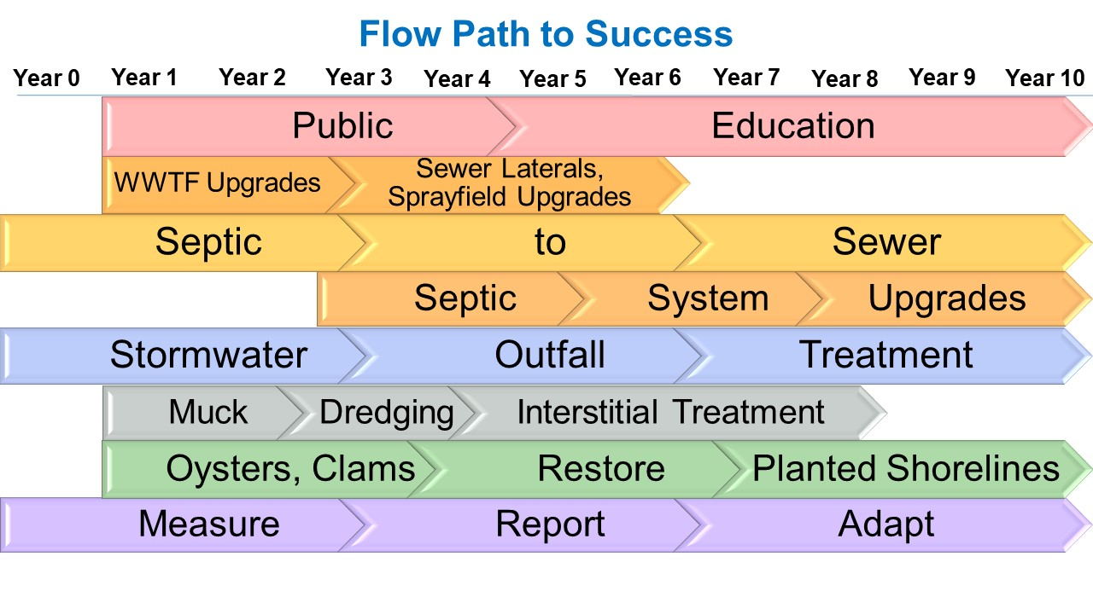
Figure ES-1: Save Our Indian River Lagoon Project Implementation Schedule
Table ES-1: Summary of Project Types, Costs, and Nutrient Reductions in the 2022 Update of the Save Our Indian River Lagoon Project Plan
Project Category | Project Type | Estimated Total Project Cost | Nitrogen Reductions (pounds per year) | Average Cost per Pound per Year of Total Nitrogen | Phosphorus Reductions (pounds per year) | Average Cost per Pound per Year of Total Phosphorus
Reduce | Public Education | $2,425,000 | 28,879 | $84 | 2,013 | $1,205
Reduce | Wastewater Treatment Facility Upgrades for Reclaimed Water | $26,766,195 | 69,823 | $383 | 13,760 | $1,945
Reduce | Rapid Infiltration Basin/Sprayfield Upgrades | $82,207 | 317 | $259 | To be determined | To be determined
Reduce | Package Plant Connection | $2,157,072 | 2,003 | $1,077 | To be determined | To be determined
Reduce | Sewer Lateral Rehabilitation | $1,580,000 | 6,196 | $255 | 188 | $8,404
Reduce | Septic System Removal by Sewer Extension | $119,686,296 | 95,816 | $1,249 | To be determined | To be determined
Reduce | Septic System Removal by Sewer Connection | $11,317,176 | 21,527 | $526 | To be determined | To be determined
Reduce | Septic System Upgrades | $29,233,106 | 37,981 | $770 | To be determined | To be determined
Reduce | Stormwater Projects | $47,515,821 | 271,170 | $175 | 37,450 | $1,269
Reduce | Vegetation Harvesting | $1,410,709 | 20,274 | $70 | 2,010 | $702
Remove | Muck Removal | $108,417,949 | 208,428 | $520 | 17,874 | $6,066
Remove | Treatment of Muck Interstitial Water | $46,977,065 | 484,332 | $97 | 28,605 | $1,642
Restore | Oyster Bars | $9,809,545 | 24,699 | $397 | 780 | $12,576
Restore | Planted Shorelines | $130,560 | 544 | $240 | 186 | $702
Restore | Clam Restoration | $60,000 | 1,000 | $60 | To be determined | To be determined
Respond | Projects Monitoring | $10,000,000 | - | - | - | -
Respond | Contingency | $19,814,425 | - | - | - | -
Respond | Inflation | $104,840,456 | - | - | - | -
Total | Total | $542,223,582 | 1,272,989 | $426 (average) | 102,866 | $5,271 (average)

Background
The Indian River Lagoon (IRL) system includes Mosquito Lagoon, Banana River Lagoon, and Indian River. A large portion of the IRL system, 71% of its area and nearly half its length, is within Brevard County (County) and provides County residents and visitors many opportunities.
However, the balance of this delicate ecosystem has been disturbed as development in the area has led to harmful impacts. Stormwater runoff from urban and agricultural areas, wastewater treatment facility discharges, septic systems, and excess fertilizer applications have led to harmful levels of nutrients and sediments entering the lagoon. In addition, these pollutants lead to muck accumulation on the lagoon bottom, which fluxes nutrients and creates a lagoon bottom that is not conducive to seagrass, shellfish, or benthic invertebrate growth.
Efforts have been ongoing to address these sources of pollution. The Indian River Lagoon System and Basin Act of 1990 (Chapter 90-262, Laws of Florida) was enacted to protect the IRL system from wastewater treatment facility discharges and the improper use of septic tanks. The act includes three objectives: elimination of surface water discharges, investigation of feasibility of reuse, and centralization of wastewater collection and treatment facilities (Florida Department of Environmental Protection, 2016). This act led to the removal of effluent discharges to the lagoon from more than 40 wastewater treatment facilities (St. Johns River Water Management District, 2016a).
Stormwater regulations were adopted in unincorporated Brevard County in 1978 and adopted statewide in 1989. Due to stormwater regulations, stormwater treatment systems were constructed along with all new development exceeding size thresholds. Privately owned and operated stormwater treatment systems have prevented more than a million pounds of sediments from entering the lagoon since 1989 (St. Johns River Water Management District, 2016a). Stormwater treatment projects also reduce nutrient inputs to the lagoon. In addition, dredging projects have been ongoing since 1998 to remove muck from the lagoon and major tributaries, including Crane Creek, Turkey Creek, and St. Sebastian River (St. Johns River Water Management District, 2016a). These stormwater treatment and muck removal projects contributed to significant improvements in water quality and water clarity in the lagoon, which allowed for a great expansion of seagrass from 2000–2010.
However, recently, human impacts on the IRL system have been magnified. In 2011, the “superbloom” occurred, an intense algal bloom in the Mosquito Lagoon, Banana River Lagoon, and North IRL, as well as a secondary, less intense bloom in Central IRL. The extent and longevity of the bloom had a detrimental impact on seagrass. There have also been recurring brown tides; unusual mortalities of dolphins, manatees, and shorebirds; and large fish kills due to low dissolved oxygen from decomposing algae.
In 2009, to improve lagoon water quality and restore seagrass, the Florida Department of Environmental Protection adopted total maximum daily loads for total nitrogen (TN) and total phosphorus (TP) allowed to discharge to the Banana River Lagoon, North IRL, and Central IRL. The purpose of these total maximum daily loads is to reduce nutrients that lead to algae growth, which block sunlight from seagrass and create low dissolved oxygen conditions that affect fish in the lagoon. To implement these total maximum daily loads, the Florida Department of Environmental Protection adopted three basin management action plans that outline responsibilities for reductions by the local stakeholders, list projects, and stipulate a timeline for implementation. The intent of the nutrient reductions is to provide water quality conditions that should result in seagrass growth in the lagoon at historical levels. Brevard County has a major responsibility in all three basin management action plans along with its 16 municipalities, Florida Department of Transportation District 5, Patrick Space Force Base, National Aeronautics and Space Administration – Kennedy Space Center, and agriculture. The Florida Department of Environmental Protection updated all three basin management action plans in 2020.
From 2012 to 2015, Brevard County led an effort with its municipalities, Florida Department of Transportation District 5, and Patrick Space Force Base to update the estimates of nutrient loadings to the lagoon. The County and its partners teamed with several consultants to develop the Spatial Watershed Iterative Loading model that revised the estimates of loading by source to the lagoon (refer to Section 2 for more details). The revised loading estimates were compared to seagrass area to recommend refinement of state and federal approved total maximum daily loads. The loading estimates and total maximum daily load targets referenced in this plan are from these local efforts, as they are based on the most up-to-date data and analyses even though the state and federal total maximum daily loads have not been officially updated.
Damage to the lagoon has been occurring for decades and will require time and money to reverse. An important example is the accumulation of muck on the bottom of 10% of the IRL. This muck kills marine life and releases stored pollutants into the IRL. To address the damage to the IRL system, in 1990, Brevard County implemented a stormwater utility assessment, which established an annual assessment rate of $36 per year per equivalent residential unit that stayed at this level until 2014. The rate increased to $52 per equivalent residential unit for 2014 and 2015 and increased to $64 per equivalent residential unit in 2016. This raised collections from $3.4 million (in 2014) to $6.0 million (in 2016). Of the funding raised, a portion is available for capital improvement programs or other stormwater best management practices and is split between water quality improvement programs and flood control and mitigation programs. In addition, funding is spent on annual program operating expenses. Operation and maintenance includes National Pollutant Discharge Elimination System permit compliance activities (street sweeping, trap and box cleaning, and aquatic weed harvesting), outfall/ditch treatments, small scale oyster restoration, as well as harvesting and replanting of floating vegetative islands.
While revenues from this stormwater assessment have funded many projects, a significant portion of projects have been partially funded by grants. When applicable, federal water quality grants provide up to 60% matching funds, state total maximum daily load grants provide up to 50% match, and St. Johns River Water Management District cost-share grants fund up to 33% of construction. All these grant programs are highly competitive and subject to variable state and federal appropriations, as well as changing priorities.
Due to funding limitations and the continuing degradation of key indicators of health in the IRL, such as seagrass and fish, Brevard County identified a need for additional funding to implement projects identified as critical to lagoon restoration. Therefore, the County placed a Save Our Indian River Lagoon 0.5 cent sales tax referendum on the ballot in November 2016. This referendum passed by more than 60% of the votes and provides a funding mechanism for the projects listed in this plan and annual updates for the County and its municipalities. Revenue collection from the sales tax began in January 2017.
This Save Our Indian River Lagoon Project Plan outlines projects planned to meet updated total maximum daily load targets and improve the health, productivity, aesthetic appeal, and economic value of the lagoon. Almost all these projects require sales tax funding to be implemented. Furthermore, the local sales tax funding is being used to leverage more in match funding from state and federal grant programs. The IRL ecosystem is an asset valued not only in Florida but also nationally; therefore, implementation of this plan would help to restore this national treasure. If additional funding is provided through matching funds from other sources, additional projects may be implemented, which would increase the overall plan cost, and/or project timelines may be moved up to allow the benefits of those projects to occur earlier than planned. Response of the lagoon ecosystem may lag for several years behind completion of nutrient reduction implementation; however, action must be accelerated now to ensure restoration succeeds over time.

Return on Investment and Economic Value
The economic value of the lagoon system was evaluated during development of this plan. It was estimated that at least a total present value of $6 billion is tied to restoration of the Indian River Lagoon (IRL). There is approximately $2 billion in benefits from restoration and an estimated $4 billion in damages if the IRL is not brought back to health during the next decade. If viewing this project plan purely as a financial investment that pays the $2 billion in benefits alone (i.e. not counting the avoidance of the $4 billion loss), the projected pretax internal rate of return is 10%, if the plan takes 10 years to implement.
Table 1-1 documents projections of three economic engines likely to have significant economic impacts on Brevard County residents with positive impacts if the IRL is restored versus negative impacts if the IRL is not restored. Additional detail on each of these impacts is provided in Section 1.1.1. The upper part of the table lists the economic benefits for restoring a healthy IRL while the lower part of the table lists the economic costs of declining IRL health in the absence of restoration through plan implementation.
Economic impacts in the table are expressed both as annual cash flows and as the discounted expected present value of those cash flows over a 30-year financial plan period. Expected present value is an economic indicator used in business to express the present monetary value of a future stream of cash flows. This expected monetary value discounts the future stream by an interest rate and discounts it further by a probability factor to account for the uncertainty of future events. Therefore, the expected present value of IRL economic benefits shown in Table 1-1 is much less than the sum of those future cash flows.
Table 1-1: Economic Impact Scenarios Based Upon the Condition of the IRL
Economic Benefits for Restoring a Healthy IRL and Costs of Declining IRL Health | Annual Cash Flow | Expected Present Value
Tourism and Recreation Growth Benefits | $95 million | $997 million
Property Value Growth Benefits | $81 million | $852 million
Rebirth of Commercial Fishing Benefits (excludes indirect benefits) | $15 million | $159 million
Healthy Residents and Tourists Benefits | Not quantified | Not quantified
Total Benefits | $191 million | $2.01 billion
Tourism and Recreation at Risk Damages | -$237 million | -$3 billion
Property Value at Risk Damages | -$92 million | -$1.2 billion
Decline of Commercial Fishing (excludes indirect impacts) | -$6 million | -$87 million
Potential Pathogen Impacts to Residents and Tourists | Not quantified | Not quantified
Total Damages | -$335 | -$4.29 billion
Note: Developed by CloseWaters LLC for the original Save Our Indian River Lagoon Project Plan.
Today there is a $6 billion decision point for the IRL. Despite unprecedented algae blooms and fish kills, conditions could become worse. If large-scale fish kills continue with increasing frequency, algae blooms continue or become toxic, or there is a pathogen outbreak, then real estate, tourism, and the quality of life and health for Brevard County residents would likely suffer.

Areas of Economic Value at Risk

Tourism and Recreation
Today's tourism revenue in Brevard County (County) comes primarily from the beaches. To diversify the tourism base and increase revenue, Brevard County has developed a plan to increase ecotourism, a globally growing and high value sector of tourism that depends on restoration and maintenance of a healthy Indian River Lagoon (IRL). High value ecotourism relies on exceptional natural experiences including fishing, bird watching, kayaking, paddle boarding, camping, hiking, and nature tours. In the short-term, there are opportunities for tourists to participate in restoration experiences, such as collecting mangrove seeds by kayak or canoe, planting mangrove seedlings, or establishing colonies of clams, oysters, or mussels. A successful example of Brevard County ecotourism is the world famous annual Space Coast Birding and Wildlife Festival that brings $1.2 million annually to the County and attracts approximately 5,000 visitors.

Property Value
While the economic benefits of IRL restoration are likely to increase property value throughout the County, to be conservative this plan assessed the exposure only to properties with frontage on Mosquito Lagoon, IRL, Banana River Lagoon, Sykes Creek, and connected waterways. Approximately 11.2% of the County's $27 billion in taxable property value is directly on the IRL. Therefore, more than $3 billion in taxable property value is directly at risk with ongoing IRL issues, such as algal blooms and fish kills. Furthermore, a weighted-average millage rate of 18.58 results in an estimated annual tax revenue of $56 million that is also at risk in the absence of IRL restoration. The $852 million of incremental expected present value assumes a 20% improvement in IRL frontage property value, which would be 90% likely after 10 years with the IRL restored.
Consultants for the County surveyed the Space Coast Association of REALTORS® to assess the likely impacts of IRL health on the waterfront property value. Approximately 170 REALTORS® most familiar with the waterfront market replied to the survey. These professionals assessed that waterfront IRL property values would increase 22% on average over five years if the IRL were healthy and would decrease by 25% over five years if the lagoon were not restored.

Commercial Fishing
IRL restoration is critical to the recovery of a once thriving, valuable, and world-class fishery, both commercial and recreational. In 1995, the commercial fish harvest in Brevard County was $22 million annually. While a 1995 ban on commercial net fishing marked economic decline, the degradation of the lagoon system contributed considerably to a severe reduction in value of only $6.7 million annually in 2015, based on Florida Fish and Wildlife Conservation Commission data (see Figure 1-1). These numbers do not include the many indirect benefits of a robust commercial fishing industry including fresh local fish for restaurants, employment, commerce of supplies and services for the industry, and benefits of local fresh fish for residents and visitors.
Figure 1-1: Decline of Commercial Fishing in Brevard County
Figure 1-1 Long Description
In addition, a healthy fish population is critical to the brand of any coastal community. Historically Brevard County was once home to a world-class abundance and diversity of rare and widespread species of fish, crabs, shrimp, and clams that made the IRL a global brand. That brand can be restored along with the fish and shellfish of the IRL.

Healthy Residents and Tourists
Septic systems within Brevard County can pollute groundwater that migrates to the lagoon. This groundwater moves slowly toward the lagoon through soils that attenuate some but not all these pollutants. It would cost at least $1.19 billion to convert all 59,500 septic tanks to central sewage treatment. While total conversion is cost prohibitive, this plan targets the septic systems with the highest potential impacts to the lagoon. Targeted action includes connection to the central sewer system or upgrade to advanced treatment systems that remove significantly more nutrients and pathogens than traditional septic systems.
Although there are studies that have identified pathogens migrating from septic systems into waterways, it is not possible to estimate the economic impact of potential disease from these waterborne pathogens. The conversion of septic systems is expensive relative to other types of nutrient reduction projects; however, the additional health benefits associated with septic system upgrades make this option a priority beyond only the abatement of nutrients.

Maximizing Benefits and Managing Risk
There is much at stake with regard to both economic outcomes and the incremental funding critical to restoration; therefore, Brevard County (County) chose to address the unavoidable risks inherent in a multi-year, large-scale restoration plan in a transparent and objective manner. To help ensure objectivity, the County retained outside consultants to assess risk and to estimate potential positive or negative outcomes.
The approach for this plan to evaluate the different project options included using expected monetary value models; a decision science tool used in business to improve decision-making and planning in a context of unavoidable uncertainty. Expected monetary value is a financial model of probability-weighted outcomes expressed in quantified financial terms that are comparable across multi-year planning periods. To compare outcomes, expected present value was used as a key metric. Expected present value has the benefit of valuing future financial costs and benefits in common present day terms to take into account the value of time and to facilitate comparisons of initiatives spanning long periods of time.
As part of this methodology, consultants engaged Subject Matter Experts to assess the uncertainties of project scenarios. Subject Matter Experts include scientists, property value experts, tourism experts, lagoon advocates, and agency staff. Subject Matter Experts brought expertise in Indian River Lagoon (IRL) science, nutrient reduction technologies, waterborne pathogens, and relevant law or county financial and accounting parameters needed for the expected monetary value models. Information gathered during these assessments was used to document the key interdependence of initiatives, minimize risk, and maximize the likely return on investment.

Project Selection to Maximize Return on Investment
Assessment of risk by Subject Matter Experts determined that the amount and speed of nutrient reductions are the two most critical factors affecting the success of restoring Indian River Lagoon (IRL) health. Therefore, those projects with the greatest nutrient reduction benefit for the least cost are recommended for funding and, of those, the projects with the greatest benefits are planned for implementation first. Three other key criteria drove this plan:
- Achieving sufficient nutrient abatement through a blend of options was a key success factor for restoration.
- No one type of project alone could achieve an adequate nutrient abatement.
- The target for nutrient reduction must be sufficient to minimize the need for recurring expensive muck removal, which is important for future cost avoidance.
The plan sequences a diversity of project types, implementing the highest nutrient reduction impact early and implementing other projects concurrently to achieve a multi-pronged blend of total nutrient abatement as quickly as possible with minimal risk. Another important consideration for project sequencing was how quickly projects could produce significant nutrient pollution reduction. For decades, man-made nutrient pollution from fertilizers, septic systems, and stormwater runoff have been introduced at varying distances from the IRL. The soils are still saturated with those nutrients. Therefore, if all sources of nutrient pollution ended today, groundwater would continue to transport nutrients accumulated in the soil into the IRL with every rain event for decades in the future. However, soils next to the IRL will purge themselves quickly, in days or weeks. Septic system conversions near the lagoon or near drainage conduits into the lagoon are likely to produce water quality and reduced pathogen benefits in the lagoon in weeks or months whereas septic conversions more distant from waterways are not anticipated to generate lagoon benefits for several decades. Therefore, whenever possible, project selection and sequencing scheduled nutrient abatements closest to the IRL first.
Undoing the damage to a unique and complex biological system as large as the IRL carries inherent risk. The County made the decision to be open and transparent about that risk. Assessing that risk diligently has allowed the County to mitigate and manage risk proactively in the development of this plan.
Two subjective risk assessments were conducted by an independent consultant working with top science Subject Matter Experts most knowledgeable about the IRL. The first assessment was conducted with individual Subject Matter Experts and occurred before plan projects were defined. These experts assessed that the likelihood of a healthy fish population in the IRL would begin to rise faster after reaching a critical point of nutrient reduction. Therefore, there is a "critical mass" of nutrient reduction needed to achieve significant and sustainable IRL health benefits. The Subject Matter Experts also assessed that the likelihood of recovery would continue to improve as more nutrients are removed from the IRL and then begin to decline if too many nutrients were removed. The result of that first risk assessment reinforced the objective of reducing nutrients in the IRL as quickly as possible through the definition and sequencing of the projects in this plan.
A second uncertainty assessment was conducted in a meeting at the Florida Institute of Technology with a group of water quality, toxicity, muck, fish, algae, invertebrates, and seagrass Subject Matter Experts. First, the experts were briefed about the projects proposed in this plan. The experts were then asked their subjective assessment of the likelihood of a healthy lagoon after this plan was implemented in each sub-lagoon. Sub-lagoons were assessed because the experts had commented previously that each sub-lagoon functioned differently. This group assessment indicated higher likelihoods of success than the first assessment. However, the scientists continued to voice concern about the restoration of the IRL in the absence of regulatory reform needed to prevent new development from adding more septic system and stormwater pollution to the lagoon. Therefore, updated regulations are needed as a complement to this plan to ensure timely and sustained success in restoring health to the IRL.
Figure 1-2 represents the input from the Subject Matter Experts.
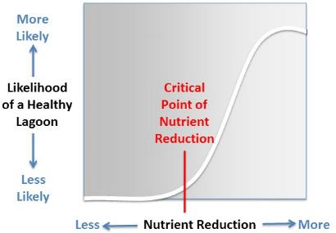
Figure 1-2: Likelihood of a Healthy IRL as Nutrients are Removed
There are other large-scale aquatic system restoration efforts that have been successful in achieving restoration. Some of these systems were damaged even more so than the IRL, but they have recovered through the implementation of extensive, multi-year, and multi-pronged restoration plans. These include the Chesapeake Bay, Cuyahoga River, Lake Erie, and Tampa Bay. These areas have reaped enormous economic and quality of life benefits as a result of dedicated investments in their restoration.

Approach, Outputs, and Outcomes
The amount and distribution of nutrient loading from the sources described in Section 3 were examined to determine the key locations where nutrient reduction projects are needed and the extent of reductions required from each source to achieve Brevard County’s proposed total maximum daily loads for each sub-lagoon. For each source, a reduction goal is set and projects are proposed to meet the goal. The estimated cost for each project is also included. Information on expected project efficiencies and project costs were gathered from data collected by Brevard County in implementation of similar projects, as well as literature results from studies in Florida, where available, and across the country. The most cost-effective projects are selected and prioritized to maximize the nutrient reductions that can be achieved.

Plan Focus Area
This plan focuses on projects implemented in three sub-lagoons in the Indian River Lagoon (IRL) system: Banana River Lagoon, North IRL, and Central IRL. Figure 2-1 shows the locations of these sub-lagoons. All the Banana River Lagoon watershed and the majority of the North IRL watershed are located within Brevard County (County). However, only a portion of the Central IRL watershed is located within the County. As shown in Figure 2-1, Central IRL Zone A is located entirely in Brevard County, whereas Zone SEB straddles Brevard and Indian River counties. For Zone SEB, the County has completed several projects in this area and the St. Johns River Water Management District is completing projects along the C-54 Canal and on the Wheeler property to treat the Sottile Canal. The reductions from these projects for total nitrogen [TN] and total phosphorus [TP]) should be sufficient to meet the estimated need for reductions in the Brevard County portion of Zone SEB, as shown in Table 2-1. This plan includes some additional beneficial projects located in Zone SEB to help ensure that the necessary reductions are achieved throughout Brevard County; however, most of the projects proposed in this plan for the Central IRL fall within Central IRL Zone A.
Table 2-1: Summary of Load Reductions and Projects in Central IRL Zone SEB
Category | Annual Total Nitrogen Load (pounds per year) | Five-Month Total Nitrogen Load (pounds per year) | Annual Total Phosphorus Load (pounds per year) | Five-Month Total Phosphorus Load (pound per year)
Stormwater and Baseflow Loading | 248,233 | 79,956 | 34,901 | 11,242
Atmospheric Deposition Loading | 22,371 | 7,206 | 404 | 130
Point Sources Loading | 0 | 0 | 0 | 0
Total Loading | 270,604 | 87,162 | 35,305 | 11,372
Target Percent Reductions | 18.0% | 38.0% | 16.0% | 35.0%
Targeted Reductions | 48,709 | 33,121 | 5,649 | 3,980
Completed County Projects (2010-February 2016) | 29,890 | 12,454 | 9,643 | 4,018
C-54 Project | 65,974 | 27,489 | 10,558 | 4,399
Wheeler Property Project | 36,582 | 15,243 | 21,784 | 9,077
Total Project Reductions | 132,446 | 55,186 | 41,985 | 17,494
% of Targeted Reductions Achieved | 271.9% | 166.6% | 743.2% | 439.5%
In addition, a small portion of the County is located within the Mosquito Lagoon. Brevard County does not have stormwater outfalls, septic systems, or point sources in this sub-lagoon.
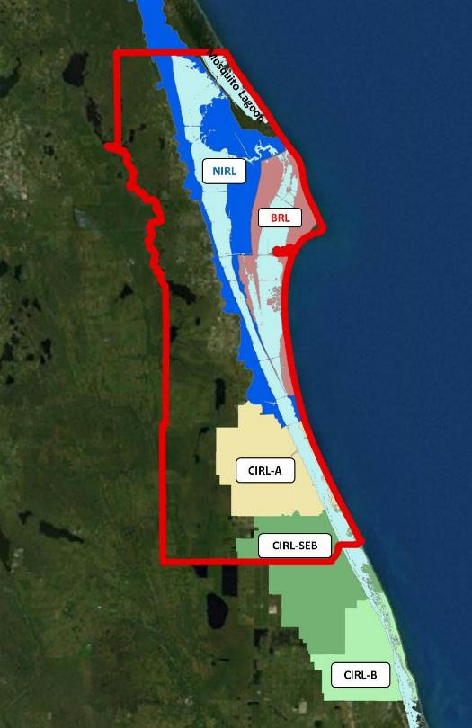
Figure 2-1: Locations of the Banana River Lagoon (BRL), North IRL (NIRL), and Central IRL (CIRL) Sub-lagoons

Plan Outputs and Outcomes
Vision Statement: An Indian River Lagoon teeming with fish, birds, and wildlife that provides recreation, economic vitality, and pride in our community.
Mission Statement: Restoring the Indian River Lagoon through collaborative, science-based projects which Reduce and Remove pollution to benefit our community, economy, and natural resources.
There are several outcomes expected from implementation of the plan. The plan outputs represent the project types included to Reduce external loads to the lagoon, Remove internal sources from the lagoon, Restore the natural filtration systems, and Respond to the changing conditions and opportunities. The outcomes from these outputs are the results, impacts, and accomplishments that will occur due to plan implementation (Figure 2-2). The timeframes for reaching various outcomes may be impacted by many factors outside Brevard County control, including federal and state legislation and weather; however, division of outcomes into short-term, mid-term, and long-term categories is meant to illustrate the sequence and approximate schedule of anticipated natural recovery.
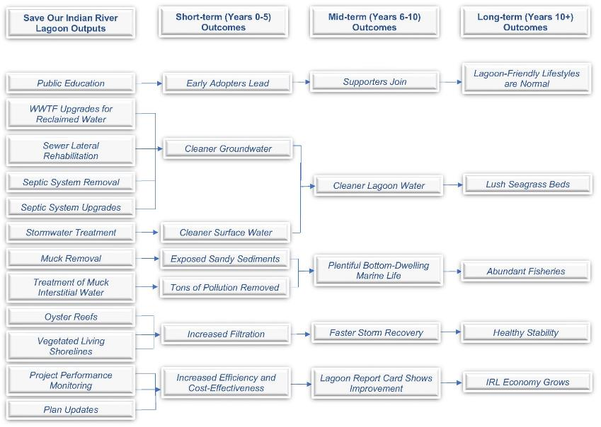
Figure 2-2. Summary of the Save Our Indian River Lagoon Outputs and Outcomes
Figure 2-2 Long Description

Pollutant Sources in the IRL Watershed
Pollutant loads in the Indian River Lagoon (IRL) watershed are generated from multiple external sources that discharge to the lagoon. Excess loads also accumulate in nutrient sinks within the lagoon, which release nutrients to the water column during certain conditions.
External sources fall into the following major categories:
- Stormwater runoff that occurs when rainfall hits the land and cannot soak into the ground:
  - Urban stormwater runoff is generated by rainfall and excess irrigation on impervious areas associated with urban development. Urban runoff picks up and transports nutrient loading from fertilizers, grass clippings, and pet waste, as well as other pollutants including sediments, pesticides, oil, and grease. Stormwater ponds and baffle boxes reduce the nutrient loading in stormwater; however, proper maintenance of these systems is necessary to maintain their performance.
  - Agricultural stormwater runoff occurs on agricultural land and this runoff also carries nutrients from fertilizers, as well as livestock waste, pesticides, and herbicides. This source of stormwater runoff is not addressed in this plan as the County does not have jurisdiction over agricultural use. The Florida Department of Agriculture and Consumer Services has an agricultural best management practice program, and they work with agricultural producers to control the loading from this source.
  - Natural stormwater runoff comes from the natural lands in the basin. This source is not addressed by this plan as natural loading does not need be controlled.
- Baseflow is the groundwater flow that contributes loading to the IRL. Due to the sandy soils in the basin and excess irrigation, nutrients can soak quickly into the groundwater with little removal. This groundwater can recharge surface water in ditches, canals, tributaries, or the IRL.
  - Excess fertilizer that soaks into the ground past the root zones.
  - Septic systems, both functioning and failing, contribute nutrient loading to the groundwater.
  - Leaking sewer pipes located above the water table can contribute nutrient loading to the groundwater.
- Atmospheric deposition that falls on both the land and the lagoon itself:
  - Nutrients in the atmosphere fall into the basin largely during rainfall events. The sources of these nutrients are from power plants, cars, and other sources that burn fossil fuels. However, because of atmospheric conditions and weather patterns, not all the nutrients from atmospheric deposition are generated within the watershed. Atmospheric loading is not directly addressed by this plan as air quality and air emission standards are regulated by the federal Clean Air Act and are not within the County’s control. However, the stormwater projects and in-lagoon projects will treat some of the nutrient loading from atmospheric deposition that falls on the land and lagoon surface.
- Point sources that treat collected sewage and discharge treated effluent:
  - The direct wastewater treatment facility discharges to the lagoon have been largely removed, and most of the facilities in the basin use the treated effluent for reclaimed water irrigation. However, depending on the level of treatment at the wastewater treatment facility, the reclaimed water can have an excessive concentration of nutrients that may contribute loading to the baseflow.
  - There have been issues with inflow and infiltration into the sanitary sewer collection system. Large rain events can result in large amounts of water entering the sewer collection system, and this additional water can cause sewer overflows that contribute nutrients and bacteria to local waterbodies.
In addition to these external sources of loading to the lagoon, nutrients from muck (muck flux) is an internal source of loading within the lagoon itself. Muck is made up of organic materials from soil erosion on the land and from decay of organic matter (leaves, grass clippings, algae, and aquatic vegetation) in the lagoon. As these organic materials decay, they constantly flux nutrients into the water column above, where they add to the surplus of nutrients coming from external sources.
Table 3-1 summarizes the estimated total nitrogen (TN) and total phosphorus (TP) loading from these sources in the Banana River Lagoon (including canals), North IRL, and Zone A of the Central IRL. The stormwater runoff and baseflow/septic systems loading estimates are from the Spatial Watershed Iterative Loading model, the point source loading estimates were based on the facility monthly operating reports and discharge monitoring reports, and the atmospheric deposition loads are from measured data at nearby stations. The muck flux load estimates are calculated based on the muck area in each portion of the lagoon and flux estimates from studies in the lagoon (refer to Section 4.2.1 for more details). The loading from these sources is also shown graphically in Figure 3-1, Figure 3-2, and Figure 3-3.
Table 3-1: Loading from Different Sources in Each Sub-lagoon
Source | Banana River Lagoon Total Nitrogen (pounds per year) | Banana River Lagoon Total Phosphorus (pounds per year) | North IRL Total Nitrogen (pounds per year) | North IRL Total Phosphorus (pounds per year) | Central IRL Zone A Total Nitrogen (pounds per year) | Central IRL Zone A Total Phosphorus (pounds per year)
Stormwater Runoff | 119,923 | 15,064 | 328,047 | 45,423 | 279,351 | 43,193
Baseflow/Septic, Leaking Sewer, Reclaimed Water | 164,225 | 22,613 | 344,111 | 47,383 | 370,129 | 50,966
Atmospheric Deposition | 175,388 | 3,222 | 301,977 | 5,505 | 49,456 | 892
Point Sources | 17,484 | 3,370 | 14,711 | 1,029 | 0 | 0
Muck Flux | 393,948 | 43,216 | 247,078 | 17,583 | 16,927 | 2,277
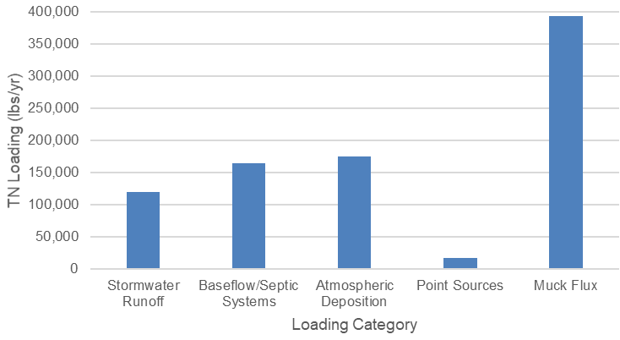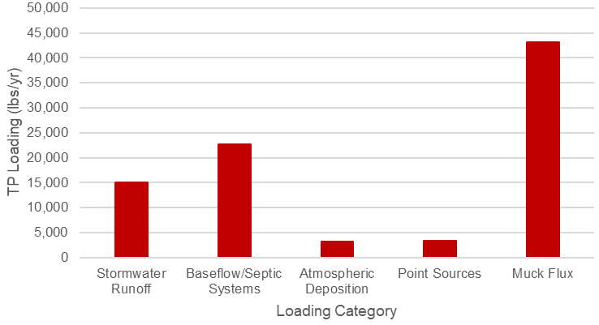
Figure 3-1: Banana River Lagoon TN (left) and TP (right) Annual Average Loads by Source
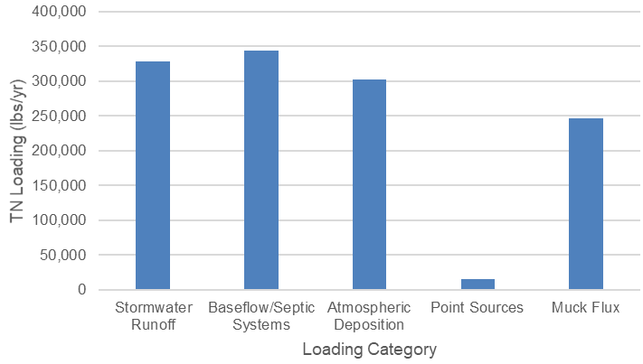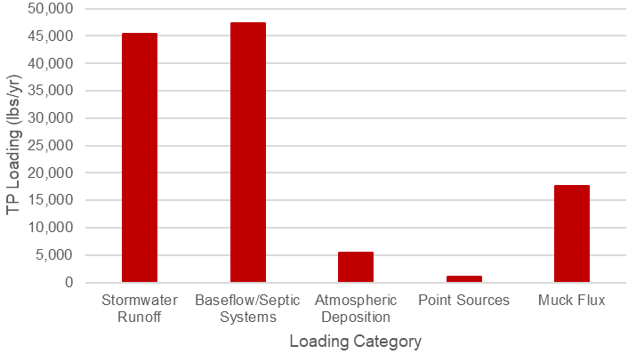
Figure 3-2: North IRL TN (left) and TP (right) Annual Average Loads by Source
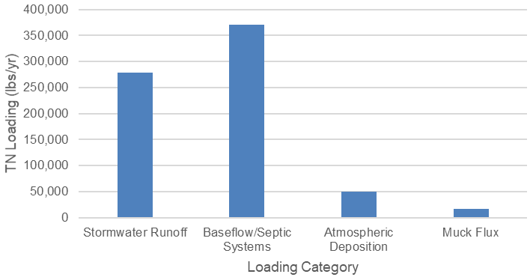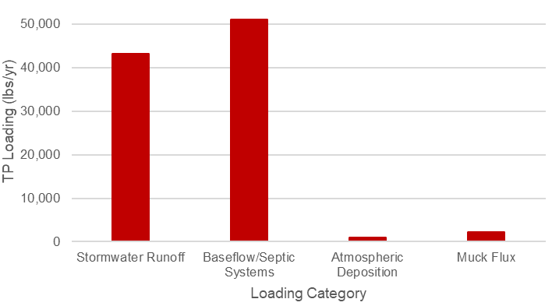
Figure 3-3: Central IRL TN (left) and TP (right) Annual Average Loads by Source

Project Options
To restore the lagoon’s balance, Brevard County has been implementing a multi-pronged approach to Reduce pollutant and nutrient inputs to the lagoon, Remove the accumulation of muck from the lagoon bottom, and Restore water-filtering oysters and related lagoon ecosystem services. This plan also recommends funding for project monitoring, needed for accountability and to Respond to changing conditions and opportunities. Respond funds will be used to track progress, measure cost effectiveness, and report on performance. Each year, the Citizen Oversight Committee (additional details are included in Section 4.4.1) will review monitoring reports and make recommendations to the Brevard County Board of County Commissioners to redirect remaining plan funds to those efforts that will be most successful and cost-effective. Although research is important to better understand factors that significantly impact the health, productivity, and natural resilience of the Indian River Lagoon (IRL), funding for research is not included in this project plan.
Several goals were set to help select the projects for this plan. The goal for the Reduce projects is to achieve the proposed total maximum daily load for each sub-lagoon (refer to Section 6 for additional details on the total maximum daily loads). The goal for the Remove projects is to achieve about a 25% reduction in estimated recycling of internal loads. The goals for the Restore projects are to filter the entire volume of the lagoon annually and to reduce shoreline erosion. The most cost-effective projects in each category were selected to maximize nutrient reductions, minimize lag time in lagoon response, reduce risk, and optimize the return on investment.
Section 4.1 through Section 4.5 provide information on the proposed projects, estimated nutrient reduction benefits, and costs, as well as the ongoing studies needed to measure and assess the project efficiencies and benefits to the lagoon system.

Projects to Reduce Pollutants
An important step in restoring the lagoon system is reducing the amount of pollutants that enter the Indian River Lagoon (IRL) through stormwater runoff and groundwater. Reduction efforts include source control (such as fertilizer reductions) to reduce the amount of pollutants generated, as well as treatment to reduce pollutants that have already been discharged before they are washed off in stormwater runoff or enter the groundwater system and ultimately discharge to the IRL. Monitoring of these projects will be performed to verify the estimated effectiveness of each project type implemented (refer to Section 4.4).
The benefits from fertilizer management and public education, wastewater treatment facility upgrades for reclaimed water, and stormwater treatment are seen fairly quickly in the lagoon system. Public education about fertilizer and other sources of pollution addresses nutrients at their source and prevents these nutrients from entering the system. Wastewater treatment facility upgrades result in reduced nutrients in the treated effluent, which is then used throughout the basin for reclaimed water irrigation. The stormwater projects will capture and treat runoff, which is currently untreated or inadequately treated, before it reaches the lagoon.
While greatly beneficial, septic system removal or upgrade projects may take longer to result in a nutrient reduction to the lagoon. The septic systems in key areas must be removed or upgraded to see the full benefits. In addition, septic systems contribute nutrient loading to the lagoon through groundwater, and the travel time of the nutrient plumes through the groundwater to a waterbody vary throughout the basin depending on watershed conditions.
The following subsections summarize (1) public education and outreach efforts; (2) infrastructure improvements for wastewater treatment facilities; (3) sprayfield and rapid infiltration basin upgrades; (4) package plant connections; (5) sewer laterals rehabilitation; (6) septic system removal and upgrades; and (7) stormwater treatment projects.

Public Outreach and Education
The education and outreach campaigns are summarized in the sections below.
Approximately 81,700 pounds per year of TN and 4,200 pounds per year of TP enter the lagoon watershed from excess fertilizer application.

Fertilizer Management
It is a common practice to apply fertilizer on urban and agricultural land uses. However, excessive and inappropriately applied fertilizer pollutes surrounding waters and stormwater. To help address fertilizer as a source of nutrient loading, local governments located within the watershed of a waterbody or water segment that is listed as impaired by nutrients are required to adopt, at a minimum, the Florida Department of Environmental Protection’s Model Ordinance for Florida-Friendly Fertilizer Use on Urban Landscapes (Section 403.067, Florida Statutes). Brevard County and its municipalities adopted fertilizer ordinances that included the required items from the Model Ordinance in December 2012, as well as additional provisions in 2013 and 2014. Local fertilizer ordinances are posted online at the Brevard County Extension website. These ordinances require zero phosphorus year-round, nitrogen to be at least 50% slow release, no nitrogen use during the rainy season, and variable surface water protection buffers.
Florida Department of Agriculture and Consumer Services compiled information on the fertilizer sales by county, as well as the estimated nutrients from those fertilizers. It is important to note that all fertilizer sold in a county may not be applied within that county because a portion of that fertilizer may be transported to another county. However, details on the amount of fertilizer transported between counties is not tracked. Therefore, the information in the Florida Department of Agriculture and Consumer Services reports is simply the best estimate of the amount of fertilizer used, and the associated nutrient content, in a county.
Based on the Florida Department of Agriculture and Consumer Services information, the lawn fertilizer sold in Brevard County in fiscal year 2014–2015 contained 408,220 pounds of nitrogen and 32,520 pounds of phosphorus. The fertilizer applied is attenuated through several naturally occurring physical, chemical, and biological processes including uptake by grass. The environmental attenuation/uptake for urban fertilizer is 80% for nitrogen (Florida Department of Environmental Protection, 2017) and 90% for phosphorus. The estimated total nitrogen (TN) and total phosphorus (TP) that is applied but is not naturally attenuated is shown in Table 4-1. It is important to note that not all the un-attenuated nutrients will migrate to the lagoon, either through runoff or baseflow (groundwater that enters ditches, canals, and tributaries), but these numbers provide an idea of the excess nutrients that could be reduced as a result of public education and changes in fertilizer use.
Table 4-1: Estimated TN and TP Not Attenuated in Fiscal Year 2014–2015
Parameter | Pounds Sold Fiscal Year 2014-15 (Lawn Only) | Environmental Attenuation (%) | Fiscal Year 2014-15 Pounds (Lawn Only) after Attenuation
Total Nitrogen | 408,220 | 80% | 81,644
Total Phosphorus | 32,520 | 90% | 3,252
When recent sales data are compared to the fertilizer sold in fiscal year 2013–2014, which is before adoption of the more protective amendments to the ordinance, significant reductions are observed. These reductions from the implementation of the ordinance are shown in Table 4-2.
Table 4-2: Reductions from Fertilizer Ordinance Compliance as of Fiscal Year 2014–2015
Parameter | Fiscal Year 2013-14 Pounds (Lawn Only) after Attenuation: Pre-Ordinance  (pounds per year) | Fiscal Year 2014-15 Pounds (Lawn Only) after Attenuation: Post-Ordinance  (pounds per year) | Reductions from Ordinance to Date (pounds per year)
Total Nitrogen | 127,540 | 81,644 | 45,896
Total Phosphorus | 12,640 | 3,252 | 9,388
Based on studies by the University of Florida, approximately 0.03% of applied nitrogen ends up in runoff during establishment of sodded Bermudagrass on a 10% slope. Nitrogen leaching ranged from 8% to 12% of the amount applied (Trenholm and Sartain, 2010). Therefore, nitrogen leaching from fertilizer into the groundwater is 300 to 400 times as much as the nitrogen running off in stormwater. To help address the leaching issue, the Brevard County fertilizer ordinance encourages the use of slow release nitrogen fertilizer. Slow release fertilizer decreases nitrogen leaching by about 30% (University of Florida-Institute of Food and Agricultural Sciences, 2012). In addition, the ordinance requires that fertilizer with zero phosphorus is used.
The public education and outreach campaign will be expanded to include focus on slow release and zero phosphorus fertilizers. An important component of this will be to reach out to stores within Brevard County to ensure they are making slow release and zero phosphorus fertilizers more visible and to add signage to let buyers know which fertilizers are compliant with all local ordinances. This would cost approximately $125,000 per year for a period of five years. If an additional 25% of fertilizer users switch to 50% slow release nitrogen and zero phosphorus formulations, compliant with the ordinance, this would result in a reduction of 6,123 pounds per year of TN and 813 pounds per year of TP.
In 2019, the University of Florida Institute of Food and Agricultural Sciences and MTN Marketing conducted a survey that was concentrated on fertilizer awareness questions. The results from the 2019 survey were compared to similar questions from the 2015 Blue Life survey to evaluate changes in fertilizer use. Based on the survey results, 33.33% of respondents in 2019 stated that they use slow release nitrogen fertilizer compared to only 6.30% in 2015, which is a 27% increase in the usage of slow release fertilizer. Therefore, as part of the 2021 Update, the estimated nitrogen reductions from the expanded fertilizer education was updated to 27%, which results in an estimated reduction of 6,613 pounds per year of TN. The TP reductions were kept at 25% compliance because, the way the survey was setup, participants were only able to select one option for the type of fertilizer used. Therefore, an update on the use of zero phosphorus formulas could not be obtained. The estimated reductions are shown in Table 4-3.
Table 4-3: Project for Additional Fertilizer Ordinance Compliance
Year Added | Project Number | Project Name | Responsible Entity | Sub-lagoon | Total Nitrogen Reduction (pounds per year) | Total Nitrogen Cost per Pound per Year | Total Phosphorus Reduction (pounds per year) | Total Phosphorus Cost per Pound per Year | Plan Funding
Original | 58a | Expanded Fertilizer Education* | Brevard County | All | 6,613 | $95 | 813 | $769 | $625,000
Note: The projects highlighted in green and marked with an asterisk were identified in the original plan.
In 2018, the Citizen Oversight Committee recommended extending the fertilizer education and outreach beyond the original plan recommendation of five years to all ten years of the plan. The $625,000 for this project will be redistributed as follows: (1) $125,000 in Year 1 to create the education campaign and begin implementation, (2) $50,000 per year to continue implementation in Years 2–10, and (3) an additional $50,000 in Year 6 (for a total of $100,000 in this year) to evaluate program success and update the outreach materials, as needed.

Grass Clippings
Grass clippings contain nutrients and those nutrients are released in stormwater or the lagoon as they decompose (Brevard County Natural Resources Management Department, 2017). St. Augustine grass contains 2.5% nitrogen and 0.2–0.5% (average of 0.5%) phosphorus and Bahia grass contains 2% nitrogen (University of Florida-Institute of Food and Agricultural Sciences, 2015). According to Okaloosa County Extension (2017), a 7,500-square foot lawn produces about 3,000 pounds of clippings per year. Unfortunately, the percentage of those total clippings that end up in stormwater is not known.
To estimate the potential nutrient reduction impact of a grass clippings campaign, it was assumed that the average home lot size is 10,000 square feet with a 100-foot by 100-foot boundary, with 2,500 square feet of built space and 7,500 square feet of lawn (Figure 4-1). The University of Florida-Institute of Food and Agricultural Sciences estimated that 3,000 pounds of grass clippings are produced annually from a healthy lawn of this size. It was assumed that most of the grass clippings in Brevard County are from St. Augustine grass, which means that 3,000 pounds of clippings contains approximately 75 pounds of TN and 10.5 pounds of TP.
It was also assumed that the standard mower size is two feet wide. From one roadside pass along 100 feet of the average lawn with a two-foot wide mower, 200 square feet or 2.6% of the total lawn clippings could be cast into the road. This equals 0.02 pounds of TN and 0.0027 pounds of TP per foot per year left in the road. With about 3,800 miles of roads in the Indian River Lagoon (IRL) Basin within Brevard County, of which approximately 1,250 miles are paved with curb and gutter and are most likely to allow the ready transport of grass clippings to the lagoon in stormwater, the potential nutrient release from those grass clippings could be up to 260,000 pounds per year of TN and 35,640 pounds per year of TP from mowing along both sides of the road.
If Brevard County expects a similar rate of awareness of 24% as Alachua County (2012), then a potential 200,000 pounds per year of TN and 27,000 pounds per year of TP may be entering the stormwater. If a successful grass clippings campaign in Brevard County can capture an increase of awareness similar to Alachua County (from 24% to 69%), then there is a potential reduction of 88,920 pounds per year of TN and 12,189 pounds per year of TP. In addition, assuming the environmental attenuation/uptake for grass clippings is similar to the urban fertilizer uptake of 80% for nitrogen and 90% for phosphorus, the estimated reductions would be 17,800 pounds per year of TN and 1,200 pounds per year of TP.
This estimate assumes a simplified worst-case scenario in which everyone leaves a portion of their clippings in the road; however, it does not take into account the number of driveways, sidewalks, medians, and other impervious surfaces that grass clippings could be falling or the grass clippings being directly cast into the IRL, canals, and other waterways. Using the available information, this provides an order of magnitude estimate of the potential benefits of a grass clippings campaign for the IRL.
Figure 4-1: Grass Clippings Example for a Typical Lot
Figure 4-1 Long Description
The Marine Resources Council proposed a partnership between the IRL Basin counties to pursue a grass clippings campaign similar to the Alachua County campaign. The Citizen Oversight Committee recommended contributing $20,000 in Year 1 of the plan towards the research and marketing to develop the campaign. This was followed by an annual investment of $20,000 per year for Years 2 through 10 for media and promotional materials targeting Brevard County. Therefore, the total project cost is $200,000. Table 4-4 summarizes the costs and benefits of implementing the grass clippings campaign.
Table 4-4: Project for Grass Clippings Campaign
Year Added | Project Number | Project Name | Responsible Entity | Sub-lagoon | Total Nitrogen Reduction (pounds per year) | Total Nitrogen Cost per Pound per Year | Total Phosphorus Reduction (pounds per year) | Total Phosphorus Cost per Pound per Year | Plan Funding
2018 | 58b | Grass Clippings Campaign+ | Brevard County | All | 17,800 | $11 | 1,200 | $167 | $200,000
Note: The projects highlighted in tan and marked with a plus sign were added to the plan as part of an annual update.
Market research needed to guide development of a grass clipping campaign was contracted through the Marine Resources Council to a community-based social marketing firm, Uppercase Inc. Survey results from 2018 are reported in Section 4.4.3.

Excess Irrigation
Fertilizer nutrients are more susceptible to leaching if turfgrass is overwatered, carrying nutrients beyond the reach of the turf roots. During excess watering, soluble nutrients, such as highly mobile nitrate, wash through the soil from the root zone too quickly. Excess irrigation is easy to accomplish in Florida’s sandy soils as these soils typically hold no more than 0.75 inches of water per foot of soil depth (Hochmuth et al., 2016). This excess irrigation is part of the baseflow contributing nutrient loading to the IRL.
From June 2015 to May 2016, 470,737 pounds of TN in fertilizer were sold within Brevard County. Florida Department of Agriculture and Consumer Services Urban Turf Fertilizer Rule (RE-1.003[2], Florida Administrative Code) does not specify a percentage of slow-released nitrogen in fertilizer or separately track slow-release nitrogen from all nitrogen sources. However, if it is assumed that 50% of fertilizer was soluble nitrogen (compliant with local fertilizer ordinances), then the total soluble nitrogen sold in Brevard County could be as high as 235,368 pounds per year. If 13% of soluble nitrogen were leached, up to 30,597 pounds per year of TN could potentially enter the groundwater. If, like South Florida survey respondents, 50% of irrigation users in Brevard County are not over-irrigating and if an outreach campaign can impact half of those who do over-irrigate, fertilizer leaching could be reduced by 7,649 pounds per year of TN. As noted above, the environmental attenuation/uptake for urban fertilizer is 80% for nitrogen (Florida Department of Environmental Protection, 2017). Therefore, the total amount of TN that could be reduced by reducing excess irrigation is 1,530 pounds per year.
Conducting an outreach campaign with an initial $50,000 social marketing research and development investment and $25,000 in annual implementation, the total 10-year budget would be $300,000. This results in an average of $196 per pound of TN reduced per year (see Table 4-5). Funding for this education campaign is not recommended at this time.
Table 4-5: Estimated TN Reductions and Costs from Reducing Excess Irrigation
Project | Cost | Estimated Total Nitrogen Reductions (pounds per year) | Cost per Pound per Year of Total Nitrogen Removed
Irrigation Education | $300,000 | 1,530 | $196

Stormwater Pond Maintenance
Wet detention ponds, also known as stormwater ponds, are one method used to remove nutrients from stormwater as mandated by Florida Statutes 403.0891. Retention/detention time of water in the pond accommodates the removal of accumulated nutrients by allowing material to settle and be absorbed. By itself, an optimally sized and properly maintained stormwater pond typically provides a 35–40% removal of nitrogen and 65% removal of phosphorus through settling (Florida Department of Environmental Protection and Water Management Districts, 2010). Additional behaviors and technologies can be combined with ponds to increase removal rates. On the other hand, poor pond maintenance practices can decrease nutrient removal rates or worse yet, release nutrients to downstream waterbodies.
A stormwater pond maintenance program would initially focus on vegetative buffers and their appropriate maintenance to reduce stormwater pollution. Brevard County contains 4,175 stormwater ponds covering 13,276 acres with 6,976,338 linear feet of shoreline. The average size of a pond is 3.2 acres with 1,671 linear feet of shoreline. These numbers include ponds affiliated with both residential and commercial areas. The average load to stormwater ponds is 11.4 pounds of TN per acre of land surrounding the pond annually according to the Florida Department of Environmental Protection’s Spreadsheet Tool for Estimating Pollutant Loads. Assuming that a 50-foot perimeter directly impacts the pond, there are 8,008 acres contributing 91,288 pounds of TN annually to the ponds. Of this, up to 40% of the TN is removed through retention in the pond leaving a potential 54,773 pounds per year of TN to enter the lagoon. For TP, approximately 18,836 pounds per year is entering the stormwater pond. Of this, up to 65% of the TP is removed through retention in the pond leaving a potential of 6,593 pounds per year TP to enter the lagoon.
Creating a 10-foot-wide low-maintenance buffer zone of un-mowed ornamental grasses has the potential to remove about 25% of the TN and TP entering the pond (United States Environmental Protection Agency, 2005). This amount increases with the width of the buffer and the addition of woody vegetation. For the plan calculations, the assumption was made that convincing homeowners to not mow a 10-foot buffer is the easiest practice to achieve. The pond will remove up to 40% of the remaining TN. Assuming that the education campaign can reach at least half of the 48% of people unaware of what stormwater is, the reduction could be 3,286 pounds per year of TN and 396 pounds per year of TP.
Conducting an outreach campaign with an initial $50,000 social marketing research and development investment plus $25,000 in annual implementation, would require a 10-year total budget of $300,000. This would result in reductions at $91 per pound of TN and $750 per pound of TP (see Table 4-6). Additionally, during focus group research in the first year, it may be possible to identify other best management practices that homeowners’ associations are willing to adopt that would further improve the performance of their stormwater pond. This would improve the cost effectiveness of this campaign. Funding for this education campaign is not recommended at this time.
Table 4-6: Estimated TN and TP Reductions and Costs from Stormwater Best Management Practice Maintenance
Project | Cost | Estimated Total Nitrogen Reductions (pounds per year) | Cost per Pound Per Year of Total Nitrogen Removed | Estimated Total Phosphorus Reductions (pounds per year) | Cost per Pound per Year of Total Phosphorus Removed
Stormwater Best Management Practice Maintenance Education | $300,000 | 3,300 | $91 | 400 | $750

Septic Systems and Sewer Laterals Maintenance
Nationwide, 10–20% of septic systems are failing from overuse, improper maintenance, unsuitable drainfield conditions, and high-water tables. When septic systems are older and failing or are installed over poor soils close to the groundwater table or open water, they can be a major contributor of nutrients and bacterial and viral pathogens to the system (De and Toor, 2017; United States Environmental Protection Agency, 2002).
A properly functioning septic tank and drainfield system reduces TN by 30–40%. However, the reduction has been measured at 0–20% in adverse conditions. The best available studies estimate a 10% reduction in nitrogen within a properly maintained tank versus an improperly maintained tank. The remaining 20–30% of nitrogen removal occurs in a properly functioning drainfield (Anderson 2006). If 15% of systems are failing and failing systems attenuate 30% less of the nitrogen load, these systems may pose far greater impacts to the groundwater, tributaries, and lagoon than the average impact reported for properly functioning systems. Without the 30% reduction, the potential load to the IRL and its tributaries is estimated to be 27.2 pounds per year of TN for properties within 55 yards (instead of 19 pounds per year of TN for functioning systems), 5.2 pounds per year of TN for properties between 55 and 219 yards away (instead of 3.6 pounds per year of TN for functioning systems), and 1.1 pounds per year of TN for properties more than 219 yards away (instead of 0.8 pounds per year of TN for functioning systems).
There are an estimated 53,204 septic systems in Brevard County within the IRL Basin. As noted in Section 4.1.6, the total loading of septic systems within 55 yards of the IRL and its tributaries is calculated at 299,590 pounds per year of TN, the total loading of systems between 55 and 219 yards is 86,575 pounds per year of TN, and the total loading of septic systems further than 219 yards is 10,805 pounds per year of TN. If the failure rate in Brevard County is about 15%, and if failing systems receive 30% less attenuation, then failing systems within 55 yards of open water are contributing 13,481 pounds per year of TN, failing systems between 55 and 219 yards of open water are contributing 3,896 pounds per year of TN, and failing tanks further than 219 yards are contributing 486 pounds per year of TN. By factoring in this failure rate, the total additional loading to the IRL from failing septic systems is approximately 17,863 pounds per year of TN.
A 10-year outreach campaign budget of $300,000, which includes $50,000 for research and campaign development and $25,000 per year for implementation to improve septic system maintenance, reduce excess use, and prevent harmful additives, would strive to reduce the number of failing systems countywide by 25%, thereby reducing the excess loading from failing systems by 4,466 pounds per year of TN. This would result in average cost of $67 per pound of TN (see Table 4-7).
Table 4-7: Project for Septic System Maintenance Program
Year Added | Project Number | Project Name | Responsible Entity | Sub-lagoon | Total Nitrogen Reduction (pounds per year) | Total Nitrogen Cost per Pound per Year | Total Phosphorus Reduction (pounds per year) | Total Phosphorus Cost per Pound per Year | Plan Funding
2018 | 58c | Septic System Maintenance Education+ | Brevard County | All | 4,466 | $67 | Not applicable | Not applicable | $300,000
Note: The projects highlighted in tan and marked with a plus sign were added to the plan as part of an annual update.
Market research needed to guide development of a septic maintenance campaign was contracted with state grant funding through the Marine Resources Council to the University of Central Florida. Survey results from 2018 are reported in Section 4.4.3. In reaching out to citizens to participate in the survey, it was found that many people are unsure of whether they are on central sewer or a septic system. When developing the septic system maintenance education program, Brevard County will identify opportunities to educate people who are on central sewer about proper maintenance of their sewer laterals. Adding this education component to the septic system maintenance education campaign is not anticipated to require additional funding.

Lagoon Loyal Program
Using funding from the fertilizer education and septic system maintenance education programs, the marketing company MTN Advertising was contracted to create an outreach campaign to engage Brevard citizens in IRL restoration efforts. The Lagoon Loyal campaign uses an incentive program to motivate positive actions that benefit the IRL (website). Citizens can create an online Lagoon Loyal profile that keeps track of participation in suggested activities that benefit the lagoon and then provides rewards. Completing each activity earns points, which can accumulate and be redeemed for discounts to local area businesses.
Lagoon Loyal businesses providing discounts are given display materials that indicate their support for the lagoon and their participation in the program. These display materials also advertise the program to their customers. Citizens who complete Lagoon Loyal actions receive coupons that encourage them to patronize Lagoon Loyal businesses, providing a positive feedback loop for local citizens and businesses. Combined with social media marketing and traditional media advertising, the program uses the slogan “Let’s Be Clear…” to share easy actions that citizens can take to reduce their contribution to lagoon pollution. Message selection is guided by focus groups and survey responses from citizens who either care for a yard or maintain a septic system.
The Lagoon Loyal program has also developed and distributed outreach materials targeted for greatest impact with the public. Fertilizer ordinance signs, educating the public on proper use of fertilizer, were distributed to all fertilizer retail locations in Brevard County. These signs must remain posted anywhere fertilizer is sold. A pilot program is underway with stickers marking ordinance compliant fertilizer bags to help direct the public in making the right choice when purchasing fertilizer.
For the septic system outreach program, a best management practices magnet was created and provided to septic contractors to distribute to clients when making service calls. An educational flyer on septic system best management practices, which also encourages septic system inspections during home purchases, was created to be distributed by realtors and title agencies to buyers of homes with septic systems. The Lagoon Loyal Program website also maintains landing pages to help interested homeowners find links to the applications for septic system upgrade and removal grants available to eligible locations.

Oyster Gardening Program
Much of the IRL system in Brevard County no longer has a sufficient oyster population to allow for natural recruitment of oysters to suitable substrate (Futch, 1967). Therefore, to create the oyster bars, the oysters must be grown and then carefully placed on appropriate substrate in the selected locations. To help grow the oyster population, in fiscal year 2013–2014, the Board of County Commissioners approved $150,000 to launch the Oyster Gardening Program. This program is a citizen-based oyster propagation program where juvenile oysters are raised under lagoon-front homeowners’ docks for about six months before being used to populate constructed oyster bar sites. Oyster Gardening participants receive spat-on-shell oysters plus all supplies needed to care for their oysters. The Oyster Gardening Program is executed in partnership with the Brevard Zoo. The project continued during fiscal year 2014–2015 with funding from the state and has continued since with annual County funding.
In 2020, the Citizen Oversight Committee approved $300,000 from the Save Our Indian River Lagoon Tax to fund two years of the Oyster Gardening Program through September 2021 (Table 4-8).
Table 4-8: Project for Oyster Gardening Program
Year Added | Project Number | Project Name | Responsible Entity | Sub-lagoon | Total Nitrogen Reduction (pounds per year) | Total Nitrogen Cost per Pound per Year | Total Phosphorus Reduction (pounds per year) | Total Phosphorus Cost per Pound per Year | Plan Funding
2020 | 193 | Oyster Gardening Program+ | Brevard County | All | Not applicable | Not applicable | Not applicable | Not applicable | $300,000
2022 | 227 | Restore Our Shores: Community Collaborative+ | Brevard County and Brevard Zoo | All | Not applicable | Not applicable | Not applicable | Not applicable | $1,000,000
Note: The projects highlighted in tan and marked with a plus sign were added to the plan as part of an annual update.

As the IRL restoration needs continue to grow, the Oyster Gardening Program is poised to help meet the need for additional resources. Through independent grants, Brevard Zoo Restore Our Shores has begun participating in seagrass and clam restoration efforts. The Oyster Gardening Program has diversified to connect waterfront homeowners with other community members to tend oyster habitats and grow Mercenaria mercenaria clams to repopulate the lagoon. Clams are important filter feeders that can live within seagrass meadows directly benefiting the habitat through local water quality improvements (Wall et al., 2008). Brevard Zoo also plans to pilot “community gardens” where residents can participate in restoration activities on public property, such as tending clam cover nets during the first year of growth.
There has been increasing need for seagrass restoration and, as water quality conditions in the lagoon become suitable, it will be necessary to raise seagrass to plant in the lagoon. The establishment of seagrass nurseries can provide opportunities for the public to engage in seagrass grow-out. The existing network of community participants in the Oyster Gardening Program will be invaluable to support these additional restoration efforts.

Wastewater Treatment Facility Upgrades
88% of reclaimed water in the County is used in public access areas and for landscape irrigation.
The direct wastewater treatment facility discharges to the Indian River Lagoon (IRL) have been largely removed, and the majority of facilities in the basin use the treated effluent for reclaimed water irrigation. While the use of reclaimed water for irrigation is an excellent approach to conserving potable water, if the reclaimed water is high in nutrient concentrations, the application of the reclaimed water for irrigation can result in nutrients leaching into the groundwater. It is important to note that there are no regulations on the concentration of nutrients in reclaimed water that is used for irrigation. However, University of Florida-Institute of Food and Agricultural Sciences studies indicate that a nitrogen concentration of 5 to 9 milligrams per liter is optimal for turfgrass growth, and each year a maximum amount of 1 pound of nitrogen can be applied per 1,000 square feet of turf (University of Florida-Institute of Food and Agricultural Sciences, 2013a and 2013b). Nitrogen leaching increases significantly when irrigation is greater than 2 centimeters per week (0.75 inches per week), even if the nitrogen concentrations are half of the maximum Institute of Food and Agricultural Sciences recommendation of 9 milligrams per liter.
In Brevard County (County), 88% of the reclaimed water is used in public access areas and for landscape irrigation. The total reclaimed water used countywide is approximately 18.5 million gallons per day, which is applied over 7,340 acres. The unincorporated County and city wastewater treatment facilities with the reclaimed water flows, total nitrogen (TN) concentrations based on permit data and loads in pounds per year are shown in Table 4-9. This table also summarizes the excess TN in the reclaimed water after environmental attenuation/uptake (75% for TN [Florida Department of Environmental Protection, 2017]), for both the current TN effluent concentration and if the facility were upgraded to achieve a TN effluent concentration of 6 milligrams per liter (the City of Palm Bay Water Reclamation Facility update will achieve a TN effluent concentration of 7.5 milligrams per liter and the City of Melbourne Grant Street Wastewater Treatment Facility will achieve a TN effluent concentration of 5 milligrams per liter).
Table 4-9: TN Concentrations in Wastewater Treatment Facility Reclaimed Water
Facility | Permitted Capacity (million gallons per day) | Reclaimed Water Flow (million gallons per day) | Total Nitrogen Concentration (milligrams per liter) | Total Nitrogen After Attenuation (pounds per year) | Total Nitrogen After Attenuation and Upgrade (pounds per year)
City of Palm Bay Water Reclamation Facility | 4.0 | 1.20 | 29.4 | 27,305 | 6,966
City of Melbourne Grant Street | 5.5 | 2.08 | 21.0 | 33,806 | 8,049
City of Titusville Osprey | 2.75 | 1.67 | 12.7 | 16,415 | 7,755
Brevard County Port St. John | 0.5 | 0.35 | 12.6 | 3,413 | 1,625
Cape Canaveral Air Force Station | 0.8 | 0.80 | 11.9 | 7,368 | 3,714
City of West Melbourne Ray Bullard Water Reclamation Facility | 2.5 | 0.85 | 11.1 | 7,302 | 3,947
Brevard County Barefoot Bay Water Reclamation Facility | 0.9 | 0.48 | 10.3 | 3,826 | 2,229
Brevard County South Beaches | 8.0 | 1.12 | 9.3 | 8,061 | 5,201
Brevard County North Regional | 0.9 | 0.26 | 8.9 | 1,791 | 1,207
Rockledge Wastewater Treatment Facility | 4.5 | 1.40 | 7.0 | 7,584 | 6,501
Brevard County South Central Regional | 5.5 | 3.79 | 6.7 | 19,653 | 17,600
City of Titusville Blue Heron | 4.0 | 0.84 | 4.8 | 4,993 | Not applicable
City of Cape Canaveral Water Reclamation Facility | 1.8 | 0.88 | 3.8 | 4,141 | Not applicable
City of Cocoa Jerry Sellers Water Reclamation Facility | 4.5 | 1.44 | 3.5 | 6,241 | Not applicable
Brevard County Sykes Creek | 6.0 | 1.48 | 3.4 | 3,895 | Not applicable
City of Cocoa Beach Water Reclamation Facility | 6.0 | 3.66 | 2.5 | 11,331 | Not applicable
Based on a 2007 study by United States Environmental Protection Agency, the cost to upgrade wastewater treatment facilities to meet advanced wastewater treatment standards is approximately $4,200,000 per plant. This cost is in 2006 dollars, which, when inflated to 2016 dollars and costs are included for design and permitting, is approximately $6,000,000 per facility. Where cost estimates were available for facility upgrades, these costs were used instead of the inflated estimated costs. Due to the high cost per pound of TN and total phosphorus (TP) removed to upgrade some of these facilities compared to other projects in this plan, only those facilities in Table 4-10 are recommended for upgrades as part of this plan. This table also includes the wastewater treatment facility upgrade projects submitted as part of an annual update to the plan. As part of the public education and outreach efforts, customers who use reclaimed water for irrigation should be informed of the nutrient content in the reuse water because they can and should eliminate or reduce the amount of fertilizer added to their lawn and landscaping. This information can be provided to the customers through their utility bill.
Table 4-10: Projects for Wastewater Treatment Facility Upgrades to Improve Reclaimed Water
Year Added | Project Number | Project Name | Responsible Entity | Sub-lagoon | Total Nitrogen Reduction (pounds per year) | Cost per Pound per Year of Total Nitrogen Removed | Total Phosphorus Reduction (pounds per year) | Cost per Pound per Year of Total Phosphorus Removed | Plan Funding
Original | 2016-17 | City of Palm Bay Water Reclamation Facility* | City of Palm Bay | Central IRL | 20,240 | $180 | 102 | $35,656 | $3,636,900
Original | 2016-02a | City of Titusville Osprey Wastewater Treatment Facility* | City of Titusville | North IRL | 8,660 | $1,016 | Not applicable | Not applicable | $8,800,000
2018 | 59 | Grant Street Water Reclamation Facility Nutrient Removal Improvements+ | City of Melbourne | Central IRL | 18,052 | $375 | 9,671 | $700 | $6,769,500
2019 | 99 | Cocoa Beach Water Reclamation Facility Upgrade+ | City of Cocoa Beach | Banana | 2,520 | $375 | 685 | $1,380 | $945,000
2020 | 2016-2b | City of Titusville Osprey Nutrient Removal Upgrade Phase 2+ | City of Titusville | North IRL | 3,626 | $83 | Not applicable | Not applicable | $300,000
2020 | 138 | Ray Bullard Water Reclamation Facility Biological Nutrient Removal Upgrade+ | City of West Melbourne | Central IRL | 11,360 | $375 | 3,302 | $1,290 | $4,260,000
2022 | 216 | City of Rockledge Flow Equalization Basin Project+ | City of Rockledge | North IRL | 5,365 | $383 | Not applicable | Not applicable | $2,054,795
- | - | Total | - | - | 69,823 | $383 (average) | 13,760 | $1,945 (average) | $26,766,195
Note: The projects highlighted in green and marked with an asterisk were identified in the original plan. The projects highlighted in tan and marked with a plus sign were added to the plan as part of an annual update.

Sprayfield and Rapid Infiltration Basin Upgrades
Another opportunity to reduce the nutrient loading from the wastewater treatment facilities is to upgrade the disposal locations, either sprayfields or rapid infiltration basins, for the treated effluent. The sprayfields and rapid infiltration basins could be modified to include biosorption activated media to provide additional nutrient removal. Examples of biosorption activated media include mixes of soil, sawdust, zeolites, tire crumb, vegetation, sulfur, and spodosols (Wanielista et al., 2011). Based on a pilot project in the City of DeLand, the potential removal of adding biosorption activated media to a sprayfield or rapid infiltration basin is 83% for total nitrogen (TN) and 66% for total phosphorus (TP) (City of DeLand and University of Central Florida, 2018). The loads for the facilities in Brevard County that dispose of reclaimed water to a sprayfield or rapid infiltration basin were estimated based on permit and discharge monitoring report information (where available). Attenuation rates used were based on Florida Department of Environmental Protection (2017) estimates of 60% for sprayfields and 25% for rapid infiltration basins. Then the biosorption activated media efficiency rate was applied to determine the TN that could be removed. Costs were estimated for each upgrade and the upgrades that could be made for the least cost per pound of TN are recommended for pilot project funding as part of this plan (see Table 4-11 and Table 4-12). Information on nutrient concentrations or the size of the sprayfield/rapid infiltration basin were missing from several facilities. As this information is gathered, additional upgrades may be found to be cost-effective.
Table 4-11: Projects for Sprayfield or Rapid Infiltration Basin Upgrades for Public Facilities
Year Added | Project Number | Project Name | Responsible Entity | Sub-lagoon | Total Nitrogen Reduction (pounds per year) | Total Nitrogen Cost per Pound per Year | Total Phosphorus Reduction (pounds per year) | Total Phosphorus Cost per Pound per Year | Plan Funding
2017 | 6 | Long Point Park Upgrade+ | Brevard County Parks Department | Central IRL | 163 | $625 | Not applicable | Not applicable | $101,854
- | - | Total | - | - | 163 | $625 | Not applicable | Not applicable | $101,854
Note: The projects highlighted in tan and marked with a plus sign were added to the plan as part of an annual update.
Table 4-12: Projects for Sprayfield or Rapid Infiltration Basin Upgrades for Private Facilities
Year Added | Project Number | Project Name | Responsible Entity | Sub-lagoon | Total Nitrogen Reduction (pounds per year) | Total Nitrogen Cost per Pound per Year | Total Phosphorus Reduction (pounds per year) | Total Phosphorus Cost per Pound per Year | Plan Funding
2022 | 196 | Sterling House Condominium Sprayfield+^ | Brevard County | Central IRL | 154 | $390 | To be determined | To be determined | $60,000
- | - | Total | - | - | 154 | $390 | To be determined | To be determined | $60,000
Note: The projects highlighted in tan and marked with a plus sign were added to the plan as part of an annual update.
^ This is the most cost-effective location that is not likely to become eligible to connect to sewer in the near future.

Package Plant Connections
Package plants are miniature wastewater treatment facilities that serve small communities producing more than 2,000 gallons of effluent per day. The most common package plant treatment methods are extended aeration, sequencing batch reactors, and oxidation ditches; the same biological treatment methods used in larger wastewater treatment plants. The smallest package plants often use the same technology as advanced septic systems. Following this treatment, the effluent is disposed of in rapid infiltration basins (ponds), sprayfields, or drainfields (United States Environmental Protection Agency, 2000).
Most package plants were removed in the 1990s following the Indian River Lagoon System and Basin Act of 1990. However, opportunities still exist to address some of the worst remaining package plants by upgrading the existing plant, adding nutrient scrubbing technology, or preferably connecting them to central sewer where the wastewater will receive further treatment and disposal far from the lagoon. A few of these package plants are located along the Indian River Lagoon (IRL) and, therefore, pose a substantial nutrient risk due to their effluent concentration and disposal methods. Table 4-13 lists the estimated total nitrogen (TN) reductions and costs to connect the package plants to the sewer system. The estimated TN load from each package plant accounts for attenuation rates that were based on Florida Department of Environmental Protection (2017) estimates of 60% for sprayfields and 25% for rapid infiltration basins.
Table 4-13: Projects for Package Plant Connection
Year Added | Project Number | Project Name | Responsible Entity | Sub-lagoon | Total Nitrogen Reduction (pounds per year) | Total Nitrogen Cost per Pound per Year | Total Phosphorus Reduction (pounds per year) | Total Phosphorus Cost per Pound per Year | Plan Funding
2022 | 202 | Merritt Island Utility Company+ | Brevard County | North IRL | 1,367 | $987 | To be determined | To be determined | $1,349,445
2022 | 228 | Indian River Shores Trailer Park+ | Brevard County | Central IRL | 450 | $1,175 | To be determined | To be determined | $528,627
2021 | 192 | Oak Point Wastewater Treatment Facility Improvements+ | Oak Point Mobile Home Park | North IRL | 186 | $1,500 | 0 | Not applicable | $279,000
- | - | Total | - | - | 2,003 | $1,077 (average) | To be determined | To be determined | $2,157,072
Note: The projects highlighted in tan and marked with a plus sign were added to the plan as part of an annual update.

Sewer Laterals Rehabilitation
Sewage overflows following heavy rainfall events are an indicator of illegal connections or inadequate sewer asset conditions. There are three major components of wastewater flow in a sanitary sewer system: (1) base sanitary (or wastewater) flow, (2) groundwater infiltration, and (3) rainfall inflow. Virtually every sewer system has some infiltration and/or inflow. Historically, small amounts of infiltration and/or inflow are expected and tolerated. However, infiltration and/or inflow becomes excessive when it causes overflows, health, and/or environmental risks. There have been recurring overflows from the South Beaches Wastewater Treatment Facility sewer system, including significant overflows following Hurricane Matthew in 2016 and Hurricane Irma in 2017. Less frequent overflows and line breaks have occurred in other sewer service areas.
In 2012, in recognition of aging infrastructure and increasingly frequent issues, the Brevard County (County) Utility Services Department engaged seven professional engineering firms to perform independent field evaluations of the condition of the sewage infrastructure assets located in each of the County’s seven independent sewer service areas. The output of this investigation was identification of $134 million in specific capital improvement needs required over a ten-year period to bring County-owned sewer system assets up to a fully-functional, reliable, affordable, efficient, and maintainable condition (Brevard County Utility Services, 2013). The field evaluation results and corresponding 10-year Capital Improvement Program Plan were presented to the Brevard County Commission in 2013. In response, the Commission approved financing the entire Capital Improvement Program Plan and increased the County’s sewer service rates to repay the debt. Plan implementation began in 2014 and projects are progressing quickly.
Because there was already a capital improvement plan and funding mechanism for updating the County’s aging sewer system infrastructure, the original Save Our Indian River Lagoon Project Plan did not include analysis or funding for sewer system repairs. Unfortunately, even in areas where capital improvements have been made, infiltration and/or inflow continues to be a problem that contributes to overflows that discharge untreated wastewater into the Indian River Lagoon (IRL). This indicates the probability of problems outside the County-owned assets and could include illegal connections and/or leaks in the privately owned lateral connections of homes and businesses to the County sewer system.
Identifying problems on the customer side of the connection required smoke testing each building or private residence to determine if leaks or illegal connections are present. The extent of infiltration and/or inflow on the customer side of the connections is unknown and, therefore, the nutrient loading associated with these issues are also unknown. As a first step to determine the extent of infiltration and/or inflow problems with the sewer laterals, the County partnered with the City of Satellite Beach on a pilot project to perform smoke testing of more than 12,000 buildings and residences within the area of concern in March through July of 2018. Smoke testing results are included in Section 4.4.3.
Repair of privately-owned portions of the sewer system is not funded in the County's adopted Capital Improvement Program Plan for the Wastewater Utility; therefore, consideration has been given to the use of the Save Our Indian River Lagoon Tax funding. The Brevard County Utility Services Department estimates that infiltration and/or inflow due to rainfall and flooding associated with Hurricane Irma, caused 1,835 pounds per year of total nitrogen (TN) and 350 pounds per year of total phosphorus (TP) to enter the lagoon from sewer overflowing from the South Beaches Regional Wastewater Treatment Facility sewer system. Staff reviewed 13 years of storm-related release data (2004–2017) to estimate the average annual nutrient load to the lagoon from emergency sewage overflows. If repairing private connections could prevent similar overflows in the future, then the average annual nitrogen reduction benefit of such repairs would be approximately 988 pounds per year of TN. The average cost effectiveness of sewer expansion projects funded in the 2017 Plan Supplement was $852 per pound of nitrogen removed, thus the cost to reduce 988 pounds per year of TN loading by implementing septic-to-sewer projects would be $841,842. Therefore, the 2018 Update allocated $840,000 to assist property owners with the cost to repair leaky sewer connections expected to be found through smoke testing.
After smoke testing was complete, based on the leaks identified, the cost to make the repairs in the pilot area was estimated at $646,200. A second pilot area for smoke testing was added in 2019 and three more areas were added in 2020; however, funds were not added to assist owners with making repairs in these areas. Instead, the Citizen Oversight Committee and Brevard County Board of County Commissioners decided in 2020 to make the $840,000 of funding available to offer grants county-wide for the repair of leaky laterals within the watershed of the IRL. Table 4-14 summarizes the sewer laterals rehabilitation projects. It should be noted that smoke testing alone does not result in nutrient load reductions; identified issues must be repaired to achieve a nutrient load reduction benefit. Therefore, the funding for this type of project is focused on repairs to achieve reductions.
The Save Our Indian River Lagoon Trust Fund will also be used to conduct performance monitoring to measure the nutrient reduction benefits of repairing privately-owned leaky lateral connections. In addition to documenting less groundwater leaking into pipes and overwhelming the sewer infrastructure, monitoring will also seek to document improvement in groundwater quality that may occur when the leaks are repaired. The results of performance monitoring will be used to consider expansion of this program from the Satellite Beach pilot areas to other city and county sewer service areas. The lessons learned from this pilot study and a pilot study in Titusville (added in the 2019 Update) will be applied to future sewer lateral evaluation and repair projects.
Table 4-14: Projects for Sewer Laterals Rehabilitation
Year Added | Project Number | Project Name | Responsible Entity | Sub-lagoon | Total Nitrogen Reduction (pounds per year) | Cost per Pound per year of Total Nitrogen Removed | Total Phosphorus Reduction (pounds per year) | Cost per Pound per Year of Total Phosphorus Removed | Plan Funding
2018, 2021 | 63ab | Satellite Beach Lateral Smoke Testing and Countywide Repair/Replacement+ | Brevard County | Banana | 988 | $850 | 188 | $4,468 | $840,000
2019 | 100 | Osprey Basin Lateral Smoke Testing+ | City of Titusville | North IRL | 640 | Not applicable | Not applicable | Not applicable | $200,000
2020 | 114 | Barefoot Bay Lateral Smoke Testing+ | Brevard County Utility Services Department | Central IRL | 864 | Not applicable | Not applicable | Not applicable | $90,000
2020 | 115 | South Beaches Lateral Smoke Testing+ | Brevard County Utility Services Department | Central IRL | 1,662 | Not applicable | Not applicable | Not applicable | $200,000
2020 | 116 | Merritt Island Lateral Smoke Testing+ | Brevard County Utility Services Department | North IRL | 2,042 | Not applicable | Not applicable | Not applicable | $250,000
- | - | Total | - | - | 6,196 | $1,230 (average) | 188 | $8,404 (average) | $1,580,000
Note: The projects highlighted in tan and marked with a plus sign were added to the plan as part of an annual update.

Septic System Removal and Upgrades
Septic systems are commonly used where central sewer does not exist. When properly sited, designed, constructed, maintained, and operated, septic systems are often a safe means of disposing of domestic waste but still add nutrients to the system. However, when septic systems are older and failing or are installed over poor soils close to the groundwater table or open water, they can be a major contributor of nutrients and bacterial and viral pathogens to the Indian River Lagoon (IRL) system. To address this source, options for both septic system removal and septic system upgrades were evaluated. It is important to note that although Brevard County (County) is taking the lead on these projects, the Florida Department of Health is responsible for the regulation and permitting of septic systems. The County will coordinate with Florida Department of Health on the septic system projects recommended in this plan.

Septic System Removal by Sewer Extension
In 2018, Brevard County conducted a more detailed evaluation of septic system impacts to surface waters through both groundwater monitoring and modeling using the Florida Department of Environmental Protection-approved ArcGIS-Based Nitrate Load Estimation Toolkit (Rios et al., 2013). This evaluation found that groundwater conductance and soil types were more important for nitrogen transport from septic systems than was previously accounted for in the approach used for ranking in the original Save Our Indian River Lagoon Plan. Therefore, for the 2019 Update, the approach to prioritize areas for septic system connection to the sewer system was modified. The updated approach and recommended projects are summarized below.
The updated approach to rank areas for septic system impacts used information on the potential nutrient contribution from the ArcGIS-Based Nitrate Load Estimation Toolkit (Rios et al., 2013). Potential nutrient contributions were determined based on numerous factors, but after testing model sensitivity to these factors, a simplified approach was developed for Brevard County that was based primarily on the spatial location of the septic system (i.e. Barrier Island, Merritt Island, Mainland, or Melbourne Tillman Water Control District), soil type (soil hydraulic conductance), and the minimum distance to waterbodies (Applied Ecology, 2018).
A direct comparison between the previous model that adapted studies from Martin and St. Lucie counties (Table 4-15) and the new model tailored to Brevard County’s soil and water (Table 4-16) is difficult. For loading in pounds per year, the previous study estimated total nitrogen (TN), which is the sum of nitrate, nitrite, ammonia, and organic nitrogen, whereas the new approach using the ArcGIS-Based Nitrate Load Estimation Toolkit estimated only nitrate and ammonia. Through the detailed ArcGIS-Based Nitrate Load Estimation Toolkit analysis it was also determined that there are 6,260 fewer septic systems in the IRL Basin than estimated in the original plan.
Table 4-15: Original Estimate of TN Loading and Cost to Connect for Septic Systems
Septic System Distance from Surface Water (yards) | Number of Septic Systems | Total Nitrogen Load Per System (pounds per year) | Total Nitrogen Load (pounds per year) | Cost per System to Connect | Total Cost | Cost per Pound per Year of Total Nitrogen
0–55 | 15,090 | 27.095 | 408,863 | $20,000 | $301,800,000 | $738
55–219 | 25,987 | 6.865 | 178,395 | $20,000 | $519,740,000 | $2,913
Greater than 219 | 18,361 | 0.001 | 10 | $20,000 | $367,220,000 | $37,624,010
Total | 59,438 | 9.880 (average) | 587,268 | $20,000 | $1,188,760,000 | $2,024 (average)
Table 4-16: Updated Estimate of TN Loading based on ArcGIS-Based Nitrate Load Estimation Toolkit and Updated Cost to Connect for Septic Systems
Septic System Distance from IRL (yards) | Number of Septic Systems | Total Nitrogen Load per System (pounds per year) | Total Nitrogen Load (pounds per year) | 2022 Cost per System to Connect | Total Cost | Cost per Pound per Year of Total Nitrogen
0–55 | 2,632 | 31.574 | 83,103 | $48,277 | $127,065,064 | $1,529
55–219 | 2,531 | 13.529 | 34,244 | $48,277 | $122,189,087 | $3,568
Greater than 219 | 48,015 | 5.823 | 279,624 | $48,277 | $2,318,020,155 | $8,291
Total | 53,178 | Not applicable | 396,971 | $48,277 | $2,567,274,306 | $6,467 (average)
Those septic systems within 55 yards of surface waters were further analyzed by soil hydraulic conductivity since it was found to be a highly influential variable in nutrient loading from septic systems. Hydraulic conductance is the ability of water to move through pore space in the soil with sandy soils having a higher conductance compared to loamy and clay soils. As shown in Table 4-17, nitrogen loading is much higher in the very high and high conductivity soils compared to the average for all soils within 55 yards. Although only half of the septic systems are in very high and high conductance soils, these account for 76% of the nitrogen loading.
Table 4-17: Septic Systems by Soil Hydraulic Conductance Class within 55 Yards of IRL
Hydraulic Conductivity of Septic Systems Within 55 Yards of IRL | Number of Septic Systems | Total Nitrogen Load per System (pounds per year) | Total Nitrogen Load (pounds per year) | Cost per System to Connect | Total Cost | Cost per Pound per Year of Total Nitrogen
Very High | 705 | 40.333 | 28,435 | $48,277 | $34,035,285 | $1,197
High | 1,243 | 35.647 | 44,309 | $48,277 | $60,008,311 | $1,354
Medium | 669 | 15.292 | 10,230 | $48,277 | $32,297,313 | $3,157
Low | 14 | 7.975 | 111 | $48,277 | $675,878 | $6,054
Very Low | 1 | 10.664 | 9,683 | $48,277 | $48,277 | $4,527
Total | 2,632 | Not applicable | 92,768 | $48,277 | $127,016,787 | $1,369 (average)
Table 4-18 shows those properties with septic systems in very high and high hydraulic conductance soils distributed by distance to surface waterbodies. Waterfront properties served by septic systems, including those properties adjacent to the lagoon, tributary rivers and creeks, or on canals or drainage ditches that discharge to the lagoon contribute 48% of all septic system loading in the IRL watershed in Brevard County. Changes in the 2019 Update shifted septic-to-sewer and septic upgrade projects as much as feasible to areas of high conductivity soils located adjacent to waterways that contribute the greatest loading to the IRL.
Table 4-18: Septic Systems in Very High and High Hydraulic Conductance Soils Distributed by Distance to Surface Waters
Septic System Distance from Surface Water (yards) | Number of Septic Systems | Total Nitrogen Load per System (pounds per year) | Total Nitrogen Load (pounds per year) | Cost per System to Connect | Total Cost | Cost per Pound per Year of Total Nitrogen
0–11 | 5,584 | 33.838 | 188,956 | $48,277 | $269,578,768 | $1,427
11–22 | 1,207 | 16.404 | 19,799 | $48,277 | $58,270,339 | $2,943
22–33 | 465 | 17.466 | 8,121 | $48,277 | $22,448,805 | $2,764
33–44 | 384 | 12.458 | 4,784 | $48,277 | $18,538,368 | $3,875
44–55 | 563 | 15.456 | 8,702 | $48,277 | $27,179,951 | $3,124
Total | 8,203 | 28.083 | 230,362 | $48,277 | $396,016,231 | $1,719 (average)
For the funded opportunities that were identified using the new ranking method, the number of lots that could be connected, associated cost of the connection, and estimated TN reductions are shown in Table 4-19. Figure 4-10 through Figure 4-14 show the location of each of these areas. These funded opportunities, including the quick connection projects described below, represent the connection of approximately 4% of the septic systems in Brevard County within the IRL Basin but reduce over 17% of the nutrient load contribution attributed to existing septic systems in Brevard.
Another opportunity for removing septic systems is to use a hybrid septic tank effluent pumping system. In this system, effluent from the septic tank is connected to sewer pressure lines. Small-diameter pipes, which can be installed relatively quickly, are used instead of the gravity sewer system. A high pressure ½ horse power pump (115 volt) pumps the effluent from the septic system to a force main or gravity sewer system. The City of Vero Beach is installing these systems and they are leaving the drainfields in place, which saves money and allows for a backup in the event that a power outage affects the septic tank effluent pumping system. If the drainfield is not left in place, a 500-gallon pump chamber is installed to allow enough reserve capacity to address power outages. Each septic tank effluent pumping system also has an emergency generator receptacle to address long-term power outages associated with hurricanes. The estimated cost per connection is $6,000 to $10,000, which includes the cost of the pipes. The City of Vero Beach maintains the septic tank effluent pumping system and pumps out the septic tank when needed. The customer pays the electrical costs to operate the pump for this system.
For highly ranked properties located within the vicinity of a pressure line or gravity sewer system, the septic tank effluent pumping system may be a good option instead of the septic system upgrades described below. If septic tank effluent pumping systems are selected as a preferred option anywhere in Brevard County, specific locations for septic tank effluent pumping system installation can be submitted for funding consideration through the annual project funding request and plan update process.
Table 4-19: Projects for Septic System Removal
Year Added | Project Number | Project Name | Responsible Entity | Sub-lagoon | Total Nitrogen Reduction (pounds per year) | Total Nitrogen Cost per Pound per Year | Total Phosphorus Reduction (pounds per year) | Total Phosphorus Cost per Pound per Year | Plan Funding
Original | 2016-47 | Sykes Creek - Zone N* | Brevard County | Banana | 2,784 | $1,500 | Not applicable | Not applicable | $4,176,000
Original | 2016-48 | Sykes Creek - Zone M* | Brevard County | Banana | 1,798 | $1,500 | Not applicable | Not applicable | $2,697,000
Original | 2016-49 | Sykes Creek - Zone T* | Brevard County | Banana | 3,360 | $1,500 | Not applicable | Not applicable | $5,040,000
Original | 2016-30 | City of Rockledge* | City of Rockledge | North IRL | 712 | $703 | Not applicable | Not applicable | $500,580
Original | 2016-31/32 | City of Cocoa – Zones J and K* | City of Cocoa | North IRL | 3,748 | $1,500 | Not applicable | Not applicable | $5,622,000
Original | 2016-33 | City of Melbourne* | City of Melbourne | North IRL | 878 | $988 | Not applicable | Not applicable | $867,672
Original | 2016-35 | South Beaches - Zone A* | Brevard County | North IRL | 1,306 | $1,500 | Not applicable | Not applicable | $1,959,000
Original | 2016-39 | City of Palm Bay – Zone A* | City of Palm Bay | Central IRL | 2,136 | $1,203 | Not applicable | Not applicable | $2,569,644
Original | 2016-46 | City of Palm Bay – Zone B* | City of Palm Bay | Central IRL | 6,809 | $1,220 | Not applicable | Not applicable | $8,309,628
Original | 109 | City of Titusville - Zones A-G* | City of Titusville | North IRL | 1,563 | $769 | Not applicable | Not applicable | $1,201,392
Original | 203 | South Central - Zone A* | Brevard County | North IRL | 3,655 | $1,500 | Not applicable | Not applicable | $5,482,500
2017 | 1 | Breeze Swept Septic-to-Sewer Connection+ | City of Rockledge | North IRL | 2,002 | $440 | Not applicable | Not applicable | $880,530
2017 | 2a | Merritt Island Septic Phase Out Project+ | Merritt Island Redevelopment Agency | North IRL | 2,501 | $128 | Not applicable | Not applicable | $320,268
2017 | 4 | Hoag Sewer Conversion+ | City of Melbourne | Central IRL | 101 | $852 | Not applicable | Not applicable | $86,031
2017 | 5 | Pennwood Sewer Conversion | City of Melbourne | Central IRL | 103 | $786 | Not applicable | Not applicable | $81,000
2018 | 60 | Sylvan Estates Septic-to-Sewer Conversion+ | City of West Melbourne | Central IRL | 1,073 | $1,455 | Not applicable | Not applicable | $1,561,215
2018 | 61 | Riverside Drive Septic-to-Sewer Conversion+ | City of Melbourne | North IRL | 305 | $872 | Not applicable | Not applicable | $265,960
2018 | 62 | Roxy Avenue Septic-to-Sewer Conversion+ | City of Melbourne | North IRL | 102 | $872 | Not applicable | Not applicable | $88,944
2019 | 2016-27 | Sharpes - Zone A+ | Brevard County | North IRL | 5,248 | $1,500 | Not applicable | Not applicable | $7,872,000
2019 | 2016-29 | South Banana - Zone B+ | Brevard County | Banana | 915 | $1,500 | Not applicable | Not applicable | $1,372,500
2019 | 2020-34 | South Central - Zone F+ | City of Melbourne | North IRL | 1,688 | $1,008 | Not applicable | Not applicable | $1,701,972
2019 | 2016-36 | South Beaches - Zone O+ | Brevard County | North IRL | 136 | $979 | Not applicable | Not applicable | $133,488
2019 | 2016-37 | South Beaches - Zone P+ | Brevard County | North IRL | 242 | $1,241 | Not applicable | Not applicable | $300,348
2019 | 2016-38 | City of Titusville - Zone H+ | City of Titusville | North IRL | 910 | $1,284 | Not applicable | Not applicable | $1,168,020
2019 | 2016-40 | Rockledge - Zone B+ | City of Rockledge | North IRL | 4,037 | $1,323 | Not applicable | Not applicable | $5,339,520
2020 | 2016-28 | South Central – Zone D (Melbourne)+ | City of Melbourne | North IRL | 177 | $1,500 | Not applicable | Not applicable | $265,500
2020 | 145 | Merritt Island - Zone F+ | Brevard County Utility Services Department | Banana | 1,292 | $851 | Not applicable | Not applicable | $1,100,000
2020 | 50b | South Central - Zone C+ | Brevard County Utility Services Department | North IRL | 5,146 | $1,283 | Not applicable | Not applicable | $6,600,000
2020 | 136 | Micco - Zone B+ | Brevard County Utility Services Department | Central IRL | 8,687 | $1,036 | Not applicable | Not applicable | $9,000,000
2020 | 146 | Merritt Island - Zone C+ | Brevard County Utility Services Department | Banana | 1,419 | $1,113 | Not applicable | Not applicable | $1,580,000
2020 | 147 | Sykes Creek - Zone R+ | Brevard County Utility Services Department | Banana | 2,925 | $1,500 | Not applicable | Not applicable | $4,387,500
2020 | 150 | South Central - Zone D+ | Brevard County Utility Services Department | North IRL | 3,387 | $1,410 | Not applicable | Not applicable | $4,774,500
2020 | 148 | North Merritt Island - Zone E+ | Brevard County Utility Services Department | Banana | 2,541 | $1,500 | Not applicable | Not applicable | $3,811,500
2020 | 151 | Merritt Island - Zone G+ | Brevard County Utility Services Department | Banana | 11,078 | $1,500 | Not applicable | Not applicable | $16,617,000
2020 | 152 | Sharpes - Zone B+ | Brevard County Utility Services Department | North IRL | 2,692 | $1,500 | Not applicable | Not applicable | $4,038,000
2020 | 153 | Cocoa - Zone C+^ | Brevard County Utility Services Department | North IRL | 3,499 | $1,500 | Not applicable | Not applicable | $800,000
2021 | 3 | Micco Sewer Line Extension (Phase I and II)+ | Brevard County | Central IRL | 1,493 | $1,500 | Not applicable | Not applicable | $2,239,500
2021 | 189 | Avendia del Rio Septic-to-Sewer+ | City of Melbourne | Central IRL | 71 | $986 | Not applicable | Not applicable | $70,000
2021 | 190 | Bowers Septic-to-Sewer+ | City of Melbourne | North IRL | 120 | $1,225 | Not applicable | Not applicable | $147,000
2021 | 191 | Kent and Villa Espana Septic-to-Sewer Conversion+ | City of Melbourne | North IRL | 542 | $1,310 | Not applicable | Not applicable | $710,000
2022 | 224 | Lake Ashley Circle+ | City of West Melbourne | Central IRL | 1,136 | $1,500 | Not applicable | Not applicable | $1,704,000
2022 | 225 | Dundee Circle and Manor Place+ | City of West Melbourne | Central IRL | 1,499 | $1,500 | Not applicable | Not applicable | $2,248,500
- | - | Total | - | - | 95,816 | $1,249 (average) | Not applicable | Not applicable | $119,690,212
Note: The projects highlighted in green and marked with an asterisk were identified in the original plan. The projects highlighted in tan and marked with a plus sign were added to the plan as part of an annual update.
^ The Cocoa – Zone C project is not fully funded at this time. The $800,000 allocated to this project is for design and permitting to prepare the project for construction and make it more competitive for grant funding.
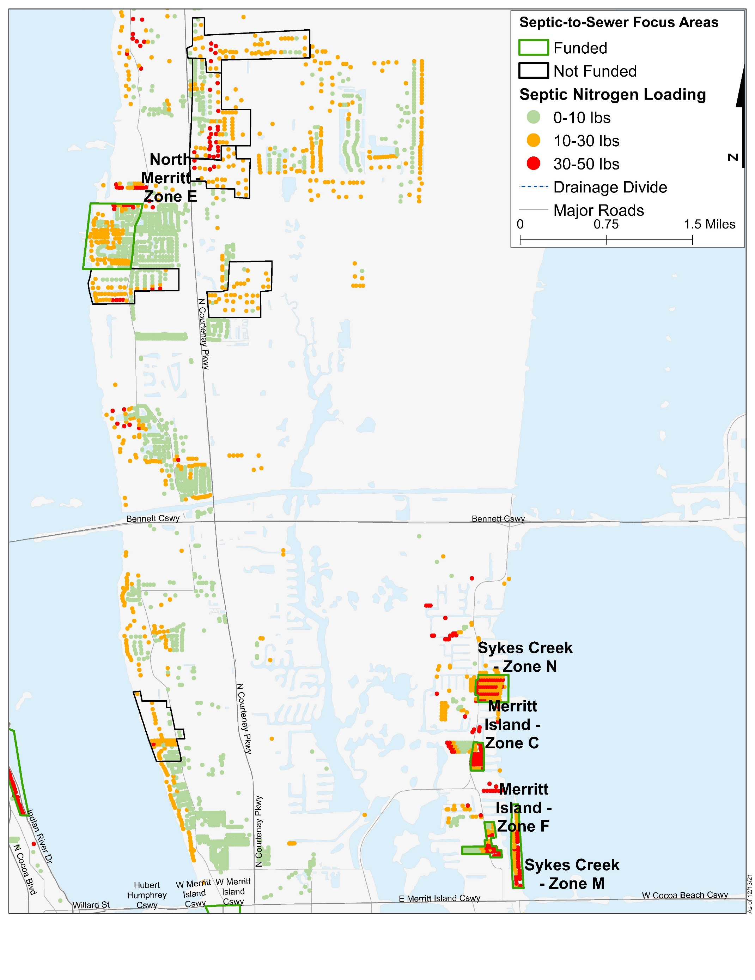
Figure 4-2: Septic System Removal Projects in Banana River Lagoon
Figure 4-2 Long Description
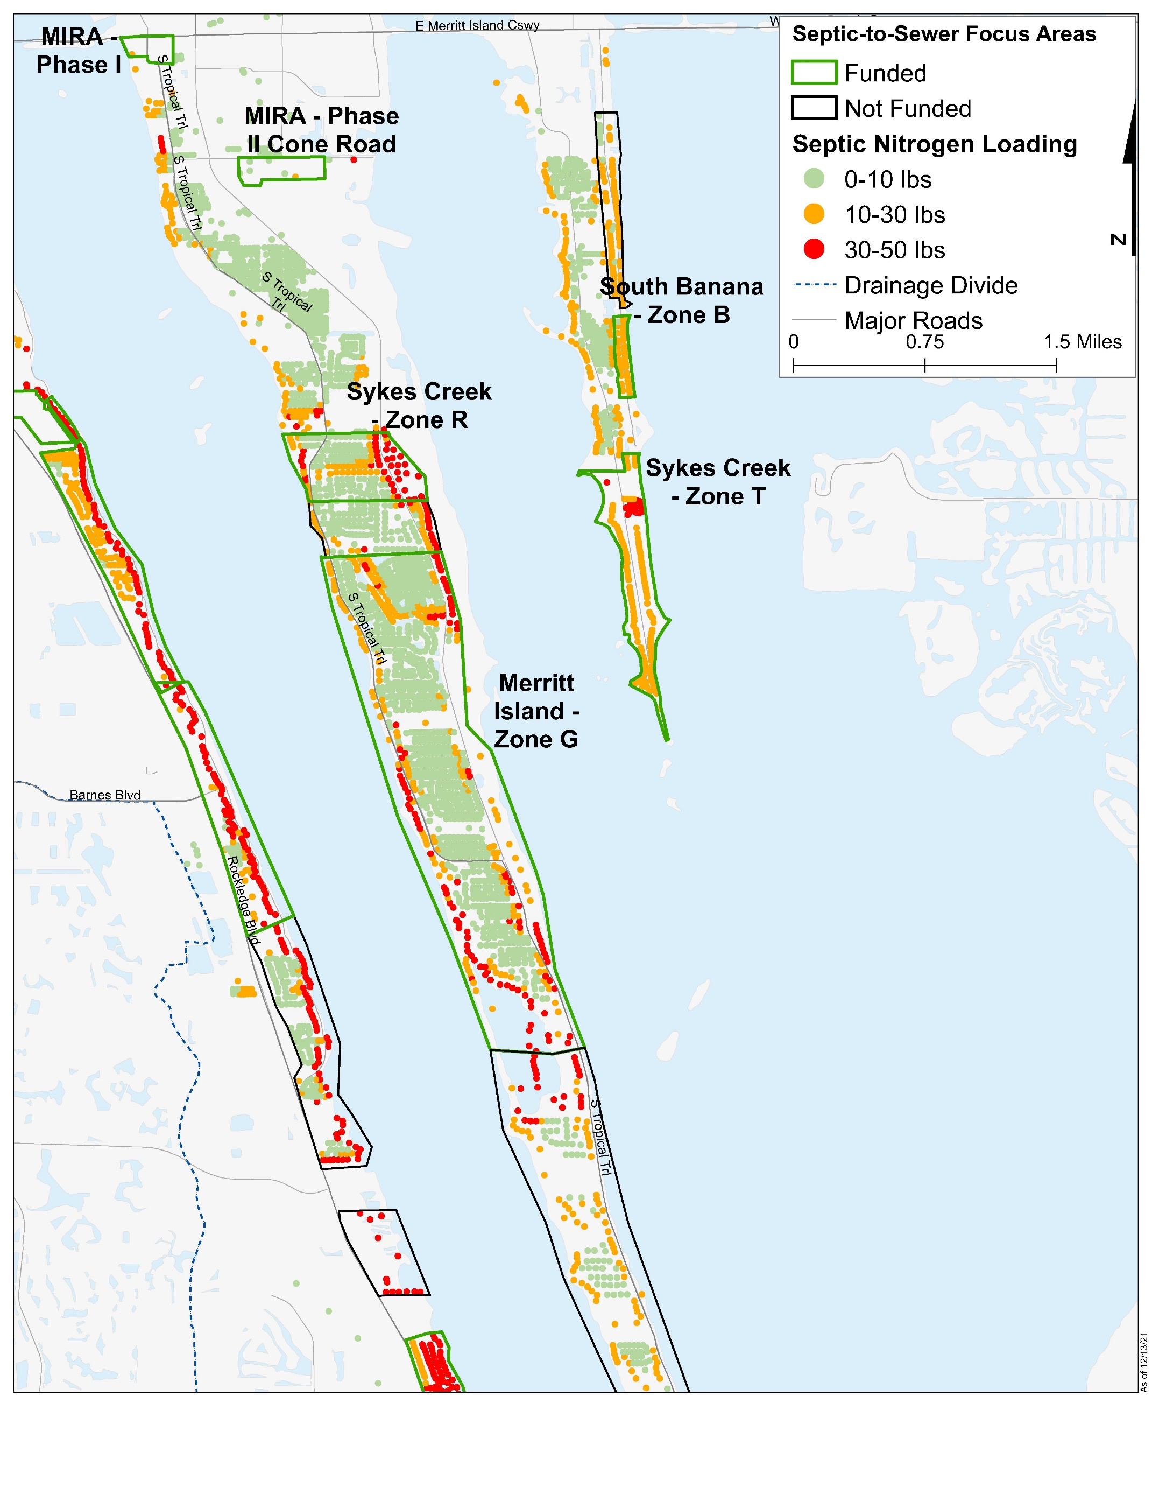
Figure 4-3: Septic System Removal Projects in Banana River Lagoon, continued
Figure 4-3 Long Description
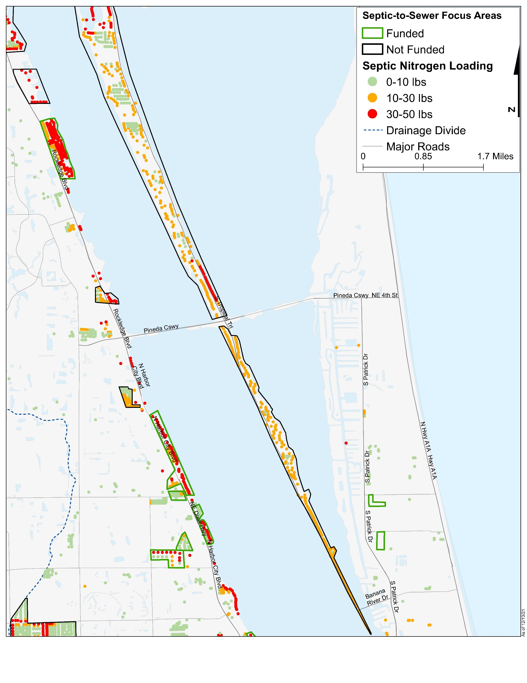
Figure 4-4: Septic System Removal Projects in Banana River Lagoon, continued
Figure 4-4 Long Description
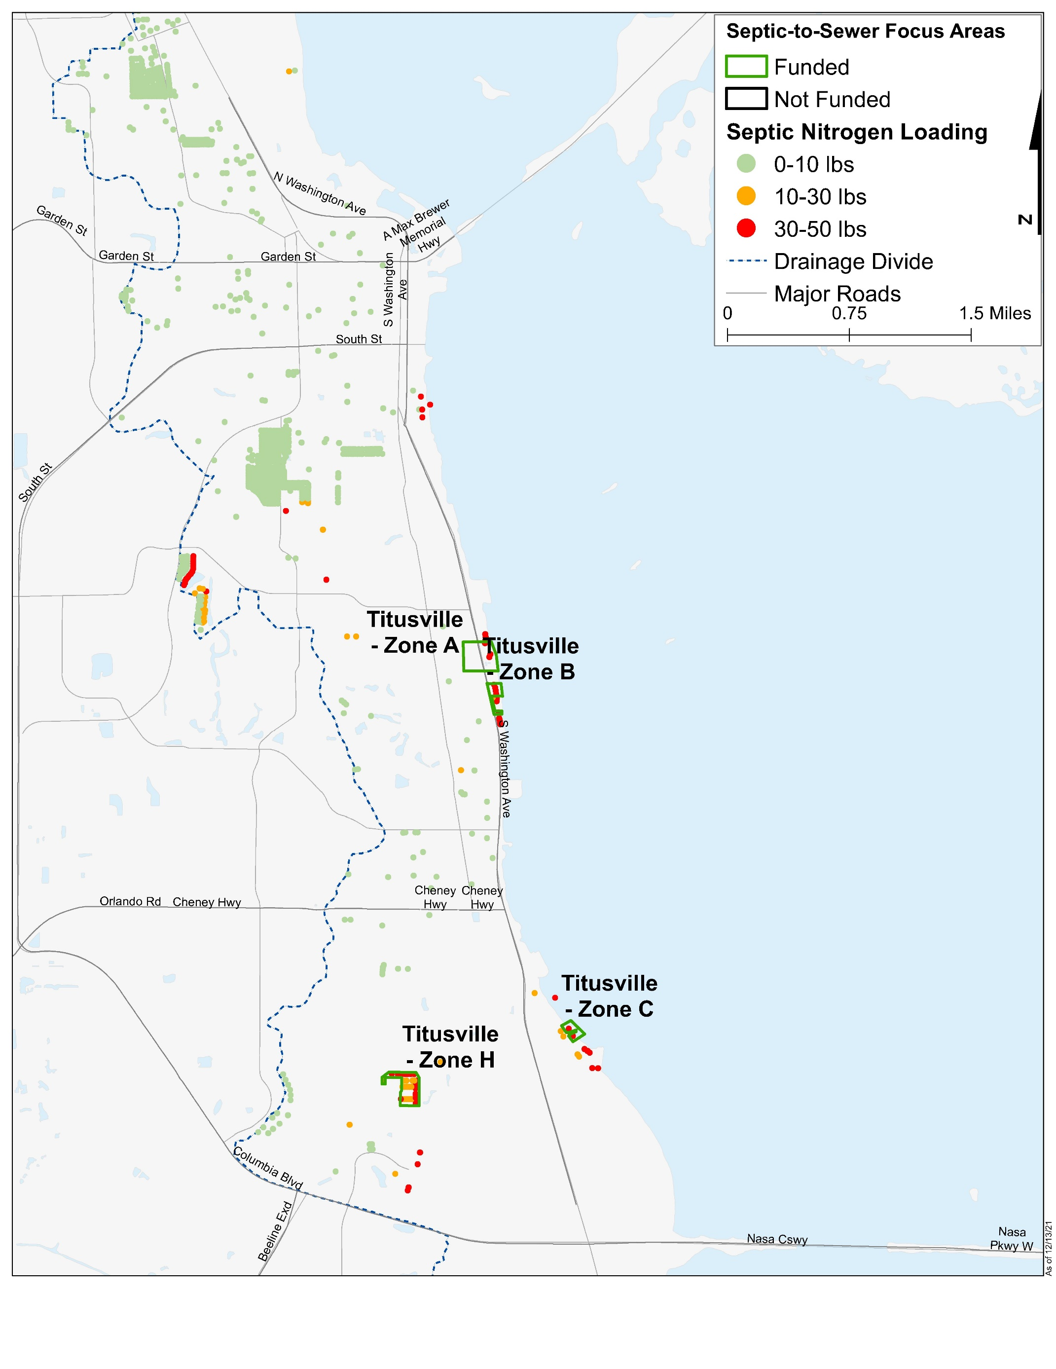
Figure 4-5: Septic System Removal Projects in North IRL
Figure 4-5 Long Description
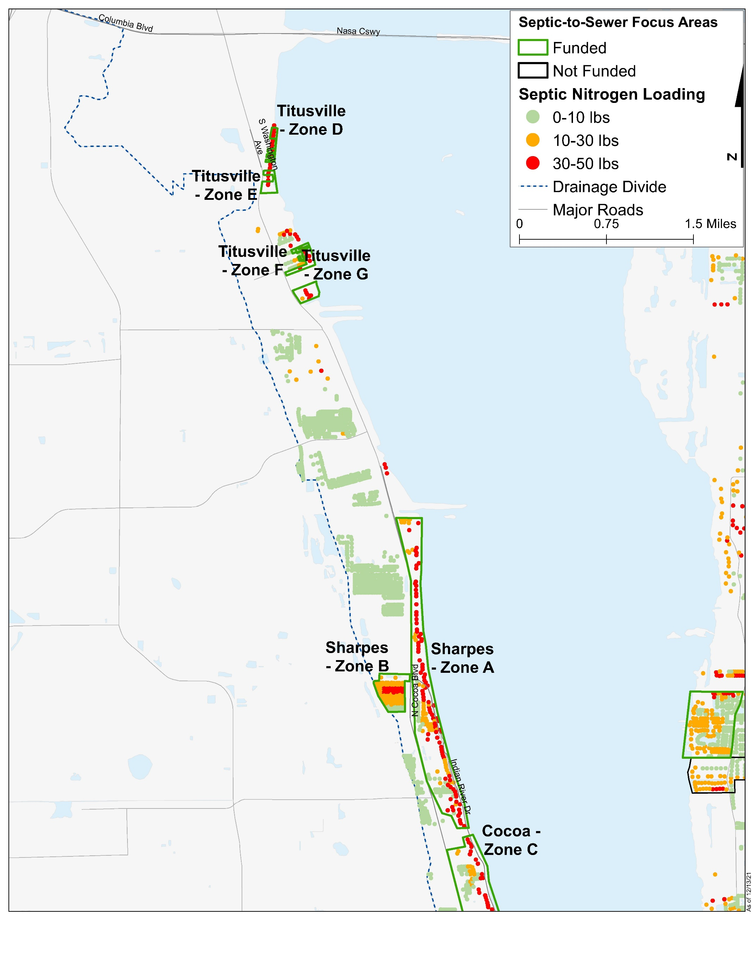
Figure 4-6: Septic System Removal Projects in North IRL, continued
Figure 4-6 Long Description
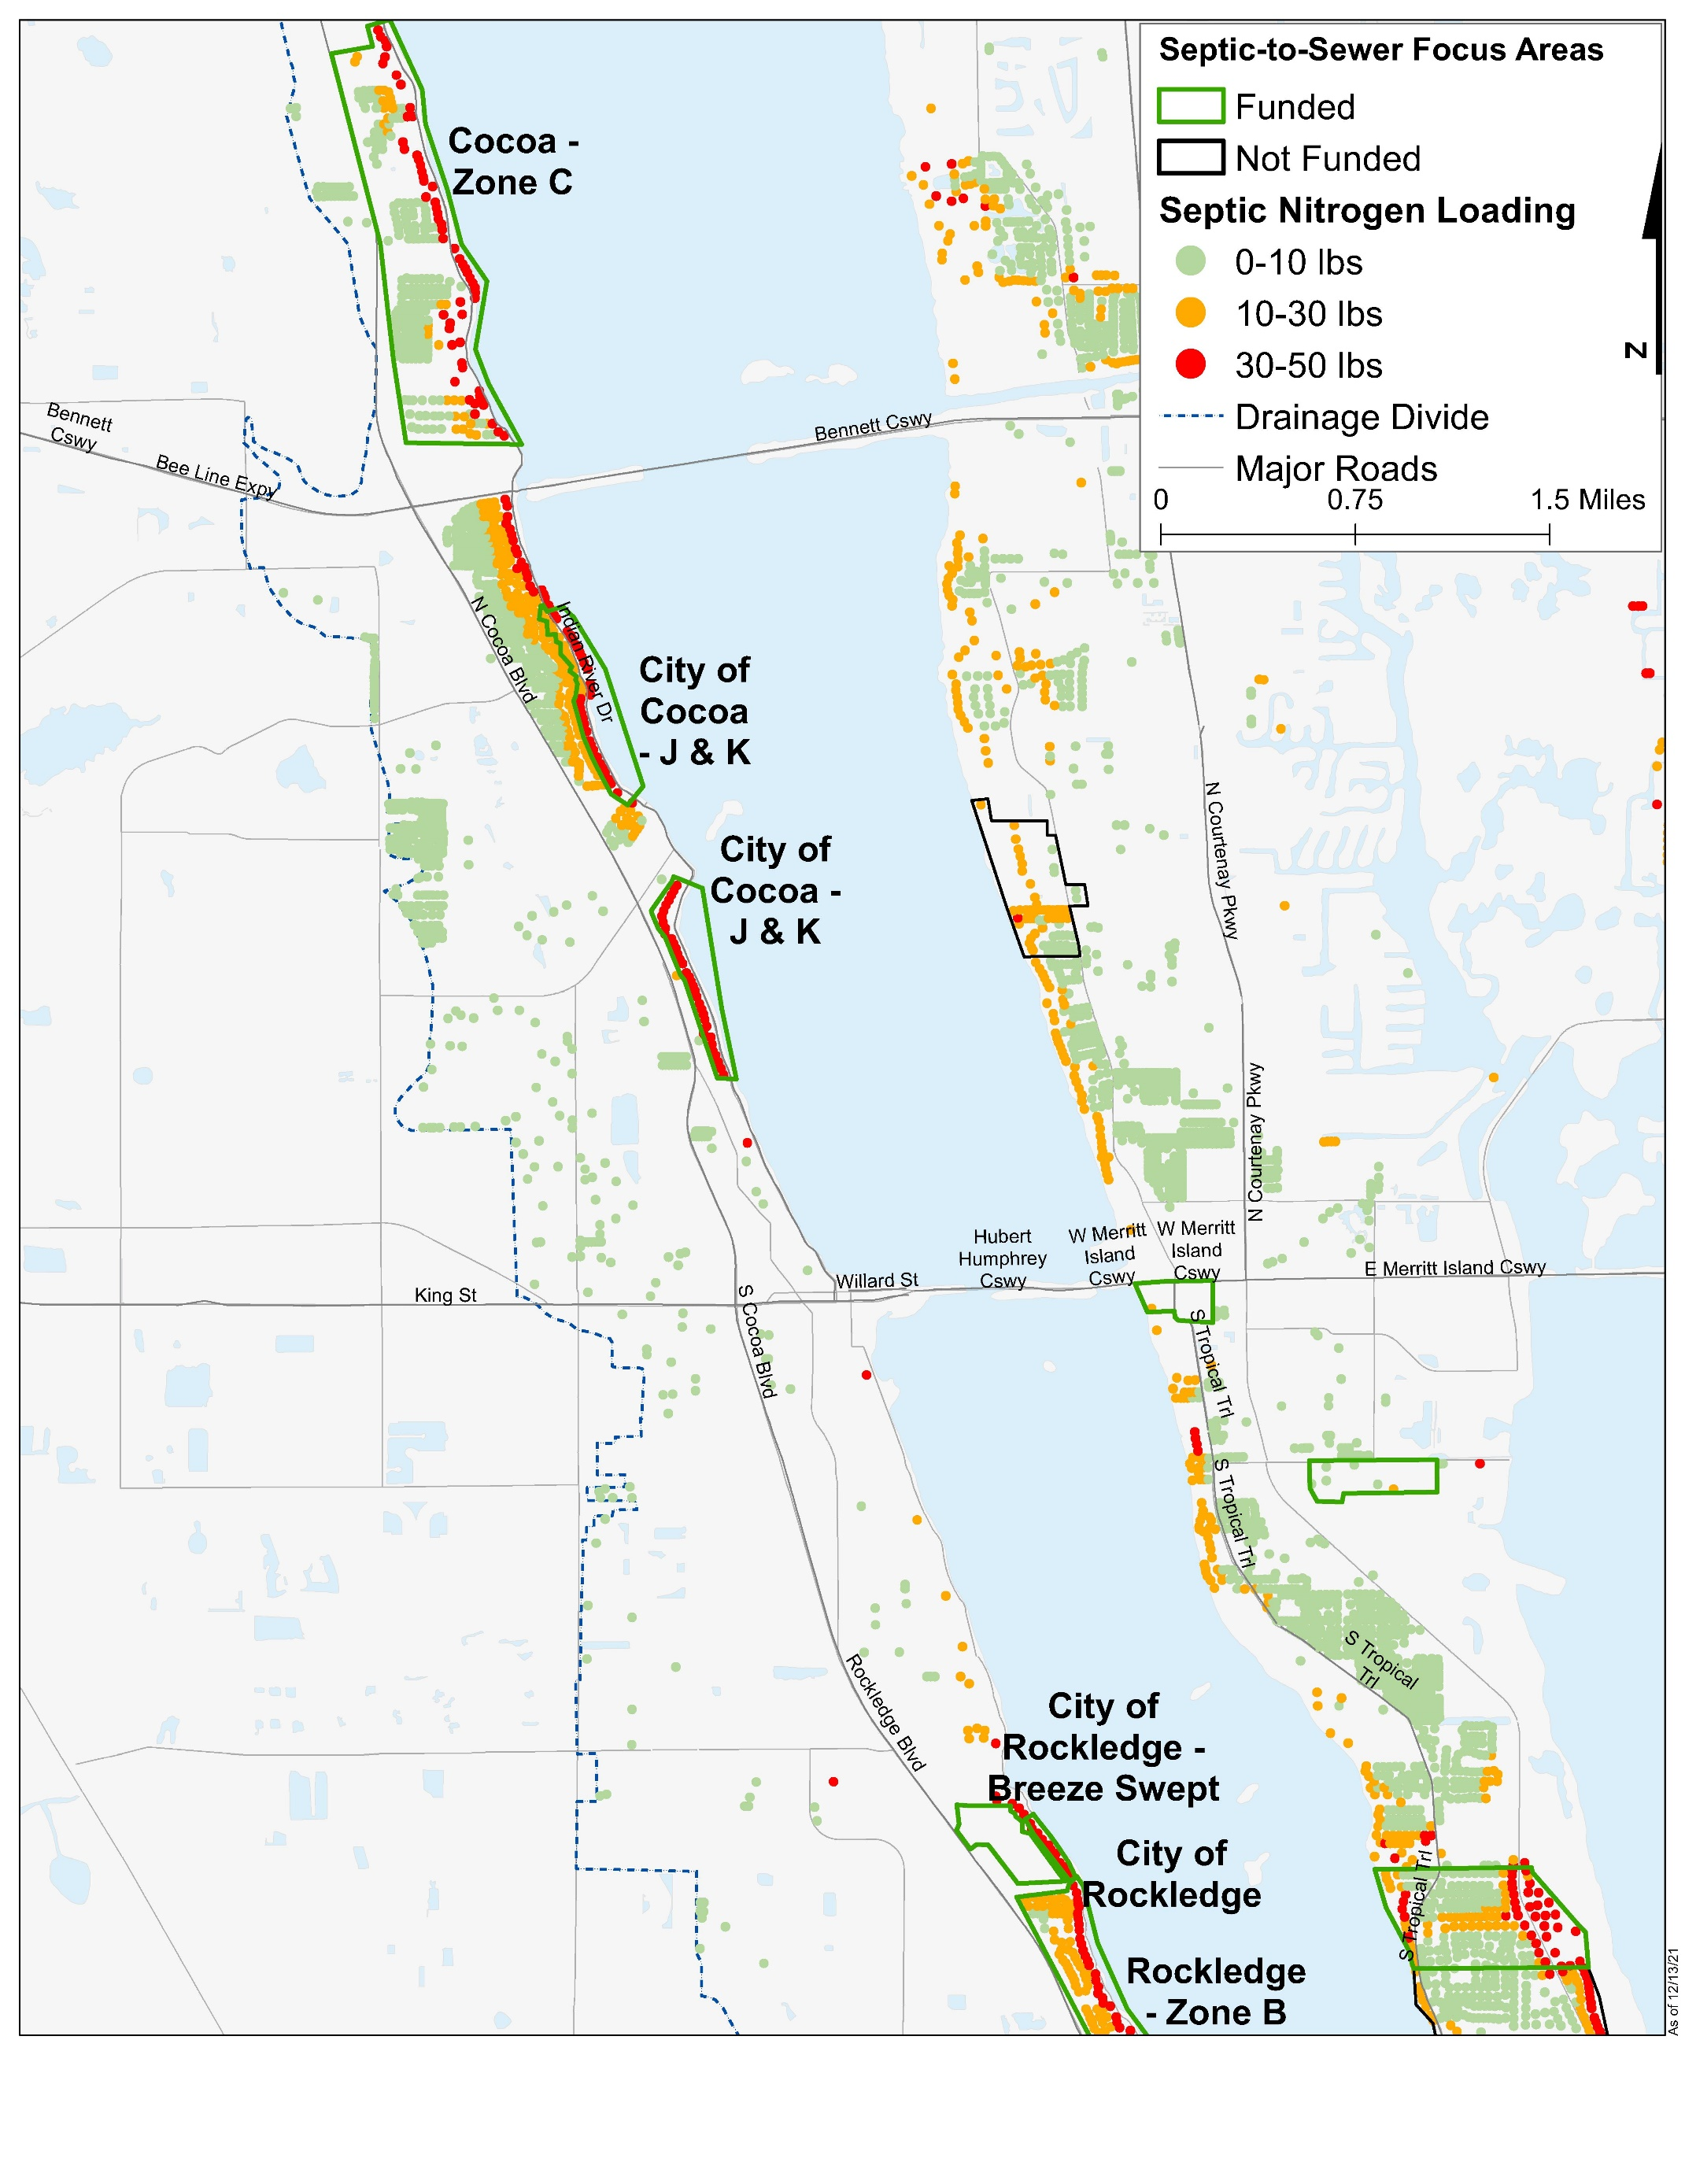
Figure 4-7: Septic System Removal Projects in North IRL, continued
Figure 4-7 Long Description
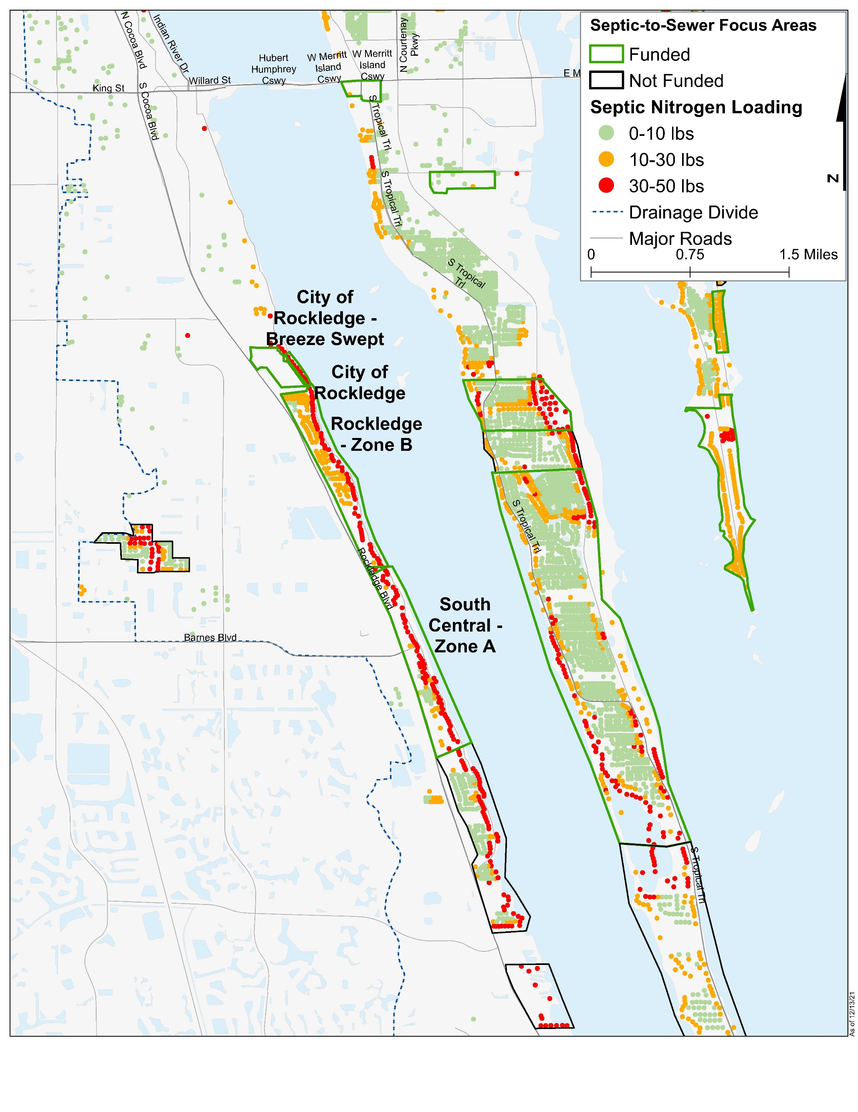
Figure 4-8: Septic System Removal Projects in North IRL, continued
Figure 4-8 Long Description
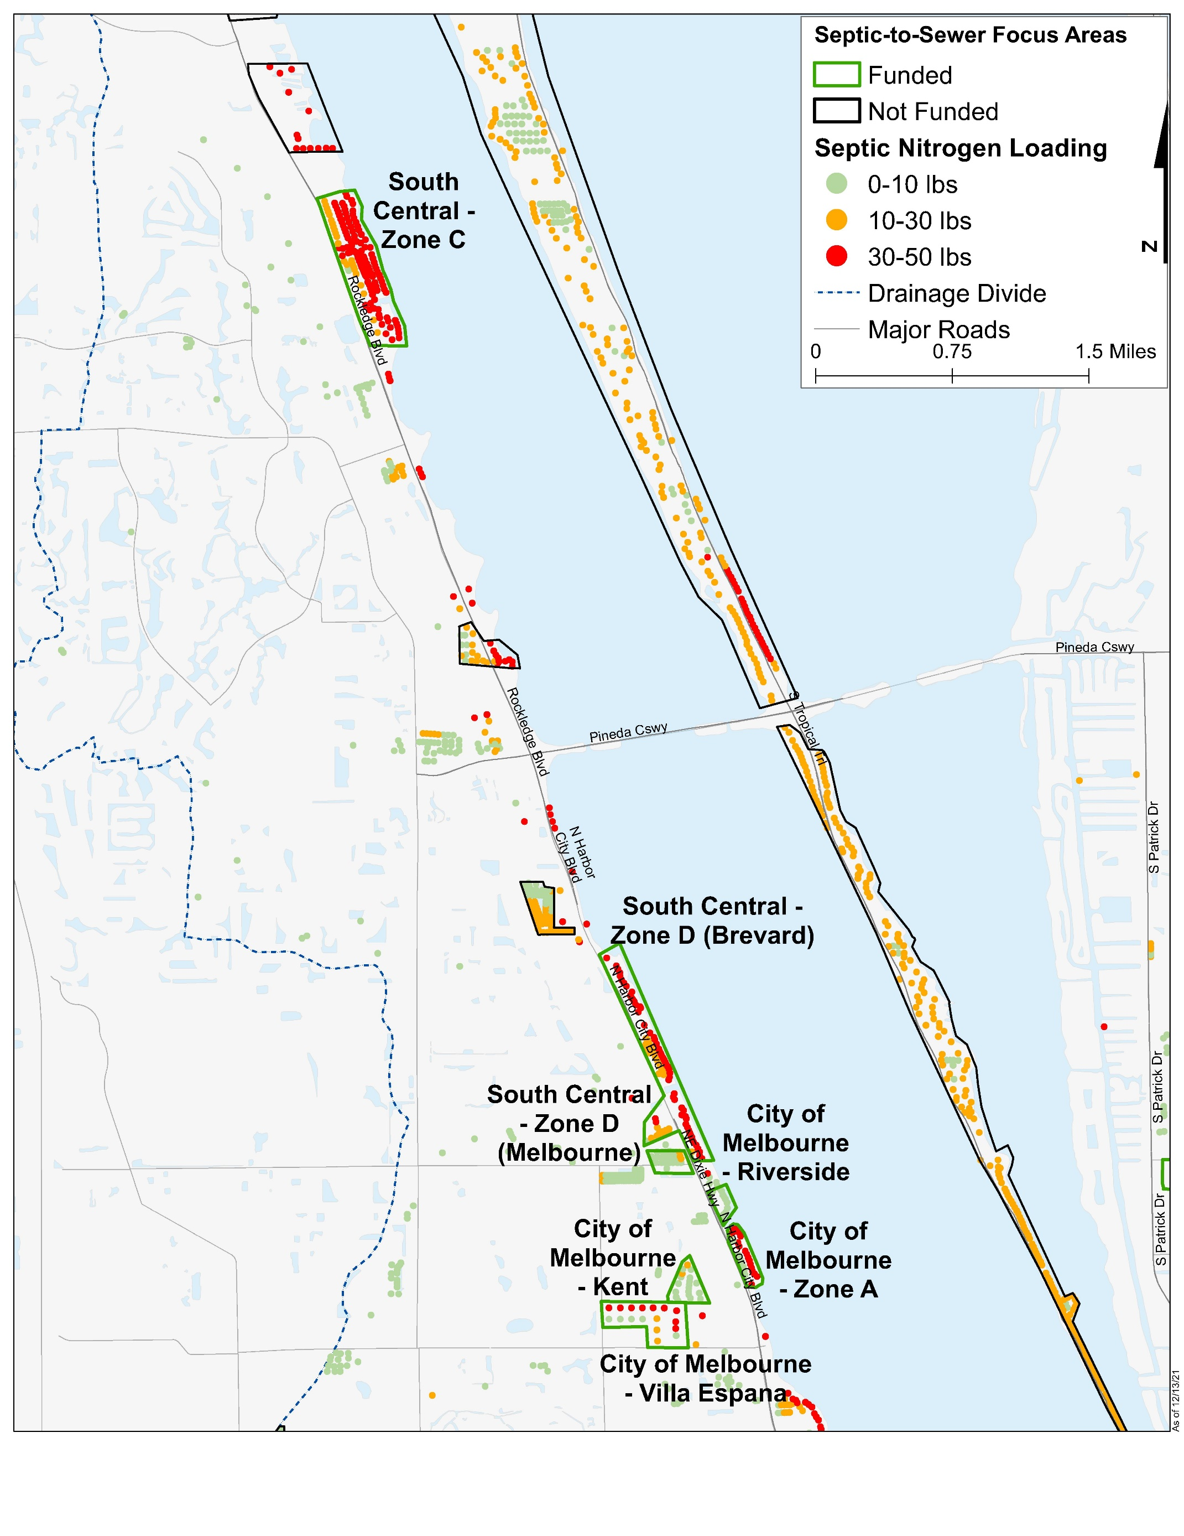
Figure 4-9: Septic System Removal Projects in North IRL, continued
Figure 4-9 Long Description
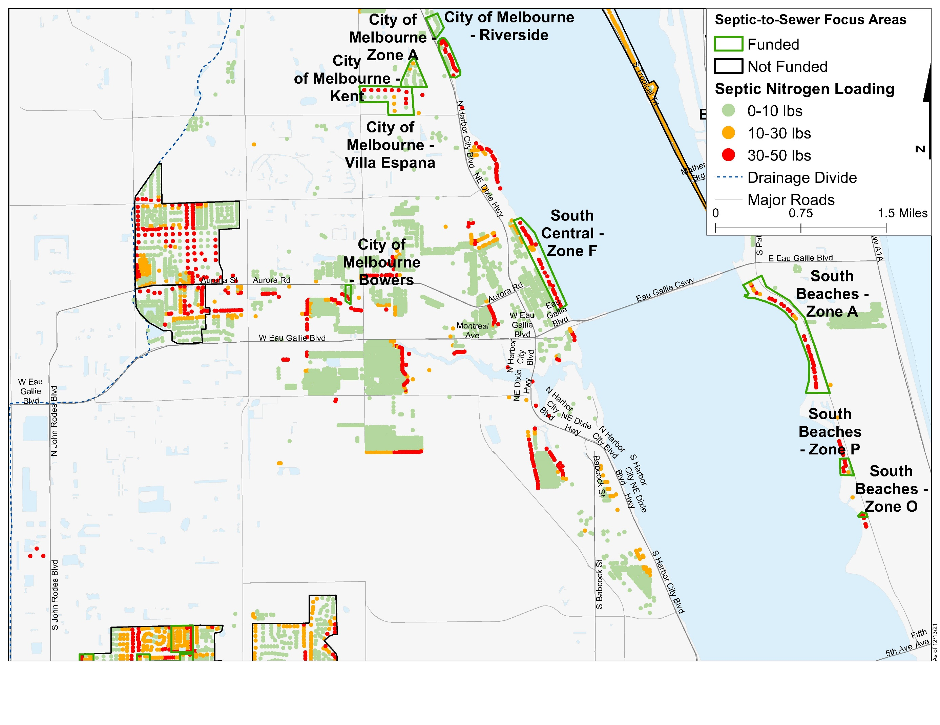
Figure 4-10: Septic System Removal Projects in North IRL, continued
Figure 4-10 Long Description
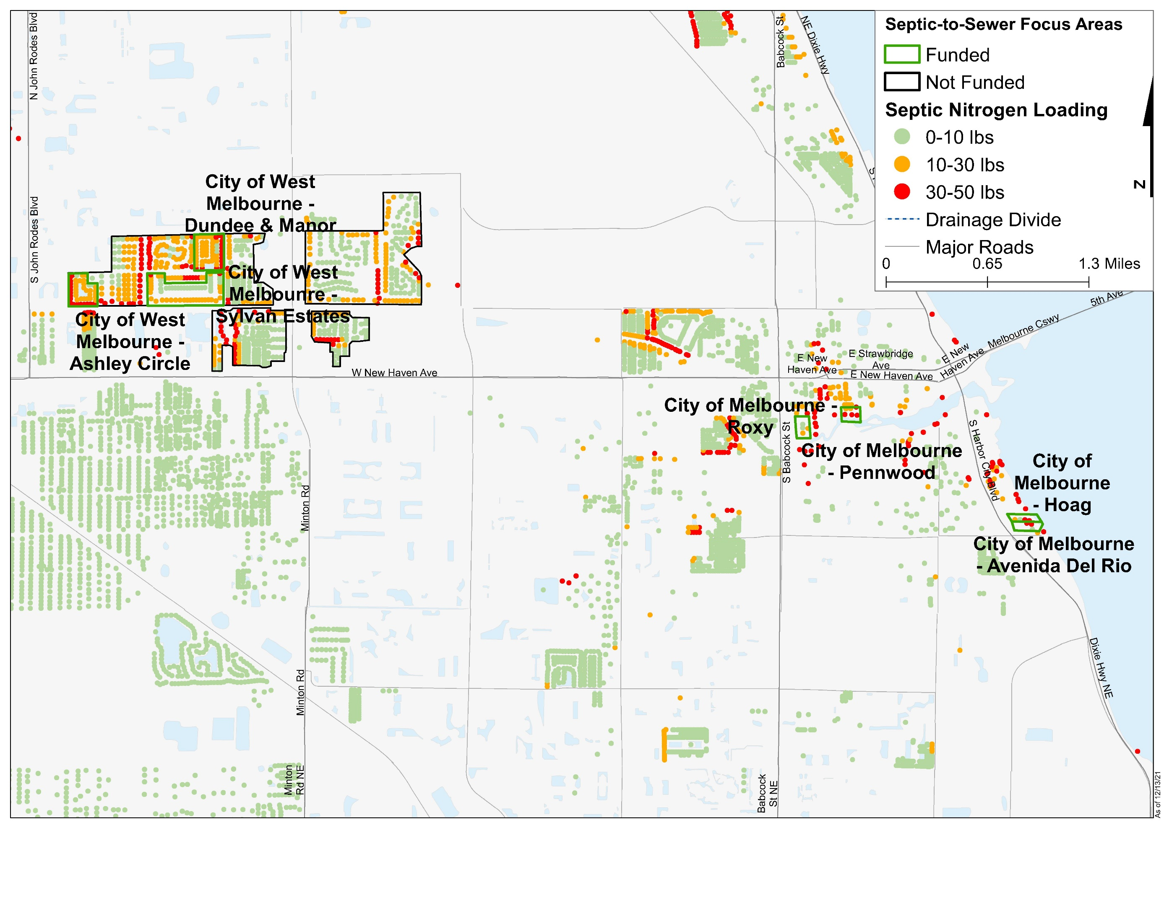
Figure 4-11: Septic System Removal Projects in Central IRL
Figure 4-11 Long Description
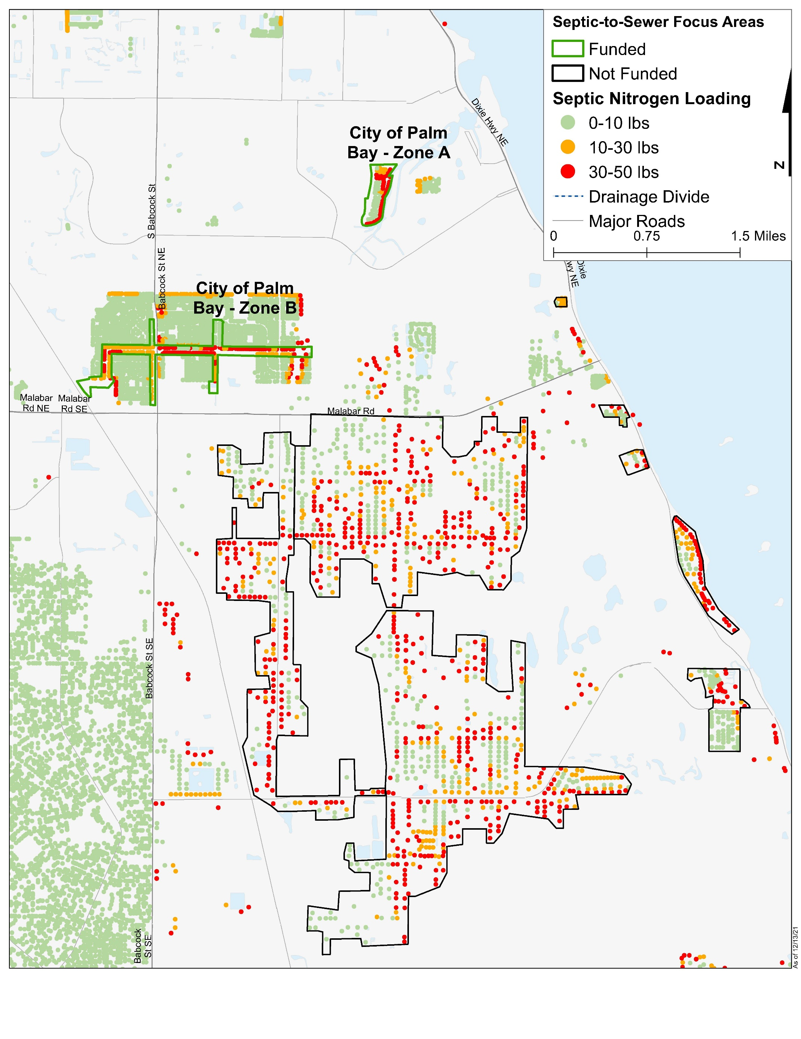
Figure 4-12: Septic System Removal Projects in Central IRL, continued
Figure 4-12 Long Description
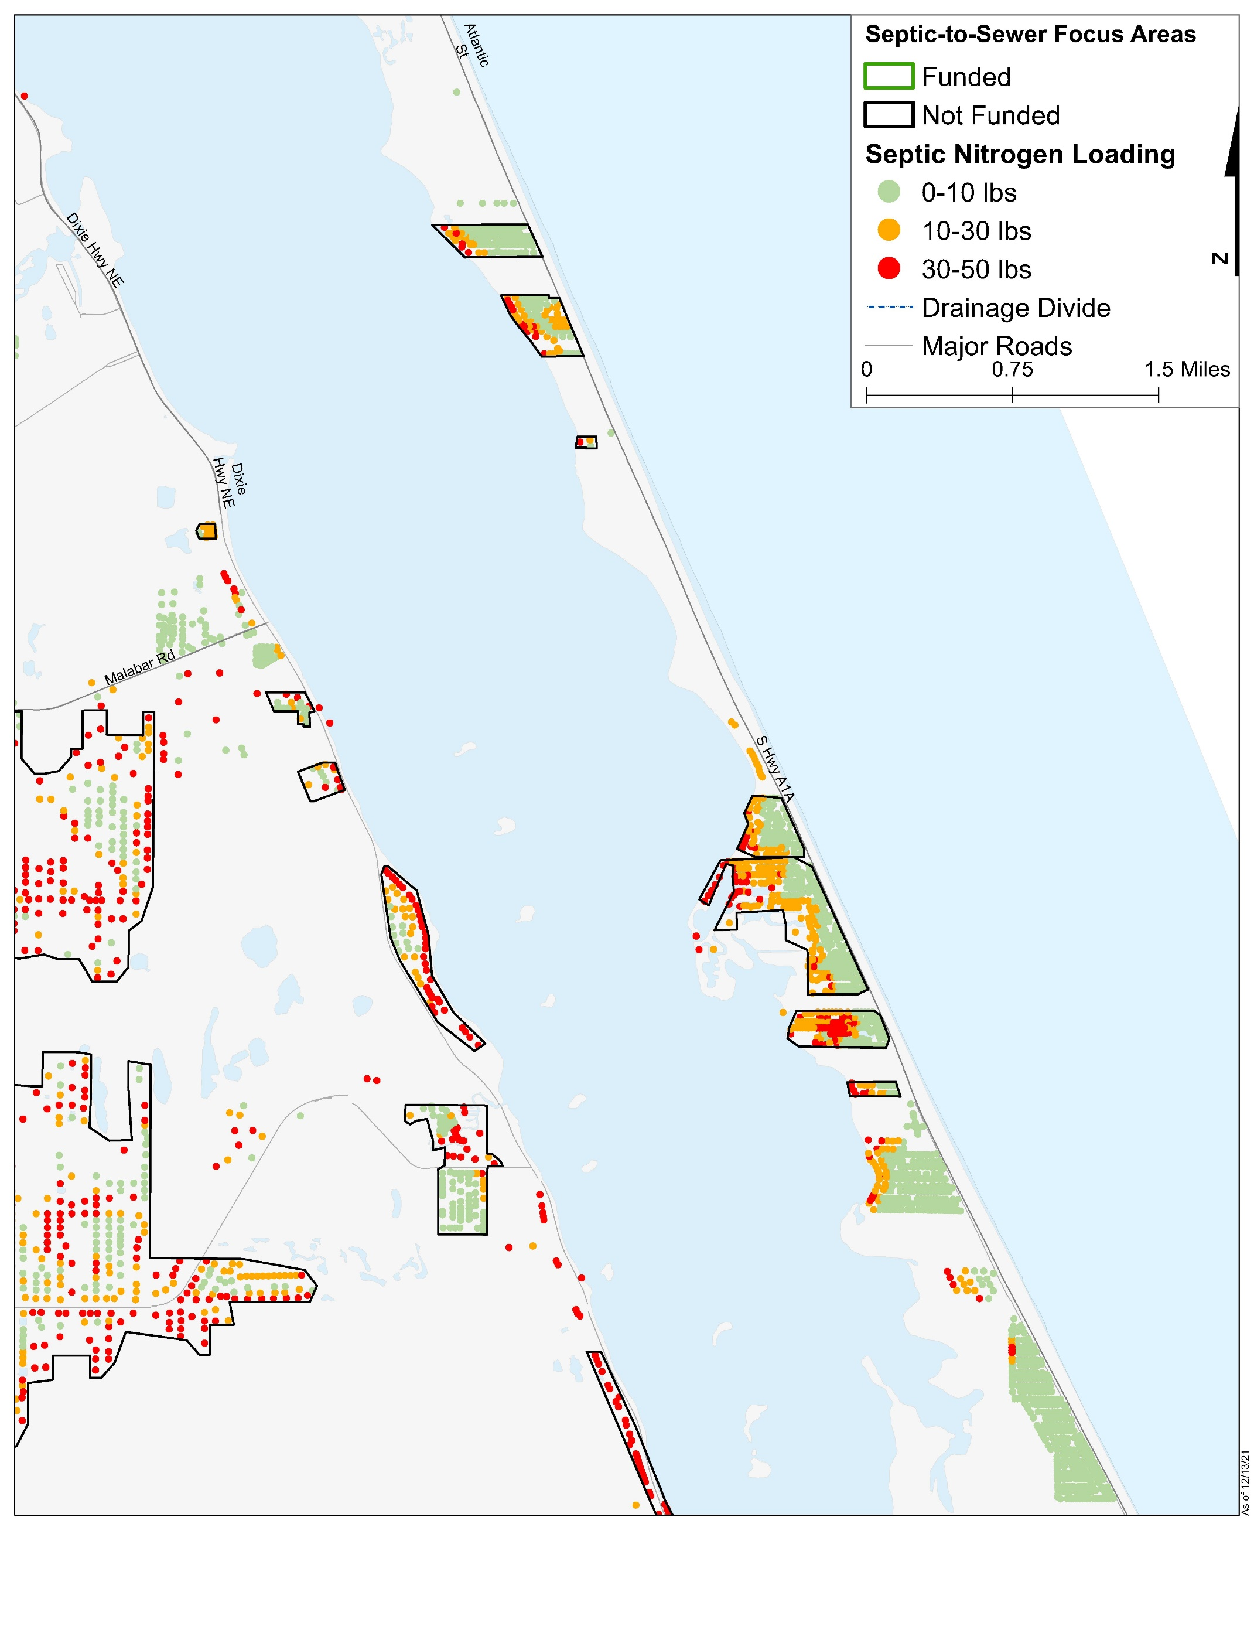
Figure 4-13: Septic System Removal Projects in Central IRL, continued
Figure 4-13 Long Description
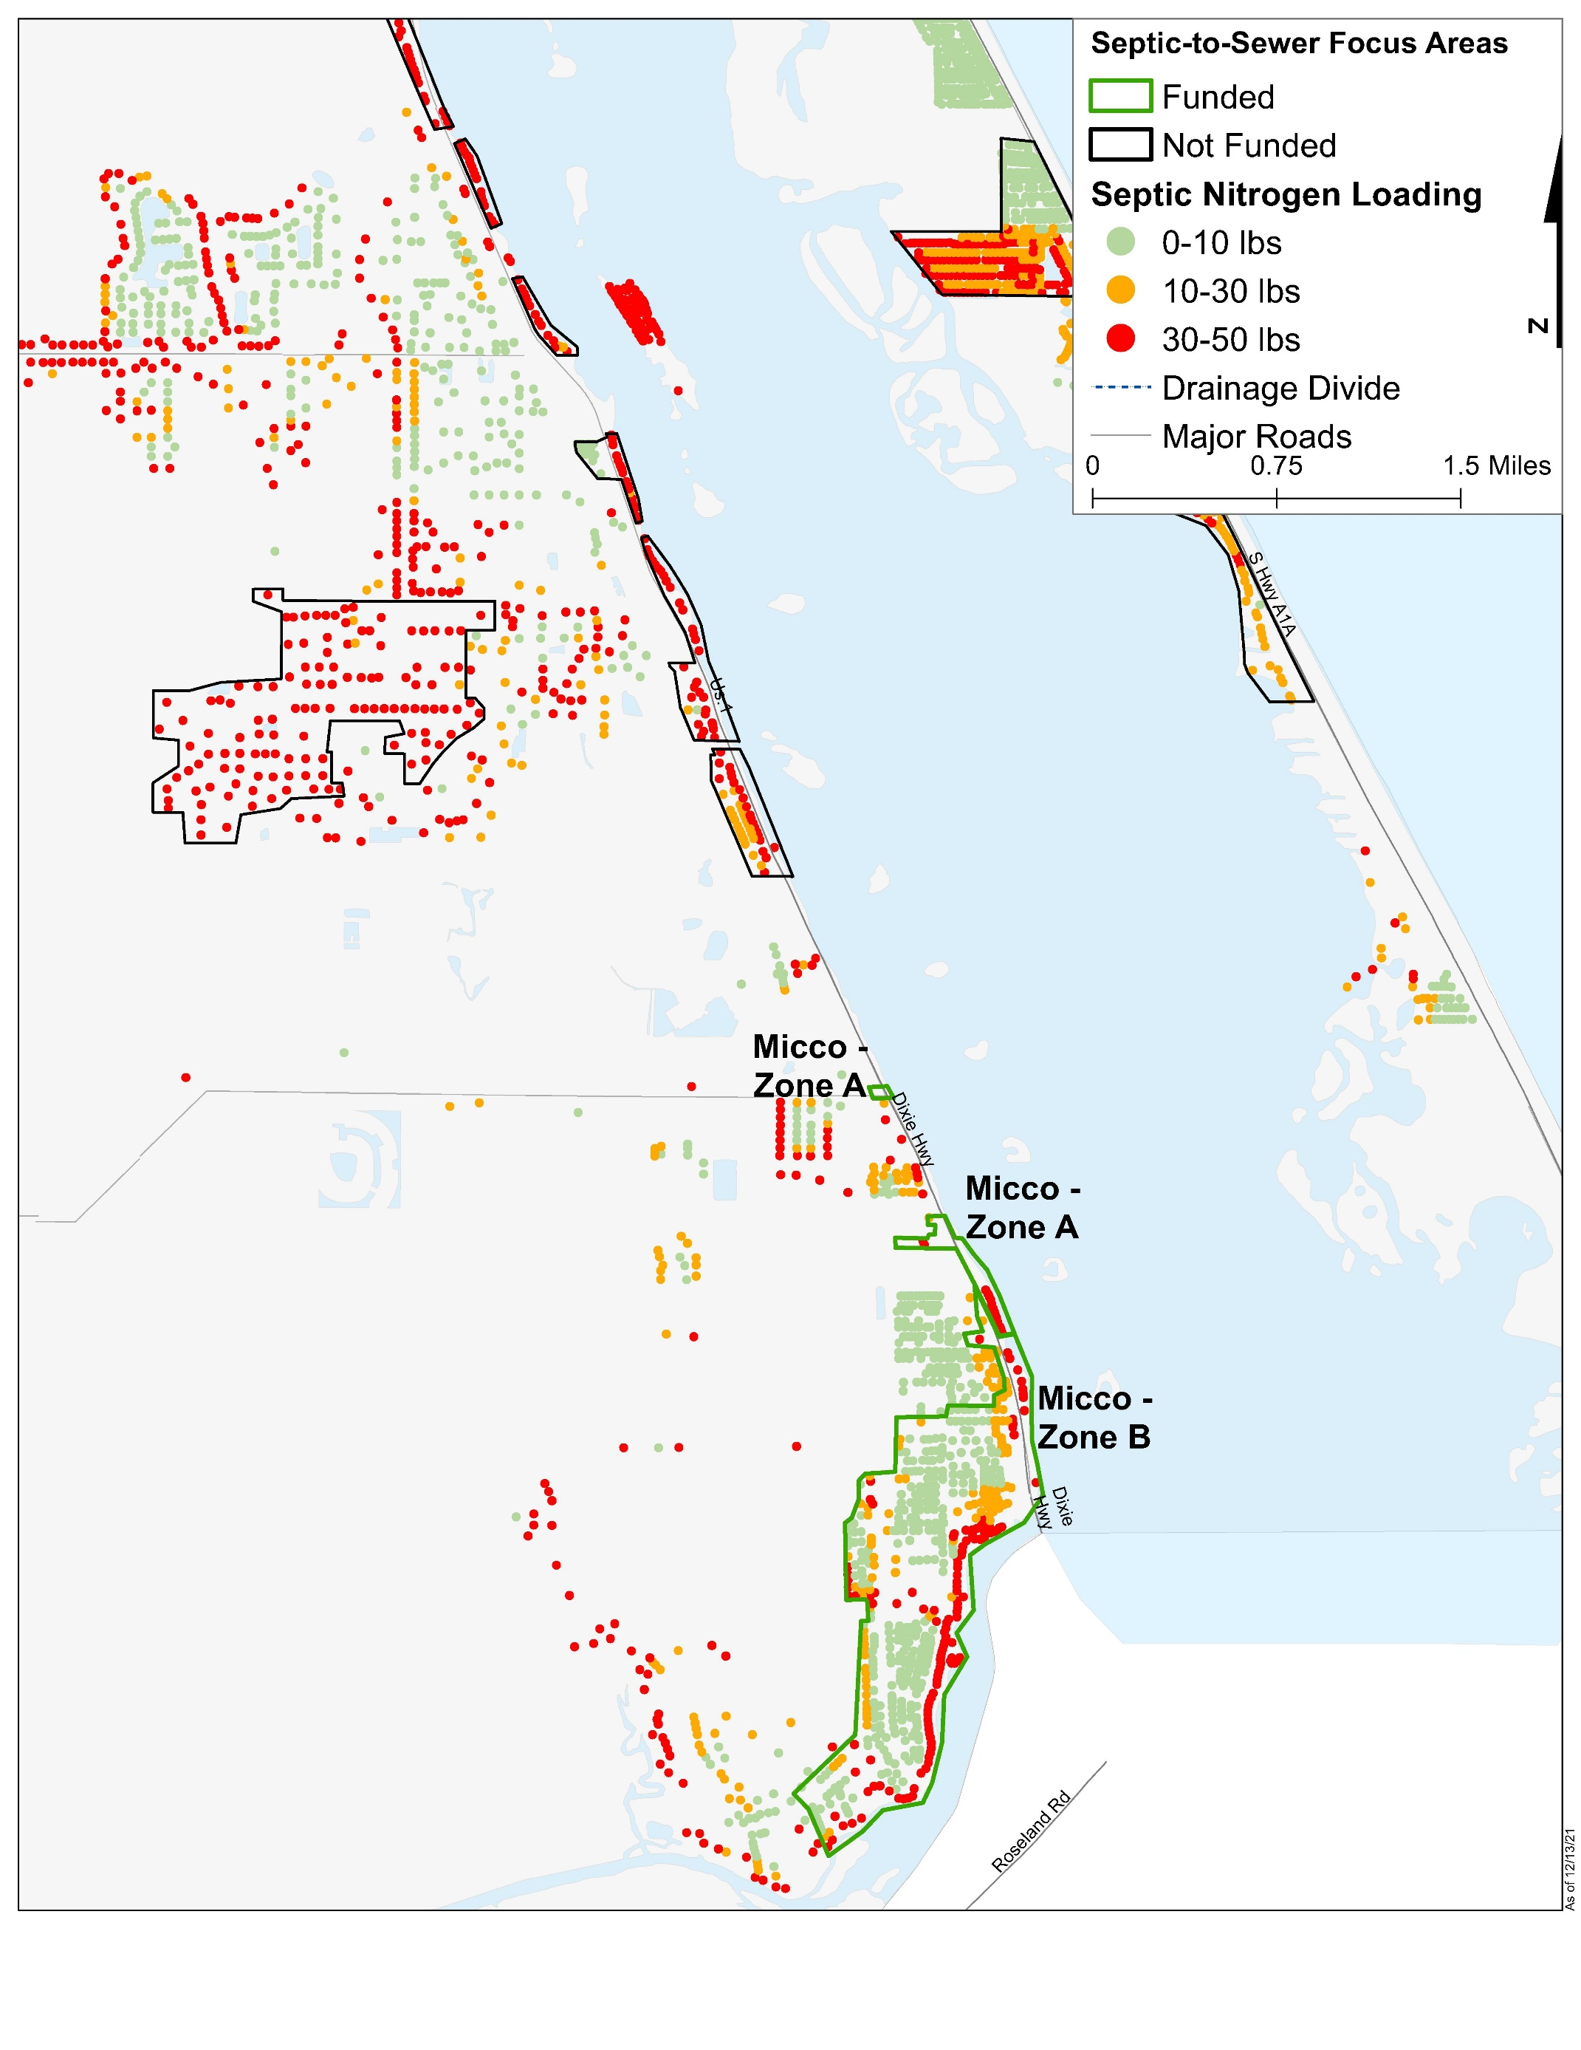
Figure 4-14: Septic System Removal Projects in Central IRL, continued
Figure 4-14 Long Description

Septic System Removal by Sewer Connection
The detailed septic analysis also identified 4,496 properties located within 30 feet of existing sewer infrastructure. The highest loading “Quick Connect” opportunities are included in Table 4-20 based on their ability to connect to gravity or force main sewer and are shown in Figure 4-15 through Figure 4-17.
Quick Connects to sewer will be funded on a prorated basis of $1,200 per pound of nitrogen loading to the lagoon reduced, up to a maximum of $18,000 for connection to force main sewer and a maximum of $12,000 for connection to gravity sewer. Funding allocation for this grant program is based on the number of highest priority connection opportunities within each sub-lagoon as reported in Table 4-20. However, recently secured funding from state cost-share grants will allow the County to offer these grants to more locations than the priority lots identified for Save Our Indian River Lagoon Trust funding listed in Table 4-20. Combined state and local funding is currently offered to all property owners within the IRL watershed on a first-come, first-served basis, prorated based on a property’s estimated nitrogen loading.
Table 4-20: Projects for Septic System Removal by Sewer Connection
Year Added | Project Number | Project Name | Responsible Entity | Sub-lagoon | Total Nitrogen Reduction (pounds per year) | Total Nitrogen Cost per Pound per Year | Total Phosphorus Reduction (pounds per year) | Total Phosphorus Cost per Pound per Year | Plan Funding
2019 | 2016-16 | Banana Quick Connects – 144 lots+ | Brevard County | Banana | 3,224 | Average of $592 Maximum of $1,200 | Not applicable | Not applicable | $1,908,000
2019 | 2016-18 | North IRL Quick Connects – 463 lots+ | Brevard County | North IRL | 11,339 | Average of $531 Maximum of $1,200 | Not applicable | Not applicable | $6,018,000
2019 | 2016-19 | Central IRL Quick Connects – 269 lots+ | Brevard County | Central IRL | 6,883 | Average of $487 Maximum of $1,200 | Not applicable | Not applicable | $3,354,000
2022 | 222 | Hedgecock/ Grabowsky and Desoto Fields+ | City of Satellite Beach | Banana | 81 | $487 | Not applicable | Not applicable | $39,447
- | - | Total | - | - | 21,527 | $526 (average) | Not applicable | Not applicable | $11,319,447
Note: The projects highlighted in tan and marked with a plus sign were added to the plan as part of an annual update.
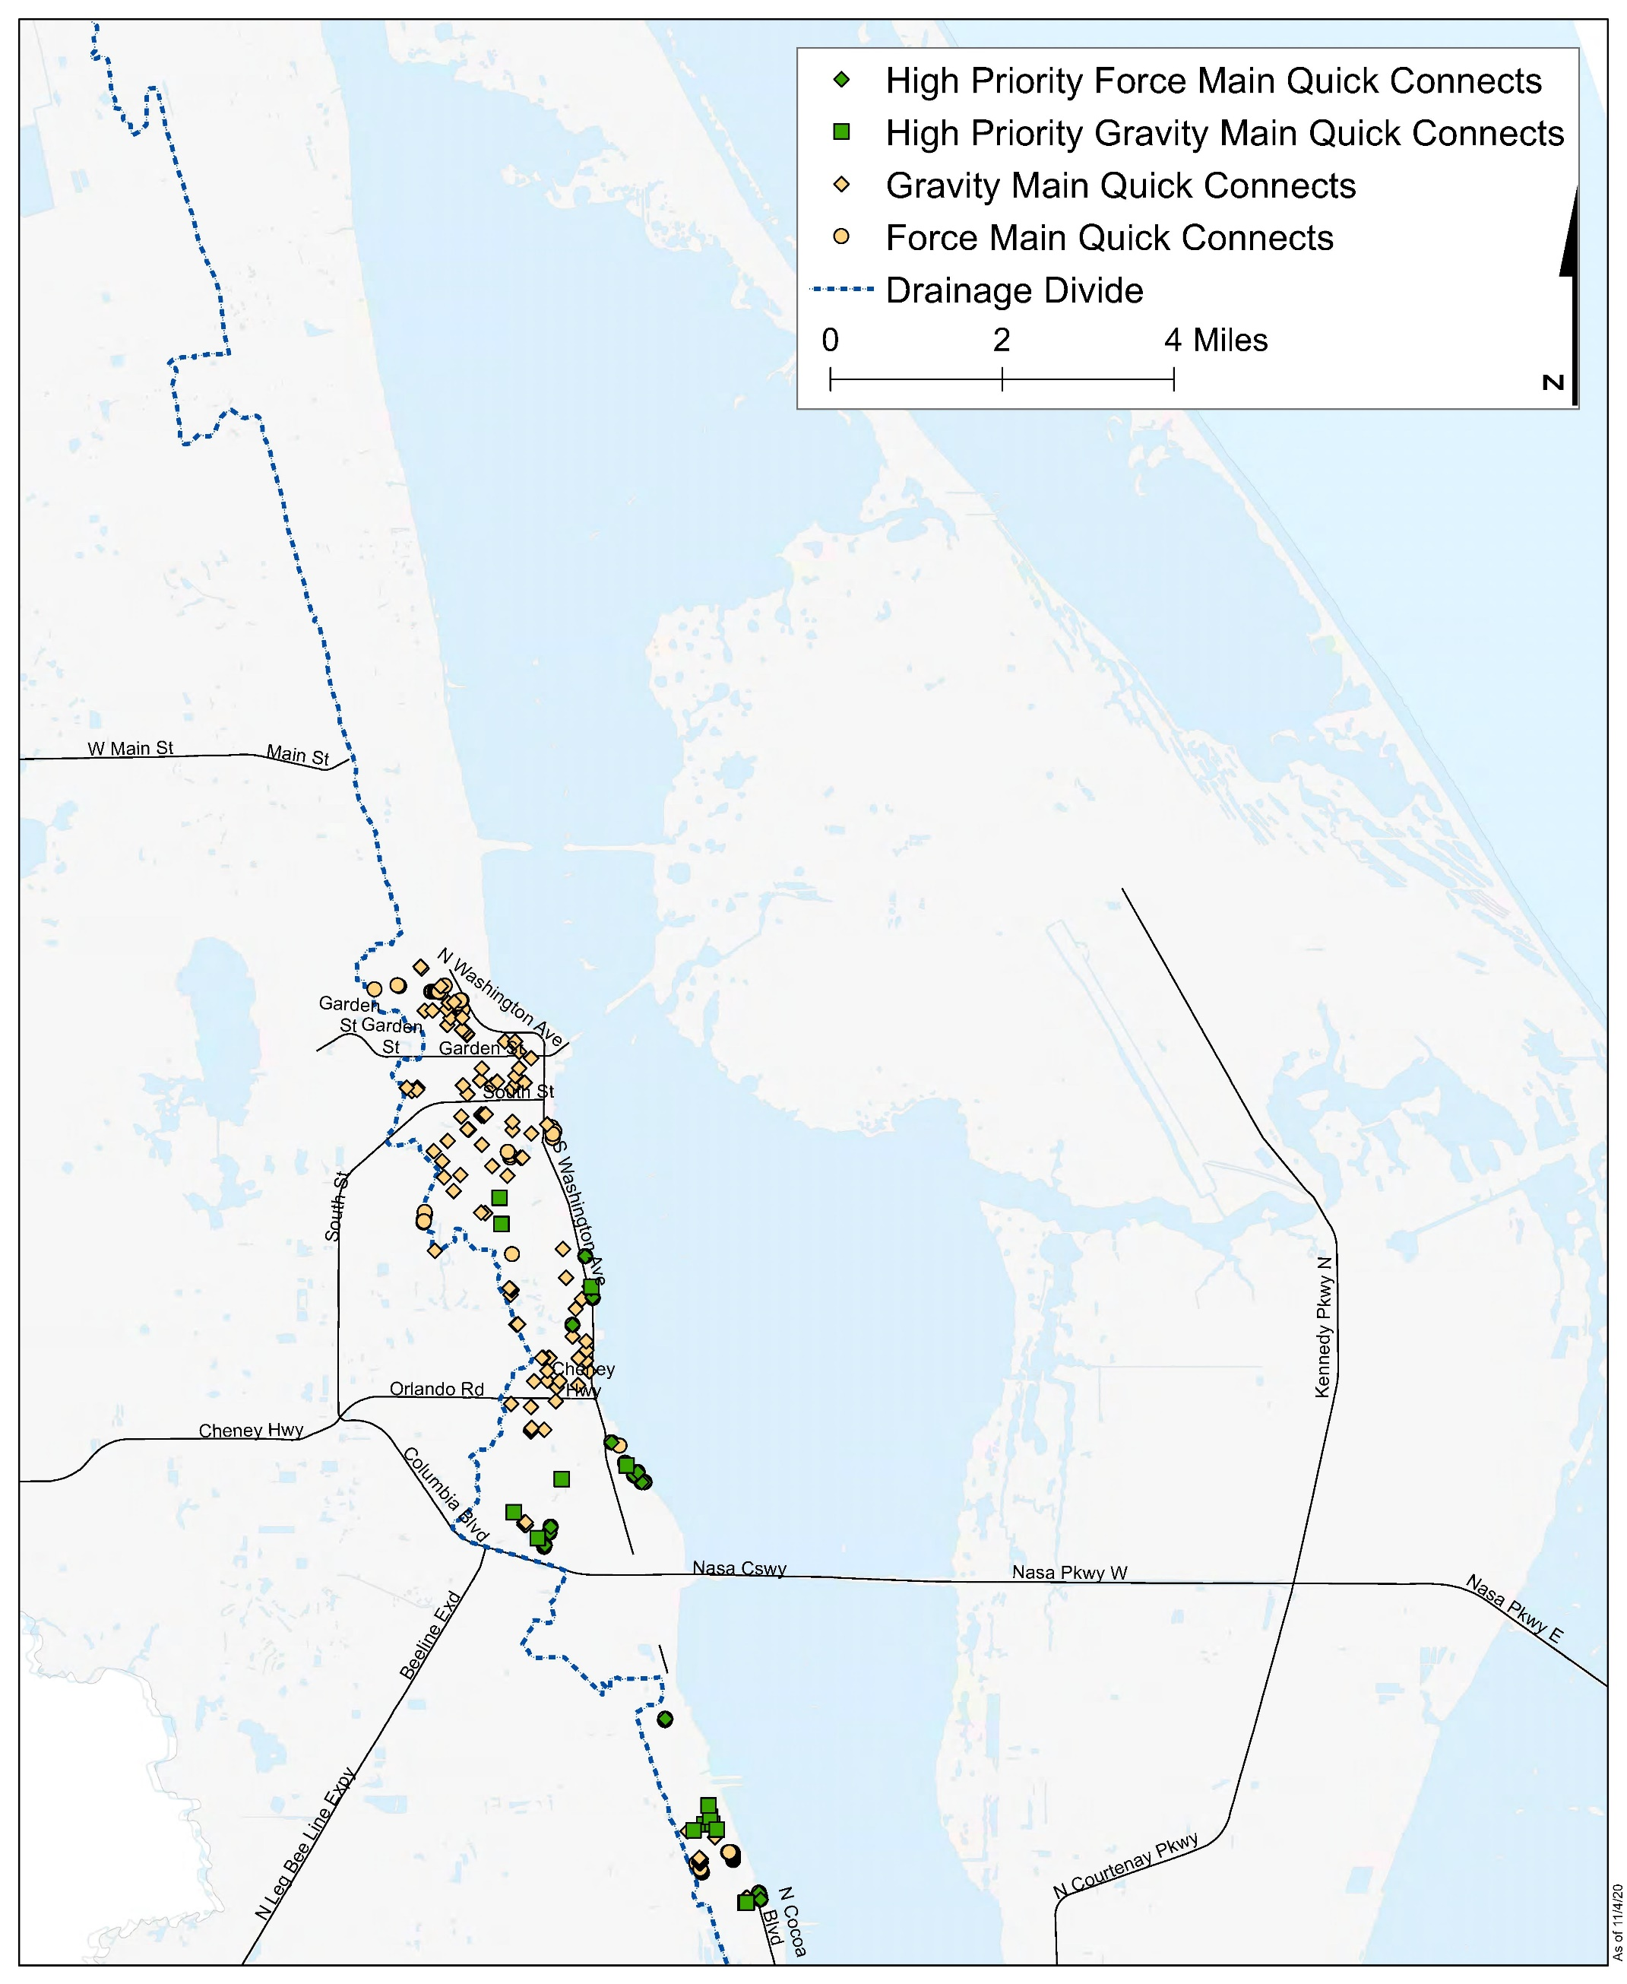
Figure 4-15: Quick Connection Septic System Removal Locations in North Brevard County
Figure 4-15 Long Description
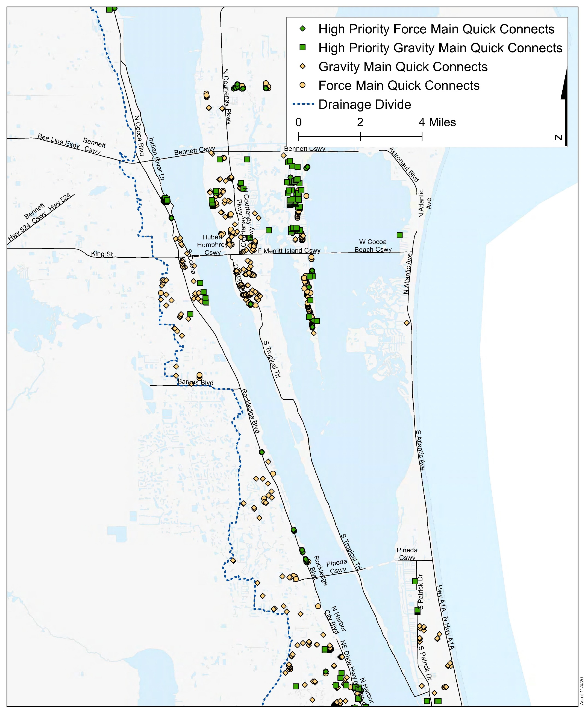
Figure 4-16: Quick Connection Septic System Removal Locations in Central Brevard County
Figure 4-16 Long Description
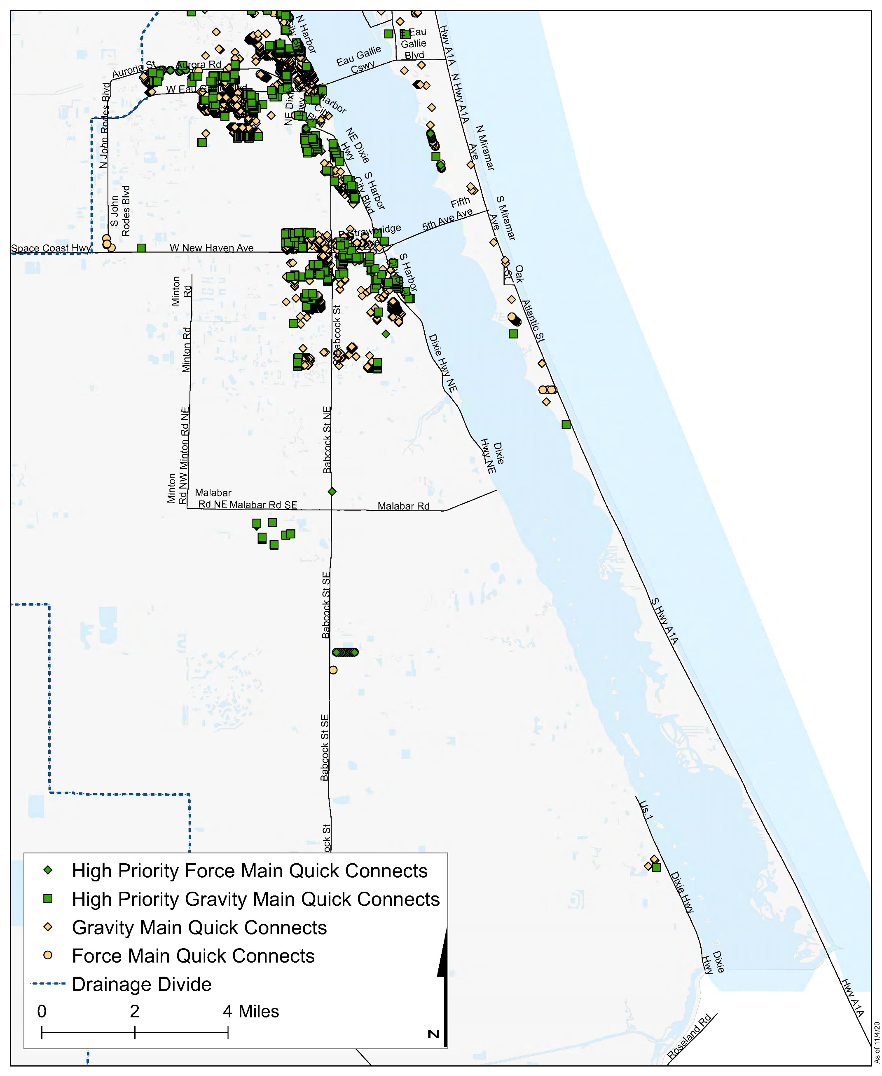
Figure 4-17: Quick Connection Septic System Removal Locations in South Brevard County
Figure 4-17 Long Description

Septic System Upgrades
In locations where providing sewer service is not feasible due to distance from sewer infrastructure, facility capacity, or insufficient density of high-risk systems, there are options to upgrade the highest risk septic systems to increase the nutrient and pathogen removal efficiency. In recent years, research has been conducted on passive treatment systems, which provide significant treatment efficiencies without monthly sewer fees or highly complex maintenance needs for mechanical features.
In July 2018, the Florida Department of Health adopted new rules that allow for In-Ground Nitrogen-Reducing Biofilters under the drainfield of septic systems (Figure 4-18). This passive nitrogen-reducing technology is a result of the Florida Onsite Sewage Nitrogen Reduction Strategies project and the Springs and Aquifer Protection Act. Pilot projects to install this new system are currently in progress throughout the state and Brevard County is a participating partner in these initial installations. This passive In-Ground Nitrogen-Reducing Biofilter system is expected to remove 65% of nitrogen from the effluent and cost an extra $4,000 above the typical costs of a conventional septic system. This system requires 51” of soil above the groundwater and, therefore, may not be appropriate in areas with shallow groundwater.
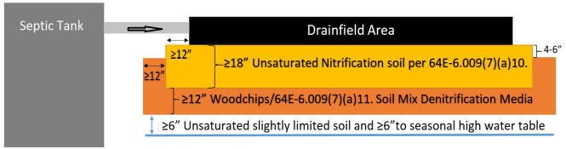
Figure 4-18: Example In-Ground Nitrogen-Reducing Biofilter Septic System
Figure 4-18 Long Description
The current ruling by Florida Department of Health only allows woodchips within the denitrification layer of this system; however, other biosorption activated media can also enhance nutrient and bacterial removal before the effluent reaches the drainfield or groundwater, potentially removing more than 65% of nitrogen from effluent, and lasting longer than woodchips. A test of the biosorption activated media removal capacity was conducted at Florida’s Showcase Green Envirohome in Indialantic, Florida. This test location is a residential site built with stormwater, graywater, and wastewater treatment in a compact footprint onsite (Wanielista et al., 2011). The media used in this study was Bold & Gold®, which is a patented blend of mineral materials, sand, and clay. In this study, the effluent from the septic tank was evenly divided between an innovative biosorption filter media bed and a conventional drainfield. The study found that the TN and TP removal efficiencies were 76.9% and 73.6%, respectively, for the Bold & Gold® media drainfield system, which was significantly higher than the 45.5% TN removal and 32.1% TP removal from the conventional drainfield.
In 2019, Brevard County entered into agreement with the Florida Department of Health to test In-Ground Nitrogen Reducing Biofilter septic systems with known nitrogen-reducing media. The first six septic systems under this agreement were installed in summer of 2020 using Bold & Gold® wastewater filtration media. To measure effectiveness of the alternative media, nutrient concentration of septic tank effluent is being measured before and after passage through a layer of filtration media. The study sites will be monitored quarterly for one year and a final report will be completed in 2022. The agreement allows for testing of other nitrogen-reducing media as they become available.
In areas where septic systems are in close proximity to a surface waterbody but are not in a location where connection to the sewer system is feasible, adding biosorption activated media to the drainfield or upgrading to the passive nitrogen removing systems could be used to retrofit the existing septic systems. The estimated cost for these retrofits was increased from $16,000 per septic system in the original plan to $18,000 each in the 2019 Update. Any operations and maintenance costs associated with these upgrades, once installed, will be the responsibility of the owner. To be conservative and to match the Florida Department of Health rule, the estimates of the TN reductions that could be achieved are based on an efficiency of 65% removal, which is the average efficiency from the two state studies described above that tested biosorption activated media in the drainfield.
In areas where the In-Ground Nitrogen-Reducing Biofilters system or biosorption activated media retrofits are not appropriate, National Sanitation Foundation 245 certified aerobic treatment units are another alternative. National Sanitation Foundation 245 certification verifies that these advanced septic systems remove at least 50% of nitrogen within the septic tank, although some systems have been shown to remove up to 80% of nitrogen. The drainfield is credited with removing another 15% of nitrogen, which brings the total nitrogen removed by the advanced septic system to 65%. Due to the electrical plumbing requirements of aerobic treatment units, the owner is required to have a maintenance agreement with a septic company and an operating permit from the Florida Department of Health. Individually engineered performance-based septic systems, some of which use the septic system effluent for drip irrigation, provide another septic system option for meeting 65% nitrogen load reduction onsite.
There are also options for distributed onsite sewage treatment systems that are approved by the Florida Department of Environmental Protection as miniature sewage treatment plants sized for residential and commercial use. These systems provide additional opportunities to improve nutrient removal from sites where connection to central sewer is not feasible and are eligible options for septic system upgrades as part of this plan. Both the Save Our Indian River Lagoon Project Plan and Springs and Aquifer Protection Act have highlighted the need for other wastewater options that have less impact on surface water and groundwater. Brevard County will continue to vet these options as they become available in Florida.
To prioritize the septic systems for upgrade, the scoring matrix used in the original Save Our Indian River Lagoon Project Plan was replaced in the 2019 Update using ArcGIS-Based Nitrate Load Estimation Toolkit modeling performed during determination of the Nitrogen Reduction Overlay area adopted in the Countywide Septic Ordinance, as noted above.
The septic systems with the highest loading in each sub-lagoon are recommended for retrofit upgrades to reduce the impacts of these septic systems on the waterbodies. The costs and nutrient reductions by sub-lagoon are shown in Table 4-21. The locations of the highest priority sites for septic system upgrades are shown in Figure 4-19, Figure 4-20, and Figure 4-21. This upgrade opportunity addresses at least 2% of the septic systems in the IRL drainage basin.
Septic retrofit upgrades will be funded on a prorated basis of $1,200 per pound of reduced nitrogen loading to the lagoon, up to a maximum of $18,000 per septic parcel. Funding allocation for this grant program is based on the number of highest priority upgrade opportunities within each sub-lagoon as reported in Table 4-21. However, recently secured funding from state cost-share grants allows the County to offer these grants to more locations than the priority lots identified for Save Our Indian River Lagoon Trust funds listed in Table 4-21. Combined state and local funding is currently offered to all property owners within the IRL watershed (excluding those within a funded septic-to-sewer project area) on a first-come, first-served basis, prorated based on a property’s estimated nitrogen loading.
In some circumstances, properties qualified for septic system upgrade funding may be near a sewer line. These septic upgrade funds can be used to connect the qualified property to sewer as this option results in a greater reduction in nitrogen loading to the lagoon.
Table 4-21: Projects for Septic System Upgrades
Year Added | Project Number | Project Name | Responsible Entity | Sub-lagoon | Total Nitrogen Reduction (pounds per year) | Cost per Pound per Year of Total Nitrogen | Total Phosphorus Reduction (pounds per year) | Cost per Pound per Year of Total Phosphorus | Plan Funding
Original | 51 | Banana River Lagoon – at least 100 lots* | Brevard County | Banana | 1,934 | Average of $931 Maximum of $1,200 | Not applicable | Not applicable | $1,800,000
Original | 52 | North IRL – 586 lots* | Brevard County | North IRL | 13,857 | Average of $761 Maximum of $1,200 | Not applicable | Not applicable | $10,548,000
Original | 53 | Central IRL – 939 lots* | Brevard County | Central IRL | 22,190 | Average of $762 Maximum of $1,200 | Not applicable | Not applicable | $16,902,000
- | - | Total | - | - | 37,981 | $770 (average) | Not applicable | Not applicable | $29,250,000
Note: The projects highlighted in green and marked with an asterisk were identified in the original plan. The projects highlighted in tan and marked with a plus sign were added to the plan as part of an annual update.
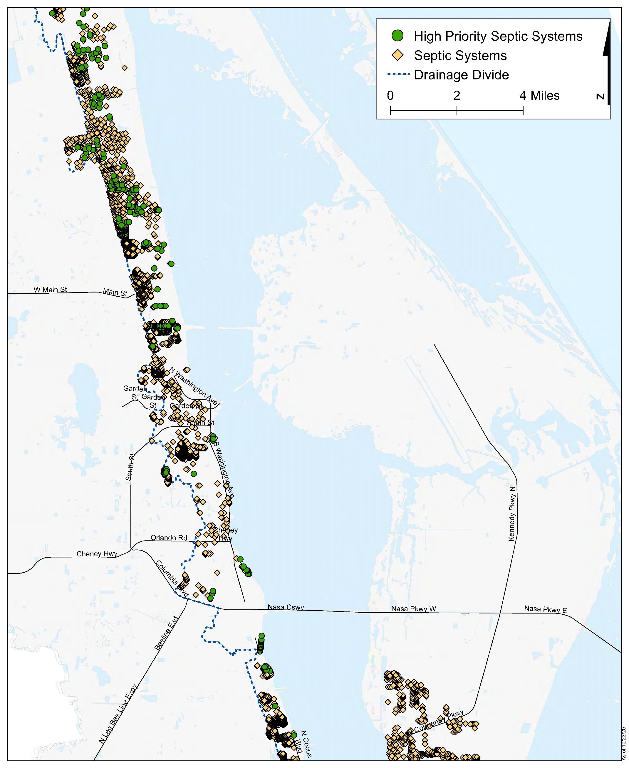
Figure 4-19: Septic System Upgrades in North Brevard County
Figure 4-19 Long Description
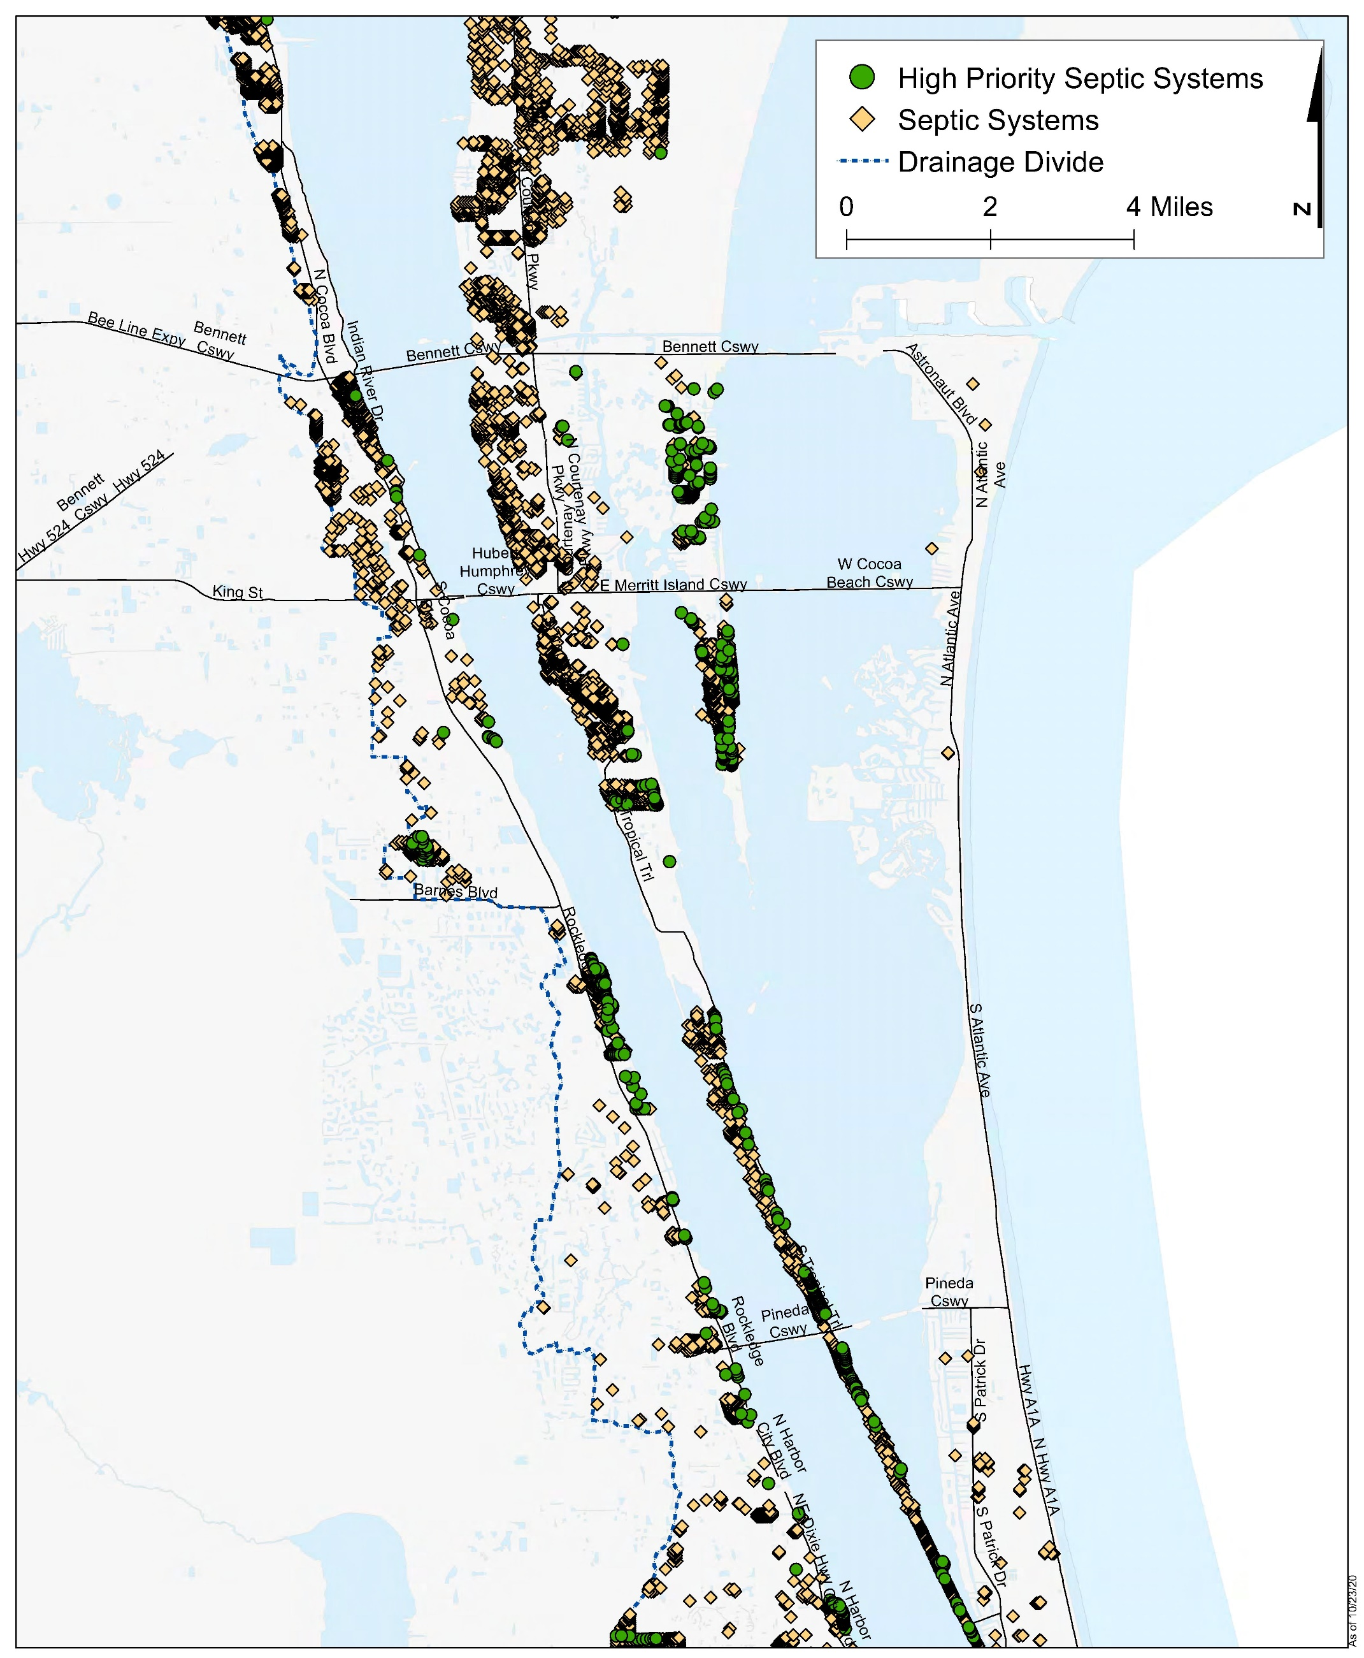
Figure 4-20: Septic System Upgrades in Central Brevard County
Figure 4-20 Long Description
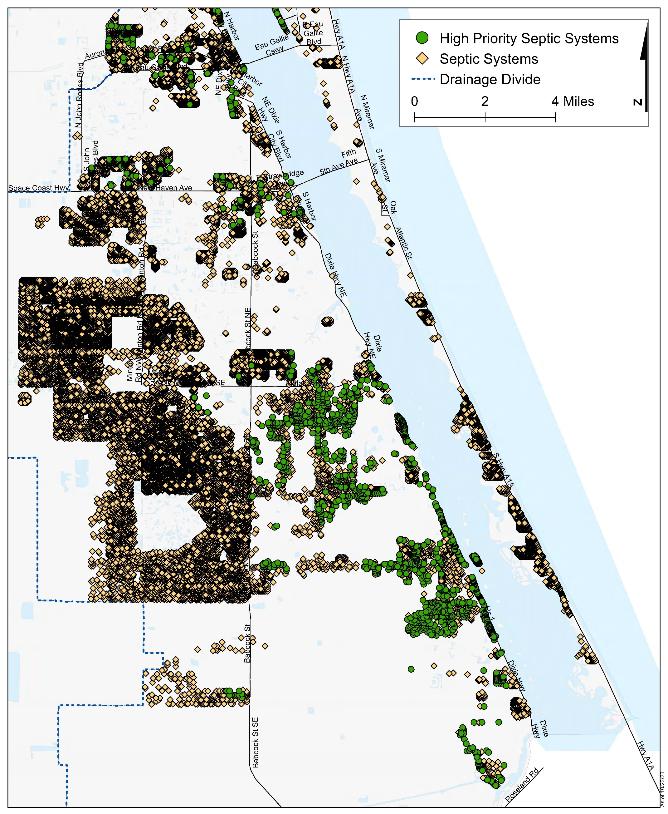
Figure 4-21: Septic System Upgrades in South Brevard County
Figure 4-21 Long Description

Stormwater Treatment
Stormwater runoff contributes 33.6% of the external TN loading and 43.4% of the external TP loading to the lagoon annually.
Stormwater runoff from urban areas carries pollutants that affect surface waters and groundwater. These pollutants include nutrients, pesticides, oil and grease, debris and litter, and sediments. In Brevard County, there are more than 1,500 stormwater outfalls to the Indian River Lagoon (IRL).
There are a variety of best management practices that can be used to capture and treat stormwater to remove or reduce these pollutants before the stormwater runoff reaches a waterbody or infiltrates to the groundwater. Potential stormwater best management practices that could help restore the IRL system include:
- Traditional best management practices – These are the typical practices used to treat stormwater runoff and include wet detention ponds, retention, swales, dry detention, baffle boxes, stormwater reuse, alum injection, street sweeping, catch basin inserts/inlet filters, floating islands/managed aquatic plant systems. Descriptions of these traditional best management practices and expected total nitrogen (TN) and total phosphorus (TP) efficiencies are shown in Table 4-22.
- Low impact development/green infrastructure – These practices use natural stormwater management techniques to minimize runoff and help prevent pollutants from getting into stormwater runoff. These best management practices address the pollutants at the source so implementing them can help decrease the size of traditional retention and detention basins and can be less costly than traditional best management practices (University of Florida Institute of Food and Agricultural Sciences, 2016). Descriptions of low impact development and green infrastructure best management practices and estimated efficiencies are shown in Table 4-23.
- Denitrification best management practices – These practices use a soil media, known as biosorption activated media to increase the amount of denitrification that occurs, which increases the amount of TN and TP removed. Biosorption activated media includes mixes of soil, sawdust, zeolites, tire crumb, vegetation, sulfur, and spodosols. Additional details about denitrification best management practices are included below.
- Best management practices to reduce baseflow intrusion – These practices are modifications to existing best management practices help reduce intrusion of captured groundwater baseflow into stormwater drainage systems. These best management practices include backfilling canals so that they do not cut through the baseflow, modifying canal cross-sections to maintain the same storage capacity while limiting the depth, installing weirs to control the water levels in the best management practice, or adding a cutoff wall to prevent movement into the baseflow.
- Re-diversion to the St. Johns River – There are portions of the current IRL Basin that historically flowed towards the St. Johns River. By re-diverting these flows back to the St. Johns River, the excess stormwater runoff, as well as the additional freshwater inputs, to the IRL would be removed. The re-diversion projects would include a treatment component so that the runoff is treated before being discharged to the St. Johns River. The St. Johns River Water Management District has taken the lead on large-scale projects while the County has re-diverted more than 400 acres in the Crane Creek basin and partnered with the St. Johns River Water Management District to increase re-diversion from the Melbourne-Tillman Water Control District canal system.
Table 4-22: Traditional Stormwater Best Management Practices with TN and TP Removal Efficiencies
Best Management Practice | Definition | Total Nitrogen Removal Efficiency | Total Phosphorus Removal Efficiency | Source
Wet detention ponds | Permanently wet ponds that are designed to slowly release a portion of the collected stormwater runoff through an outlet structure. Recommended for sites with moderate to high water table conditions. Provide removal of both dissolved and suspended pollutants through physical, chemical, and biological processes. | 8%-44% | 45%-75% | Florida Department of Environmental Protection et al., 2010
Off-line retention | Recessed area that is designed to store and retain a defined quantity of runoff, allowing it to percolate through permeable soils into the groundwater aquifer. Runoff in excess of the specified volume of stormwater does not flow into the retention system storing the initial volume of stormwater. | 40%-84% | 40%-84% | Harper et al., 2007
On-line retention and swales | Recessed area that is designed to store and retain a defined quantity of runoff, allowing it to percolate through permeable soils into the groundwater aquifer. Runoff in excess of the specified volume of stormwater does flow through the retention system that stores the initial volume of stormwater. | 30%-74% | 30%-74% | Harper et al., 2007
Dry detention | Designed to store a defined quantity of runoff and slowly release it through an outlet structure to adjacent surface waters. After drawdown of the stored runoff is completed, the storage basin does not hold any water. Used in areas where the soil infiltration properties or seasonal high-water table elevation will not allow the use of a retention basin. | 10% | 10% | Harper et al., 2007
2nd generation baffle box | Box chambers with partitions connected to a storm drain. Water flows into the first section of the box where most pollutants settle out. Overflows into the next section to allow further settling. Water ultimately overflows to the stormwater pipe. Floating trays capture leaves, grass clippings, and litter to prevent them from dissolving in the stormwater. | 19.05% | 15.5% | GPI, 2010
Stormwater reuse | Reuse of stormwater from wet ponds for irrigation. Compare volume going to reuse to total volume of annual runoff to pond. | Amount of water not discharged annually | Amount of water not discharged annually | Not applicable
Alum injection | Chemical treatment systems that inject aluminum sulfate into stormwater systems to cause coagulation of pollutants. | 50% | 90% | Harper et al., 2007
Street sweeping | Cleaning of pavement surfaces to remove sediments, debris, and trash deposited by vehicle traffic. Prevents these materials from being introduced into the stormwater system. | Total nitrogen content in dry weight of material collected annually | Total phosphorus content in dry weight of material collected annually | University of Florida, 2011
Catch basin inserts/inlet filters | Devices installed in storm drain inlets to provide water quality treatment through filtration of organic debris and litter, settling of sediment, and adsorption of hydrocarbon by replaceable filters. | Total nitrogen content in dry weight of material collected annually | Total phosphorus content in dry weight of material collected annually | University of Florida, 2011
Managed Aquatic Plant System | Aquatic plant-based best management practices that remove nutrients through a variety of processes related to nutrient uptake, transformation, and microbial activities. | 10% with 5% pond coverage | 10% with 5% pond coverage | Florida Department of Environmental Protection, 2018
Table 4-23: Low Impact Development and Green Infrastructure Best Management Practices and TN and TP Removal Efficiencies
Best Management Practice | Definition | Total Nitrogen Removal Efficiency | Total Phosphorus Removal Efficiency | Source
Permeable pavement | Hard, yet penetrable, surfaces reduce runoff by allowing water to move through them into groundwater below (University of Florida Institute of Food and Agricultural Sciences, 2016). | 30%-74% | 30%-74% | Harper et al., 2007
Bioswales | An alternative to curb and gutter systems, bioswales convey water, slow runoff, and promote infiltration. Swales may be installed along residential streets, highways, or parking lot medians (University of Florida Institute of Food and Agricultural Sciences, 2016). Must be designed for conveyance, greater in length than width, have shallow slopes, and include proper landscaping. | 38%-89% | 9%-80% | Florida Department of Environmental Protection, 2014
Green roofs | These systems can significantly reduce the rate and quantity of runoff from a roof and provide buildings with thermal insulation and improved aesthetics (University of Florida Institute of Food and Agricultural Sciences, 2016). Retention best management practice covered with growing media and vegetation that enables rainfall infiltration and evapotranspiration of stored water. Including a cistern capture, retain, and reuse water adds to effectiveness. | 45% (without cistern)  60%-85% (with cistern) | Not applicable | Florida Department of Environmental Protection, 2014
Bioretention basins/rain gardens | Small, vegetated depressions in the landscape collect and filter stormwater into the soil (University of Florida Institute of Food and Agricultural Sciences, 2016). Constructed adjacent to roof runoff and impervious areas. | 30%-50% | 30%-90% | Florida Department of Environmental Protection, 2014
Tree boxes | Bioretention systems with vertical concrete walls designed to collect/retain specified volume of stormwater runoff from sidewalks, parking lots and/or streets. Consists of a container filled with a soil mixture, a mulch layer, under-drain system, and shrub or tree (Florida Department of Environmental Protection, 2014). | 38%-65% | 50%-80% | Florida Department of Environmental Protection, 2014

Due to the importance of treating dry season baseflow to the lagoon, Brevard County has found that ditch denitrification is the most cost-effective best management practice. Biosorption activated media can be added in existing best management practices or to new best management practices to improve the nutrient removal efficiency. The removal efficiencies of using biosorption activated media in various stormwater treatment projects (Wanielista, 2015) are summarized in Table 4-24. While the efficiencies in Table 4-24 are only for Bold & Gold®, other types of biosorption activated media may be used in a project, if there is Florida-specific information available on the removal efficiencies for that media.
Table 4-24: TN and TP Removal Efficiencies for Biosorption Activated Media
Location in Best Management Practice Treatment Train | Material | Total Nitrogen Removal Efficiency | Total Phosphorus Removal Efficiency
Bold & Gold® as a first practice, example up-flow filter in baffle box and a constructed wetland | Expanded clay, tire chips | 55% | 65%
Bold & Gold® in up-flow filter at wet pond and dry basin outflow | Organics, tire chips, expanded clay | 45% | 45%
Bold & Gold® in inter-event flow using up-flow filter at wet pond and down-flow filter at dry basin | expanded clay, tire chips | 25% | 25%
Bold & Gold® down-flow filters 12-inch depth at wet pond or dry basin pervious pavement, tree well, rain garden, swale, and strips | Clay, tire crumb, sand and topsoil | 60% | 90%
Note: From Wanielista, 2015
The County’s proposed total maximum daily loads include two components: (1) a total maximum daily load for the five-month period (January–May) that is critical for seagrass growth, and (2) a total maximum daily load for the remaining seven months of the year to avoid algal blooms and protect healthy dissolved oxygen levels. In 2019, Brevard County updated the estimates for nutrient loading entering the lagoon through each stormwater ditch and outfall. The update incorporated more recent land use data, more recent rainfall and evapotranspiration data, and improved stormwater infrastructure mapping and topography. There are more than 2,000 hydrologically distinct catchment basin areas within the lagoon watershed countywide. These connect to the lagoon through more than 1,500 stormwater ditches and outfall structures. For the purpose of maximizing seagrass response to stormwater treatment, these new loading estimates for catchment basins were prioritized based on the amount of nutrients migrating into the stormwater system as groundwater baseflow during a five-month season found to be most critical to annual seagrass expansion or loss.
The stormwater project benefits were estimated, as follows, to ensure both components of the total maximum daily load are adequately addressed. The five-month total maximum daily load covers the dry season in this area when there is minimal rainfall and stormwater runoff; therefore, the benefits of stormwater biosorption activated media projects during this period were based only on January–May baseflow loading estimates from the Spatial Watershed Iterative Loading model. The estimated project treatment efficiencies used for January to May baseflow only are 55% for TN and 65% for TP. To estimate annual load reduction benefits, the annual baseflow and stormwater loading estimates from the Spatial Watershed Iterative Loading model were used with a project efficiency of 45% for TN and 45% for TP. The estimated TN and TP reductions in pounds per year accomplished by using biosorption activated media upstream of these priority outfalls are summarized in Table 4-22. The locations of the basins to be treated are shown in Figure 4-22, Figure 4-23, and Figure 4-24. Projects approved as part of an annual update to the plan are also included in Table 4-25.
Table 4-25: Projects for Stormwater Treatment
Year Added | Project Number | Project Name | Responsible Entity | Sub-Lagoon | Total Nitrogen Reduction (pounds per year) | Cost per Pound of Total Nitrogen Removed | Total Phosphorus Reduction (pounds per year) | Cost per Pound of Total Phosphorus Removed | Plan Funding
Original | - | Basin 1329* | Brevard County | Banana | 51 | $76 | 8 | $483 | $3,864
Original | - | Basin 611* | Brevard County | Banana | 1,354 | $130 | 115 | $873 | $176,300
Original | - | Basin 828* | Brevard County | Banana | 1,397 | $155 | 127 | $785 | $215,900
Original | - | Basin 951* | Brevard County | Banana | 1,562 | $166 | 154 | $812 | $258,900
Original | - | Basin 691* | Brevard County | Banana | 1,749 | $172 | 183 | $682 | $300,600
Original | - | Basin 984* | Brevard County | Banana | 1,412 | $178 | 143 | $873 | $251,100
Original | - | Basin CCB-E* | Brevard County | Banana | 1,335 | $182 | 210 | $596 | $243,400
Original | - | Basin 873* | Brevard County | Banana | 775 | $182 | 69 | $1,439 | $141,500
Original | - | Basin CCB-F* | Brevard County | Banana | 1,043 | $195 | 158 | $632 | $203,100
Original | - | Basin 497* | Brevard County | Banana | 952 | $196 | 95 | $1,051 | $186,700
Original | - | Basin 925* | Brevard County | Banana | 895 | $197 | 90 | $1,115 | $176,000
Original | - | Basin 1066* | Brevard County | Banana | 1,150 | $202 | 173 | $579 | $232,200
Original | - | Basin 602* | Brevard County | Banana | 1,135 | $203 | 122 | $817 | $230,000
Original | - | Basin 998* | Brevard County | Banana | 953 | $204 | 144 | $696 | $194,400
Original | - | Basin 1002* | Brevard County | Banana | 903 | $205 | 126 | $792 | $185,300
Original | - | Basin CCAFS-4A* | Brevard County | Banana | 2,091 | $208 | 296 | $675 | $435,000
Original | - | Basin 979A* | Brevard County | Banana | 1,162 | $209 | 173 | $721 | $242,300
Original | - | Basin 781* | Brevard County | Banana | 817 | $209 | 82 | $1,224 | $170,900
Original | - | Basin CCB-G* | Brevard County | Banana | 956 | $211 | 147 | $680 | $201,300
Original | - | Basin 539* | Brevard County | Banana | 935 | $212 | 98 | $1,023 | $198,200
Original | - | Basin CCAFS-6B* | Brevard County | Banana | 3,907 | $212 | 545 | $505 | $829,500
Original | - | Basin 1037* | Brevard County | Banana | 708 | $212 | 97 | $1,029 | $150,400
Original | - | Basin CCAFS-3A* | Brevard County | Banana | 2,896 | $221 | 450 | $611 | $640,700
Original | - | Basin CCAFS-5A* | Brevard County | Banana | 1,967 | $225 | 281 | $713 | $442,300
Original | - | Basin CCB-B* | Brevard County | Banana | 760 | $226 | 110 | $905 | $172,100
Original | - | Basin CC-B2A* | Brevard County | Banana | 774 | $228 | 125 | $803 | $176,700
Original | - | Basin CCAFS-1A* | Brevard County | Banana | 2,531 | $229 | 390 | $705 | $580,100
Original | - | Basin 674* | Brevard County | Banana | 1,206 | $230 | 145 | $859 | $277,900
Original | - | Basin 650* | Brevard County | Banana | 1,251 | $232 | 160 | $937 | $289,900
Original | - | Basin 1222* | Brevard County | Banana | 931 | $235 | 135 | $739 | $218,800
Original | - | Basin CCAFS-6D* | Brevard County | Banana | 905 | $236 | 107 | $931 | $213,200
Original | - | Basin 1024* | Brevard County | Banana | 668 | $237 | 104 | $960 | $158,700
Original | - | Basin CCAFS-6A* | Brevard County | Banana | 734 | $243 | 81 | $1,231 | $178,300
Original | - | Basin CCAFS-2A* | Brevard County | Banana | 1,778 | $244 | 309 | $648 | $434,200
Original | - | Basin 1304*^ | Brevard County | Banana | 397 | $245 | To be determined | To be determined | $97,171
Original | - | Basin CCB-C* | Brevard County | Banana | 525 | $249 | 83 | $1,209 | $130,700
Original | - | Basin 1172* | Brevard County | Banana | 919 | $249 | 133 | $754 | $228,800
Original | - | Basin CCB-D* | Brevard County | Banana | 628 | $250 | 103 | $972 | $156,700
Original | - | Basin 1067* | Brevard County | Banana | 811 | $250 | 114 | $876 | $202,600
Original | - | Basin 484* | Brevard County | Banana | 445 | $251 | 40 | $2,495 | $111,800
Original | - | Basin CCB-I* | Brevard County | Banana | 1,337 | $253 | 187 | $934 | $338,000
Original | - | Basin 730* | Brevard County | Banana | 576 | $255 | 61 | $1,628 | $146,900
Original | - | Basin 483* | Brevard County | Banana | 708 | $261 | 84 | $1,189 | $184,400
Original | - | Basin CCB-H* | Brevard County | Banana | 629 | $261 | 102 | $977 | $163,900
Original | - | Basin 601* | Brevard County | Banana | 506 | $261 | 52 | $1,912 | $132,100
Original | - | Basin 1309* | Brevard County | Banana | 593 | $262 | 89 | $1,118 | $155,500
Original | - | Basin 1280B* | Brevard County | Banana | 551 | $263 | 81 | $1,228 | $145,100
Original | - | Basin 350* | Brevard County | Banana | 695 | $266 | 85 | $1,174 | $184,500
Original | - | Basin 997* | Brevard County | Banana | 545 | $266 | 83 | $1,206 | $144,900
Original | - | Basin 476* | Brevard County | Banana | 680 | $266 | 78 | $1,274 | $181,100
Original | - | Basin 479* | Brevard County | Banana | 445 | $268 | 42 | $2,379 | $119,300
Original | - | Basin 520* | Brevard County | Banana | 400 | $269 | 35 | $2,843 | $107,600
Original | - | Basin 1037A* | Brevard County | Banana | 540 | $270 | 79 | $1,258 | $145,700
Original | - | Basin 537* | Brevard County | Banana | 591 | $272 | 68 | $1,464 | $161,100
Original | - | Basin 543* | Brevard County | Banana | 511 | $272 | 54 | $1,853 | $139,300
Original | - | Basin 1187* | Brevard County | Banana | 645 | $275 | 85 | $1,182 | $177,400
Original | - | Basin CCAFS-9A* | Brevard County | Banana | 614 | $277 | 129 | $774 | $170,100
Original | - | Basin 1124* | Brevard County | Banana | 533 | $278 | 78 | $1,287 | $148,100
Original | - | Basin 585* | Brevard County | Banana | 474 | $279 | 48 | $2,083 | $132,000
Original | - | Basin 591* | Brevard County | Banana | 399 | $279 | 37 | $2,698 | $111,200
Original | - | Basin 508* | Brevard County | Banana | 546 | $281 | 59 | $1,683 | $153,600
Original | - | Basin 673* | Brevard County | Banana | 595 | $282 | 70 | $1,421 | $167,900
Original | - | Basin CCAFS-4C* | Brevard County | Banana | 801 | $288 | 115 | $1,085 | $230,900
Original | - | Basin 638* | Brevard County | Banana | 445 | $292 | 47 | $2,112 | $130,200
Original | - | Basin 940B* | Brevard County | Banana | 523 | $293 | 75 | $1,329 | $153,200
Original | - | Basin CC-B2C* | Brevard County | Banana | 430 | $298 | 63 | $1,579 | $128,000
Original | - | Basin CC-B4B* | Brevard County | Banana | 411 | $304 | 66 | $1,506 | $125,100
Original | - | Basin 592* | Brevard County | Banana | 359 | $305 | 34 | $2,903 | $109,500
Original | - | Basin 716* | Brevard County | North IRL | 1,157 | $108 | 84 | $1,188 | $124,800
Original | - | Basin 622* | Brevard County | North IRL | 1,172 | $130 | 86 | $1,162 | $152,100
Original | - | Basin 608* | Brevard County | North IRL | 744 | $138 | 69 | $1,455 | $102,800
Original | - | Basin 286* | Brevard County | North IRL | 839 | $154 | 63 | $1,578 | $129,500
Original | - | Basin 668* | Brevard County | North IRL | 1,508 | $156 | 139 | $720 | $235,400
Original | - | Basin 659* | Brevard County | North IRL | 784 | $157 | 56 | $1,797 | $122,700
Original | - | Basin 384* | Brevard County | North IRL | 986 | $161 | 84 | $1,193 | $158,700
Original | - | TV-St. Johns Basin* | Brevard County | North IRL | 2,588 | $162 | 351 | $569 | $419,300
Original | - | Basin 253* | Brevard County | North IRL | 1,242 | $167 | 132 | $760 | $207,100
Original | - | Basin 911* | Brevard County | North IRL | 1,004 | $168 | 90 | $1,108 | $168,500
Original | - | Basin 560* | Brevard County | North IRL | 572 | $169 | 41 | $2,447 | $96,800
Original | - | TV-ST Teresa Basin* | Brevard County | North IRL | 2,872 | $171 | 426 | $528 | $492,400
Original | - | Basin 16* | Brevard County | North IRL | 1,095 | $172 | 176 | $567 | $188,800
Original | - | Basin 338* | Brevard County | North IRL | 1,938 | $176 | 210 | $713 | $340,900
Original | - | Basin 1419* | Brevard County | North IRL | 1,735 | $181 | 249 | $603 | $313,800
Original | - | TV-Addison Canal Basin* | Brevard County | North IRL | 7,070 | $181 | 914 | $301 | $1,280,300
Original | - | Basin 199* | Brevard County | North IRL | 1,125 | $181 | 108 | $929 | $204,100
Original | - | Basin 973* | Brevard County | North IRL | 2,134 | $182 | 307 | $570 | $387,600
Original | - | TV-Chain of Lakes Basin* | Brevard County | North IRL | 4,707 | $182 | 683 | $403 | $857,100
Original | - | Basin 498* | Brevard County | North IRL | 1,243 | $183 | 118 | $847 | $227,900
Original | - | Basin 662* | Brevard County | North IRL | 977 | $184 | 101 | $995 | $180,000
Original | - | Basin 1399* | Brevard County | North IRL | 1,498 | $185 | 232 | $539 | $276,500
Original | - | Basin CO-2K* | Brevard County | North IRL | 1,448 | $186 | 204 | $612 | $269,500
Original | - | Basin 1430* | Brevard County | North IRL | 2,361 | $186 | 347 | $576 | $439,700
Original | - | TV-La Paloma Basin* | Brevard County | North IRL | 2,146 | $186 | 314 | $557 | $399,600
Original | - | Basin CO-2QA* | Brevard County | North IRL | 1,354 | $187 | 199 | $627 | $253,200
Original | - | Basin 895* | Brevard County | North IRL | 1,130 | $189 | 135 | $740 | $213,100
Original | - | TV-South Marine Basin* | Brevard County | North IRL | 1,252 | $189 | 176 | $567 | $237,200
Original | - | Basin 176* | Brevard County | North IRL | 797 | $191 | 74 | $1,357 | $152,400
Original | - | Basin 1396* | Brevard County | North IRL | 1,011 | $192 | 147 | $680 | $193,900
Original | - | Basin RL-2A* | Brevard County | North IRL | 1,715 | $192 | 246 | $610 | $329,500
Original | - | Basin 62* | Brevard County | North IRL | 721 | $192 | 118 | $847 | $138,500
Original | - | Basin 141*^ | Brevard County | North IRL | 482 | $276 | 77 | $1,726 | $132,926
Original | - | Basin 19* | Brevard County | North IRL | 818 | $193 | 128 | $779 | $157,600
Original | - | TV-Main Street Basin* | Brevard County | North IRL | 1,298 | $193 | 189 | $662 | $250,200
Original | - | Basin 94* | Brevard County | North IRL | 1,141 | $194 | 178 | $562 | $221,500
Original | - | Basin 115*^ | Brevard County | North IRL | 707 | $289 | 98 | $2,086 | $204,390
Original | - | Basin 478* | Brevard County | North IRL | 896 | $195 | 80 | $1,254 | $174,400
Original | - | Basin RL-3B* | Brevard County | North IRL | 2,158 | $196 | 307 | $652 | $422,400
Original | - | Basin 992* | Brevard County | North IRL | 1,241 | $197 | 186 | $671 | $244,000
Original | - | Basin 865* | Brevard County | North IRL | 879 | $198 | 109 | $918 | $174,300
Original | - | Basin 388* | Brevard County | North IRL | 1,203 | $198 | 130 | $768 | $238,700
Original | - | Basin 116* | Brevard County | North IRL | 936 | $199 | 142 | $703 | $185,700
Original | - | Basin 193*^ | Brevard County | North IRL | 343 | $510 | 49 | $3,571 | $174,965
Original | - | Basin 1377* | Brevard County | North IRL | 1,324 | $199 | 200 | $625 | $263,400
Original | - | TV-Parrish Basin* | Brevard County | North IRL | 1,070 | $199 | 163 | $612 | $213,200
Original | - | Basin 26*^ | Brevard County | North IRL | 295 | $358 | 46 | $2,298 | $105,690
Original | - | Basin RL-3*I | Brevard County | North IRL | 3,009 | $200 | 423 | $650 | $600,700
Original | - | Basin 1392* | Brevard County | North IRL | 1,050 | $200 | 159 | $629 | $210,600
Original | - | Basin 204* | Brevard County | North IRL | 622 | $201 | 55 | $1,810 | $125,000
Original | - | Basin 451* | Brevard County | North IRL | 1,075 | $201 | 123 | $811 | $216,100
Original | - | Basin 1335 (Sherwood Park)* | Brevard County | North IRL | 1,452 | $201 | 209 | $598 | $292,400
Original | - | Basin 72* | Brevard County | North IRL | 1,038 | $202 | 150 | $668 | $209,300
Original | - | TV-Sycamore Basin* | Brevard County | North IRL | 1,246 | $202 | 184 | $680 | $251,900
Original | - | Basin 1387* | Brevard County | North IRL | 890 | $203 | 125 | $799 | $180,400
Original | - | Basin 474* | Brevard County | North IRL | 801 | $204 | 76 | $1,309 | $163,100
Original | - | Basin 157* | Brevard County | North IRL | 898 | $204 | 90 | $1,110 | $183,500
Original | - | Basin 816* | Brevard County | North IRL | 678 | $205 | 130 | $770 | $138,800
Original | - | TV-Marina Basin* | Brevard County | North IRL | 1,169 | $205 | 170 | $587 | $239,500
Original | - | Basin 410* | Brevard County | North IRL | 1,322 | $205 | 158 | $791 | $271,300
Original | - | Basin 1456* | Brevard County | North IRL | 952 | $205 | 138 | $727 | $195,400
Original | - | Basin 824* | Brevard County | North IRL | 721 | $206 | 103 | $967 | $148,500
Original | - | Basin 833* | Brevard County | North IRL | 1,083 | $207 | 183 | $545 | $224,300
Original | - | Basin 254* | Brevard County | North IRL | 581 | $207 | 45 | $2,229 | $120,200
Original | - | Basin 575* | Brevard County | North IRL | 662 | $208 | 54 | $1,859 | $137,600
Original | - | Basin 218* | Brevard County | North IRL | 491 | $208 | 39 | $2,562 | $102,100
Original | - | Basin CO-2I* | Brevard County | North IRL | 979 | $209 | 146 | $687 | $204,500
Original | - | Basin 155* | Brevard County | North IRL | 913 | $209 | 94 | $1,068 | $191,100
Original | - | Basin 1464* | Brevard County | North IRL | 968 | $210 | 134 | $746 | $202,800
Original | - | Basin 1368* | Brevard County | North IRL | 1,125 | $211 | 162 | $616 | $237,200
Original | - | Basin 738* | Brevard County | North IRL | 497 | $211 | 51 | $1,980 | $104,900
Original | - | Basin 832*^ | Brevard County | North IRL | 506 | $317 | 90 | $1,784 | $160,536
Original | - | Basin 314* | Brevard County | North IRL | 827 | $212 | 86 | $1,166 | $175,100
Original | - | Basin 1458* | Brevard County | North IRL | 947 | $212 | 128 | $780 | $200,500
Original | - | Basin 901* | Brevard County | North IRL | 1,895 | $212 | 232 | $860 | $401,100
Original | - | Basin 1256* | Brevard County | North IRL | 1,580 | $213 | 236 | $635 | $337,000
Original | - | TV-South Street Basin* | Brevard County | North IRL | 900 | $215 | 131 | $762 | $193,300
Original | - | Basin 829* | Brevard County | North IRL | 812 | $216 | 161 | $621 | $175,200
Original | - | Basin 6* | Brevard County | North IRL | 716 | $216 | 84 | $1,191 | $154,900
Original | - | Basin 22*^ | Brevard County | North IRL | 293 | $323 | 19 | $4,985 | $94,723
Original | - | Basin 439* | Brevard County | North IRL | 585 | $217 | 53 | $1,898 | $127,100
Original | - | Basin 10*^ | Brevard County | North IRL | 356 | $378 | To be determined | To be determined | $134,627
Original | - | Basin 413* | Brevard County | North IRL | 915 | $218 | 103 | $975 | $199,200
Original | - | Basin 1263* | Brevard County | North IRL | 914 | $218 | 132 | $759 | $199,500
Original | - | Basin 758* | Brevard County | North IRL | 533 | $219 | 49 | $2,023 | $116,900
Original | - | Basin 835* | Brevard County | North IRL | 1,134 | $220 | 159 | $785 | $249,000
Original | - | Basin 1078* | Brevard County | North IRL | 1,017 | $221 | 150 | $666 | $224,800
Original | - | Basin 831* | Brevard County | North IRL | 733 | $221 | 105 | $950 | $162,200
Original | - | TV-Royal Palm Basin* | Brevard County | North IRL | 878 | $223 | 127 | $786 | $195,500
Original | - | Basin 499* | Brevard County | North IRL | 761 | $223 | 78 | $1,289 | $169,800
Original | - | Basin 1381* | Brevard County | North IRL | 968 | $224 | 146 | $686 | $216,500
Original | - | Basin 1342* | Brevard County | North IRL | 1,034 | $224 | 157 | $637 | $231,700
Original | - | Basin 1298*^ | Brevard County | North IRL | 750 | $384 | 113 | $2,552 | $288,371
Original | - | Basin 112* | Brevard County | North IRL | 734 | $226 | 107 | $931 | $165,700
Original | - | Basin RL-3A* | Brevard County | North IRL | 796 | $226 | 113 | $881 | $179,800
Original | - | Basin 89* | Brevard County | North IRL | 1,084 | $226 | 150 | $835 | $245,100
Original | - | Basin 2159* | Brevard County | Central IRL | 2,754 | $148 | 350 | $500 | $407,500
Original | - | Basin 2185* | Brevard County | Central IRL | 1,208 | $162 | 94 | $1,064 | $196,200
Original | - | Basin 2163* | Brevard County | Central IRL | 1,264 | $163 | 89 | $1,118 | $205,500
Original | - | Basin 1736* | Brevard County | Central IRL | 4,263 | $167 | 551 | $499 | $710,600
Original | - | Basin 1604* | Brevard County | Central IRL | 2,916 | $167 | 425 | $529 | $486,400
Original | - | Basin 2239* | Brevard County | Central IRL | 1,643 | $169 | 261 | $479 | $276,900
Original | - | Basin 1762* | Brevard County | Central IRL | 4,250 | $169 | 621 | $443 | $716,700
Original | - | Basin 2222* | Brevard County | Central IRL | 1,534 | $169 | 226 | $552 | $258,700
2017 | 13 | Central Boulevard Baffle Box+ | City of Cape Canaveral | Banana | 481 | $72 | 14 | $2,479 | $34,700
2017 | 14 | Church Street Type II Baffle Box+ | City of Cocoa | North IRL | 937 | $94 | 135 | $652 | $88,045
2017 | 15 | Bayfront Stormwater Project+ | City of Palm Bay | Central IRL | 348 | $88 | 83 | $369 | $30,624
2017 | 16 | Gleason Park Reuse+ | City of Indian Harbour Beach | Banana | 48 | $88 | 9 | $469 | $4,224
2017 | 18 | Denitrification Retrofit of Johns Road Pond+ | Brevard County | North IRL | 1,199 | $88 | Not applicable | Not applicable | $105,512
2017 | 19 | St. Teresa Basin Treatment+ | City of Titusville | North IRL | 3,100 | $88 | 459 | $594 | $272,800
2017 | 20 | South Street Basin Treatment+ | City of Titusville | North IRL | 987 | $88 | 156 | $557 | $86,856
2017 | 21 | La Paloma Basin Treatment+ | City of Titusville | North IRL | 2,367 | $88 | 346 | $602 | $208,296
2017 | 22 | Kingsmill-Aurora Phase Two+ | Brevard County | North IRL | 4,176 | $88 | 814 | $451 | $367,488
2017 | 23 | Denitrification Retrofit of Huntington Pond+ | Brevard County | North IRL | 1,190 | $88 | Not applicable | Not applicable | $104,720
2017 | 24 | Denitrification Retrofit of Flounder Creek Pond+ | Brevard County | North IRL | 856 | $88 | Not applicable | Not applicable | $75,328
2017 | 34 | Cliff Creek Baffle Box+ | City of Melbourne | North IRL | 3,952 | $88 | 797 | $436 | $347,781
2017 | 35 | Thrush Drive Baffle Box+ | City of Melbourne | North IRL | 3,661 | $88 | 773 | $417 | $322,200
2018 | 64 | Stormwater Low Impact Development Convair Cove 1 – Blakey Boulevard+ | City of Cocoa Beach | Banana | 30 | $155 | 3 | $1,550 | $4,650
2018 | 65 | Stormwater Low Impact Development Convair Cove 2 – Dempsey Drive+ | City of Cocoa Beach | Banana | 29 | $155 | 3 | $1,498 | $4,495
2018 | 66 | Big Muddy at Cynthia Baffle Box+ | City of Indian Harbour Beach | Banana | 269 | $155 | 48 | $869 | $41,695
2018 | 67 | Grant Place Baffle Box+ | City of Melbourne | Central IRL | 937 | $88 | 193 | $427 | $82,481
2018 | 68 | Crane Creek/M-1 Canal Flow Restoration+ | St. Johns River Water Management District | Central IRL | 23,113 | $88 | 2,719 | $748 | $2,033,944
2018 | 69 | Apollo/GA Baffle Box+ | City of Melbourne | North IRL | 3,381 | $88 | 479 | $621 | $297,522
2019 | 66b | Big Muddy at Cynthia Baffle Box Expansion+ | City of Indian Harbour Beach | Banana | 167 | $155 | 10 | $2,584 | $25,837
2019 | 85 | Basin 1304 Bioreactor+ | Brevard County | Banana | 958 | $94 | 127 | $709 | $90,000
2019 | 87 | Fleming Grant Biosorption Activated Media+ | Brevard County | Central IRL | 602 | $94 | 91 | $622 | $56,588
2019 | 88 | Espanola Baffle Box+ | City of Melbourne | Central IRL | 1,119 | $94 | 148 | $711 | $105,186
2019 | 89 | Basin 1298 Bioreactor+ | Brevard County | North IRL | 917 | $94 | 116 | $743 | $86,198
2019 | 90 | Johns Road Pond Biosorption Activated Media+ | Brevard County | North IRL | 245 | $94 | 37 | $622 | $23,030
2019 | 91 | Burkholm Road Biosorption Activated Media+ | Brevard County | North IRL | 685 | $94 | 104 | $619 | $64,390
2019 | 92 | Basin 115 Carter Road Biosorption Activated Media+ | Brevard County | North IRL | 665 | $94 | 101 | $619 | $62,510
2019 | 93 | Basin 193 Wiley Avenue Biosorption Activated Media+ | Brevard County | North IRL | 954 | $87 | 144 | $575 | $82,735
2019 | 94 | Basin 832 Broadway Pond Biosorption Activated Media+ | Brevard County | North IRL | 456 | $94 | 69 | $621 | $42,864
2019 | 95 | Cherry Street Baffle Box+ | City of Melbourne | North IRL | 980 | $313 | 174 | $1,763 | $306,740
2019 | 96 | Spring Creek Baffle Box+ | City of Melbourne | North IRL | 1,057 | $313 | 232 | $1,426 | $330,841
2019 | 97 | Titusville High School Baffle Box+ | City of Titusville | North IRL | 1,190 | $94 | 166 | $674 | $111,813
2019 | 98 | Coleman Pond Managed Aquatic Plant System+ | City of Titusville | North IRL | 1,240 | $28 | 198 | $177 | $35,000
2020 | 110 | Osprey Plant Pond Managed Aquatic Plant Systems+ | City of Titusville | North IRL | 606 | $99 | 88 | $682 | $60,000
2020 | 117 | Basin 10 County Line Road Woodchip Bioreactor+ | Brevard County Stormwater | North IRL | 597 | $122 | 90 | $809 | $72,773
2020 | 118 | Basin 26 Sunset Avenue Serenity Park Woodchip Bioreactor+ | Brevard County Stormwater | North IRL | 605 | $122 | 92 | $802 | $73,810
2020 | 119 | Basin 141 Irwin Avenue Woodchip Bioreactor+ | Brevard County Stormwater | North IRL | 567 | $122 | 86 | $804 | $69,174
2020 | 120 | Draa Field Pond Managed Aquatic Plant Systems+ | City of Titusville | North IRL | 256 | $122 | 38 | $823 | $31,281
2020 | 121 | Basin 2258 Babcock Road Woodchip Bioreactor+ | Brevard County Stormwater | Central IRL | 412 | $122 | 62 | $810 | $50,203
2020 | 122 | Basin 22 Hunting Road Serenity Park Woodchip Bioreactor+ | Brevard County Stormwater | North IRL | 329 | $122 | 50 | $802 | $40,077
2020 | 124 | Floating Wetlands to Existing Stormwater Ponds+ | City of Cocoa | North IRL | 12 | $125 | 3 | $499 | $1,497
2020 | 125 | Diamond Square Stormwater Pond+ | City of Cocoa | North IRL | 85 | $122 | 23 | $451 | $10,383
2020 | 127 | Basin 5 Dry Retention+ | Town of Indialantic | North IRL | 113 | $148 | 18 | $927 | $16,680
2020 | 128 | Jackson Court Stormwater Treatment Facility+ | City of Satellite Beach | Banana | 56 | $148 | 8 | $1,033 | $8,266
2020 | 129 | Forrest Avenue 72-inch Outfall Baseflow Capture/Treatment+ | City of Cocoa | North IRL | 94 | $148 | 12 | $1,163 | $13,956
2021 | 169 | Sherwood Park Enhancement+ | City of Melbourne | North IRL | 1,762 | $57 | 670 | $149 | $99,708
2021 | 174 | St. Johns 2 Baffle Box+ | City of Titusville | North IRL | 1,992 | $122 | 611 | $398 | $243,070
2021 | 123 | Ray Bullard Water Reclamation Facility Stormwater Management Area+ | City of West Melbourne | Central IRL | 1,317 | $122 | 400 | $402 | $160,674
2021 | 175 | High School Baffle Box+ | City of Melbourne | North IRL | 1,183 | $122 | 319 | $452 | $144,326
2021 | 176 | Funeral Home Baffle Box+ | City of Melbourne | North IRL | 481 | $122 | 129 | $455 | $58,682
2021 | 177 | North and South Lakemont Ponds Floating Wetlands+ | City of Cocoa | North IRL | 107 | $122 | 25 | $522 | $13,054
2021 | 178 | Marina B Managed Aquatic Plant Systems+ | City of Titusville | North IRL | 55 | $122 | 7 | $953 | $6,670
2021 | 179 | Lori Laine Basin Pipe Improvement Project+ | City of Satellite Beach | Banana | 117 | $150 | 21 | $835 | $17,525
2022 | 213 | Johnson Junior High Denitrification Media Chamber Modification+ | Brevard County Natural Resources | Central IRL | 206 | $313 | Not applicable | Not applicable | $64,478
2022 | 214 | Sand Point Park Baffle Box+ | City of Titusville | North IRL | 438 | $313 | 71 | $1,931 | $137,135
2022 | 215 | Basin 960 Pioneer Road Denitrification+ | Brevard County Natural Resources | Banana | 105 | $370 | 3 | $12,950 | $38,850
2022 | 219 | McNabb Outfall Bioretention+ | City of Cocoa Beach | Banana | 44 | $441 | 7 | $2,775 | $19,423
2022 | 220 | Basin 1398 Sand Dollar Canal Bioreactor+ | Brevard County Natural Resources | North IRL | 444 | $446 | 70 | $2,829 | $198,024
2022 | 221 | Burris Way Alley West Stormwater Low Impact Development Improvement+ | City of Cocoa Beach | Banana | 3 | $416 | 0 | Not applicable | $1,249
- | - | Total | - | - | 271,170 | $175 (average) | 37,450 | $1,270 (average) | $47,577,124
Note: The projects highlighted in green and marked with an asterisk were identified in the original plan. The projects highlighted in tan and marked with a plus sign were added to the plan as part of an annual update.
^ The costs and nutrient reductions for these original projects were modified to exclude portions of these priority basins that were funded as separate projects.
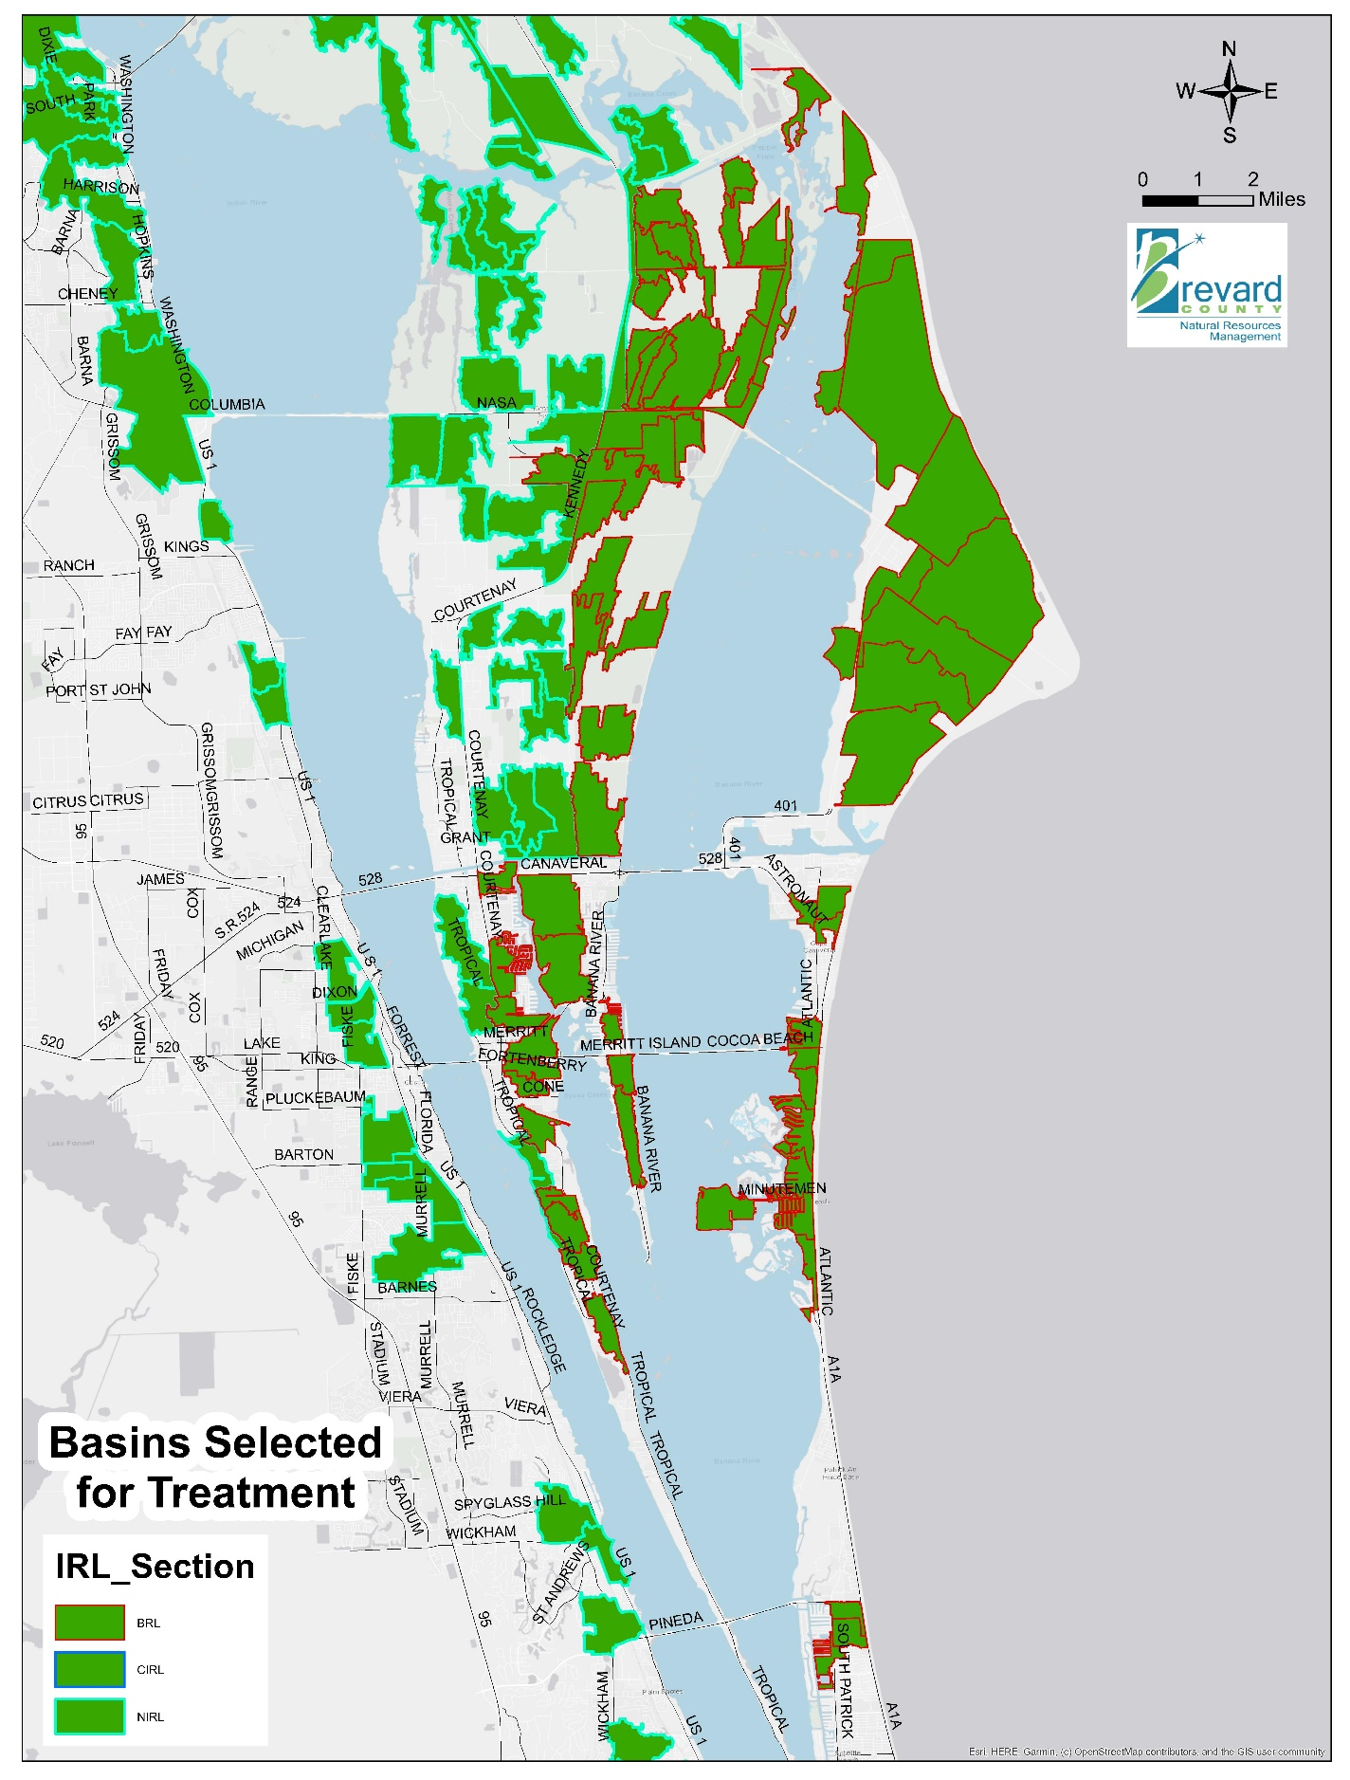
Figure 4-22: Stormwater Projects in North Brevard County
Figure 4-22 Long Description
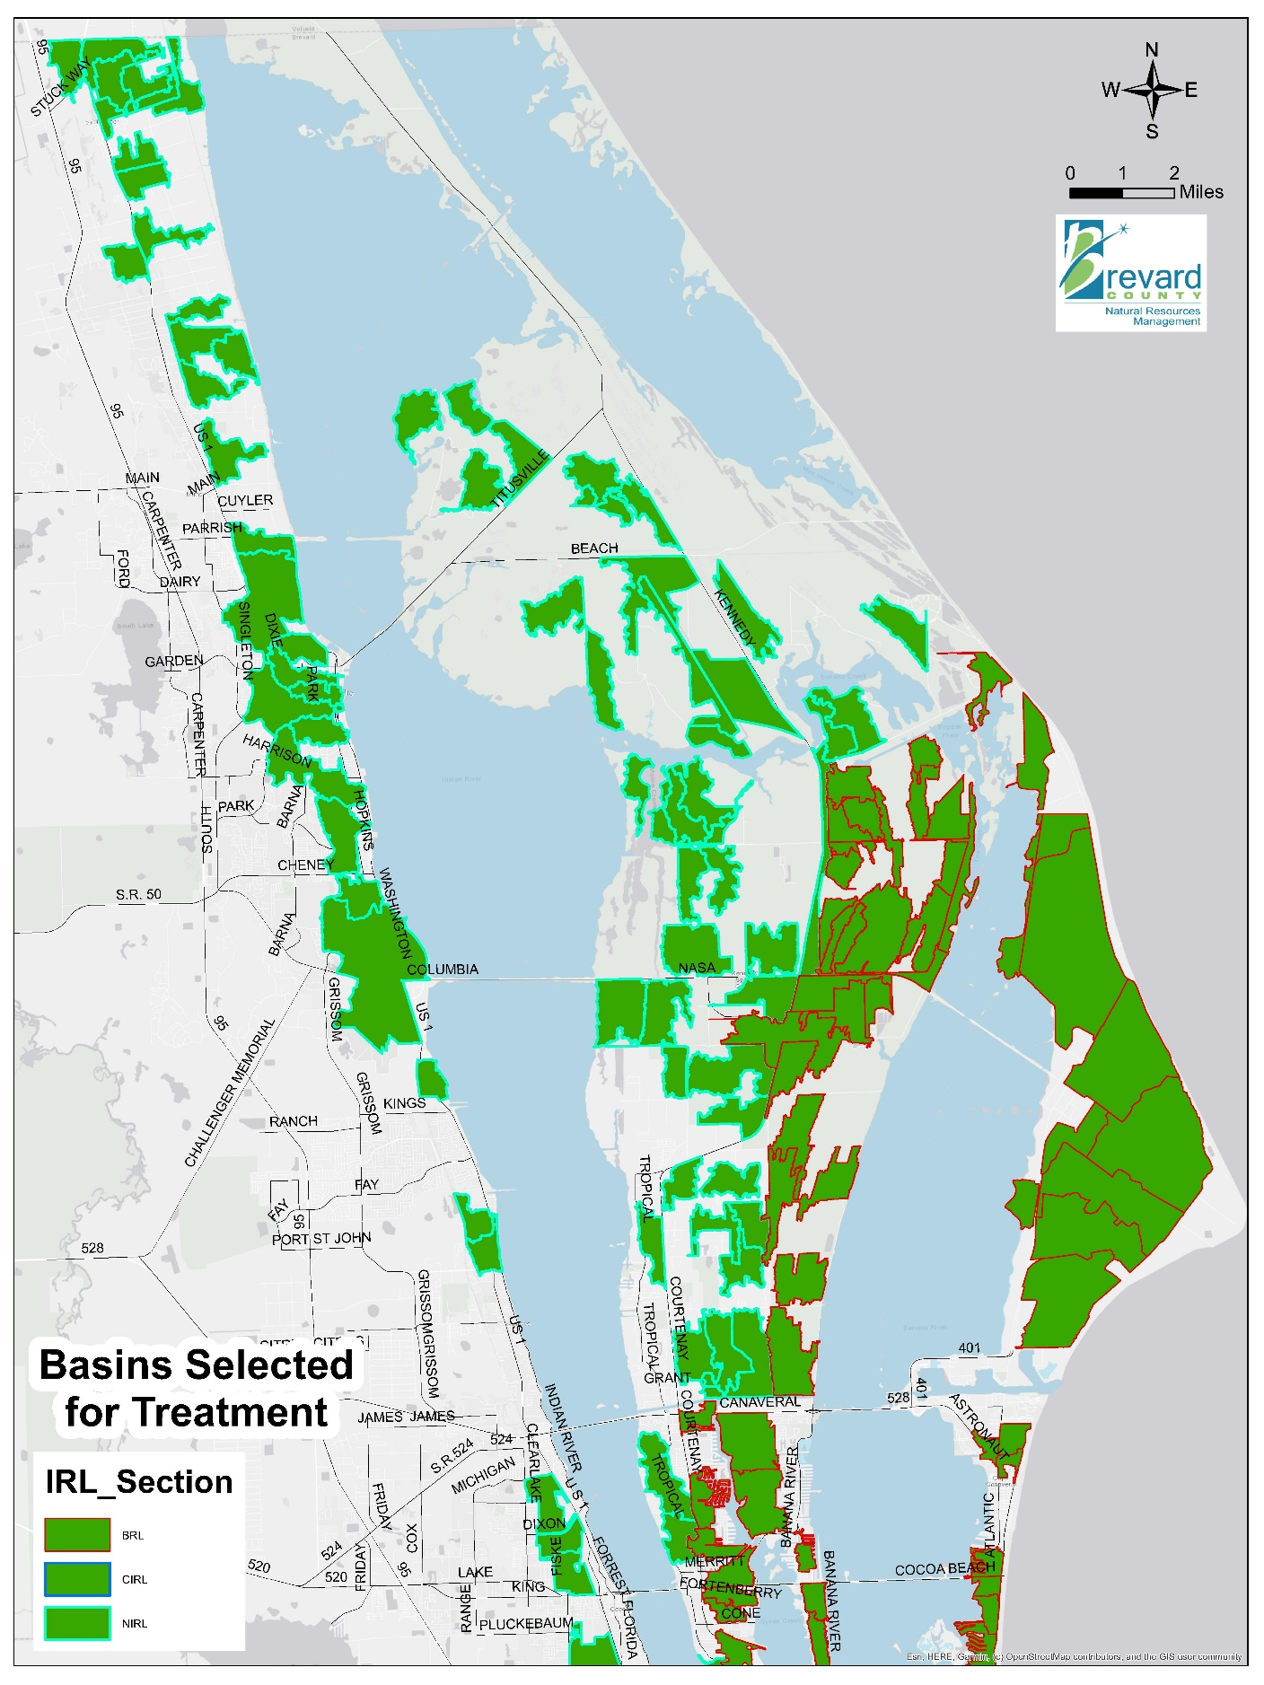
Figure 4-23: Stormwater Projects in Central Brevard County
Figure 4-23 Long Description
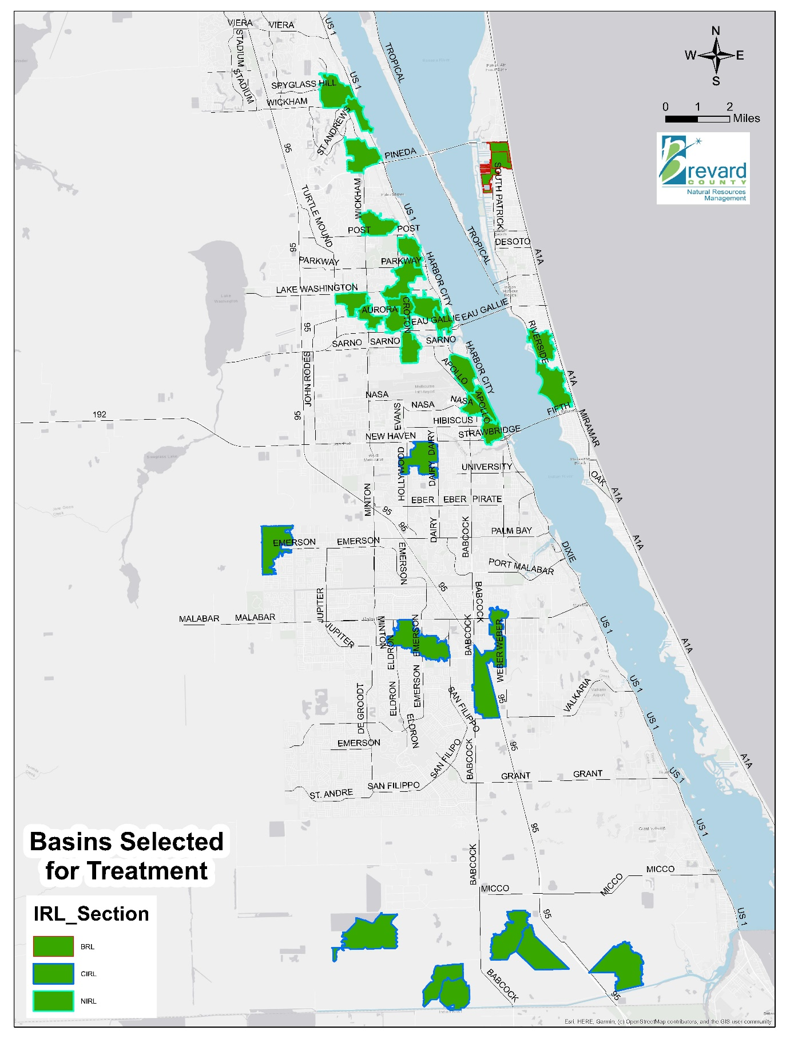
Figure 4-24: Stormwater Projects in South Brevard County
Figure 4-24 Long Description

Vegetation Harvesting
Mechanical removal or harvest of aquatic vegetation rather than treatment with herbicides or other control mechanisms may be one method of reducing nutrient loads to the Indian River Lagoon (IRL) and its tributaries. The use of aquatic plants for nutrient management has been considered since at least the 1960s (Boyd, 1969). The harvest of aquatic vegetation removes nutrients from the waterbody rather than recycling them through decomposition and settlement of the plant material into the sediment. Most freshwater plants do not tolerate the salinity of the IRL and, upon release (such as floating plants washed out of canals) to the lagoon, will die and decompose adding a nutrient load directly to the IRL.
Aquatic vegetation can occur either in mixed stands or as large monocultures. It is not uncommon for invasive plants to form largely monotypic stands. The plant material can form dense floating mats that prevent light diffusion into the water column, thus shading the bottom and limiting benthic habitat. The dense layer of vegetation also limits exchange of gases across the water surface and can cause depletion of dissolved oxygen under the mat. At greater densities, vegetation may also form floating islands or tussocks and incorporate woody plants.
Common invasive plants present in waterways that connect to the IRL are hydrilla, water lettuce, duck weed, and water hyacinth, and these plants present the greatest opportunity for harvest and removal of nutrients through plant biomass. However, native vegetation can be intermixed with exotics. Examples of common native aquatic vegetation that may also be removed includes cattails, fanwort, coontail, bladderwort, and water lilies.
The removal of aquatic vegetation may be accomplished in several ways. For canals or waterbodies with small surface area, booms laid across the water surface can divert flow to screening and sorting facilities for removal of floating vegetation. Also, in canals, drag lines or back hoes can be used for removal of submerged vegetation or modified front end loaders with baskets can collect floating plant material. There are also specifically designed harvesters and shredders that move through the water and cut and remove vegetation (Florida Department of Environmental Protection, 2012).
The cost-share for vegetation harvesting was based on actual annualized costs and laboratory analyses of the total nitrogen (TN) and total phosphorus (TP) content of plant material removed from floating vegetative islands in eight Brevard County stormwater ponds (see Table 4-26). Cost-share reimbursement of approved projects will be based on laboratory analysis of plant material to determine true nutrient removal. Eligible cost-share will be adjusted as additional cost and nutrient removal benefit data are collected.
Table 4-26: Estimated Costs and Nutrient Reductions for Vegetation Harvesting
Project | Annualized Cost | Annualized Total Nitrogen Reductions (pounds per year) | Cost per Pound per Year of Total Nitrogen Reduction | Annualized Total Phosphorus Reductions (pounds per year) | Cost per Pound per Year of Total Phosphorus Reduction
Vegetation Harvesting | $198,868 | 1,812 | $110 | 191 | $1,041
Table 4-27 summarizes the approved projects for vegetation harvesting.
Table 4-27: Projects for Vegetation Harvesting
Year Added | Project Number | Project Name | Responsible Entity | Sub-lagoon | Total Nitrogen Reduction (pounds per year) | Cost per Pound per Year of Total Nitrogen Reduction | Total Phosphorus Reduction (pounds per year) | Cost per Pound per Year of Total Nitrogen Reduction | Plan Funding
2020 | 111 | Draa Field Vegetation Harvesting+ | City of Titusville | North IRL | 786 | $110 | 99 | $873 | $86,413
2020 | 112 | County Wide Stormwater Pond Harvesting+ | Brevard County Stormwater | North IRL | 140 | $100 | 28 | $500 | $14,000
2021 | 171 | Mechanical Aquatic Vegetation Harvesting+ | Melbourne-Tillman Water Control District | Central IRL | 16,636 | $61 | 1,664 | $608 | $1,011,976
2021 | 172 | Horseshoe Pond Vegetative Harvesting+ | Brevard County Stormwater | North IRL | 74 | $110 | 7 | $1,163 | $8,140
2021 | 173 | North and South Lakemont Ponds Vegetation Harvesting+ | City of Cocoa | North IRL | 18 | $110 | 4 | $495 | $1,980
2022 | 208 | Maritime Hammock Preserve Stormwater Pond Aquatic Vegetation Harvesting+ | City of Cocoa Beach | Banana | 70 | $110 | 5 | $1,540 | $7,700
2022 | 209 | Basin 1398 Sand Dollar Canal Harvesting+ | Brevard County Natural Resources | North IRL | 222 | $110 | 21 | $1,163 | $24,420
2022 | 210 | Basin 958 Pioneer Road Vegetation Harvesting+ | Brevard County Natural Resources | Banana | 363 | $110 | 47 | $850 | $39,930
2022 | 211 | Cocoa Beach Golf Course Stormwater Ponds Aquatic Vegetation Harvesting+ | City of Cocoa Beach | Banana | 1,965 | $110 | 135 | $1,601 | $216,150
- | - | Total | - | - | 20,274 | $70 (average) | 2,010 | $702 (average) | $1,410,709
Note: The projects highlighted in tan and marked with a plus sign were added to the plan as part of an annual update.

Projects to Remove Pollutants
The purpose of the projects in this section is to remove pollutants that have accumulated in the lagoon. Brevard County (County) has already begun to remove deep accumulations of muck from the lagoon bottom. Dredging to remove muck in other locations of the lagoon will continue, as well as treatment of the interstitial water when feasible. These muck removal projects have more immediate benefits on the lagoon water quality than external reduction projects because the nutrient flux is reduced as soon as muck is dredged from the system whereas it takes time for the external load reduction benefits to reach the lagoon. The County is also evaluating opportunities to use new treatment technologies to provide surface water remediation. In addition, the St. Johns River Water Management District, Indian River Lagoon National Estuary Program, and Florida Institute of Technology are evaluating opportunities for enhanced circulation projects, which will allow additional water to flow into the lagoon system to help remove the built-up sediments and muck. The following sections describe the County’s proposed muck removal projects, scrubbing of muck interstitial water, as well as potential surface water remediation and potential circulation enhancement projects.

Muck Removal
Muck flux contributes 45% of the TN and 49% of TP load to the Banana River Lagoon each year.
The muck in the Indian River Lagoon (IRL) increases turbidity, inhibits seagrass growth, promotes oxygen depletion in sediments and the water above, stores and releases nutrients, covers the natural bottom, and destroys healthy communities of benthic organisms (Trefry, 2013). When muck is suspended within the water column due to wind or human activities such as boating, these suspended solids limit light availability and suppress seagrass growth. Even for deeper water areas without seagrass growth, muck remains a nutrient source that potentially affects a broader area of the lagoon through nutrient flux and resuspension of fine sediments and their subsequent transport. As shown in Table 3-1, the annual release of nutrients from decaying muck is almost as much as the annual external loading delivered by stormwater and groundwater baseflow combined. The muck deposits cover an estimated 6,700 acres of the lagoon system bottom in Brevard County (Trefry, 2018).
The muck deposits in the lagoon flux nutrients that enter the water column and contribute to algal blooms and growth of macroalgae. Muck flux rates for nitrogen and phosphorus have been estimated through studies in the IRL system. For this plan, the average flux rates used are 150 pounds of total nitrogen (TN) per acre per year and 20 pounds of total phosphorus (TP) per acre per year (Trefry, 2018) except where specific measurements indicate otherwise.
The focus of the muck removal projects for this plan is on large deposits of muck in big, open water sites within the lagoon itself. Several of the canal systems that directly connect to the lagoon are also included for muck removal. The goal of the muck removal is to reduce TN and TP muck flux loads by 25%, which should result in a significant improvement in water quality and seagrass extent, as well as a reduced risk of massive algal blooms and fish kills. A 70% efficiency for muck removal projects was applied. This efficiency accounts for two factors: (1) each target dredge area has less than 100% muck cover, and (2) some pockets of muck within dredged areas will inevitably be left behind regardless of the dredge technology used. In 2018 and 2019, the Florida Institute of Technology conducted evaluations of the muck deposits throughout the lagoon system for Brevard County (Fox and Trefry, 2018; Fox and Trefry, 2019; Shenker, 2018; Souto, 2018; Trefry et al., 2019a and 2019b; Zarillo and Listopad, 2019). The updated muck acreage estimates are shown in Table 4-28.
Table 4-28: Muck Acreages in the IRL System
Muck Reduction Targets | Open Banana | Banana Canals | North IRL | North IRL Canals | Central IRL | Central IRL Canals | Mosquito Lagoon
Muck area (acres) | 1,276 | 752 | 3,035 | 51 | 59 | 37 | 398
Muck flux (pounds of total nitrogen per year) | 281,148 | 112,800 | 233,992 | 7,650 | 40,226 | 5,550 | 7,164
Funded dredging sites (acres) | 223 | 0 | 251 | 0 | 0 | 0 | 0
Flux from funded dredging sites (pounds of total nitrogen per year) | 123,723 | 0 | 85,325 | 0 | 0 | 0 | 0
Flux reduction from funded sites (pounds of total nitrogen per year) | 86,606 | 0 | 59,728 | 0 | 0 | 0 | 0
Percent of total flux reduced by dredging the funded sites | 31% | 0% | 26% | 0% | 0% | 0% | 0%
Using the information from the Florida Institute of Technology, Brevard County reevaluated the priority muck locations for dredging. The estimated area and nutrient flux using average flux rates for Brevard County or site-specific data collected by the Florida Institute of Technology are shown in Table 4-29 for the recommended projects. Table 4-30 provides a summary of the recommended projects and the projects submitted as part of an annual plan. The locations of these projects are shown in Figure 4-25 through Figure 4-28.
As dredging proceeds, upland input of muck components must be reduced to prevent new muck accumulation. Therefore, land-based source control measures for nutrients, organic waste, and erosion are needed. Without source controls, muck removal will need to be frequently repeated, which is neither cost-effective nor beneficial to the lagoon’s health. Public awareness and commitment are needed to control future muck accumulation. Activities that contribute organic debris and sediment to stormwater and open water must be curtailed. Additional scientific assessment should be carried out to evaluate and optimize the dredging process.
Table 4-29: Estimated Costs and Nutrient Reductions for Muck Removal Project Areas
Location | Sub-Lagoon | Cubic Yards | Acres | Total Nitrogen Flux (pounds per acre per year) | Total Phosphorus Flux (pounds per acre per year)
Canaveral South | Banana | 420,000 | 55 | 919 | 50
Pineda Banana River Lagoon | Banana | 195,000 | 28 | 767 | 35
Patrick Space Force Base | Banana | 205,000 | 26 | 357 | 21
Cocoa Beach Golf | Banana | 975,000 | 140 | 303 | 21
Titusville Railroad West | North IRL | 90,000 | 70 | 294 | 12
National Aeronautics and Space Administration Causeway East | North IRL | 285,000 | 34 | 919 | 44
Rockledge A | North IRL | 125,000 | 38 | 285 | 31
Titusville Railroad East | North IRL | 115,000 | 36 | 214 | 9
Eau Gallie Northeast | North IRL | 250,000 | 73 | 205 | 29

Table 4-30: Projects for Muck Removal
Year Added | Project Number | Project Name | Responsible Entity | Sub-Lagoon | Total Nitrogen Reduction (pounds per year) | Cost per Pound per Year of Total Nitrogen Removed | Total Phosphorus Reduction (pounds per year) | Cost per Pound per Year of Total Phosphorus Removed | Plan Funding
Original | 2016-10a | Canaveral South* | Brevard County | Banana | 35,382 | $415 | 1,925 | $7,636 | $14,700,000
Original | 2016-5a | Pineda Banana River Lagoon* | Brevard County | Banana | 15,033 | $454 | 686 | $9,949 | $6,825,000
Original | 2016-11a | Patrick Space Force Base* | Brevard County | Banana | 6,497 | $1,104 | 382 | $18,783 | $7,175,000
Original | 168a | Cocoa Beach Golf*^ | Brevard County | Banana | 29,694 | $719 | 2,058 | $10,374 | $21,350,000
Original | 2016-06a | Titusville Railroad West* | Brevard County | North IRL | 14,406 | $219 | 588 | $5,357 | $3,150,000
Original | 2016-07a | National Aeronautics and Space Administration Causeway East* | Brevard County | North IRL | 21,872 | $456 | 1,047 | $9,527 | $9,975,000
Original | 2016-04a | Rockledge A* | Brevard County | North IRL | 7,581 | $577 | 825 | $5,303 | $4,375,000
Original | 2016-08a | Titusville Railroad East* | Brevard County | North IRL | 5,393 | $746 | 227 | $17,731 | $4,025,000
Original | 54a | Eau Gallie Northeast* | Brevard County | North IRL | 10,476 | $835 | 1,482 | $5,904 | $8,750,000
2017 | 41a | Grand Canal Muck Dredging+# | Brevard County | Banana | 10,469 | $251 | 1,396 | $1,882 | $2,626,600
2017 | 42a | Sykes Creek Muck Dredging+ | Brevard County | Banana | 19,635 | $240 | 2,618 | $1,797 | $4,705,428
2018 | 70a | Cocoa Beach Muck Dredging – Phase III+ | City of Cocoa Beach | Banana | 4,095 | $336 | 780 | $1,764 | $1,376,305
2018 | 71 | Merritt Island Muck Removal – Phase 1+ | Brevard County | Banana | 8,085 | $957 | 1,540 | $5,022 | $7,733,517
2018 | 72a | Muck Removal of Indian Harbour Beach Canals+ | City of Indian Harbour Beach | Banana | 3,780 | $961 | 720 | $5,044 | $3,631,815
2018 | 2016-3a | Muck Re-dredging in Turkey Creek+ | Brevard County | Central IRL | 5,691 | $38 | 221 | $973 | $215,000
2019 | 101 | Cocoa Beach Muck Dredging Phase II-B+ | City of Cocoa Beach | Banana | 6,300 | $939 | 840 | $7,045 | $5,917,650
2020 | 144 | Satellite Beach Muck Dredging+ | City of Satellite Beach | Banana | 3,885 | $485 | 518 | $3,638 | $1,884,225
2022 | 223 | Spring Creek Dredging+ | City of Melbourne | North IRL | 154 | $520 | 21 | $3,813 | $80,080
- | - | Total | - | - | 208,428 | $521 (average) | 17,874 | $6,070 (average) | $108,495,620
Note: The projects highlighted in green and marked with an asterisk were identified in the original plan. The projects highlighted in tan and marked with a plus sign were added to the plan as part of an annual update.
^ The Cocoa Beach Golf project is not fully funded at this time. A total of $21,350,000 is available and Brevard County is looking for options to fund the remaining $12,775,000 for dredging plus associated interstitial water treatment.
# In 2021, contingency funding was approved to add Berkeley Canal to the Grand Canal project.
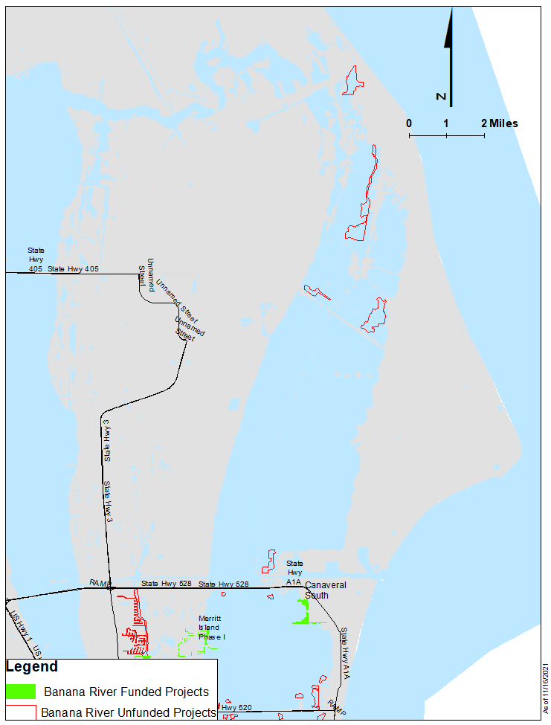
Figure 4-25: Location of Muck Removal Projects in the Northern Banana River Lagoon
Figure 4-25 Long Description
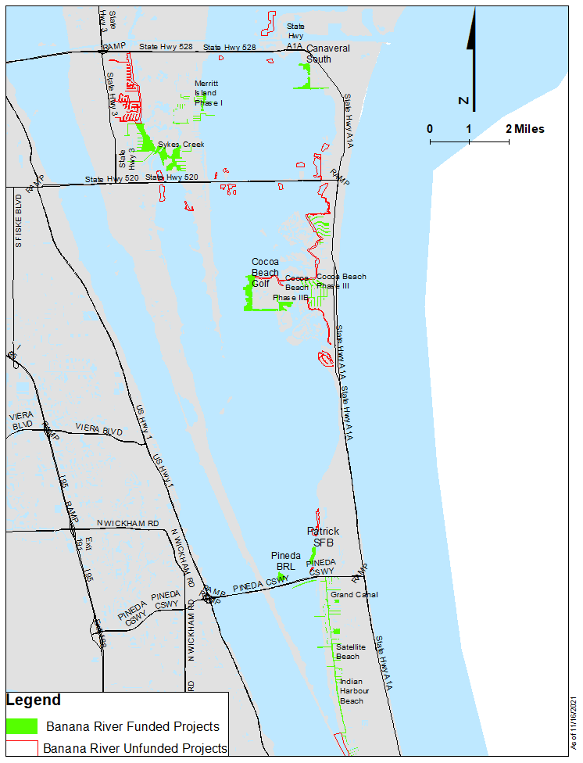
Figure 4-26: Location of Muck Removal Projects in the Southern Banana River Lagoon
Figure 4-26 Long Description
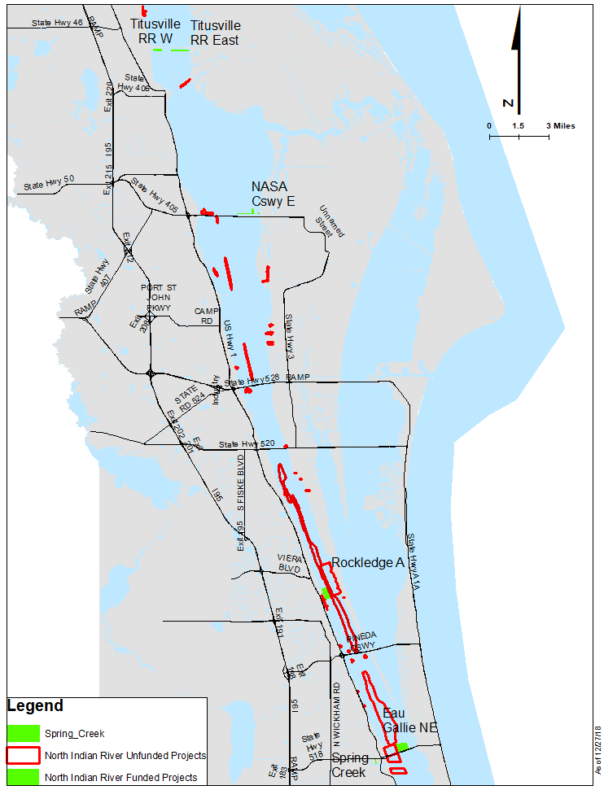
Figure 4-27: Location of Muck Removal Projects in North IRL
Figure 4-27 Long Description
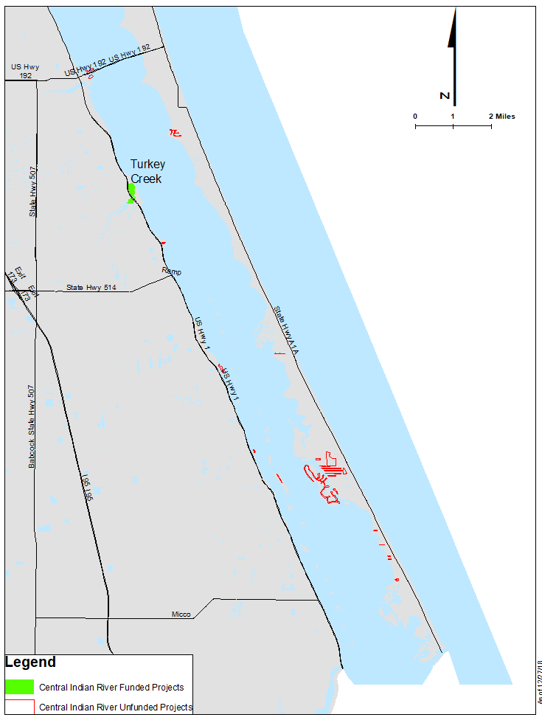
Figure 4-28: Location of Muck Removal Projects in Central IRL
Figure 4-28 Long Description

Treatment of Muck Interstitial Water
Interstitial water refers to the water content that is present within the muck material. Sampling and testing conducted by Florida Institute of Technology researchers has shown that the majority of nutrients are bound to solid particles in the muck; however, the interstitial water also contains a significant amount of dissolved nutrients. When the muck material is dredged, interstitial water nutrients are pumped with the muck and lagoon water in a slurry to the dredged material management area. At the dredged material management area, the muck slurry is processed in a settling pond where sediments settle out and overflow water is returned to the Indian River Lagoon (IRL). Treatment of this overflow water represents a significant opportunity to prevent return of these nutrients to the IRL.
Working with the dredging industry, sewage treatment industry, stormwater treatment entrepreneurs and industrial waste treatment engineers, feasible and reasonably cost-effective concentration targets for return water to the IRL were initially identified as 2,000–3,000 parts per billion for total nitrogen (TN) and 75–100 parts per billion for total phosphorus (TP). Treatment options for TP were demonstrated during the state-funded initial dredging of Turkey Creek, with Florida Institute of Technology researchers providing independent third-party verification of performance levels. These targets can be achieved through a variety of technologies including, but not limited to, coagulants, polymers, biosorption activated media, or a combination of these technologies. Costs associated with these technologies vary by technology, target nutrient reduction levels, and interstitial nutrient concentrations. Open market costs were initially collected through three bid solicitations: (1) Mims Boat Ramp muck removal project, (2) Sykes Creek muck removal project, and (3) Grand Canal muck removal project. More recent dredging experience indicates that concentration targets for TN may need to be adjustable and procured as bid options or alternates to allow market conditions to identify what targets are most cost-effective.
To encourage partnering entities and applicants for Save Our Indian River Lagoon Trust Fund dollars to take advantage of this opportunity to enhance the performance of muck removal projects by removing interstitial water nutrients from the dredge slurry during muck dredging operations whenever project configuration allows, a separate cost-share was developed to account for this added cost and associated nutrient reduction benefit. Using available cost information from Turkey Creek, Mims, and Sykes Creek, County staff considered how to incentivize the addition of this processing step as soon as possible into permitted muck removal projects, as well as future projects. When the substitute project request form was distributed to the public in 2018, staff estimated that a cost-share of $200 per pound of TN removed would be sufficient to entice most partners to agree to stipulate a specific condition in their bids and dredging contracts that return water not exceed 3,000 parts per billion of TN nor 100 parts per billion of TP. However, based on recent bids for nutrient mitigation alternatives for sediment dewatering for Sykes Creek (Tetra Tech, 2015), Grand Canal, and Mims, the cost-share used for Brevard County projects in the 2019 Update was reduced to $50 per pound of TN removed. This cost will remain volatile until a contractor meets the concentration targets long enough to determine cost more accurately.
The recommended locations for interstitial water treatment and load reductions are shown in Table 4-31.
Table 4-31: Projects for Treatment of Interstitial Water
Year Added | Project Number | Project Name | Responsible Entity | Sub-lagoon | Total Nitrogen Reduction (pounds per year) | Cost per Pound per Year of Total Nitrogen Removed | Total Phosphorus Reduced (pounds per year) | Cost per Pound per Year of Total Phosphorus Removed | Plan Funding
2017 | 40 | Mims Muck Removal: Outflow Water Nutrient Removal+* | Brevard County | North IRL | 2,803 | $143 | 244 | $1,639 | $400,000
2018 | 2016-10b | Canaveral South+ | Brevard County | Banana | 42,688 | $50 | 3,887 | $549 | $2,134,419
2018 | 2016-5b | Pineda Banana River Lagoon+ | Brevard County | Banana | 19,820 | $50 | 1,804 | $549 | $990,980
2018 | 2016-11b | Patrick Space Force Base+ | Brevard County | Banana | 20,836 | $50 | 1,897 | $549 | $1,041,800
2018 | 168b | Cocoa Beach Golf+^ | Brevard County | Banana | 99,098 | $30 | 9,022 | $334 | $3,013,100
2018 | 41b | Grand Canal+# | Brevard County | Banana | 89,495 | $174 | To be determined | To be determined | $15,610,821
2018 | 42b | Sykes Creek+ | Brevard County | Banana | 64,278 | $175 | To be determined | To be determined | $11,248,704
2018 | 2016-06b | Titusville Railroad West+ | Brevard County | North IRL | 9,148 | $50 | 833 | $549 | $457,375
2018 | 2016-07b | National Aeronautics and Space Administration Causeway East+ | Brevard County | North IRL | 28,967 | $50 | 2,637 | $549 | $1,448,355
2018 | 2016-04b | Rockledge A+ | Brevard County | North IRL | 12,705 | $50 | 1,157 | $549 | $635,244
2018 | 2016-08b | Titusville Railroad East+ | Brevard County | North IRL | 11,688 | $50 | 1,064 | $549 | $584,424
2018 | 54b | Eau Gallie Northeast+ | Brevard County | North IRL | 25,410 | $50 | 2,313 | $549 | $1,270,487
2018 | 2016-3b | Muck Interstitial Water Treatment for Turkey Creek+ | Brevard County | Central IRL | Not applicable | Not applicable | 688 | Not applicable | Part of dredging cost
2018 | 72b | Muck Interstitial Water Treatment for Indian Harbour Beach Canals+ | City of Indian Harbour Beach | Banana | 27,418 | $200 | To be determined | To be determined | $5,483,600
2020 | 113 | Satellite Beach Interstitial Water Treatment+ | City of Satellite Beach | Banana | 29,978 | $102 | 3,059 | $1,000 | $3,057,756
- | - | Total | - | - | 484,332 | $98 (average) | 28,605 | $1,656 (average) | $47,377,065
Note: The projects highlighted in tan and marked with a plus sign were added to the plan as part of an annual update.
* Outflow Water Nutrient Removal for the Mims Muck Removal project was funded, bid, and awarded to the lowest successful bidder; however, the contractor was unsuccessful at reducing outflow water nutrient concentrations as much as required by the contract. Therefore, only partial reductions were achieved and the Save Our Indian River Lagoon 0.5 cent sales tax funding was not used.
^ The Cocoa Beach Golf project is not fully funded at this time. A total of $3,013,100 is available and Brevard County is looking for options to fund the remaining $1,941,800.
# In 2021, contingency funding was approved to add Berkeley Canal to the Grand Canal project.

Spoil Management Areas
As Brevard County (County) seeks to execute muck dredging projects, the availability of upland processing areas for the treatment of dredge spoils has become a growing concern. These working sites, referred to as temporary spoil management areas or in the industry as dredged material management areas, are upland parcels of land that can be used as needed for the temporary processing of dredge spoils until such time as the materials can be moved offsite to a permanent beneficial use or disposal location.
To move muck dredging projects forward in a timely manner, initial project locations were selected to make use of existing dredged material management areas through the County’s long-standing partnership with the Florida Inland Navigation District. The Florida Inland Navigation District manages Florida’s Intracoastal Waterway for which it has acquired eight dredged material management area sites distributed from north to south along the 72 miles of the Indian River Lagoon (IRL), not the Banana River, in Brevard County. Only three of these Florida Inland Navigation District dredged material management areas are presently developed; however, the County is working on partnership agreements with the Florida Inland Navigation District to construct dredged material management area facilities at their remaining sites.
The eight Florida Inland Navigation District sites are insufficient to meet the volume and timing of muck dredging projects included in this plan. As the distance between dredging sites and dredged material management areas increase, more booster pumps are required. Booster pumps can complicate project operations and increase cost, particularly as multiple boosters become necessary. Booster pumps are required as project pump distances approach one-mile and are required at one-mile intervals thereafter. Each booster pump adds approximately $1 per cubic yard of material dredged. Pump distances for the Eau Gallie and Sykes Creek projects have five- to seven-mile pump distances to the Florida Inland Navigation District sites and project amounts in excess of 400,000 cubic yards each.
As a supplement to the Florida Inland Navigation District sites, Brevard County staff investigated lease and purchase options for the development of additional multi-use spoil management areas. Lease options for parcels of interest resulted in unfavorable cost-benefit ratios on these short-term investments due to the up-front costs of site development including design, permitting, mitigation, and construction. Similar cost effectiveness issues arise from depending on private sector contractors to provide a temporary dredged material management area as part of construction costs. The contractor passes along most or all the costs of providing a dredged material management area, but the County does not have the benefit of using the site multiple times over the 10-year timespan of this plan or thereafter.
Fee simple purchase and development of spoil management areas, designed with multi-use options for the implementation of regional surface water or stormwater treatment projects, emerges as the most cost-effective long-term option. Through fee simple site acquisition and a prescribed site use and management plan, investments in acquisition and development costs, including required mitigation, can be recovered. For example, the acquisition of a spoil management site four miles closer than the nearest Florida Inland Navigation District site could reduce booster pump costs by $1.6 million on a single 400,000 cubic yard muck removal project. This savings can offset site acquisition and development costs associated with the parcel.
Publicly owned dredged material management area sites could be used for stormwater or surface water treatment, when not being used for dredging. These additional uses can be factored into site selection and design to provide supplementary lagoon benefits. Therefore, land acquisition shall be considered an eligible muck management project cost, particularly when the site can be designed to provide multi-use regional surface water or stormwater treatment alongside or intermittently between usages for muck management. A preliminary project design and construction layout with cost evaluation (comparison to an existing, more distant dredged material management area) shall be part of the site selection and land acquisition decision process.
Another factor to consider when evaluating long-term operations and the feasibility of muck dredging projects is the strategy for final disposal and the development of permanent beneficial use or disposal locations. Often left to the contractor as part of their construction and implementation plan, a final disposition strategy is in many cases not part of the dredging project plan. The dependency on private sector contractors to provide a final disposition strategy and permanent material disposal site can have consequences that a managed permanent disposal site can avoid. These consequences can increase the contractor’s risk and drive up project costs.
A managed disposal site would consider the fiscal, environmental, and social implications of the site. A final disposition strategy evaluates the appropriateness of the disposal site in terms of the local community and future development, the environmental proximity to surface waters and runoff potential, groundwater protection, hauling costs, and minimizing risk by providing a defined disposal site. A defined material disposal site, laid-out in the project design, provides a level of security at the time of project bidding that reduces risk to the contractor and potentially lowers the project cost. Staff investigation into the purchase, use and reclamation of existing borrow pits are an example of final disposal areas that are being considered. Similar to what is seen with the development of temporary spoil management areas, the most cost-effective long-term option for the disposal of muck material should include the evaluation of fee simple purchase options and the development of spoil disposal areas.

Surface Water Remediation System
In 2016, AquaFiber Technologies Corporation had a technology that could treat up to 25 cubic feet per second (16 million gallons per day) of water from Turkey Creek, which is a major tributary to the Central Indian River Lagoon (IRL). This project would reduce total suspended solids by more than 90%, remove algal blooms and cyanobacteria to improve the lagoon’s color and clarity, improve the dissolved oxygen concentration by returning water with near 100% oxygen saturation, and produce a biomass that can be processed into fertilizer pellets or used as a feedstock for waste-to-energy utilities to produce electricity.
This project would remove an estimated 35,633 pounds per year of total nitrogen (TN) and 2,132 pounds per year of total phosphorus (TP) from the watershed. The facility would cost $19,720,760 for design, permitting, construction, and use of a technology to destroy the biomass onsite. The cost to operate and maintain the remediation facility is estimated to be $6,271,200 per year. Table 4-32 summarizes the benefits and costs of nutrient removal for this project for a 10-year period. On an annual basis, the yearly costs would be $8,243,276, which would result in an annual cost per pound per year of TN removed of $231 and cost per pound per year of TP removed of $3,867.
Brevard County also received information from Phosphorus Free Water Solutions, which has a pay for performance treatment technology to reduce phosphorus, nitrogen, color, and turbidity in surface waters. Phosphorus Free evaluated a project to treat 50 cubic feet per second of water from Turkey Creek. Based on the measured concentrations in Turkey Creek, Phosphorus Free Water Solutions provided two options for treating nitrogen. The measured phosphorus concentration in Turkey Creek is very low and it would not be cost-effective to remove additional phosphorus from the system through this technology. The first option would use the basic nitrogen removal process, which would remove a portion of the dissolved organic nitrogen. This option would reduce TN by 53% or 50,353 pounds per year at a cost of $6,797,000 or $135 per pound of TN removed. The second option would include an additional treatment step to increase the removal of dissolved organic nitrogen. This option would reduce TN by 86% or 81,469 pounds per year at a cost of $13,035,000 or $160 per pound of TN removed (Table 4-32). The costs for each scenario do not include the capital costs to construct the treatment facility, only the annual pay for performance cost estimates for a ten-year contract for treatment.
Table 4-32: Summary of Annual Benefits and Ten-Year Costs of a Surface Water Remediation System
Project | Ten-Year Project Cost | Total Nitrogen Reduction (pounds per year) | Cost per pound per Year of Total Nitrogen Removed | Total Phosphorus Reduction (pounds per year) | Cost per Pound per Year of Total Phosphorus Removed
AquaFiber | $82,432,760 | 35,633 | $2,313 | 2,132 | $38,665
Phosphorus Free Option 1 | $67,970,000 | 50,353 | $1,350 | To be determined | To be determined
Phosphorus Free Option 2 | $130,350,000 | 81,469 | $1,600 | To be determined | To be determined
These technologies have not yet been tested in estuarine systems; therefore, these remediation systems are not recommended at this time. However, these types of treatment technologies offer additional benefits that should be more thoroughly explored to better assess the total value to restoring and maintaining lagoon health. In 2020, Brevard County received a grant to collaborate with AquaFiber Technologies Corporation to pilot test their surface water remediation technologies. Unfortunately, AquaFiber had to cancel the project due to COVID-19 related economic hardships. Brevard County continues to investigate potential surface water remediation technologies and a portion of the Respond funding may be used to incentivize pilot testing. As feasible technologies are proven, projects may be added to future plan updates.

Enhanced Circulation
The 2011 superbloom occurred in the Banana River Lagoon, North Indian River Lagoon (IRL), and southern Mosquito Lagoon. These areas have long residence times, which means that water in these areas stagnates and nutrients can build up leading to additional algal blooms. Options to address this condition are to increase circulation by replacing causeways with bridges, installing culverts under causeways, or increasing ocean exchange by adding culverts, pump stations, or inlets to provide new connections to the ocean. Addressing manmade causeways that interfere with natural circulation should be beneficial without unintended consequences and modeling can help prioritize actions, but implementation is costly and requires participation by the Florida Department of Transportation.
New artificial ocean exchange projects introduce a lot of unknowns. While the residence time of water in the IRL system would decrease, the input ocean water with its complement of marine life has the potential to alter the lagoon ecosystem. Whether the amount of ocean exchange needed to have a beneficial impact on the system can be achieved without causing unintended harm to the lagoon is unknown. Artificial ocean exchange projects are costly with significant social implications and permitting hurdles to overcome. For these reasons, causeway replacements are encouraged while ocean exchange projects are not a recommended component of this plan. Other entities are taking the lead on evaluating options. The results of evaluations by the St. Johns River Water Management District and the IRL National Estuary Program are summarized below.
The St. Johns River Water Management District contracted with CDM Smith and Taylor Engineering to identify potential locations where enhanced circulation projects would be beneficial. The first phase of the project (CDM Smith et al., 2014) involved a literature review and geographic information system desktop analysis. All the locations considered in Phase I, including the top ranked locations, are shown in Figure 4-29. From this first phase, ten locations were identified for future evaluation as shown in Table 4-33. The external projects are those that could potentially connect the IRL system with the Atlantic Ocean whereas internal projects are connections within the IRL (CDM Smith et al., 2015).
Table 4-33: Phase I Top Ranked Potential Enhanced Circulation Project Locations
Project Site | Project Description | Zone | Project Type | Rank
D | Canaveral Lock* | Banana River Lagoon | External | 1
C | Port Canaveral* | Banana River Lagoon | External | 2
15 | Sykes Creek/Merritt Island Causeway* | Banana River Lagoon | Internal | 3
B | Pad 39-A* | Banana River Lagoon | External | 4
16 | Cocoa Beach Causeway | Banana River Lagoon | Internal | 5
23 | South Banana River | Banana River Lagoon | Internal | 6
E | Patrick Air (Space) Force Base * | Banana River Lagoon | External | 7
20 | Minuteman Causeway | Banana River Lagoon | Internal | 8
1 | Port Canaveral (East) | Banana River Lagoon | External | 9
8 | Coconut Point Park* | Central and Southern Portion of IRL Study Area | External | 10
Source: CDM Smith et al., 2015.
* Sites evaluated in Phase 2 of the CDM Smith and Taylor Engineering project for the St. Johns River Water Management District.
As part of the second phase of the project, six of the top ranked sites were further evaluated to assess the water volumes. These sites are noted in Table 4-33. Based on the initial evaluation of the sites, CDM Smith and Taylor Engineering determined that a project at the Sykes Creek/Merritt Island Causeway was not feasible. This location had a relatively new bridge crossing with built-up abutment protection that precludes construction of culverts and the increase of bridge openings. In addition, this connection would only provide an internal connection in the IRL and would not increase the tidal exchange. The five remaining sites were evaluated for the following types of connections (additional information in Table 4-34):
- Port Canaveral (Project Site C) – Culvert connection
- Pad 39-A (Project Site B) – Culvert connection
- Patrick Air (Space) Force Base (Project Site E) – Culvert connection
- Canaveral Lock (Project Site D) – Open channel flow by keeping the Canaveral Lock open over extended periods. Additional maintenance dredging may be needed to remove sediment deposition near the gates.
- Coconut Point Park (Project Site 8) – Culvert connection
- Coconut Point Park (Project Site 8) – Inlet connection with an inlet that is at least 1,350-feet long, with an average depth of about 25 feet below mean sea level.
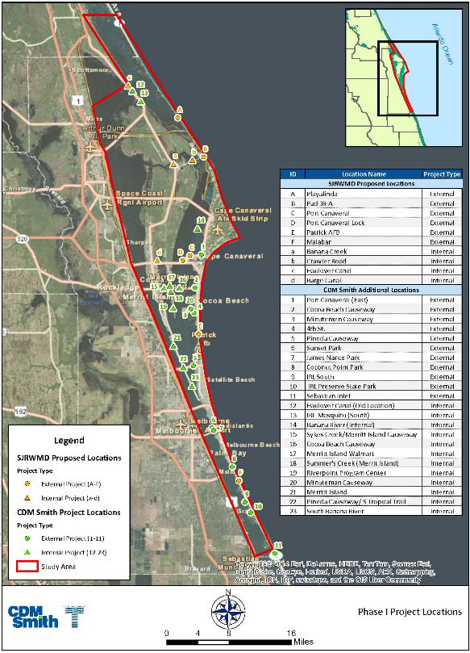
Source: CDM Smith et al., 2015.
Figure 4-29: Phase I Potential Enhanced Circulation Project Locations
Figure 4-29 Long Description
Table 4-34: Computed Hydraulics for Connections at Select Locations
Site/Potential Project | Flood Prism (million cubic feet) | Ebb Prism (million cubic feet) | Maximum Flow (cubic feet per second) | Estimated Impacted Area for 0.27 Foot Tide Range (acres)
Port Canaveral Culvert (Project Site C) | 1.51 | -1.08 | 89 | 92 to 128
Pad 39-A Culvert (Project Site B) (estimated) | 1.38 to 1.51 | -1.08 to -1.59 | Not applicable | 92 to 135
Patrick Air (Space) Force Base Culvert (Project Site E) (estimated) | 1.38 to 1.51 | -1.08 to -1.59 | Not applicable | 92 to 135
Canaveral Lock Open Channel Flow (Project Site D) | 68.67 | -83.03 | -4,670 | 5,839 to 7,060
Coconut Point Park Culvert (Project Site 8) | 1.38 | -1.59 | -94 | 117 to 135
Coconut Point Park Inlet (Project Site 8) | 1,890 | Not applicable | 111,000 | 160,698
Source: CDM Smith et al., 2015.
Note: Positive flow is towards the IRL.
A screening matrix was used to evaluate the costs and benefits of the project based on the criteria for the tidal prism, area affected, land acquisition, relative costs, ease of construction, seagrass loss, and benefit to cost ratio. The top ranked project from this evaluation is the Port Canaveral culvert (CDM et al., 2015). It is important to note that a culvert will likely not provide the amount of exchange needed to provide a significant benefit to the lagoon. The size of the lagoon in Brevard County is more than 150,000 acres. The second ranked project is the Canaveral Lock open channel. This option may have challenges moving forward based on past experience with sediment blocking submarines from using the port after the lock was held open for an extended period of time. In addition, there are limited data for estimating the water quality benefits and unintended ecological consequences that could result from keeping the lock open.
In 2019, the Florida Institute of Technology received $800,000 in funding from the Florida Legislature, which is administered by the Florida Department of Education, to plan and perform studies at sites within the lagoon and along the coast to restore lagoon inflow. The first phase of the study gathered baseline data and performed modeling on existing water quality, biological parameters, and hydrologic conditions at potential locations for future temporary permitted inflow test structures. The Phase 1 modeling and engineering project research was conducted in parallel with the biological and water quality monitoring to gather data for an enhanced circulation pilot project. The first phase of the project was completed in September 2020. Phase 1 provided baseline biological and geochemical data near the three proposed inflow locations: Port Canaveral and south Cocoa Beach in Brevard County and Bethel Creek in Indian River County. Modeling results were provided for different flow rates in each location based on preliminary engineering concepts for three structure options: pipe with no pump, pump and pipe, and weir (Florida Institute of Technology, 2020).
In 2020, the Florida Institute of Technology received another $752,000 in funding from the Florida Legislature, which was also administered by the Florida Department of Education, for Phase 2 of the study. Phase 2 identified the most feasible and cost-effective location for a temporary inflow pilot system in the Banana River Lagoon within a cove that would receive inflow from the ocean side of the Port Canaveral lock system. Engineering design for a 0.5 cubic meter per second pumping system was completed, and pre-application meetings were held with the permitting agencies. This phase also included additional water quality, geochemical, and biological monitoring to build a baseline conditions database, and updated models to predict changes due to the pilot inflow. Phase 2 was completed in September 2021. Future proposed project phases include permitting and constructing the pilot inflow system, which would be operated for a one-year period to gather data to help determine the feasibility of a permanent inflow project (Florida Institute of Technology, 2021).
Temporary Inlet: Another potential option for ocean exchange is when a large storm creates an opening. Instead of immediately filling in the new opening, an evaluation should be completed using available models to determine the potential benefits of temporarily stabilizing the opening long enough to provide significant ocean exchange for short-term water quality benefits, but not long enough to excessively alter beach erosion and sand transport into the lagoon.
Causeway Modification: In 2018, the IRL National Estuary Program, in partnership with the Canaveral Port Authority, worked with the Florida Institute of Technology to assess the potential for modifications of the State Road 528 and State Road 520 causeways and bridge structures to enhance circulation in the northern portion of the Banana River Lagoon and adjacent North IRL. The Florida Institute of Technology used the United States Army Corps of Engineers Coastal Modeling System for this evaluation (Zarillo, 2018).
The model was set up to reproduce the physical conditions of 2015 to ensure the model was well calibrated. Measured data, including water levels, freshwater inflows, wind velocity, and topography, were used to drive the model. Nine model tests were performed to represent current conditions and scenarios with hypothetical bridge spans over the Banana River Lagoon and North IRL. Three of the model tests included flow relief structures embedded in the State Road 528 and State Road 520 causeways. The tests were run using numerical tracer dye concentration throughout the model domain to track the dye concentration reduction throughout the model simulation. Circulation in the model occurred through ocean exchanges though the Sebastian Inlet, freshwater inflows, and wind (Zarillo, 2018).
The model results indicated that modifying the bridge and causeway structures would have a detectible influence on exchange rates within the Banana River Lagoon and North IRL. Longer bridge spans over the Banana River Lagoon along State Road 528 combined with longer bridge spans over State Road 520 resulted in a 10% net reduction in the dye concentration in the Banana River Lagoon between State Road 528 and State Road 520 at the end of the 340-day model run. The net improvement in exchange in the Banana River Lagoon immediately to the north of State Road 528 was predicted to be 5% if bridge spans are present on both state roads. The study concluded that a significant improvement in exchange in the Banana River Lagoon study area and adjacent North IRL would require bridge spans on both State Road 520 and State Road 528 (Zarillo, 2018).
In 2019, Dr. Zarillo expanded his circulation model to include Mosquito Lagoon and the ocean inlet at New Smyrna instead of a closed boundary at Haulover Canal. This expanded model was run again to estimate the impact of causeways on residence time in various compartments of the IRL. In this study, longer bridge spans over the Banana River Lagoon along State Road 528 and State Road 520 resulted in a 17% net reduction in the dye concentration in the Banana River Lagoon between State Road 528 and State Road 520 at the end of the 340-day model run. The net improvement in exchange in the Banana River Lagoon immediately to the north of State Road 528 was predicted to be 8% and exchange within Sykes Creek improved by 20% (Zarillo, 2019).
In response to the 2019 model results, the St. Johns River Water Management District offered to use their state-of-the-art ecological modeling tools to quantify water quality improvements and algal bloom reductions anticipated from the proposed causeway modifications. At the request of Brevard County, Port Canaveral, and IRL National Estuary Program, the Florida Department of Transportation agreed to pause their causeway widening project for six months until the ecological impacts could be estimated and evaluated. The modeling results confirmed the improvement in residence time identified in Dr. Zarillo's modeling but found little corresponding change in chlorophyll a concentrations (St. Johns River Water Management District, 2020).

Projects to Restore the Lagoon
Another component of this plan is to implement projects that will restore important, filtering ecosystem services within and adjacent to the lagoon to improve water quality and resilience. Oyster reefs provide ecosystem services including improved water quality, shoreline stabilization, carbon burial, and habitat (Grabowski et al., 2012). Creating oyster bars and planting shorelines with natural vegetation will help to filter excess nutrients and suspended solids from the lagoon (Grizzle et al., 2008; Reidenbach et al., 2013), which will improve water quality, allowing for seagrass growth (Newell and Koch, 2004) and may reduce the number and severity of algal blooms in the lagoon system. Oyster bars and planted shorelines also create habitat for more than 300 different lagoon species. These types of projects take years before the full benefits are seen in the lagoon as it takes some time for the oysters and vegetation to grow and become established.
The sections below summarize the oyster restoration and planted shoreline projects that are proposed, as well as considerations for seagrass planting.

Oyster Restoration
The primary mechanism by which oyster bars remove nitrogen is by increasing local denitrification rates.
In addition to the fisheries value of oysters, they provide a variety of nonmarket ecosystem services, with a combined estimated economic value between $5,500 and $99,000 per hectare per year (Grabowski et al., 2012). Restored oyster bars have been shown to result in a positive net effect on the removal and sequestration of nitrogen compared to unrestored sites. As nitrogen is a major contributor to algal blooms and resulting increased turbidity, removal of nitrogen from the system often yields water quality benefits. The nitrogen is removed through three pathways: (1) assimilation of the nitrogen in the shell and tissues of the oysters, (2) enhanced burial of nitrogen into the sediments surrounding oyster bars, and (3) conversion to gaseous form with return to the atmosphere through microbe-related denitrification (zu Ermgassen, 2016).
The primary mechanism by which oysters remove nitrogen from the system is by increasing local denitrification rates (Grabowski et al., 2012). While the impacts of oyster bars may be localized, they also influence the larger ecosystem. For example, a study by Sharma et al. (2016) found that even with limited bio-filtration and nonsignificant reef effects on water velocity, there was a “shadow” effect on seagrass beds between the reef and shoreline, which resulted in higher localized seagrass area five years after deployment relative to other nearby areas. Further, in a study by Kroeger (2012), it was noted that the eastern section of Mobile Bay had experienced harmful algal blooms that caused fish kills. These conditions occur in the summer months when denitrification by restored oysters would be highest. Therefore, the nitrogen removal associated with the oyster bar project in the bay may make a noticeable contribution to the local water quality by avoiding peak nitrogen concentrations that may trigger algal blooms. In a study by Kellogg et al. (2013), the denitrification rates associated with oyster bars from various studies were documented. Based on these studies, the average denitrification rate is 159.3 pounds of total nitrogen (TN) per acre per year (291 micromoles of TN per square meter per hour, which equates to 0.04 pounds of TN per square meter per year). A 2017 study was also conducted in the Mosquito Lagoon to determine the local benefits from oyster bed restoration. This study found that the average denitrification rate is 401.5 pounds of TN per acre per year (450 kilograms of TN per hectare per year) and measured nitrogen sequestration in oyster tissues and shells is 0.04 pounds of TN per square foot, which equates to 4,741.1 pounds of TN per acre per year (Schmidt and Gallagher, 2017).
The focus for oyster restoration in the Indian River Lagoon (IRL) system is to provide filtration, sequestration, denitrification, and scour protection along the shoreline (see Section 4.3.2 for details on scour protection). The goal is not to restore historical oysters in the system because limited information is available on where oysters were historically located. In addition, seagrasses are a more critical component of the system, so restoration efforts aim to use the beneficial aspects of oysters in protecting seagrass from waves and increasing light availability (Newell and Koch, 2004) while minimizing the competition for space. Therefore, sites are evaluated for relative seagrass and oyster habitat requirements such as salinity, depth, and bottom type. In October 2021, Brevard County adopted an Oyster Habitat Suitability and Rehabilitation Success Plan, which details environmental and biological targets to guide site selection for oyster bar projects, outlines adaptive management strategies, and defines related success criteria. Oyster bars may be constructed in submerged areas deeper than seagrass, in areas without an historic persistence of seagrass presence, or as narrow bars along the shoreline to act as a living wave break to reduce erosion.
The oysters from the Oyster Gardening Program have been used to develop several pilot bars and demonstration sites in the IRL. In fiscal year 2014–2015, Brevard County received a $410,000 appropriation from the Florida Legislature for the Indian River Lagoon Oyster Restoration Project. This pilot study was completed in fall 2016. The design of oyster wave breaks funded by the Save Our Indian River Lagoon tax is based on monitoring results from the pilot bars and wave tank studies at Florida Institute of Technology that tested the oyster bar stability and wave attenuation of different designs. From these studies the importance of reef location and seasonal water depth (Anderson, 2016) as well as the ability of the reef to act as a wave break (Weaver et al., 2017) were highlighted.
To create enough oyster bar area to filter the volume of lagoon water annually, approximately 20 miles (105,600 feet) of oyster bars is needed at a width of six feet. These bars will be placed throughout the IRL system, at sites that meet Habitat Suitability selection criteria, along mosquito impoundments, parks, and private properties where owners want to participate. Based on the pilot project costs and knowing that larger bars will be constructed more efficiently (using information from the pilot projects), it was estimated that the 20 miles of oyster bars could be constructed at a cost of $10 million.
With the recent study on oyster bars in the IRL system (Schmidt and Gallagher, 2017), the benefits associated with oyster bars versus planted shorelines could be delineated. For the proposed oyster bar along 20 miles (105,600 feet) of shoreline with a width of six feet (total of 633,600 square feet), the estimated reductions are 25,344 pounds per year of TN and 906 pounds per year of total phosphorus (TP). These estimates are based on the estimated TN reduction rate of 0.04 pounds of TN per square foot of oyster bar from Schmidt and Gallagher 2017 and the estimated TP reduction rate of 0.001 pounds of TP per square foot of oyster bar from Kellogg et al. (2013). The projects for oyster bar restoration are summarized in Table 4-35.
Table 4-35: Projects for Oyster Restoration
Year Added | Project Number | Project Name | Responsible Entity | Sub-lagoon | Total Nitrogen Reduction (pounds per year) | Cost per Pound per Year of Total Nitrogen Reduction | Total Phosphorus Reduction (pounds per year) | Cost per Pound per Year of Total Phosphorus Reduction | Plan Funding
Original | 2016-55 | Banana River Lagoon Oyster Bars* | Brevard County | Banana | 7,864 | $395 | 197 | $15,750 | $3,102,755
Original | 2016-56 | North IRL Oyster Bars* | Brevard County | North IRL | 7,314 | $395 | 183 | $15,770 | $2,885,834
2018 | 75 | Marina Isles Oyster Bar+ | Brevard Zoo | Banana | 60 | $445 | 20 | $1,335 | $26,700
2018 | 76 | Bettinger Oyster Bar+ | Brevard Zoo | Banana | 24 | $445 | 8 | $1,335 | $10,680
2018 | 78a | McNabb Park Oyster Bar+ | City of Cocoa Beach | Banana | 72 | $473 | 24 | $1,419 | $34,056
2018 | 79 | Gitlin Oyster Bar+ | Brevard Zoo | Banana | 36 | $445 | 12 | $1,335 | $16,020
2018 | 80 | Coconut Point/Environmentally Endangered Lands Oyster Bar+ | Brevard Zoo | Central IRL | 96 | $470 | 2 | $22,560 | $45,120
2018 | 81 | Wexford Oyster Bar+ | Brevard Zoo | Central IRL | 70 | $445 | 24 | $1,298 | $31,150
2018 | 82a | Riverview Park Oyster Bar+ | City of Melbourne | Central IRL | 230 | $473 | 78 | $1,395 | $108,790
2018 | 83 | Bomalaski Oyster Bar+ | Brevard Zoo | North IRL | 20 | $445 | 7 | $1,271 | $8,900
2018 | 73 | Riverview Senior Resort Oyster Bar+ | Brevard County | Central IRL | 77 | $394 | 2 | $15,152 | $30,304
2019 | 104 | Brevard Zoo Banana River Oyster Project+ | Brevard Zoo | Banana | 1,476 | $395 | 37 | $15,757 | $583,020
2019 | 105 | Brevard Zoo Central IRL Oyster Project+ | Brevard Zoo | Central IRL | 408 | $395 | 10 | $16,116 | $161,160
2019 | 106 | Brevard Zoo North IRL Oyster Project+ | Brevard Zoo | North IRL | 864 | $395 | 22 | $15,513 | $341,280
2020 | 139 | Brevard Zoo North IRL Oyster Project 2+ | Brevard Zoo | North IRL | 841 | $400 | 21 | $16,019 | $336,400
2020 | 140 | Brevard Zoo Central IRL Oyster Project 2+ | Brevard Zoo | Central IRL | 677 | $400 | 17 | $15,929 | $270,800
2020 | 141 | Brevard Zoo Banana River Oyster Project 2+ | Brevard Zoo | Banana | 662 | $400 | 17 | $15,576 | $264,800
2020 | 142 | Brevard Zoo Oyster Reef Adjustments North IRL+ | Brevard Zoo | North IRL | 68 | $400 | 2 | $13,600 | $27,200
2020 | 143 | Brevard Zoo Oyster Reef Adjustments Banana River+ | Brevard Zoo | Banana | 32 | $400 | 1 | $12,800 | $12,800
2021 | 184 | Brevard Zoo North Indian River Lagoon Oyster Project 3+ | Brevard Zoo | North IRL | 1,056 | $397 | 26 | $16,124 | $419,232
2021 | 185 | Brevard Zoo Central Indian River Lagoon Tributary Pilot Oyster Project+ | Brevard Zoo | Central IRL | 581 | $397 | 15 | $15,377 | $230,657
2021 | 186 | Brevard Zoo North Indian River Lagoon Individual Oyster Project+ | Brevard Zoo | North IRL | 436 | $397 | 11 | $15,736 | $173,092
2021 | 187 | Brevard Zoo Central Indian River Lagoon Oyster Project 3+ | Brevard Zoo | Central IRL | 218 | $397 | 5 | $17,309 | $86,546
2021 | 188 | Brevard Zoo Banana River Oyster Project 3+ | Brevard Zoo | Banana | 143 | $397 | 4 | $14,193 | $56,771
2022 | 217 | Central IRL Oyster Project 4+ | Brevard Zoo | Central IRL | 348 | $397 | 9 | $15,351 | $138,156
2022 | 218 | Central Oyster Project Offshore Reefs+ | Brevard Zoo | Central IRL | 900 | $397 | 23 | $15,535 | $357,300
2022 | 226 | Hog Point Offshore Oyster Bar+ | Brevard County | Central IRL | 126 | $397 | 3 | $16,674 | $50,022
- | - | Total | - | - | 24,699 | $397 (average) | 780 | $12,576 (average) | $9,809,545
Note: The projects highlighted in green and marked with an asterisk were identified in the original plan. The projects highlighted in tan and marked with a plus sign were added to the plan as part of an annual update. As specific project locations are added each year, the amount of funding for the original projects is reduced accordingly to keep the total funding allocation constant for projects that restore natural filtration processes (including oyster, clam, and planted shoreline projects).

Planted Shorelines
Typically, efforts to protect shorelines have involved hardened structures, such as seawalls, rock revetments, or bulkheads, to dampen or reflect wave energy. Although these types of structures may mitigate shoreline retreat, they accelerate scour and the ecological damages that result can be great (Scyphers et al., 2011). The planted shoreline approach incorporates natural habitats into a shoreline stabilization design; maintains the connectivity between aquatic, intertidal, and terrestrial habitats; and minimizes the adverse impacts of shoreline stabilization on the estuarine system. These efforts range from maintaining or transplanting natural shoreline vegetation without additional structural components to incorporating shoreline vegetation with hardened features, such as rock sills or oyster bars, in settings with higher wave energy (Currin et al., 2010). Selection of the most appropriate management system begins with a site analysis to evaluate the type of shoreline, amount of energy that a shoreline experiences, sediment transport forces, type and location of ecological resources, and adjacent land uses (Restore America’s Estuaries, 2015).
Oyster bars can function as natural breakwaters, in addition to providing nutrient removal benefits through denitrification, as noted in Section 4.3.1. The rate of vertical oyster bar growth on unharvested bars (2–6.7 centimeters per year) is greater than predicted sea-level rise rate (2–6 millimeters per year); therefore, bars could serve as natural protection against shoreline erosion, shoreline habitat loss, and property damage and loss along many estuarine shorelines (Ridge et al., 2017). Oyster bars reduce erosion of other estuarine habitats such as salt marshes and submerged aquatic vegetation by serving as a living breakwater that attenuates wave energy and stabilizes sediments (Grabowski et al., 2012).
As part of a study for the Chesapeake Bay, Forand et al. (2014) evaluated the pollutant load reductions from planted shoreline projects in the area. The results of this evaluation are shown in Table 4-36, and were used to update the United States Environmental Protection Agency Chesapeake Bay Program Office estimate of the total nitrogen (TN) and total phosphorus (TP) reductions per foot of planted shoreline. The estimated nutrient reductions from planted shorelines can be calculated using Chesapeake Bay Program Office recommended rates of 0.2 pounds of TN per linear foot and 0.068 pounds of TP per linear foot (Forand et al., 2014.), which is for an average planting width of 24 feet. These values were adjusted for the proposed average planting width of eight feet, which results in a reduction of 0.067 pounds of TN per linear foot and 0.023 pounds of TP per linear foot.
Table 4-36: Pollutant Load Reductions for Shoreline Management Practices
Source | Total Nitrogen (pounds per foot per year) | Total Phosphorus (pounds per foot per year) | Study Location
Ibison, 1990 | 1.65 | 1.27 | Virginia
Ibison, 1992 | 0.81 | 0.66 | Virginia
Proctor, 2012 | Not applicable | 0.38 or 0.29 | Virginia
Maryland Department of the Environment, 2011 | 0.16 | 0.11 | Maryland
Baltimore County mean (Forand, 2013) | 0.27 | 0.18 | Maryland
Chesapeake Bay Program Office Scenario Builder, 2012 | 0.02 | 0.0025 | Chesapeake Bay Program policy threshold from one restoration site
New Interim Chesapeake Bay Program Office Rate (Expert Panel, 2013) | 0.20 | 0.068 | Chesapeake Bay Program Office policy thresholds that comes from six stream restoration sites
Note: Table is from Forand et al., 2014.
To promote success, mangroves incorporated into planted shorelines will be at least three years old with fully woody trunks, which have been found to increase successful establishment by 1,087% compared to seedlings based on studies conducted in Mosquito Lagoon (Fillya, 2021). A capstone project with students at the United States Naval Academy is currently underway to further investigate methods to increase the successful establishment of planted shorelines. Methods will be developed and tested in a wave tank by students and faculty.
At this time, the plan does not recommend a total length of planted shoreline. Planted shoreline projects will be considered for funding annually as partners submit projects for the plan. A cost-share of $16 per linear foot of shoreline, planted in eight-foot wide swaths, was established by using typical nursery installation costs and standard canopy dimensions for native shoreline species found in Brevard County. This equates to $240 per pound of nitrogen reduced by shoreline plantings.
Brevard County conducted a survey of the shorelines, in conjunction with the University of Central Florida, to determine if the shoreline included a bulkhead/seawall, hardened slope/riprap, or no structure to help identify potential locations for future oyster bars and planted shorelines (Donnelly et al., 2018) (Figure 4-30).
Table 4-37 summarizes the approved projects for planted shorelines and the estimated load reductions.
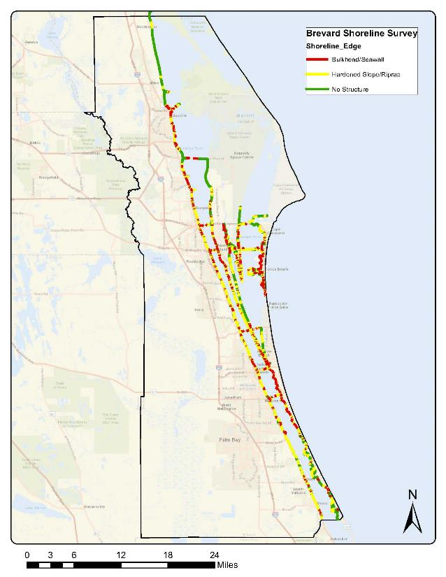
Figure 4-30: Shoreline Survey to Identify Locations Appropriate for Oyster Bars and Planted Shorelines
Figure 4-30 Long Description
Table 4-37: Projects for Planted Shorelines
Year Added | Project Number | Project Name | Responsible Entity | Sub-lagoon | Total Nitrogen Reduction (pounds per year) | Cost per Pound per Year of Total Nitrogen Reduction | Total Phosphorus Reduction (pounds per year) | Cost per Pound per Year of Total Phosphorus Reduction | Plan Funding
2018 | 77a | Cocoa Beach Country Club Planted Shoreline+ | Marine Resources Council | Banana | 67 | $240 | 23 | $699 | $16,080
2018 | 77b | Lagoon House Shoreline Restoration Planting+ | Marine Resources Council | Central IRL | 100 | $240 | 34 | $706 | $24,000
2018 | 78b | McNabb Park Planted Shoreline+ | City of Cocoa Beach | Banana | 24 | $240 | 8 | $720 | $5,760
2018 | 82b | Riverview Park Planted Shoreline+ | City of Melbourne | Central IRL | 77 | $240 | 26 | $711 | $18,480
2019 | 103 | Brevard Zoo North IRL Plant Project+ | Brevard Zoo | North IRL | 3 | $240 | 1 | $720 | $720
2020 | 130 | Brevard Zoo North IRL Plant Project 2+ | Brevard Zoo | North IRL | 41 | $240 | 14 | $703 | $9,840
2020 | 133 | Fisherman's Landing+ | Marine Resources Council | Central IRL | 20 | $240 | 7 | $686 | $4,800
2020 | 135 | Rotary Park+ | Marine Resources Council | Central IRL | 20 | $240 | 7 | $686 | $4,800
2021 | 180 | Scottsmoor Impoundment+ | Marine Resources Council | North IRL | 44 | $240 | 15 | $704 | $10,560
2021 | 181 | Riveredge+ | Marine Resources Council | North IRL | 17 | $240 | 6 | $680 | $4,080
2022 | 212 | Titusville Causeway Multi-Trophic Restoration and Living Shoreline Resiliency Action Project+ | Brevard County Natural Resources | North IRL | 131 | $240 | 45 | $699 | $31,440
- | - | Total | - | - | 544 | $240 (average) | 186 | $702 (average) | $130,560
Note: The projects highlighted in tan and marked with a plus sign were added to the plan as part of an annual update.

Clam Restoration and Aquaculture
Another potential tool for nutrient extraction, scour prevention, and water filtration in the Indian River Lagoon (IRL) is through clam aquaculture and restoration. Like oysters, clams can remove nitrogen from a system by burying it in sediments and enhancing the denitrification process through increased microbial activity in biodeposits (Clements and Comeau, 2019). The harvesting of clam shells and tissues can also extract nitrogen, as bivalves directly incorporate nitrogen (i.e., from consumption of phytoplankton and detritus; not dissolved nitrogen in the water) into their tissues and shells (Clements and Comeau, 2019).
Studies suggest that bivalve aquaculture has the potential to stimulate rates of denitrification equal to that of wild oyster beds and that the impacts of biodeposition from aquaculture are minimal (Clements and Comeau, 2019). The culture gear (bags, cover netting) used by growers creates a favorable environment for a myriad of plants and animals, such as juvenile fish and crabs, by providing habitat, substrate, and protection. This is especially significant since shellfish aquaculture leases can only be located in areas of the lagoon that undergo a resource survey to ensure the site is devoid of seagrasses and other marine life.
The exploration of clam aquaculture in Brevard County as a mitigation tool to extract excess nutrients from the IRL is warranted. According to the University of Florida Clam Farm Benefits Calculator, a single littleneck clam can filter 4.5 gallons of seawater per day and remove 0.09 grams of nitrogen when harvested. Therefore, in 2020, the Citizen Oversight Committee approved allocating $60,000 in funds to stimulate bivalve aquaculture in Brevard County. This funding would be used to sponsor 10 farms with up to $6,000 per farmer to plant up to 500,000 clams each. The funding would help to offset licensure, lease, and/or material costs. It is estimated that the clams from this stimulus project would remove 1,000 pounds per year of total nitrogen (TN) at a cost of $60 per pound of TN (Table 4-38). This program will also help promote education directed toward awareness of local aquaculture industries and their dependence on water quality to create mindfulness of the effects of eutrophication in a visceral, practical way. IRL clam restoration may lead to opportunities for successful partnerships with local clam farmers. Public sentiment toward clam restoration has been positive and the nutrient-removal aspects of shellfish aquaculture align with the Plan’s goals.
In addition, a statewide partnership aims to restore clams in the IRL using genetic stock able to withstand the unfavorable condition of an algae bloom-ridden lagoon. The IRL Clam Restoration project is a cooperative venture between the Coastal Conservation Association, Florida Fish and Wildlife Conservation Commission, University of Florida Whitney Lab, Brevard Zoo, and Florida Oceanographic Society. They collected brood stock living in the IRL, spawned them, and have begun outplanting these “super clams” in bags or under cover netting to strategic locations in the IRL (based upon historical sites and current water quality trends) including existing partner habitat restoration and commercial lease areas. Next steps include tracking survivorship and growth. One final goal is to establish brood stock that will serve as the optimized variety (phenotype) lines for further stock enhancement.
In 2020, grant funding was requested (but has not yet been secured) to outplant super clam progeny at 100 sites throughout the lagoon. The sites would be a combination of private properties and public locations so that volunteers can assist with restoration. This project would help to obtain information on survival rates in different locations to improve restoration efforts.
Table 4-38: Projects for Clam Restoration
Year Added | Project Number | Project Name | Responsible Entity | Sub-lagoon | Total Nitrogen Reduction (pounds per year) | Cost per Pound per Year of Total Nitrogen Reduction | Total Phosphorus Reduction (pounds per year) | Cost per Pound per Year of Total Phosphorus Reduction | Plan Funding
2021 | 194 | Aquaculture Stimulus Project+ | Brevard County | All | 1,000 | $60 | Not applicable | Not applicable | $60,000
- | - | Total | - | - | 1,000 | $60 | Not applicable | Not applicable | $60,000
Note: The projects highlighted in tan and marked with a plus sign were added to the plan as part of an annual update.

Seagrass Planting
The original Indian River Lagoon (IRL) Surface Water Improvement and Management Plan of 1989, as well as subsequent management plans up to and including the current basin management action plans, target a healthy, estuarine ecosystem populated by seagrasses. Seagrasses provide crucial benefits to Florida’s estuaries by providing food and shelter to a variety of animals, improving water quality, and preventing erosion of sediment (Orth et al., 2006). In total, the lagoon’s 72,000 acres of seagrass could provide an economic benefit of more than $900 million per year (Figure 4-31; Dewsbury et al., 2016).
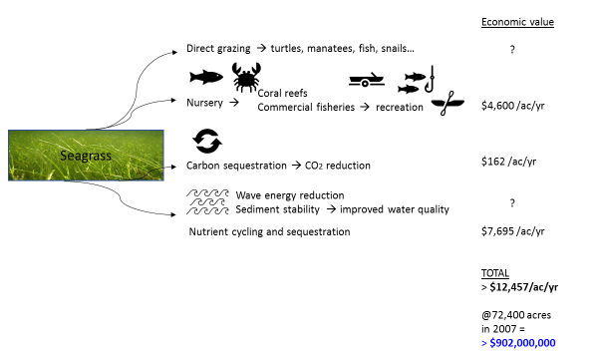
Note: Adapted from Dewsbury et al., 2016
Figure 4-31: Estimated Economic Value of Some Seagrass Services
Figure 4-31 Long Description
One key ecological role for seagrasses is to absorb and cycle nitrogen and phosphorus (Romero et al., 2006). Seagrasses do not remove these nutrients permanently, but they compete for them against phytoplankton and macroalgae and hold them longer (Banta et al., 2004). By stabilizing the cycling of nutrients, seagrasses can increase a system’s ability to absorb nutrient loads without the initiation of detrimental blooms of phytoplankton or macroalgae (Schmidt et al., 2012). Seagrasses can filter nitrogen inputs via photosynthesis and nutrient uptake, acting as a sink seasonally (McGlathery, 2008). However, when systems become eutrophic, this function can be lost (McGlathery, 2008). The contribution of seagrasses can be evaluated by examining the quantity of nutrients bound in its aboveground and belowground structures (its mass of biological material or biomass), with this approach treating uptake and release of nutrients as offsetting components of the nutrient cycle (Table 4-39).
Table 4-39: Average Nutrients in Seagrass from 1996–2009
Sub-lagoon | Acres | Seagrass (pounds per 100 acres) | Nitrogen (pounds per 100 acres) | Phosphorus (pounds per 100 acres)
Southern Mosquito Lagoon | 14,000 | 45,000 | 1,000 | 100
Banana River Lagoon | 21,000 | 45,000 | 1,000 | 100
North IRL | 19,000 | 37,000 | 900 | 90
Central IRL | 7,000 | 36,000 | 900 | 90
Seagrass restoration may be necessary because more than 30,000 acres of seagrasses were lost due to shading during the superbloom in 2011, recovery has been limited, and the brown tide in 2016 exacerbated the situation. In fact, the Banana River Lagoon in Brevard County experienced the largest initial losses of seagrass (Appendix C). Throughout the northern lagoon, decreases in the extent and cover of seagrass between 2009 and 2019 meant that approximately 216,053 pounds (98 metric tons) of nitrogen and 22,046 pounds (10 metric tons) of phosphorus were no longer stored in seagrass. These quantities represent 11% and 40% of the mean concentrations of dissolved nitrogen and phosphorus in the northern lagoon, respectively (Morris et al., In Review). After the loss of seagrass, nitrogen and phosphorus became available to phytoplankton, drift algae, and other primary producers (Table 4-40). Furthermore, the absence of seagrasses has made the sediments less stable, which will hamper future colonization and spread of new seagrass.
Overall, seagrasses may need some help to recover in the short-term, with more rapid recovery helping to sequester nutrients and reduce the amounts available to phytoplankton. Measures that could help seagrasses recover include protecting existing seagrass to promote expansion or protecting areas from waves to reduce the movement of sediment and allow seagrasses to colonize. Planting has also been discussed, and Halodule wrightii would be the initial focus because it has been the most widespread species in the lagoon (Dawes et al., 1995; Morris et al., 2021), and this species can act as a pioneer due to its rapid growth and wide tolerance thresholds.
Table 4-40: Average Seagrass Lost and Nutrients Made Available to Other Primary Producers in 2015
Sub-lagoon | Reduction in Acres | Seagrass Reduction* (pounds per 100 acres) | Nitrogen Reduction (pounds per 100 acres) | Phosphorus Reduction (pounds per 100 acres)
Southern Mosquito Lagoon | 0 | 15,000 | 300 | 30
Banana River Lagoon | 12,000 | 37,000 | 900 | 90
North IRL | 1,000 | 8,000 | 200 | 20
Central IRL | 4,000 | 20,000 | 500 | 50
* Changes in seagrass cover yield changes in biomass of seagrass within the same number of acres.
Planting seagrass is not a trivial undertaking; it requires considerable planning, resources, and time. For example, having suitable conditions is critical as shown in Tampa Bay where stakeholders invested more than $500 million in projects to reduce nutrient pollution before they saw any return from planting seagrass (Lewis et al., 1999). Costs documented during a workshop on seagrass restoration started at $1.4 million per acre for larger scale projects (Treat and Lewis, 2006). Seagrass meadows influence nutrient dynamics through storage, cycling, and promoting denitrification. Scaled nitrogen storage and removal rates vary from 6 to 78 pounds per acre per year based on studies of various seagrass species conducted in Australia, Virginia, North Carolina, and IRL (Russel and Greening, 2015; Smyth et al., 2015; Aoki et al., 2019; Morris et al., In Review). With project costs ranging from approximately $2 to $7 per pound of seagrass, this equates to $1,085 to $48,306 per pound of nitrogen sequestration. Some of the lessons learned from past projects include selecting sites that will support seagrass growth, employing optimal methods for planting (e.g., type of planting units, use of chemicals to enhance growth, and density of initial planting), and protecting newly planted seagrass from disturbance (e.g., grazing, waves, exposure, and low salinity) until it is established. It may be best to tailor approaches to a specific location; therefore, one or more pilot studies prior to attempting full-scale restoration should prove valuable.
The Brevard County Natural Resources Management Department has submitted a grant for state resiliency funds to support a pilot project at a location in the Central IRL. If funded, Brevard County will partner with private and non-profit entities to plant 1.5 acres of seagrass and build an adjacent oyster bar to aid in dampening wave energy and stabilizing sediments. The project would be designed to test different planting methods (e.g., type of unit to be planted and density of units) to better understand how to approach, most effectively and economically, future, larger-scale restoration. The area would be monitored for two years post-restoration to document growth and survival, with potential measures being density, percent cover, and canopy height, as well as water depth, dissolved oxygen concentration, light availability, and other environmental conditions.
Similar or more complex pilot studies could be designed to investigate other key components of restoration. Overall, successfully incorporating planting into restoration of tens of thousands of acres of seagrass will benefit from strategic investment in optimizing techniques. For example, site selection and project scale may be critical to surviving chronic natural disturbance and increasing the potential for natural recolonization (Fonseca presentation to the Citizen’s Oversight Committee on August 20, 2021). Brevard County is investing in a decision tree that will help all interested groups with these issues. The decision tree will be based on decades of research by St. Johns River Water Management District regarding abiotic factors and thresholds found to limit seagrasses in the IRL. Appendix C includes additional details about seagrass.

Projects to Respond to New Information
The funding raised from the Save Our Indian River Lagoon sales tax will go towards the projects listed in the sections above that will reduce or remove pollutants and restore the lagoon. In addition, $10 million of the funding, over a period of 10 years, will go towards monitoring efforts to measure the success, nutrient removal efficiency, and cost effectiveness of projects included in this plan and in future updates of this plan. Measuring effectiveness is important for reporting progress toward total load reduction targets and for refining project designs to be more effective with each iteration. The monitoring data will be used to determine which projects are providing the most benefit in the most cost-effective manner so that the plan can be updated, as needed. The data will also be used to ensure the lagoon is responding as anticipated to the reductions made so that changes to the plan can be implemented if the lagoon is not responding as expected.

Adaptive Management to Report, Reassess, and Respond
The Indian River Lagoon (IRL) is located along the Space Coast, which is also known as a global center for exploration, innovation, and development of cutting edge technology. With a dedicated funding source and a brilliant community dedicated to meeting the challenges of today and tomorrow, it is wise to have a process that allows this plan to be updated and revised as new opportunities and better solutions are developed. The intent of the proposed adaptive management strategy is to provide a process that not only allows but also fosters the development and implementation of better tools and techniques and allows the tax rate to be reduced accordingly or retired ahead of schedule.
Although this plan was developed with the best information available in 2016, identifying the sources of water quality pollution and pairing those problems with the most timely and cost-effective solutions is a rapidly changing field of knowledge. To respond to change and take advantage of future opportunities, monitoring is necessary. Even without change in the industry, monitoring will provide data to support and refine the application of existing technology. An adaptive management approach is used to provide a mechanism to make adjustments to the plan based on new information. As projects from this plan are implemented, the actual costs and nutrient reduction benefits will be tracked, and the plan will be modified, as needed, as project performance in the lagoon basin is better understood.
This plan will be updated approximately annually with information from implemented projects and adjustments to the remaining projects. A volunteer committee of diversely skilled citizens has been assembled to assist Brevard County with the annual plan updates. The Citizen Oversight Committee consists of seven representatives and seven alternates that represent the following fields of expertise: science, technology, economics/finance, real estate, education/outreach, tourism, and lagoon advocacy. The League of Cities nominated representatives for three fields of expertise and nominated alternates for the remaining four fields of expertise. The Brevard County Board of County Commissioners nominated representatives for the other four fields of expertise and alternates for the remaining three fields of expertise. All Citizen Oversight Committee representatives and alternates were appointed by the Brevard County Board of County Commissioners. Appointees serve for two-year terms, after which time they may be considered for reappointment or replacement. The first term ended in February 2019 and the second term ended in February 2021. The Committee’s recommendations for plan updates will be presented at least annually to the Board of County Commissioners, and changes to the plan will be approved by the Board of County Commissioners.
Brevard County staff provides project monitoring reports to the Citizen Oversight Committee and works with them to recommend adjusting the planned projects, as needed. The adaptive management process allows for alternative projects to be submitted by the county, municipalities, and other community partners to be reviewed by the Citizen Oversight Committee for inclusion in the next annual update to this plan. Projects that deliver comparable nutrient removal benefits may be approved for inclusion in the plan. If a new approved project costs more than the average cost per pound of total nitrogen for that project type listed in this plan at the time of project submittal, the requesting partner must provide the balance of the costs. The requesting partner will be allowed reasonable overhead cost to manage the project from design and permitting through construction completion.
As projects are implemented, progress toward meeting the County's proposed revisions to the total maximum daily loads are being tracked. Adjustments to the types and locations of projects implemented will be made to ensure that total maximum daily loads can be achieved in all Brevard County portions of the lagoon.

Cost-share for Substitute Projects
For the 2022 Update, local municipalities and partners were once again invited to submit new projects for inclusion in the Save Our Indian River Lagoon Project Plan. The projects submitted were required to deliver comparable nutrient removal benefits as those projects listed in the original plan and plan updates for each sub-lagoon.
The requesting partners each submitted a “Save Our Indian River Lagoon Project Plan Project Submittal Request” to Brevard County for review of the proposed projects. The project requests were provided to the Citizen Oversight Committee to evaluate the potential for inclusion in the plan. The projects recommended by the Citizen Oversight Committee were included in the draft plan update presented to the Brevard County Board of County Commissioners for approval.
To determine the amount of funding that a project would be eligible to receive from the Save Our Indian River Lagoon Trust Fund, the estimated total nitrogen (TN) reductions from the project were multiplied by the allowable cost per pound per year of TN shown below in Table 4-41 for that project type. The costs shown in Table 4-41 were included in the application instructions provided to the partners in July 2021 and were an average of the actual or engineer’s estimate of cost per pound of TN removed from the projects previously listed in the Save Our Indian River Lagoon Project Plan, as amended, or comparable projects recently planned or completed elsewhere in the Indian River Lagoon (IRL) watershed.
Table 4-41: Cost-share Offered for Project Requests Submitted for the 2022 Update
Project Type | Average Cost per Pound per Year of Total Nitrogen
Wastewater Treatment Facility Upgrades for Reclaimed Water | $383
Rapid Infiltration Basin/Sprayfield Upgrades | $136
Package Plant Connections | $1,500
Sewer Lateral Rehabilitation | $255
Septic System Removal by Sewer Extension | $1,500
Septic System Removal by Sewer Connection | $487
Septic System Upgrades | $1,200
Stormwater Projects | -
Mainland | $313
Merritt Island | $370
Beaches | $446
Muck Removal | $520
Treatment of Muck Interstitial Water | $98
Vegetation Harvesting | $110
Oyster Bar | $397
Planted Shorelines | $240

Additional Project Benefits
Although the eligible Save Our Indian River Lagoon Trust Fund contribution to new projects is determined based on the amount of total nitrogen removed, the benefits of implementing these projects include reductions in other pollutant sources, as well. These projects will reduce a multitude of different contaminates to meet water quality targets and improve the health, productivity, aesthetic appeal, and economic value of the lagoon. These additional benefits vary according to project design and site-specific conditions but often include significant reduction of pathogenic bacteria, viruses, human and animal wastes, chemicals, metals, plastics, and sediments (see Table 4-42).
Table 4-42: Pollutants Removed by Different Project Types
Stormwater | Septic System Removal | Septic System Upgrade | Muck Removal
Nitrogen  Phosphorus  Sediments  Escherichia coli  Viruses  Fecal coliform  Pesticides  Metals  Oil  Litter | Nitrogen  Phosphorus  Escherichia coli  Viruses  Fecal coliform  Pharmaceuticals  Biochemical oxygen demand | Nitrogen  Phosphorus  Escherichia coli  Viruses  Fecal coliform  Biochemical oxygen demand | Nitrogen  Phosphorus  Clay sediments  Hydrogen sulfide  Biochemical oxygen demand
This Save Our Indian River Lagoon Project Plan is an adaptable document informed by science and under supervision of the community. As monitoring updates our understanding of Indian River Lagoon pollutants, the plan projects will target funds to the most successful and cost-effective projects.

Responding to Implemented Projects
During the first years of plan implementation, dozens of projects have been completed throughout the Indian River Lagoon (IRL) system as shown in Figure 4-32 through Figure 4-34. The implementation of these projects provided new cost information and actual pollution reduction measurements used to update the project cost-effectiveness for the 2022 Update. The project costs and Save Our Indian River Lagoon Tax Fund money expended on completed projects are shown in Table 4-43. Table 4-44 summarizes the Save Our Indian River Lagoon Tax Fund money that has been contracted and/or expended on projects that are currently underway.
Table 4-43: Save Our Indian River Lagoon Tax Funds Expended on Completed Construction Projects (as of October 31, 2021)
Project Number | Project | Project Type | Estimated Total Cost | Final Total Cost | Change in Total Cost | Eligible Save Our Indian River Lagoon Cost | Final Save Our Indian River Lagoon Cost | Change in Save Our Indian River Lagoon Cost
193 | Oyster Gardening | Public Education | $300,000 | $300,000 | $0 | $300,000 | $300,000 | $0
99 | Cocoa Beach Water Reclamation Facility Upgrades | Wastewater Treatment Facility Upgrades | $5,920,320 | $6,554,233 | $633,913 | $945,000 | $945,000 | $0
6 | Long Point Park Denitrification | Package Plant Rapid Infiltration Basin Upgrade | $101,854 | $22,207 | -$79,647 | $101,854 | $22,207 | -$79,647
1 | Breeze Swept Septic-to-Sewer | Septic-to-Sewer | $3,400,000 | $3,400,000 | $0 | $880,530 | $880,530 | $0
2 | Merritt Island Redevelopment Agency Phase 1 and 2 Septic-to-Sewer | Septic-to-Sewer | $3,138,098 | To be determined | To be determined | $320,000 (plus $268 of contingency) | $320,268 | $268
60 | Sylvan Estates Septic-to-Sewer | Septic-to-Sewer | $1,720,430 | $2,431,490 | $711,060 | $1,561,215 | $1,561,215 | $0
52 | North IRL 15 of 586 Septic System Upgrades | Septic System Upgrades | $270,000 | $275,998 | $5,998 | $270,000 | $270,000 | $0
53 | Central IRL 28 of 939 Septic System Upgrades | Septic System Upgrades | $504,000 | $506,642 | $2,642 | $504,000 | $487,106 | -$16,894
2016-16 | Banana Septic System 2 of 144 Quick Connections | Quick Connections | $24,000 | $21,789 | -$2,211 | $24,000 | $21,729 | -$2,271
2016-18 | North IRL Septic System 32 of 463 Quick Connections | Quick Connections | $869,428 | $908,516 | $39,088 | $570,000 | $570,000 | $0
13 | Central Boulevard Baffle Box | Stormwater | $41,700 | $43,700 | $2,000 | $34,700 | $34,700 | $0
14 | Church Street Baffle Box | Stormwater | $233,455 | $233,455 | $0 | $88,045 | $88,045 | $0
15 | Bayfront Stormwater Ponds | Stormwater | $630,956 | $635,702 | $4,746 | $30,624 | $30,624 | $0
16 | Gleason Park Reuse Expansion | Stormwater | $11,000 | $7,193 | -$3,807 | $4,224 | $4,224 | $0
19 | St. Teresa Basin Treatment | Stormwater | $375,250 | $474,292 | $99,042 | $272,800 | $272,800 | $0
20 | South Street Basin Treatment | Stormwater | $475,125 | $683,969 | $208,844 | $86,856 | $86,856 | $0
21 | La Paloma Basin Treatment | Stormwater | $375,250 | $462,347 | $87,097 | $208,296 | $208,296 | $0
34 | Cliff Creek Baffle Box | Stormwater | $350,000 | $737,612 | $387,612 | $347,781 | $347,781 | $0
35 | Thrush Drive Baffle Box | Stormwater | $350,000 | $609,394 | $259,394 | $322,200 | $322,200 | $0
66 | Big Muddy at Cynthia Baffle Box | Stormwater | $288,640 | $288,640 | $0 | $67,532 | $59,631 | -$7,901
85 | Basin 1304 Bioreactor | Stormwater | $125,000 | $141,988 | $16,988 | $90,000 | $83,029 | -$6,971
87 | Basin 2134 Fleming Grant Biosorption Activated Media | Stormwater | $172,300 | $169,300 | -$3,000 | $56,588 | $56,588 | $0
89 | Basin 1298 Bioreactor | Stormwater | $125,000 | $136,100 | $11,100 | $86,198 | $85,829 | -$369
90 | Basin 51 Johns Road Biosorption Activated Media | Stormwater | $116,905 | $154,000 | $37,095 | $23,030 | $23,030 | $0
91 | Basin 100 Burkholm Road Biosorption Activated Media | Stormwater | $117,735 | $141,457 | $23,722 | $64,390 | $64,390 | $0
92 | Basin 115 Carter Road Biosorption Activated Media | Stormwater | $156,079 | $146,950 | -$9,129 | $62,510 | $62,510 | $0
93 | Basin 193 Wiley Ave Biosorption Activated Media | Stormwater | $117,735 | $162,216 | $44,481 | $82,735 | $82,735 | $0
94 | Basin 832 Broadway Pond Biosorption Activated Media | Stormwater | $269,751 | $269,750 | -$1 | $42,864 | $42,864 | $0
98 | Coleman Pond Managed Aquatic Plant System | Stormwater | $35,000 | $11,438 | -$23,563 | $35,000 | $11,438 | -$23,563
110 | Osprey Pond Managed Aquatic Plant System | Stormwater | $60,000 | $37,500 | -$22,500 | $60,000 | $37,500 | -$22,500
117 | Basin 10 County Line Road Woodchip Bioreactor | Stormwater | $180,116 | $166,174 | -$13,942 | $72,773 | $72,773 | $0
119 | Basin 141 Irwin Avenue Woodchip Bioreactor* | Stormwater | $124,626 | $146,926 | $22,300 | $69,174 | $69,174 | $0
120 | Draa Field Pond Managed Aquatic Plant Systems | Stormwater | $60,000 | $48,750 | -$11,250 | $31,281 | $31,281 | $0
122 | Basin 22 Huntington Road Serenity Park Woodchip Bioreactor* | Stormwater | $103,852 | $99,334 | -$4,518 | $40,077 | $40,077 | $0
124 | Floating Wetlands to Existing Stormwater Ponds | Stormwater | $50,000 | $14,336 | -$35,664 | $1,497 | $1,497 | $0
127 | Indialantic Basin 5 Dry Retention Pond | Stormwater | $74,700 | $62,718 | -$11,982 | $16,680 | $16,680 | $0
169 | Sherwood Park Stormwater Quality Project | Stormwater | $1,696,489 | $1,696,489 | $0 | $292,400 (plus $99,708 of contingency) | $392,108 | $0
178 | Marina B Managed Aquatic Plant System | Stormwater | $14,531 | $17,424 | $2,893 | $6,670 | $6,670 | $0
111 | Draa Field Vegetation Harvesting | Vegetation Harvesting | $60,000 | $115,261 | $55,261 | $57,360 (plus $29,053 of contingency) | $86,413 | $0
112 | County Stormwater Pond Harvesting | Vegetation Harvesting | $14,000 | $14,777 | $777 | $14,000 | $14,000 | $0
2016-03 | Turkey Creek Hurricane Dredge and Interstitial Treatment | Muck Removal & Interstitial Treatment | $1,545,522 | $1,098,631 | -$446,891 | $215,000 | $137,329 | -$77,671
40 | Mims Muck Dredging Interstitial Treatment* | Interstitial Treatment | $2,162,286 | $1,546,187 | -$616,099 | $400,000 | $0 | -$400,000
70 | Cocoa Beach Muck Dredging Phase III | Muck Removal | $3,109,818 | $2,903,356 | -$206,462 | $1,376,305 | $1,376,305 | $0
73 | Riverview Senior Oyster Bar | Oyster | $30,304 | $30,304 | $0 | $30,304 | $30,304 | $0
75 | Marina Isles Oyster Restoration | Oyster | $26,700 | $26,700 | $0 | $26,700 | $26,700 | $0
76 | Bettinger Oyster Bar | Oyster | $10,680 | $10,680 | $0 | $10,680 | $10,680 | $0
79 | Gitlin Oyster Bar | Oyster | $16,020 | $16,020 | $0 | $16,020 | $16,020 | $0
80 | Brevard Zoo Coconut Point/Environmentally Endangered Lands Oyster Restoration | Oyster | $45,120 | $45,120 | $0 | $45,120 | $45,120 | $0
81 | Wexford Oyster Bar | Oyster | $31,150 | $31,150 | $0 | $31,150 | $31,150 | $0
83 | Bomalaksi Oyster Bar | Oyster | $8,900 | $8,900 | $0 | $8,900 | $8,900 | $0
77a | Cocoa Beach Country Club Living Shoreline | Living Shoreline | $16,080 | $16,080 | $0 | $16,080 | $16,080 | $0
77b | Lagoon House Living Shoreline | Living Shoreline | $24,000 | $24,000 | $0 | $24,000 | $24,000 | $0
103 | Brevard Zoo North Plant Project | Living Shoreline | $720 | $720 | $0 | $720 | $720 | $0
130 | Brevard Zoo Plant Project 2 | Living Shoreline | $9,840 | $9,840 | $0 | $9,840 | $9,840 | $0
133 | Fisherman's Landing Living Shoreline | Living Shoreline | $4,800 | $4,800 | $0 | $4,800 | $4,800 | $0
135 | Rotary Park Living Shoreline | Living Shoreline | $4,800 | $4,800 | $0 | $4,800 | $4,800 | $0
- | Total | - | $30,100,065 | $28,127,356 | $1,165,398 | $10,365,303 | $9,856,544 | -$637,520
* Not paid due to the contractor not meeting nutrient scrubbing contract requirements.
Table 4-44: Save Our Indian River Lagoon Tax Funds Contracted or Expended on Projects Underway (as of October 31, 2021)
Project Number | Project | Project Type | Save Our Indian River Lagoon Plan Funding | Save Our Indian River Lagoon Funds Contracted | Save Our Indian River Lagoon Expenditures for Projects Underway
58 | Expanded Fertilizer Education | Public Education | $625,000 | $312,500 | $216,999
58 | Grass Clippings Campaign | Public Education | $200,000 | $100,000 | $26,638
58 | Septic System Maintenance Education | Public Education | $300,000 | $150,000 | $120,334
2016-02 | City of Titusville Osprey Wastewater Treatment Facility | Wastewater Treatment Facility Upgrade | $8,300,000 | $8,300,000 (plus $800,000 of contingency) | $3,242,18
2016-17 | City of Palm Bay Water Reclamation Facility | Wastewater Treatment Facility Upgrade | $3,636,900 | $3,636,900 | $3,100,699
59 | City of Melbourne Grant Street Water Reclamation Facility | Wastewater Treatment Facility Upgrade | $6,769,500 | $6,769,500 | $0
138 | Ray Bullard Water Reclamation Facility | Wastewater Treatment Facility Upgrade | $4,260,000 | $4,260,000 | $123,592
63ab | Satellite Beach Pilot & County-wide Repair/Replacement | Sewer Laterals | $840,000 | $840,000 | $10,432
114 | Barefoot Bay Lateral Smoke Testing | Sewer Laterals | $90,000 | $90,000 | $0
115 | South Beaches Lateral Smoke Testing | Sewer Laterals | $200,000 | $200,000 | $0
116 | Merritt Island Lateral Smoke Testing | Sewer Laterals | $250,000 | $250,000 | $0
192 | Oak Point Wastewater Treatment Facility Improvements | Package Plant Connection | $279,000 | $279,000 | $11,403
27 | Sharpes – Zone A | Septic System Removal | $6,207,192 | $562,031 | $0
29 | South Banana - Zone B | Septic System Removal | $1,368,252 | $735,750 | $0
2020-34 | South Central - Zone F | Septic System Removal | $1,701,972 | $1,701,972 | $0
2016-35 | South Beaches - Zone A | Septic System Removal | $1,234,764 | $18,000 | $18,000
2016-36 | South Beaches - Zone O | Septic System Removal | $133,488 | $133,488 | $16,855
2016-37 | South Beaches - Zone P | Septic System Removal | $500,580 | $500,580 | $65,931
2016-47 | Sykes Creek - Zone N | Septic System Removal | $2,603,016 | $2,603,016 | $202,702
2016-48 | Sykes Creek - Zone M | Septic System Removal | $1,868,832 | $1,868,832 | $96,786
2016-49 | Sykes Creek - Zone T | Septic System Removal | $4,939,056 | $4,939,056 | $144,764
2016-50 | South Central - Zone C | Septic System Removal | $6,600,000 | $6,600,000 | $312,932
3 | Micco Sewer Line Extension | Septic System Removal | $2,038,500 | $2,038,500 | $240,971
4 | Hoag Sewer Conversion | Septic System Removal | $86,031 | $86,031 | $26,095
5 | Pennwood Sewer Conversion | Septic System Removal | $40,632 | $40,632 (plus $40,368 of contingency) | $17,074
61 | Riverside Drive Septic-to-Sewer Conversion | Septic System Removal | $265,960 | $262,044 | $0
62 | Roxy Avenue Septic-to-Sewer Conversion | Septic System Removal | $88,944 | $88,944 | $39,495
109 | City of Titusville - Zones A-G | Septic System Removal | $1,201,392 | $943,110 | $86,860
136 | Micco - Zone B | Septic System Removal | $9,000,000 | $2,248,125 | $0
145 | Merritt Island - Zone F | Septic System Removal | $1,100,000 | $735,750 | $0
146 | Merritt Island - Zone C | Septic System Removal | $1,580,000 | $735,750 | $0
147 | Sykes Creek - Zone R | Septic System Removal | $3,500,000 | $735,750 | $0
148 | North Merritt Island - Zone E | Septic System Removal | $3,635,000 | $562,031 | $0
151 | Merritt Island - Zone G | Septic System Removal | $16,617,000 | $735,750 | $0
152 | Sharpes - Zone B | Septic System Removal | $4,038,000 | $562,031 | $0
153 | Cocoa - Zone C | Septic System Removal | $5,248,500 | $562,031 | $0
18 | Basin 62 Denitrification Retrofit of Johns Road Pond | Stormwater | $105,512 | $105,512 | $27,230
22 | Basin 1387 Kingsmill-Aurora Phase Two | Stormwater | $367,488 | $367,488 | $0
23 | Basin 41 Denitrification Retrofit of Huntington Pond | Stormwater | $104,720 | $104,720 | $9,074
24 | Basin 71 Denitrification Retrofit of Flounder Creek Pond | Stormwater | $75,328 | $75,328 | $19,923
64/65 | Convair Cove | Stormwater | $9,145 | $9,145 | $0
68 | Crane Creek/M-1 Canal Flow Restoration | Stormwater | $2,033,944 | $2,033,944 | $100,000
97 | Titusville High School Baffle Box | Stormwater | $111,813 | $111,813 | $0
118 | Basin 26 Sunset Avenue Serenity Park Woodchip Bioreactor | Stormwater | $73,810 | $73,810 | $0
121 | Basin 2258 Babcock Street Woodchip Bioreactor | Stormwater | $50,203 | $50,203 | $0
123 | Ray Bullard Water Reclamation Facility Stormwater Management Area | Stormwater | $160,674 | $160,674 | $52,368
128 | Jackson Court Stormwater Treatment Facility | Stormwater | $8,266 | $8,266 | $0
174 | St. Johns 2 Baffle Box | Stormwater | $243,070 | $243,070 | $0
205 | Basin 998 Hampton Homes | Stormwater | $194,400 | $63,618 | $0
206 | Basin 1066 Angel Ave | Stormwater | $232,200 | $29,487 | $0
207 | Basin 1124 | Stormwater | $148,100 | To be determined | $0
171 | Mechanical Aquatic Vegetation Harvesting | Vegetation Harvesting | $1,011,976 | $1,011,976 | $0
172 | Horseshoe Pond Vegetation Harvesting | Vegetation Harvesting | $8,140 | $8,140 | $0
2016-04 | Rockledge A Muck & Interstitial Treatment | Muck and Interstitial | $5,010,244 | $175,340 | $143,331
2016-05 | Pineda Banana River Lagoon & Interstitial Treatment | Muck and Interstitial | $7,815,980 | $0 | $0
2016-06 | Titusville Railroad West & Interstitial Treatment | Muck and Interstitial | $3,607,375 | $146,361 | $143,107
2016-07 | National Aeronautics and Space Administration Causeway East & Interstitial Treatment | Muck and Interstitial | $11,423,355 | $209,255 | $182,059
2016-08 | Titusville Railroad East & Interstitial Treatment | Muck and Interstitial | $4,609,424 | $204,017 | $268,499
2016-10 | Canaveral South & Interstitial Treatment | Muck and Interstitial | $16,834,419 | To be determined | $0
2016-11 | Patrick Space Force Base & Interstitial Treatment | Muck and Interstitial | $8,216,800 | To be determined | $0
41 | Grand Canal Muck & Interstitial Treatment | Muck and Interstitial | $18,020,368 | $18,020,368 | $3,550,830
42 | Sykes Creek Muck & Interstitial Treatment | Muck and Interstitial | $15,954,132 | $1,078,266 | $852,108
54 | Eau Gallie Northeast Muck & Interstitial Treatment | Muck and Interstitial | $10,020,487 | $98,323 | $117,094
71 | Merritt Island Muck Removal – Phase 1 | Muck and Interstitial | $7,733,517 | To be determined | $0
72 | Muck Removal of Indian Harbour Beach Canals & Interstitial Treatment | Muck and Interstitial | $9,115,415 | $9,115,415 | $0
101 | Cocoa Beach Muck Dredging Phase II-B | Muck and Interstitial | $5,917,650 | $5,917,650 | $4,294,790
168 | Cocoa Beach Golf Muck & Interstitial Treatment | Muck and Interstitial | $24,363,100 | $24,363,100 | $402,766
78a | McNabb Park Oyster Project | Oyster Bars | $34,056 | $34,056 | $0
104 | Brevard Zoo Banana River Oyster Project | Oyster Bars | $583,020 | $583,020 | $19,424
105 | Brevard Zoo Central IRL Oyster Project | Oyster Bars | $161,160 | $161,160 | $20,459
106 | Brevard Zoo North IRL Oyster Project | Oyster Bars | $341,280 | $341,280 | $169,188
139 | Brevard Zoo North IRL Oyster Project 2 | Oyster Bars | $336,400 | $336,400 | $45,913
140 | Brevard Zoo Central IRL Oyster Project 2 | Oyster Bars | $270,800 | $270,800 | $50,622
184 | Brevard Zoo North Indian River Lagoon Oyster Project 3 | Oyster Bars | $419,232 | $419,232 | $38,943
78b | McNabb Park Planted Shoreline | Planted Shoreline | $5,670 | $5,670 | $0
181 | Riveredge | Planted Shoreline | $4,080 | $4,080 | $0
182 | Newfound Harbor Drive | Planted Shoreline | $1,680 | $1,680 | $0
- | Respond and Monitoring | Respond | $10,000,000 | - | $1,897,314
- | Total | - | $267,085,944 | $121,129,771 | $20,525,792

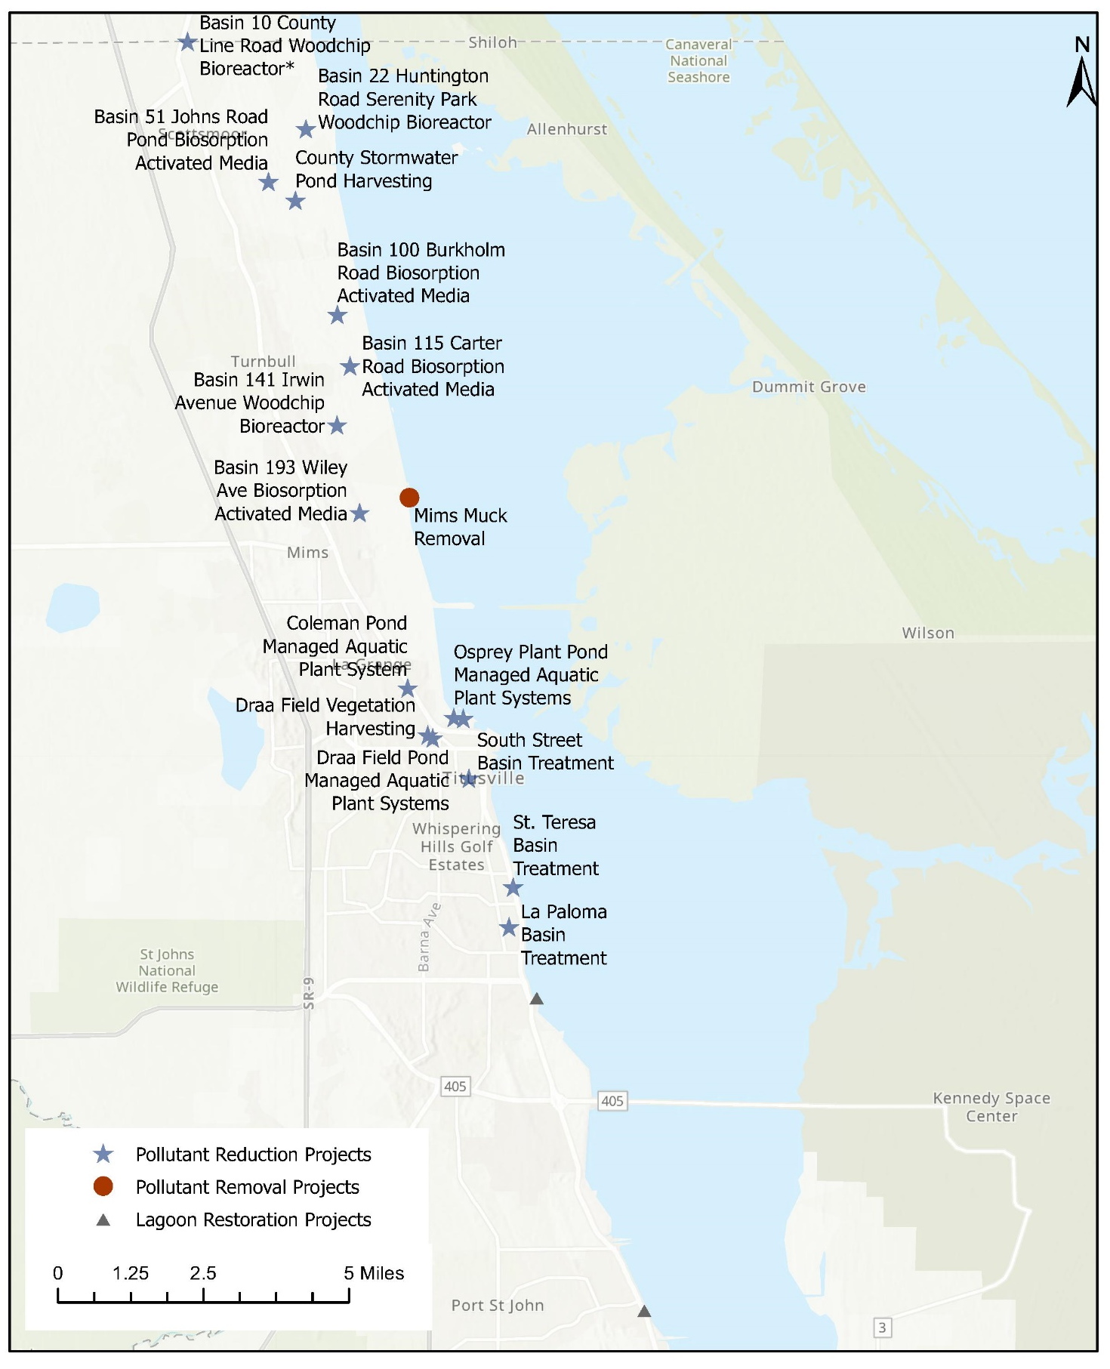
Figure 4-32: Completed Projects in North Brevard County
Figure 4-32 Long Description
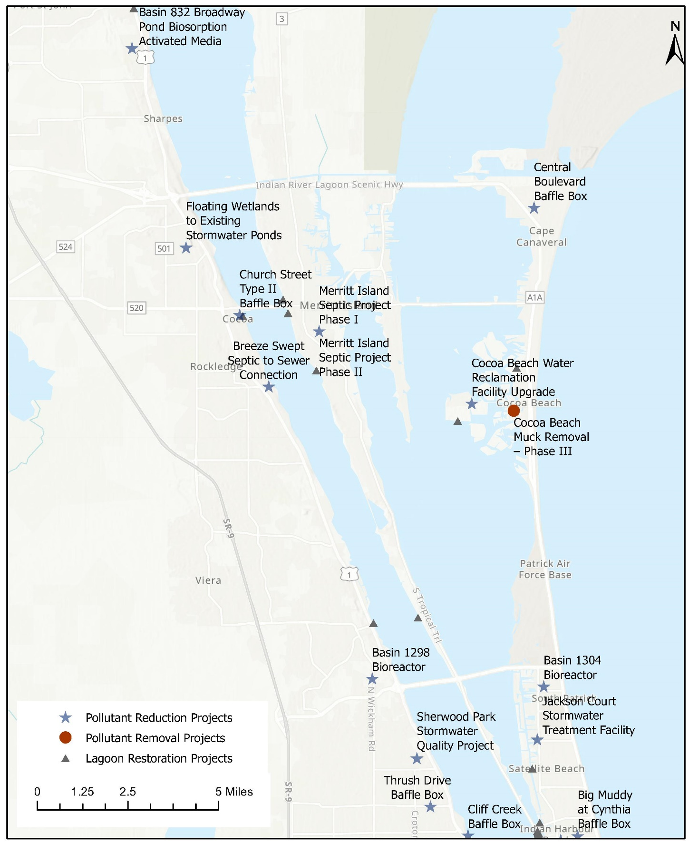
Figure 4-33: Completed Projects in Central Brevard County
Figure 4-33 Long Description
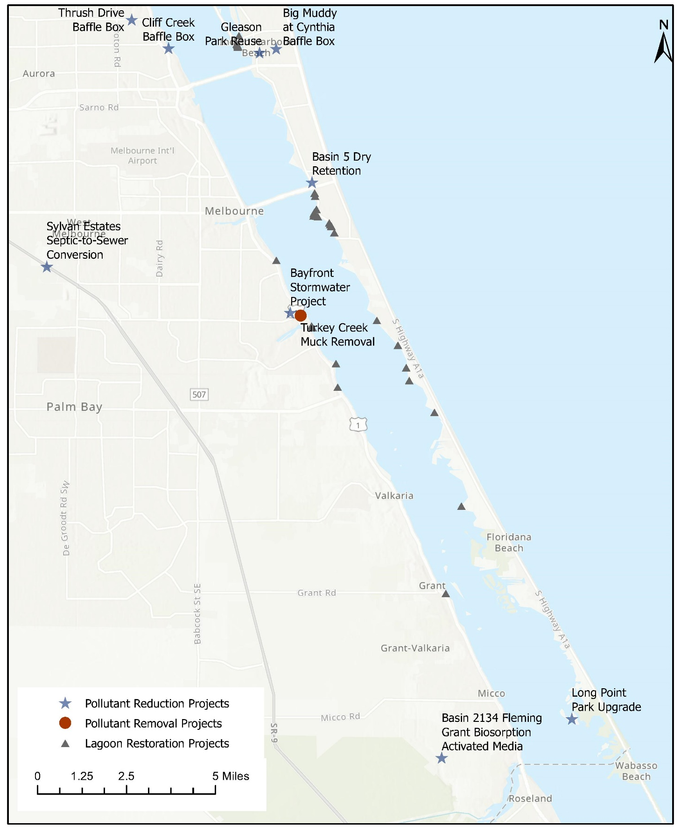
Figure 4-34: Completed Projects in South Brevard County
Figure 4-34 Long Description

Fertilizer Management Outreach
As noted in Section 4.1.1, in 2019, the University of Florida Institute of Food and Agricultural Sciences and MTN Marketing conducted a survey that was concentrated on fertilizer awareness questions. The results from the 2019 survey were compared to similar questions from the 2015 Blue Life survey to evaluate changes in fertilizer use. Based on the survey results, 33.33% of respondents in 2019 stated that they use slow release nitrogen fertilizer compared to only 6.30% in 2015, which is a 27% increase in the usage of slow release fertilizer. This resulted in better than anticipated cost effectiveness. The cost per pound of total nitrogen (TN) removed improved from an initial estimate of $102 to a revised estimate of $95. The total phosphorus (TP) reductions were kept at the original plan estimate of an additional 25% compliance because, the way the survey was setup, participants were only able to select one option for the type of fertilizer used. Therefore, an update on the use of zero phosphorus formulas could not be obtained.
Also in 2019, Brevard County amended the fertilizer ordinance to require all fertilizer retail stores to display signage at the point of sale informing the public on the ordinance and best practices for fertilizer management. Focus groups were conducted to enhance the design of the sign. A total of 132 signs were distributed to 53 retails stores across Brevard County. In summer 2020, the stores were surveyed for compliance with the ordinance. Only eight stores were out of compliance with no signage posted. Request for compliance letters were issued to the eight stores and additional signs were delivered to stores that could not locate the original signs. The stores were receptive of the letters and willing to come into compliance.

Grass Clipping Outreach
Uppercase, Inc. conducted a survey between September 9, 2018 and November 11, 2018 reaching out to citizens of Brevard, Martin, and Volusia counties through advertisements on social media sites, in popular mobile apps, on Google advertisements, in instant messenger, and other online and app platforms, as well as on the counties' social media pages. The survey received 733 responses from the three counties. When asked which items in the list provided are pollutants, 61% of respondents said grass clippings were a pollutant and 50% said leaves were a pollutant. Landscape professionals were more likely to say grass clippings were a pollutant (65%). About 48% of respondents maintained their own yards and 36% used a lawn care company. When asking those respondents who maintain their own yards what they do with grass clippings, 68% say they "seldom" or "never" leave the clippings where they land. 70% of respondents say they "always" or "usually" blow clippings back into their yard, 94% said they “never” or “seldom” blow clippings into the middle of the road, 97% said they “seldom” or “never” blow clippings toward a storm drain, and 97% say they “never” or “seldom” blow grass clippings toward a waterbody. The survey also tested taglines and images to encourage keeping grass clippings out of the street and waterbodies, and the best communication channels to provide this information (Uppercase, 2018). The results from this survey will be used to guide the grass clipping campaign.

Septic System and Sewer Lateral Maintenance Outreach
The University of Central Florida conducted a survey of Brevard County residents to gather information on septic system-related topics. The survey was conducted between May 2018 and September 2018 through phone calls and door-to-door visits, resulting in a total of 404 completed surveys. Most respondents (70%) said that they have had their septic system pumped out, of which most (39.1%) had their system pumped out in the last 2–4 years or within the last 12 months (38%). Most respondents (51%) answered that they have had their current septic system inspected although many (42%) answered that they have not had their septic system inspected. Of those who responded that their septic systems had been inspected, most were inspected within the past 12 months (41.8%) followed by within the past 2–4 years (37.2%). Most residents (53%) did not receive any information regarding the home’s septic system when they moved into the home. Of the total respondents, 55.8% strongly agreed with the statement “I restrict what I flush in toilets to prevent damage.” The participants strongly agree (44.8%) and agree (42.8%) with the statement “I avoid pouring chemicals and solvents down the sink" (Olive et al., 2018). The results from this survey will be used to help guide implementation of the septic system maintenance education program.

Lagoon Loyal Program
The full launch of the Lagoon Loyal website and incentive program was on July 1, 2020. To date, there are 1,245 citizens and 90 businesses participating in the Lagoon Loyal Program. They have reported a total of 2,612 actions taken to help the lagoon. There have also been 46,815 educational sessions on the Lagoon Loyal websites.

Measuring Performance
Groundwater monitoring wells have been installed to measure the pre-project pollution levels in multiple project areas. This includes areas where upgrades are underway for the reduction of nutrients in the reclaimed water supplied by two wastewater treatment plants, in several septic areas where permitting is underway to provide sewer service, in sewer areas to estimate pollution from leaky infrastructure, and at six septic upgrade pilot projects.
This countywide groundwater monitoring effort has been ongoing for more than three years. It demonstrates that septic systems and reclaimed water communities have significantly higher TN concentrations in comparison to sewer service areas and natural areas across all regions of the county. Communities on septic systems had significantly higher TP concentrations compared to the other communities across all regions of the county (Figure 4-35) (Applied Ecology and Marine Resources Council, 2021).

Package Plant Rapid Infiltration Basin Upgrade
A denitrification wall was built surrounding a rapid infiltration basin approximately 120 feet from the IRL at Long Point Park in Melbourne Beach. Six monthly measurements of nitrogen and phosphorus from within the rapid infiltration basin were compared to nutrient measurements in the IRL versus in the groundwater at three locations between the basin and the lagoon. Average percent removals have been high when comparing concentrations in the rapid infiltration basin to the groundwater location closest to the lagoon. Ammonia decreased by 62%, nitrite by 99%, nitrate by 82%, TN by 60%, total Kjeldahl nitrogen by 59%, orthophosphate by 72%, and TP by 66%. When comparing the basin concentrations to the groundwater inside the denitrification wall, the ammonia was reduced by 59%, nitrite by 98%, TN by 53%, total Kjeldahl nitrogen by 57%, orthophosphate by 78%, and TP by 61%; however, nitrate increased by 834%. Once the water passes through the denitrification wall, nitrate levels drop substantially (97% immediately). Overall, this project has been successful and no further monitoring is planned. Based on actual costs and current data on nitrogen removal, the cost effectiveness is $136 instead of $802 per pound of TN reduced.
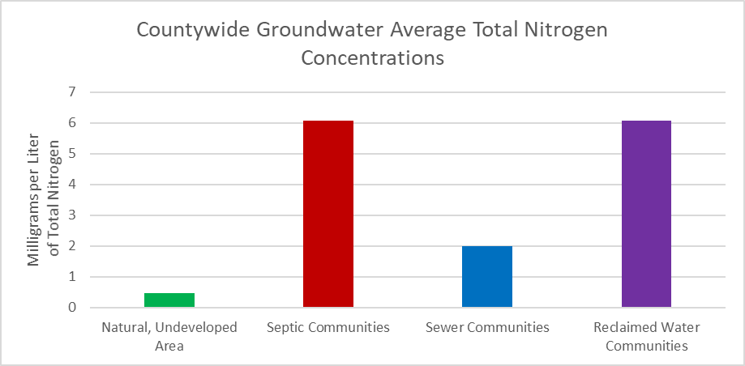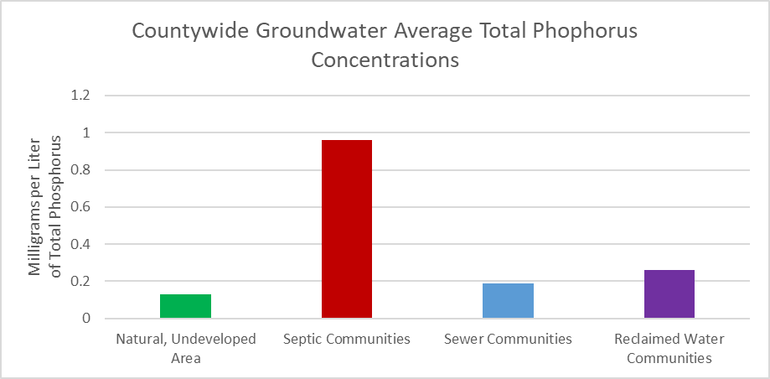
Figure 4-35. Countywide Groundwater Nutrient Concentrations for TN (top) and TP (bottom)
Figure 4-35 Long Description

Sewer Lateral Rehabilitation
Brevard County Utilities hired Kimley-Horn to conduct a sanitary sewer system smoke testing pilot study within the South Beaches service area in the City of Satellite Beach. The intent of the study was to use smoke testing to identify major contributors of stormwater into the sanitary sewer system and identify the necessary repairs. A smoke blowing machine that produces a non-toxic artificial “smoke” is used to pump smoke into the sewer system through an open manhole. As the smoke travels through the sanitary sewer system, it rises to the surface through any deficiencies in the lateral lines, such as cracks, leaks, and breaks. The South Beaches service area was selected because it had been experiencing elevated sanitary flow rates during storm events due to stormwater flow into the sanitary sewer through broken or missing infrastructure. Smoke testing was performed for the Phase 1 area in April and May 2018 for 5,165 properties. The testing identified 99 deficiencies of which there were 87 broken/missing cleanout caps, 9 broken lateral pipes, 2 damaged gravity sewer pipes, and 1 damaged manhole. Smoke testing was performed for the Phase 2 area in May and July 2018 for 7,592 properties. The testing identified 190 deficiencies of which there were 163 broken or missing cleanout caps, 21 broken lateral pipes, 1 storm connection, and 5 damaged manholes/gravity mains. The County purchased cleanout caps and replaced the damaged or missing caps that were identified, accessible, and had no damage to the cleanout port (Kimley Horn, 2018a and 2018b).
Based on the data collected during the pilot study, the Save Our Indian River Lagoon Trust Fund will cover the costs to repair up to 250 broken cleanout ports or missing caps and 30 broken private lateral lines. The estimated cost for these repairs is $646,200, which is well below the $840,000 budgeted for this project. The lessons learned from this pilot study will be applied to future sewer lateral evaluation and repair projects. Because the broken sewer pipes are buried, the potential repair costs are unknown. This unknown cost has dis-incentivized cash-limited homeowners from starting repairs in a timely manner. In response, Brevard County now has qualified plumbers that can be paid directly by the county to fix these repairs.
The preliminary results from performance data for this area noted that the groundwater sampled at seven of the eight lateral sites had evidence of sewage leaking out of the lateral when the groundwater table was low. Multiple sites had high nitrogen concentration values at or near the break locations, likely directly caused by a sewer leak. Most of the elevated phosphorus was in the readily bioavailable form of ortho-phosphorus (Applied Ecology, 2019). Additional sampling will be conducted after repairs are complete to verify improvements.
Additional smoke testing will take place in Titusville, Merritt Island, Barefoot Bay, and the South Beaches during 2022. The results from these efforts will add to these existing data to provide a more accurate average deficiency rate for private sewer laterals in Brevard County.

Septic System Removal
The Breeze Swept septic-to-sewer project in the City of Rockledge removed 143 septic systems installed between 1958 and 1967. This was the first septic-to-sewer conversion project to be undertaken as a strategic measure to reduce the nutrient loading to the IRL. During construction, the contractor noticed that many septic systems were already failing, which posed an increased health and environmental risk. The City of Rockledge authorized Applied Ecology to install five shallow groundwater monitoring wells in June 2017, three within the Breeze Swept community and two additional reference (i.e., control) wells in an adjacent septic community. Post-construction monitoring continued through summer 2019. There were 18 sampling events with a total of 90 samples collected. All samples were sent to a certified lab and analyzed for ammonia, nitrate-nitrite, total Kjeldahl nitrogen, and fecal coliform. The median ammonia, nitrate-nitrite, total Kjeldahl nitrogen, and mean TN concentrations from the post-construction samples taken from wells within the Breeze Swept community decreased with a statistically significant difference while the control wells showed no significant differences in median concentrations of nitrate-nitrite, total Kjeldahl nitrogen, and TN concentrations during the sampling period. These data provide a better understanding of the impact of septic systems on local water quality and help inform future septic-to-sewer conversion projects.
Construction costs for septic-to-sewer projects increased significantly since the original plan was developed in 2016. At that time, the estimated cost per lot for connection to gravity sewer was $20,000. This estimate included construction of the public and private side of the sewer, abandonment of the septic tank, connection fee, and restoration of the site. Based on 2018 actual and budgeted costs from within Brevard County and surrounding counties, the estimated cost per lot was previously increased to $33,372. Cost estimates have continued to increase due to construction inflation and supply-chain issues. Challenges associated with constructing sewer within old, narrow rights-of-way filled with existing utilities also drive up costs.
The project in the Breeze Swept community in the City of Rockledge, completed in 2017, cost $23,800 per lot. The West Melbourne Sylvan Estates project increased from an engineer’s estimate of $28,800 to an actual project cost of $41,212 per lot. Indian River County experienced a similar increase in costs for a sewer project in West Wabasso. Phase 1 of West Wabasso was approved in 2011 with an estimated cost of $20,348 per lot. Actual costs for construction in 2014 were $22,942 per lot. Cost estimates for phase 2 of West Wabasso are $46,269 per lot. The South Central C sewer project was recently contracted at $73,748 per lot.
There are many opportunities to remove septic systems in areas with existing sewer lines. The plan currently allocates $12,000 to these connection opportunities. Costs to connect to gravity lines were found to be consistent with this estimate; however, costs to connect to force main lines were more. In the 2019 Update, connection costs to force main sewer were increased to $18,000 to cover the cost of a grinder pump, the pump’s electrical connection, directional drilling of the lateral line, abandonment of the septic tank, connection fee, and restoration of the site.

Septic System Upgrades
The average cost of an upgraded septic system was increased from $16,000 to $18,000 in the 2019 Plan Update to reflect the more accurate cost to safely decommission the old tank and install the new tank and drainfield, electrical costs, and restoration of the site. Many of the oldest septic systems that are contributing the most loading to the lagoon do not comply with modern setbacks established by the Florida Department of Health. Bringing these septic systems to current standards in small lots is contributing to the higher average upgrade costs. The estimate of $16,000 is more accurate for new construction. For the 49 upgrades completed so far, the average cost was $18,353 (previously noted as $17,811 for the first eight completed upgrades).

Stormwater Treatment
Brevard County was awarded a grant to help upgrade multiple baffle boxes to second generation technology. Eight baffle boxes in Cocoa, Cape Canaveral, Melbourne, and Titusville were retrofitted with screens to collect larger items such as litter, leaves, and twigs from the stormwater entering the baffle box. Three of the baffle box projects were sampled twice each to estimate the pollutant removal effectiveness of the added screens. The baffle box projects chosen for sampling were Central Boulevard (City of Cape Canaveral), Church Street (City of Cocoa), and South Street (City of Titusville). By applying state-approved dry bulk density ratios to the volumes of material captured in the screens, nutrient removal was estimated to be 7.12 pounds of TN per year and 0.57 pounds of TP per year.

Muck Removal
Pre-project muck flux data have been collected by researchers at Florida Institute of Technology for more than 20 potential muck dredging sites. These data were considered with other available data to reprioritize muck dredging areas in the 2019 Update.
The goal of the muck removal program is to improve water quality and ecosystem health within the IRL. Muck removal benefits include reducing nitrogen, phosphorus, hydrogen sulfide, turbidity, pathogens, and contaminants; improving dissolved oxygen and pH; as well as uncovering clean, sandy sediments for recolonization by seagrass, shellfish, and a diversity of benthic marine life to support an abundant and productive food web. The St. Johns River Water Management District maintains several long-term water quality monitoring stations in the IRL, including one northeast of Brevard County's Turkey Creek muck removal project and one east of the St. Johns River Water Management District's Eau Gallie River and Elbow Creek restoration dredging project. Median turbidity values, measured monthly for 17.5 years at the St. Johns River Water Management District monitoring station near Turkey Creek, were 2.79 nephelometric turbidity units before dredging, 1.71 nephelometric turbidity units during dredging, and 2.26 nephelometric turbidity units for the three years of monthly data available after dredging. Median turbidity values, measured monthly for 25 years at the St. Johns River Water Management District monitoring station near Eau Gallie River and Elbow Creek, were 3.07 nephelometric turbidity units before dredging, 2.83 nephelometric turbidity units during dredging, and 1.61 nephelometric turbidity units for the two years of monthly data available after dredging. Although the median turbidity values are lower after dredging compared with before dredging, there is too much monthly variability in the data to determine if the water quality improvements are statistically significant. However, the data indicate no significant increase in turbidity during dredging.
In 2020, Tetra Tech prepared a document with lessons learned for the muck dredging projects implemented between 2014 and 2019. One lesson learned is that the thickness and extent of muck deposits is generally difficult to determine. Therefore, a combination of sediment probes to plan an optimum density and pattern of sediment cores can improve the accuracy of muck sediment isopach mapping. Another lesson learned was related to the use of polymers and flocculants. The contractor methods used at the Mims Boat Ramp did not work for performance-based specifications for nutrient removal. For future projects, more than just bench testing of the chemicals is needed and enhanced contract standards, developed by Brevard County, should be included in future project specifications. Muck sediments with high clay contents can be difficult to dewater. Design efforts should include bench testing of polymer additives to improve flocculation of the suspended sediments and the geotechnical testing of the dredged material slurry to help optimize the dewatering of the dredged material. Significant benefits to TP removal can be realized through the appropriate use of polymers (Tetra Tech, 2020).

In-lagoon Aeration Study
Dr. Austin Fox and Dr. John Trefry from the Florida Institute of Technology conducted two separate aeration studies in the northern IRL. The first studied microbubble aeration in two canals that were similar in bottom type and hydrology before aeration: (1) Anderson Canal (south of Anderson Court, Satellite Beach, Florida) was used as the control canal, and (2) Redwood Canal (south of Redwood Court, Satellite Beach, Florida) was used as the aeration canal. In the first study, from July 2017 to July 2018, microporous diffusers were installed at 50-meter intervals along the bottom of the aerated canal. An additional three diffusers were placed at the mouth the aerated canal, forming a bubble curtain to prevent any suspended material from being blown out of the canal. Water quality sampling was collected monthly for one year at the aeration and control sites. Microbubble aeration creates overturning vertical circulation of the water column, facilitating gas exchange at the water’s surface and from the bubbles themselves. In a separate second study using a similar experiment setup, aeration using nanobubbles (highly-concentrated dissolved oxygen) was studied from February 2019 to March 2020 in the canal off Turkey Creek along the Florida Institute of Technology Rivers Edge property. During the second study, highly-concentrated dissolved oxygen was injected directly into bottom water using six injection nozzles located at the bottom of the Rivers Edge Canal, with a control area adjacent to the aerated canal.
Results from the first study showed that aeration using microporous diffusers created a uniform concentration of dissolved oxygen vertically throughout the water column, whereas sites in the control (non-aerated) canal had high dissolved oxygen saturation at the surface and low to no dissolved oxygen saturation near the bottom. Nanobubble aeration used in the second study resulted in oversaturation of oxygen in bottom water without causing vertical mixing. Benthic fluxes of nitrogen and phosphorous showed similar seasonal variations between the aerated and control canals, except when the average nitrogen flux between February to April 2018 was 35% lower in the microbubble-aerated canal than in its control. It was also noted that the microbubble-aerated canal experienced recruitment of benthic infauna during winter months when oxygen was able to enter the sediment, but in the summer months when bacterial metabolism and oxygen demand was high, mortality of the recruits occurred. Muck thickness, volume, and dissolved nutrients did not significantly decrease and water clarity did not significantly improve using either the microbubble or nanobubble aeration techniques. Despite this, these two studies illustrated how aeration using microporous diffusers or highly concentrated dissolved oxygen can decrease benthic fluxes during cool months and how both types of aeration can increase bottom water dissolved oxygen in localized areas surrounding the aerators.
Brevard County conducted a separate aeration experiment in Sykes Creek (2576 Sykes Creek Drive, Merritt Island, Florida) from December 4–7, 2018. A commercial, floating, surface-pond aerator with no fountain was deployed in a fixed location. Dissolved oxygen levels were measured in 10-foot increments at a depth of two feet extending out from the aerator in both a northeast and southeast direction for 200 feet, before the aerator was turned on and after it was run continuously for three days (but before it was turned off and removed). The results showed dissolved oxygen concentrations near 100% saturation at 7.9–9.0 milligrams per liter before aeration began, and significantly higher (p<0.001), above 100% saturation, at 10.3–11.1 milligrams per liter at the end of the three-day experiment. Aeration using atmospheric air is only capable of bringing dissolved oxygen to 100% saturation. Therefore, although dissolved oxygen increased during aeration, the rise above 100% dissolved oxygen saturation suggests that aeration was not directly responsible for the significant increase in dissolved oxygen — it was likely due to increased photosynthetic activity in the area on the sunny December 7, relative to the overcast December 4. Wind direction in the area from December 4–7 (Time and Date, 2021) was consistently from the north, north-northwest, or northwest with similar low speeds (about 10 miles per hour), indicating similar physical parameters across the study days and that differences in weather conditions were mainly influenced by cloud cover before and during aeration.
Thus, both the Florida Institute of Technology studies and Brevard County experiment illustrated how aeration — whether from microbubbles, nanobubbles, or surface aeration — can help create small areas of refugia for benthic organisms against hypoxic events, although benefits are limited to localized areas surrounding the aerators.

Oyster Restoration and Planted Shorelines
Brevard County oyster bars are predominately built using mesh bags filled with oyster shell, known as cultch. They are typically two layers tall and, in some areas, are seeded with approximately 100 young adult oysters per square yard of the top layer. A University of Central Florida research team conducts independent monitoring of oyster bar projects, visually inspecting for oysters growing through the bags and cementing or “bridging” of adjacent oysters, and documenting the presence of predators, algal cover, and sedimentation. Additionally, a subsample of building units is emptied to quantify oyster survival, growth, recruitment, and the abundance as well as the diversity of fish and invertebrates living within the modules.
Monitoring results inform future decisions about oyster bar site selection, design, material type, and the need for seeding. Recruitment is necessary for oyster bars to sustain themselves without additional seeding. Significant recruitment of new oysters has been observed at nine of the 11 sites graphed in Figure 4-36 (University of Central Florida, 2020b). Ten of the 11 sites are reported in the University of Central Florida monitoring reports. Riverview Senior Center was funded with grants and is monitored by Brevard Zoo.
The formation of bridges between bags has been noted at Bomalaski and Marina Isles, two of the oldest sites. Comparison of data from multiple sites indicates that oyster bars located in narrow canals are exposed to more variable salinities and less recruitment and, although surviving oysters do grow, the numbers of live oysters declines over time (University of Central Florida, 2020a). In contrast, bars constructed in open waters of the lagoon have up to nine times as many oysters as initially seeded. Finally, two projects located within 500 feet of one another are being compared to determine the influence of initial seeding in the Central IRL (Ahmed/Niland and MacNeill/Pitner locations in Figure 4-36). At one year of age, recruitment and oyster density were similar at both sites, 10 and 12 settlers and 28 and 26 oysters per bag at the two sites, respectively.
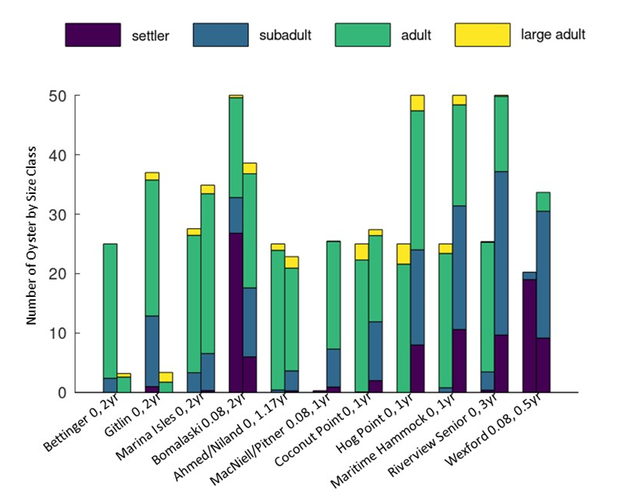
Figure 4-36. Distribution of Oyster Sizes, Age, and Average Number of Measured Oysters Per Unit
Figure 4-36 Long Description
The University of Central Florida has also monitored planted shorelines projects. Earlier projects (2018–2019) had higher success rates; 46–64% for red mangroves and 36–38% for sand cordgrass. In more recent projects, survival was initially similar to previous projects at equivalent ages. However, significant erosion was noted at two locations after fall 2020. Competition with terrestrial vegetation and erosion via waves and boat wakes are common causes of loss.
In response to concerns related to the breakdown of plastics in the environment, alternative oyster restoration materials are being examined. Six alternatives to using ultraviolet stabilized plastic mesh bags for securing loose oyster shell, are being tested at three locations in the IRL. With funding from the IRL National Estuary Program and collaborators from the University of Florida, Brevard County and Brevard Zoo Restore Our Shores team built test structures that will be monitored throughout an 18-month study. Modules were hung from docks and consist of controls (NaltexTM bags); two gauges of galvanized steel gabions; and multiple configurations of cement, oyster shell, and several natural materials including Community Oyster Reef Enhancement modules, jute-reinforced calcium sulfoaluminate Plastic-free Restoration of Oyster Shorelines units, and oyster balls. Monitoring of degradation, fouling, and oyster recruitment and growth occurs quarterly. Data collected will build on material testing results from other studies, while ensuring they will meet site-specific constraints of the IRL in Brevard County. In the first six months, the NaltexTM bags, Community Oyster Reef Enhancement modules, Plastic-free Restoration of Oyster Shorelines units, and gabions have had successful recruitment and growth of oysters, with gabions generally supporting the greatest number of oysters.
Data on oyster reef denitrification rates are very limited in Florida; therefore, a scientist with the University of Florida’s Institute of Food and Agricultural Sciences will sample sediment from three oyster bar projects, one each from the North IRL, Central IRL, and Banana River Lagoon. This work will build on a previous study conducted for Brevard County on intertidal oyster reefs of different ages within the Mosquito Lagoon (Schmidt and Gallagher, 2017). Improved analysis techniques will be employed on the subtidal oyster bars present in Brevard County to obtain sediment denitrification, percent organic matter, oxygen demand, and nitrate, ammonium, and phosphate flux rates across the sediment-water interface. The field component of this study has been completed and final results are expected by spring 2022.

Remote Sensing of Harmful Algal Blooms in IRL and Connected Waterways in Brevard County
The identification of algae bloom triggers and behaviors is vital to local efforts to manage the watershed. In 2021, Brevard County was awarded $290,972 from a Florida Department of Environmental Protection Water Protection Grant for development of innovative technologies to address harmful algal blooms. Brevard County will use remote sensing technologies as a cost-effective and encompassing approach to provide rapid identification of harmful algal bloom formation, determine the harmful algal bloom lifecycle, and identify hotspots of harmful algal bloom occurrences.
The scope of work includes the development, implementation, and analysis of satellite and unmanned aerial vehicle remote sensing of harmful algal blooms in the lagoon. The European Space Agency Sentinel-2 and Sentinel-3 satellites will be the primary sources of remote sensing data to provide Brevard County with weekly harmful algal bloom updates. Applied Ecology, Inc. will perform spatiotemporal statistical analysis of these harmful algal blooms and corresponding water quality parameters. Applied Ecology, Inc. will also fly an unmanned aerial vehicle equipped with a hyperspectral camera, which will provide high resolution imagery of the lagoon tributaries and canals as well as on-the-ground data to improve the analysis of the satellite imagery. The year of weekly mapping and data that will be collected and analyzed for this project will be made available to interested agencies and researchers through an ArcGIS Online webapp.

Research Needs
Although this project plan does not fund research, it should be recognized that many important research questions need attention. Universities, state agencies, and non-profit organizations are currently leading lagoon research efforts. This plan acknowledges the research needs identified in the Florida Department of Environmental Protection basin management action plans, St. Johns River Water Management District 2011 Superbloom Report, and Indian River Lagoon (IRL) National Estuary Program Comprehensive Conservation and Management Plan, which are summarized below.
- Research needs identified in the basin management action plans (Florida Department of Environmental Protection 2021a, 2021b, and 2021c):
  - Collect data to update the bathymetry for the IRL Basin, which would be used in evaluations of seagrass depth limits.
  - Continue coordinated monitoring of phytoplankton, periphyton, drift algae, and macroalgae in the basin to gain insights into the cycling of nutrients as well as toxin production and release.
  - Analyze storm event monitoring data at the major outfalls.
  - Refine load estimates delivered by baseflows and modeling the contributions of baseflows.
  - Synthesize data on nutrient flux/internal recycling of legacy nutrient loads held within IRL sediments and exchanged with the water column.
- Complete the development, calibration, and validation of a water quality model that can be used to design, site, and prioritize projects that reduce nutrient loads (e.g., Hydrologic Simulation Program FORTRAN or Spatial Watershed Iterative Loading model coupled with the Environmental Fluid Dynamics Code model, or another model that generates predictions of conditions that may be favorable for seagrass growth).
- Research needs identified in the Comprehensive Conservation and Management Plan revision (IRL National Estuary Program 2019):
- Undertake further studies to quantify the impacts of septic systems on the IRL with a focus on identifying high priority “problem” and “potential problem” areas.
- Develop, improve, and implement best management practices and education programs for stormwater management and freshwater discharges.
- Determine the impacts of atmospheric deposition of nutrients and other pollutants on the nutrient budget, water quality, and resources of the IRL.
- Support implementation, review, and update of IRL total maximum daily loads as needed and as best available science evolves.
- Work to continue, expand, update, and improve the IRL species inventory.
- Research and develop new and improved wetland best management practices with a focus on understanding wetland responses to sea level rise and climate change.
- Continue to support and expand research initiatives and coordinated finfish and shellfish management strategies specific to the IRL.
- Prepare a Risk-Based Vulnerability Assessment and Adaptation Plan for the IRL.
- Develop a comprehensive IRL monitoring plan.
- Advance the ten research priorities in the 2018 Looking Ahead – Science 2030 Report.
- Update the IRL economic analysis produced by the Treasure Coast and East Central Florida Regional Planning Councils every five years.
- Support advancements in hydrological model development, verification, and application.
- Continue evaluation of options to enhance water flow through engineering solutions that have well defined water quality and ecological outcomes.
- Complete muck mapping of the entire IRL, prioritize muck dredging projects and site selection for seagrass and filter feeder restoration projects, and reduce source contributions of sediment and biomass that result in muck formation.
- Track emerging technologies, innovative approaches or alternatives to dredging, muck capping, upstream controls of muck transport, more efficient approaches to dewatering, enhanced pollutant removal in post-dredge water, and enhanced muck management to improve process efficiency and identify beneficial uses of muck.
- Monitor and research to better understand contaminants of emerging concern within the IRL system.
- Research spatially explicit data on the extent and condition of existing filter feeder habitat.
- Research and report on science-based siting, planning, design, and construction criteria for living shorelines.
- Support research and assessment to identify and map suitable habitats and spawning habitats for forage fishes and track population size and health.
- Research needs identified in 2011 Superbloom Report (St. Johns River Water Management District 2016b):
- Garner an improved understanding of the ideal biological and physiological conditions and tolerances of picocyanobacteria (small cyanobacteria) and Pedinophyceae (green microflagellate), including their ability to use organic forms of nutrients, their ability to fix nitrogen, their nutrient uptake rates, their reproductive rates, and their defenses against grazers.
- Maintain or expand water quality sampling to ensure spatiotemporal variations are captured adequately, which could include continuous monitoring of various parameters to fill gaps between monthly samples.
- Develop an improved understanding of the physiological tolerances of drift algae and seagrasses, especially manmade conditions that could be mitigated to improve health or natural resilience.
- Maintain or expand surveys of drift algae and seagrasses to improve the capacity to evaluate their role in nutrient cycles.
- Improve the ability to model bottom-up influences from external and internal nutrient loads, including atmospheric deposition, surface water runoff, groundwater inputs, diffusive flux from muck, decomposition of drift algae, and cycling and transformation of nitrogen and phosphorus.
- Enhance surveys of bacterioplankton to improve the understanding of nutrient cycling.
- Improve surveys of potential zooplanktonic, infaunal, epifaunal, and fish grazers to enhance the understanding of spatiotemporal variation in top-down control of phytoplankton blooms.
- Evaluate grazing pressure exerted by common species to enhance the understanding of top-down control of phytoplankton blooms.

Unfunded Projects
Throughout initial development and annual updates of this plan, there have been projects considered that are not funded due to being less cost-effective than similar projects that were selected for funding. If some of the recommended projects in the plan receive funding from outside sources, such as grants or legislative appropriations, additional projects could be implemented using the Save Our Lagoon Trust Fund. If funding becomes available, the projects listed in Table 4-45 through Table 4-50 include numerous unfunded opportunities sorted by the next most cost-effective projects (based on total nitrogen [TN] and total phosphorus [TP] load reductions in pounds per year available for each major type of pollution reduction strategy.
Table 4-45: Unfunded Public Outreach and Education Projects
Project | Cost | Total Nitrogen Reductions (pounds per year) | Cost per Pound per year of Total Nitrogen Removed | Total Phosphorus Reductions (pounds per year) | Cost per Pound per Year of Total Phosphorus Removed
Irrigation Education | $300,000 | 1,530 | $196 | Not applicable | Not applicable
Stormwater Pond Best Management Practice Maintenance Education | $300,000 | 3,300 | $91 | 400 | $750
Total | $600,000 | 4,830 | $124 (average) | 400 | $1,500 (average)
Table 4-46: Unfunded Wastewater Treatment Facility Reclaimed Water Upgrade Projects
Facility | Cost to Upgrade | Total Nitrogen Removed after Attenuation (pounds per year) | Cost per Pound per Year of Total Nitrogen Removed | Total Phosphorus Removed after Attenuation (pounds per year) | Cost per Pound per Year of Total Phosphorus Removed
Cape Canaveral Air Force Station | $6,000,000 | 3,653 | $1,642 | To be determined | To be determined
Brevard County South Beaches | $6,000,000 | 2,860 | $2,098 | To be determined | To be determined
Brevard County South Central Regional | $6,000,000 | 2,053 | $2,923 | To be determined | To be determined
Brevard County Port St. John | $6,000,000 | 1,788 | $3,356 | To be determined | To be determined
Rockledge Wastewater Treatment Facility | $6,000,000 | 1,084 | $3,460 | To be determined | To be determined
Brevard Count Barefoot Bay Water Reclamation Facility | $6,000,000 | 1,597 | $5,535 | To be determined | To be determined
Total | $36,000,000 | 13,035 | $2,762 (average) | To be determined | To be determined
Table 4-47: Unfunded Package Plant Connection Projects
Facility Name | Number of Units | Cost to Connect to Sewer | Total Nitrogen Load Reduction (pounds per year) | Cost per Pound Per Year of Total Nitrogen Removed
Pelican Bay Mobile Home (also known as Riverview) | 200 | $1,028,802 | 537 | $1,916
Housing Authority of Brevard County | 26 | $451,375 | 230 | $1,963
Willow Lakes Recreational Vehicle Park | 280 | $1,822,750 | 680 | $2,681
River Grove I & II Mobile Home Park | 200 | $1,761,167 | 594 | $2,965
Sterling House Condominium | 45 | $660,445 | 203 | $3,253
Tropical Trail Village | 74 | $648,025 | 155 | $4,181
Lighthouse Cove | 80 | $1,182,706 | 216 | $5,463
River Forest Mobile Home Park | 130 | $725,029 | 131 | $5,520
Riverview Mobile Home and Recreational Vehicle Park | 110 | $763,933 | 130 | $5,876
South Shores Utility | 134 | $1,301,154 | 208 | $6,256
Palm Harbor Mobile Home Park | 130 | $728,858 | 94 | $7,754
Cove At South Beaches Condominium Association | 80 | $751,007 | 71 | $10,578
Treetop Villas | 28 | $1,157,797 | 48 | $24,121
Canebreaker Condo | 24 | To be determined | No data | To be determined
Enchanted Lakes Estates | 190 | To be determined | No data | To be determined
Camelot Recreational Vehicle Park Inc. | 178 | To be determined | No data | To be determined
Southern Comfort Mobile Home Park | 40 | To be determined | No data | To be determined
Summit Cove Condominium | 84 | To be determined | No data | To be determined
Total | 2,285 | $14,861,120 | 5,114 | $2,906 (average)
Table 4-48: Unfunded Sprayfield or Rapid Infiltration Basin Upgrade Projects
Facility | Type | Estimated Cost to Upgrade | Total Nitrogen Removed from Upgrade (pounds per year) | Cost per Pound per Year of Total Nitrogen Removed
Indian River Shores Trailer Park | Rapid Infiltration Basin | $38,145 | 193 | $198
Housing Authority of Brevard County | Rapid Infiltration Basin | $52,272 | 180 | $290
River Grove Mobile Home Village | Rapid Infiltration Basin | $182,299 | 493 | $370
South Shores Utility | Sprayfield | $300,564 | 771 | $390
Merritt Island Utility Company | Rapid Infiltration Basin | $495,277 | 1,135 | $436
Pelican Bay Mobile Home | Rapid Infiltration Basin | $222,156 | 446 | $498
Lighthouse Cove | Sprayfield | $120,000 | 180 | $667
River Forest Mobile Home Park | Sprayfield | $78,405 | 109 | $719
Cove At South Beaches Condominium Association | Sprayfield | $51,480 | 59 | $873
Tropical Trail Village | Rapid Infiltration Basin | $90,169 | 54 | $1,670
Treetop Villas | Sprayfield | $105,000 | 58 | $1,810
Riverview Mobile Home and Recreational Vehicle Park | Sprayfield | $333,234 | 108 | $3,086
Palm Harbor Mobile Home Park | Sprayfield | $300,564 | 78 | $3,853
Harris Malabar Facility | Rapid Infiltration Basin | $2,085,000 | 495 | $4,212
Enchanted Lakes Estates | Sprayfield | $36,000 | To be determined | To be determined
Camelot Recreational Vehicle Park Inc | Sprayfield | Unknown size | To be determined | To be determined
Southern Comfort Mobile Home Park | Rapid Infiltration Basin | To be determined | To be determined | To be determined
Space X Launch Complex 39A | Sprayfield | To be determined | To be determined | To be determined
Total | - | $4,550,565 | 4,513 | $1,008 (average)
Table 4-49: Unfunded Septic-to Sewer-Projects
Service Area | Number of Lots | Cost | Total Nitrogen Reduction (pounds per year) | Total Nitrogen Cost per Pound Per Year
Grant-Valkaria – Zone G | 30 | $1,001,160 | 1,418 | $706
Grant-Valkaria – Zone E | 128 | $4,271,616 | 5,862 | $729
Grant-Valkaria – Zone B | 34 | $1,134,648 | 1,501 | $756
Grant-Valkaria – Zone F | 17 | $567,324 | 688 | $824
Grant-Valkaria – Zone D | 18 | $600,696 | 690 | $871
Grant-Valkaria – Zone A | 42 | $1,401,624 | 1,296 | $1,082
Malabar – Zone B | 64 | $2,135,808 | 1,929 | $1,107
Grant-Valkaria – Zone C | 30 | $1,001,160 | 853 | $1,173
Malabar – Zone A | 430 | $14,349,960 | 11,456 | $1,253
Valkaria – Zone I | 223 | $7,441,956 | 5,380 | $1,383
South Beaches – Zone F | 3 | $100,116 | 70 | $1,435
Valkaria – Zone J | 503 | $16,786,116 | 11,507 | $1,459
Malabar – Zone C | 14 | $467,208 | 289 | $1,617
South Central – Zone B | 180 | $6,006,960 | 3,700 | $1,623
Sharpes – Zone B | 136 | $4,538,592 | 2,692 | $1,686
South Beaches – Zone E | 387 | $12,914,964 | 7,491 | $1,724
Rockledge – Zone C | 91 | $3,036,852 | 1,736 | $1,749
South Beaches – Zone K | 21 | $700,812 | 397 | $1,765
North Merritt Island – Zone F | 34 | $1,550,000 | 830 | $1,867
North Merritt Island – Zone D | 29 | $1,293,000 | 685 | $1,888
City of West Melbourne | 60 | $2,002,320 | 1,041 | $1,923
Pineda | 27 | $1,257,000 | 644 | $1,952
Sykes Creek – Zone IJ | 77 | $1,900,000 | 62 | $1,974
South Beaches – Zone L | 178 | $5,940,216 | 2,973 | $1,998
Sykes Creek – Zone J | 63 | $2,102,436 | 1,028 | $2,045
South Banana – Zone A | 88 | $3,025,000 | 1,444 | $2,095
South Central – Zone BC | 13 | $1,222,000 | 582 | $2,100
South Beaches – Zone G | 112 | $3,737,664 | 1,764 | $2,119
City of West Melbourne – Zone B | 60 | $2,002,320 | 894 | $2,240
Malabar – Zone D | 24 | $800,928 | 352 | $2,278
North Merritt Island – Zone A | 107 | $4,245,000 | 1,821 | $2,331
South Beaches – Zone D | 89 | $2,970,108 | 1,273 | $2,333
South Central – Zone E | 411 | $13,715,892 | 5,761 | $2,381
South Beaches – Zone M | 334 | $11,146,248 | 4,293 | $2,596
Grant-Valkaria – Zone H | 100 | $3,337,200 | 1,272 | $2,624
Malabar – Zone F | 14 | $467,208 | 174 | $2,683
Melbourne Village – Zone B | 224 | $7,475,328 | 2,705 | $2,763
Sykes Creek – Zone H | 74 | $2,469,528 | 887 | $2,783
South Central – Zone I | 72 | $2,170,000 | 772 | $2,811
Sykes Creek – Zone G | 52 | $1,735,344 | 602 | $2,881
South Beaches – Zone N | 103 | $3,437,316 | 1,193 | $2,882
Sykes Creek – Zone C | 81 | $2,703,132 | 929 | $2,909
Melbourne Village – Zone A | 85 | $2,836,620 | 918 | $3,091
South Central – Zone H | 165 | $5,506,380 | 1,779 | $3,096
South Central – Zone G | 196 | $6,540,912 | 2,090 | $3,129
North Merritt Island – Zone C | 71 | $2,369,412 | 737 | $3,217
Merritt Island – Zone H | 285 | $22,500,000 | 5,464 | $4,118
Sykes Creek – Zone S | 164 | $6,600,000 | 1,584 | $4,167
North Merritt Island – Zone B | 56 | $4,690,000 | 1,066 | $4,399
Merritt Island – Zone A | 249 | $16,700,000 | 3,440 | $4,855
South Beaches – Zone C | 118 | $3,937,896 | 683 | $5,763
Total | 6,166 | $232,843,980 | 111,598 | $2,086 (average)

Table 4-50: Unfunded Muck Dredging and Interstitial Treatment Projects
Sub-Lagoon | Indian River Lagoon Muck Sites | Dredging Cost Estimate | Interstitial Water Treatment Cost | Total Cost | Total Nitrogen Reduction (pounds per year) | Cost per Pound of Total Nitrogen Removed | Total Phosphorus Reduction (pounds per year) | Cost per Pound of Total Phosphorus Removed
Banana | Cocoa Beach Golf (unfunded portion)* | $12,775,000 | $1,941,800 | $14,716,800 | Not applicable | Not applicable | Not applicable | Not applicable
Central IRL | Goat Creek | $350,000 | $50,819 | $400,819 | 735 | $545 | 98 | $4,090
North IRL | Pineda to Eau Gallie | $30,625,000 | $4,446,705 | $35,071,705 | 34,965 | $1,003 | 1,554 | $22,569
North IRL | 520 to Pineda | $31,500,000 | $4,573,754 | $36,073,754 | 35,280 | $1,022 | 1,568 | $23,006
Central IRL | Mullet Creek Islands Area | $4,550,000 | $660,653 | $5,210,653 | 4,305 | $1,210 | 574 | $9,078
North IRL | National Aeronautics and Space Administration Causeway West | $4,375,000 | $635,244 | $5,010,244 | 3,903 | $1,284 | 193 | $25,960
North IRL | Pineda | $5,250,000 | $762,292 | $6,012,292 | 4,610 | $1,304 | 492 | $12,220
Banana | Kent Drive | $1,750,000 | $254,097 | $2,004,097 | 1,365 | $1,468 | 182 | $11,012
Banana | National Aeronautics and Space Administration Area | $98,000,000 | $14,229,457 | $112,229,457 | 68,985 | $1,627 | 9,198 | $12,202
Banana | 528 East | $1,225,000 | $177,868 | $1,402,868 | 840 | $1,670 | 112 | $12,526
North IRL | North IRL Venetian Canals/Channels | $13,475,000 | $1,956,551 | $15,431,551 | 9,160 | $1,685 | 1,243 | $12,415
Banana | Newfound Harbor East | $1,575,000 | $228,688 | $1,803,688 | 1,050 | $1,718 | 140 | $12,883
Banana | Banana Venetian Collector Canals/Channels | $119,000,000 | $17,278,627 | $136,278,627 | 78,960 | $1,726 | 10,927 | $12,472
Banana | Patrick Space Force Base Borrow Pit-2 | $4,725,000 | $686,063 | $5,411,063 | 3,045 | $1,777 | 406 | $13,328
Banana | Newfound Harbor South | $4,725,000 | $686,063 | $5,411,063 | 3,045 | $1,777 | 406 | $13,328
Banana | Mathers Bridge Area | $12,250,000 | $1,778,682 | $14,028,682 | 7,875 | $1,781 | 1,050 | $13,361
North IRL | Max Brewer Causeway | $2,800,000 | $406,556 | $3,206,556 | 1,785 | $1,796 | 238 | $13,473
Banana | Newfound Harbor North | $3,150,000 | $457,375 | $3,607,375 | 1,995 | $1,808 | 266 | $13,562
Banana | Cocoa Beach High School | $6,825,000 | $990,980 | $7,815,980 | 4,305 | $1,816 | 574 | $13,617
Central IRL | Central IRL Venetian Collector Canals/Channels | $6,300,000 | $914,750 | $7,214,750 | 3,904 | $1,848 | 537 | $13,435
Banana | Brightwaters | $8,225,000 | $1,194,258 | $9,419,258 | 5,040 | $1,869 | 672 | $14,017
Banana | Patrick Space Force Base Borrow Pit-4 | $525,000 | $76,229 | $601,229 | 315 | $1,909 | 42 | $14,315
Banana | Sunset Café | $3,850,000 | $559,014 | $4,409,014 | 2,310 | $1,909 | 308 | $14,315
Banana | 520 Borrow Pit-1 | $1,400,000 | $203,278 | $1,603,278 | 840 | $1,909 | 112 | $14,315
Banana | Cape Canaveral Hospital | $2,100,000 | $304,917 | $2,404,917 | 1,260 | $1,909 | 168 | $14,315
Banana | 520 Borrow Pit-2 | $700,000 | $101,639 | $801,639 | 420 | $1,909 | 56 | $14,315
Banana | 520 Borrow Pit-3 | $525,000 | $76,229 | $601,229 | 315 | $1,909 | 42 | $14,315
Banana | 520 Borrow Pit-4 | $1,400,000 | $203,278 | $1,603,278 | 840 | $1,909 | 112 | $14,315
Banana | 520 Borrow Pit-5 | $1,050,000 | $152,458 | $1,202,458 | 630 | $1,909 | 84 | $14,315
Banana | 520 Borrow Pit-6 | $525,000 | $76,229 | $601,229 | 315 | $1,909 | 42 | $14,315
Banana | 520 Borrow Pit-7 | $700,000 | $101,639 | $801,639 | 420 | $1,909 | 56 | $14,315
Central IRL | Trout Creek | $175,000 | $25,410 | $200,410 | 105 | $1,909 | 14 | $14,315
Central IRL | Melbourne Causeway North | $875,000 | $127,049 | $1,002,049 | 525 | $1,909 | 70 | $14,315
Central IRL | Front St Park | $875,000 | $127,049 | $1,002,049 | 525 | $1,909 | 70 | $14,315
North IRL | Warwick Dr | $700,000 | $101,639 | $801,639 | 420 | $1,909 | 56 | $14,315
North IRL | Crab Shack | $700,000 | $101,639 | $801,639 | 420 | $1,909 | 56 | $14,315
Banana | Port Canaveral | $9,275,000 | $1,346,716 | $10,621,716 | 4,988 | $2,129 | 245 | $43,354
North IRL | Cocoa South | $5,250,000 | $762,292 | $6,012,292 | 1,947 | $3,088 | 182 | $33,035
Central IRL | Turkey Creek | $4,900,000 | $711,473 | $5,611,473 | 1,750 | $3,207 | 231 | $24,292
North IRL | National Aeronautics and Space Administration Causeway to 528 | $16,625,000 | $2,413,926 | $19,038,926 | 4,694 | $4,056 | 313 | $60,827
North IRL | Rockledge A | $29,575,000 | $4,294,247 | $33,869,247 | 8,093 | $4,185 | 1,184 | $28,606
North IRL | Eau Gallie Northwest | $19,145,000 | $2,779,826 | $21,924,826 | 3,207 | $6,837 | 244 | $89,856
North IRL | Cocoa 520-528 | $3,850,000 | $559,014 | $4,409,014 | 599 | $7,361 | 40 | $110,225
North IRL | Eau Gallie South | $40,250,000 | $5,844,241 | $46,094,241 | 4,144 | $11,123 | 777 | $59,323
- | Total | $518,420,000 | $75,360,713 | $593,780,713 | 314,234 | $1,890 (average) | 35,032 | $16,961 (average)
*Note: The funding for the Cocoa Beach Golf project is the balance of funding needed to fully implement this project. Brevard County is looking for sources of funding for this balance.

Project Funding

Project Funding, Schedule, and Scope Adjustments

Contingency Fund Reserve
The 2018 Update established a Contingency Fund Reserve (Reserve) that will be included with the development and adoption of the County’s budget each fiscal year. The Reserve will amount to inflation plus 5% of the total Trust Fund dollars that are budgeted for all approved projects scheduled to occur or move ahead in that fiscal year. This includes projects in the Save Our Indian River Lagoon Project Plan (Plan), including additions captured in annual updates or supplements. The purpose of the Reserve is to fund emergency response to harmful algal blooms and major fish kills; cover reasonable funding shortfalls that may occur during project implementation and would delay implementation or completion of that project unless a ready source of funds is on hand; provide funding for projects (whether during the term of the project or upon project completion) that remove additional nutrients beyond the amount originally planned or anticipated in the project cost-share agreement; or move projects forward ahead of schedule if ready to proceed.
The Reserve includes an additional amount of funding to account for the impact of inflation on project delivery costs. Inflation is estimated by applying the Consumer Price Index to project costs, compounded for the number of years between the year the project cost was estimated and the year that the project is expected to be constructed. Since 2016, the Consumer Price Index has varied between 1.3% and 3.25%, with a high of 6.8% in 2021. For the 2022 Plan Update, inflation is applied and compounded annually for the years between when a project was added to the plan and when its construction is now anticipated. For projects that are not yet completed, an inflation factor of 2.5% is applied for Years 0–3, 6.8% for Year 4, and 5.9% for Years 5–10.
If a cost increase for an individual project is less than 10% of the amount identified in the project’s cost-share agreement or the estimated cost or eligible amount of Trust Fund cost-share stated in the Save Our Indian River Lagoon Project Plan, as updated, then additional funding from the Reserve may be allocated to the project, as needed, in accordance with Brevard County approvals, policies, and administrative orders. For projects that are contracted with government entities and other partners that encounter cost overruns, the cost-share agreement may be increased up to 10% over the eligible cost-share amount stated in Attachment E of the respective cost-share agreement. Such an amendment will be executed by the authorized County representative and the appropriate representative or authorized agent of the government entity or partnering organization.
For project cost increases that are more than 10% above the amount identified in the project's cost-share agreement or the estimated cost or eligible amount of Trust Fund cost-share stated in the Save Our Indian River Lagoon Project Plan, as updated, County staff will evaluate the project circumstances and present findings to the Citizen Oversight Committee for review. The Committee will recommend rejection, modification, or approval of the funding request and provide such recommendation to the County representative authorized to sign the amendment. Staff will provide the Committee’s recommendation to the County representative authorized to sign the request based on the authority granted by the County Commission.
The Reserve may also be used to increase funding for approved projects (whether during the term of the project or upon project completion) that provide greater nutrient reduction benefits than planned or anticipated if funding could be made available before the next Plan update. If a project can be or was expanded or altered to provide greater nutrient reduction benefits than planned, contingency funds can be allocated at the rate for that project type established in the most recently adopted Plan update in the table titled “Cost-share Offered for Project Requests Submitted for the 2022 Update" (Table 4-41). In no case shall the governmental entity or partnering organization request Reserve funds that result in the total cost-share award exceeding the actual project costs incurred by the recipient, minus other grants or donations for that project.
Amendments to the project cost-share agreements shall follow one of the two approval processes identified below:
- If a cost increase for an individual project is less than 10% of the cost identified in the project’s cost-share agreement, then the authorized County representative is eligible to review and, if acceptable, approve an amendment to the project cost-share agreement.
- If a cost increase for an individual project is more than 10% of the cost identified in the project’s cost-share agreement, then County staff will bring the item before the Citizen Oversight Committee for a recommendation to reject, modify, or approve the funding request. This recommendation will then be brought to the authorized County representative for review and, if acceptable, approval of an amendment to the project cost-share agreement.

Schedule Acceleration
If a project has already been approved by the County Commission and is: (1) ready to move forward earlier than scheduled in the Plan; (2) consistent with temporal sequencing goals in the Plan; and (3) recommended by the Citizen Oversight Committee, and if there are sufficient Trust Fund dollars available for the project, then the County Manager (for budget changes less than $100,000) or County Commission (in any circumstance) are authorized to adjust the project schedule to ensure that approved projects funded in the Plan move forward as soon as feasible. This authority allows projects to move forward as soon as they are ready and funding is available.

Scope Reduction
If a project is not able to be fully completed as initially approved in the Plan due to extenuating circumstances including, but not limited to, permitting restrictions, loss of additional funding, or other situations beyond the entity’s control, then the project may be downsized, within the framework of the already-approved project, and upon recommendation by the Citizen Oversight Committee. This recommendation will then be brought to the authorized County representative for review and, if acceptable, approval of an amendment to the costs and scope of the project’s cost-share agreement. The revised funding amount will be based on the pounds of nitrogen removal estimated for the reduced project multiplied by the eligible cost-share per pound of total nitrogen removed that is adopted for that project type in the most recent Save Our Indian River Lagoon Project Plan. If a project is downsized between Plan updates, the revised Plan costs and nutrient load reductions will be reflected in the next annual Plan update.

Revenue Projection Update
Brevard County calculated a new estimate for Save Our Indian River Lagoon Sales Tax revenues. This estimate is based on the actual revenues for 2017, 2018, 2019, 2020, and the first nine months of 2021. The October, November, and December 2020 revenues were used to estimate the revenue for the remaining three months of 2021 by using a rate of growth of 6.8%. The estimate then uses a rate of growth of 4.0% for 2022 and 3.0% for future years compounded over the remaining life of the tax. The new estimate for the total tax revenue is $542,223,794, or an average of $54.2 million per year. This current estimate is $20.2 million per year more than the $34 million per year estimate in the original Save Our Indian River Lagoon Plan, which was based on 2016 dollars, and $5.3 million per year more than the projection in the 2021 Plan Update.

Project Funding Allocations
Figure 5-1 summarizes the funding allocated by category (Reduce, Remove, Restore, and Respond) in this 2022 Plan Update. Figure 5-1 shows the funding allocations by project type from the original plan through the 2022 Plan Update.
Figure 5-1: Funding for Reduce, Remove, Restore, and Respond Projects

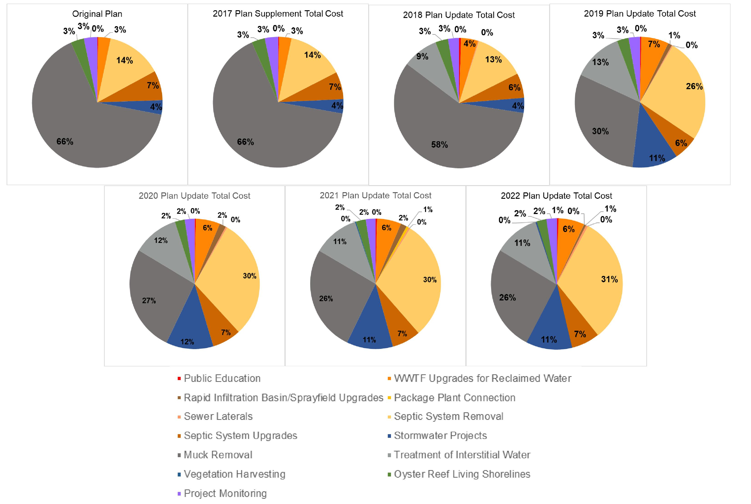
Figure 5-2: Evolution of Project Funding Allocations
Figure 5-2 Long Description

Summary of the Plan through the 2022 Update

Progress Toward the Local Targets for Maximum Total Loads
The County has been working with its municipalities, Florida Department of Transportation District 5, and Patrick Space Force Base to update total loading estimates to the lagoon and revise the total maximum daily loads for nitrogen and phosphorus using the best available data and more detailed modeling than previously available. Based on this process, five-month total maximum daily loads, which target the load reductions needed during the seagrass growing period (January – May), were proposed in addition to annual total maximum daily loads that protect water quality year-round. These load reductions specifically target water quality conditions needed for restoring lagoon seagrass beds to provide crucial habitat for fish and other marine life. Therefore, as this Save Our Indian River Lagoon Project Plan was developed, the total nitrogen (TN) and total phosphorus (TP) reductions from the project types that Reduce incoming load were compared to the proposed five-month total maximum daily loads for each sub-lagoon. After satisfying the five-month total maximum daily loads, annual load reductions for each project were compared to the 12-month total maximum daily loads. In all cases, the projects identified to meet the five-month total maximum daily loads were sufficient to meet the proposed 12-month total maximum daily loads. As projects are implemented, progress toward meeting the five-month and full-year total maximum daily loads are being tracked.
Only the projects that reduce external loading to the lagoon, not muck removal or living shorelines, were used to meet the total maximum daily loads. Even though decades of treatment projects to reduce nutrient loads have been completed to date, only the reductions associated with basin management action plan projects that were completed between January 1, 2010 (the last year of the Spatial Watershed Iterative Loading model period) and February 29, 2016 (the end of the last basin management action plan reporting period when the Save Our Indian River Lagoon Project Plan was developed) were included in the load reduction calculations as these projects also provide nutrient load reductions that have occurred after the period of record used to develop the proposed total maximum daily load updates. In Zone A of the Central Indian River Lagoon (IRL), the reductions from the St. Johns River Water Management District’s C-1 re-diversion project, which was implemented with cost-share funding from the Florida Department of Environmental Protection and Brevard County, were also included as this project results in significant load reductions that were not included in the February 29, 2016 basin management action plan annual progress report. As shown in Table 6-1, Table 6-3, and Table 6-5, the projects proposed in this plan plus the recently completed basin management action plan projects and C-1 re-diversion project exceed the five-month reductions called for by the proposed total maximum daily load updates.
The total project reductions were also compared to the full year estimated loading to the lagoon from the Spatial Watershed Iterative Loading model. As shown in Table 6-2, Table 6-4, and Table 6-6, the proposed projects in this plan, as well as the recently completed basin management action plan projects and C-1 re-diversion project, achieve significant reductions of the overall loading to the lagoon and exceed the full year reductions called for by the proposed local total maximum daily loads).
Table 6-1: Banana River Lagoon Project Reductions to Meet Five-Month Total Maximum Daily Load
Project | Total Nitrogen Reductions (pounds per year) | Total Phosphorus Reductions (pounds per year)
Fertilizer Ordinance Implementation | 2,945 | 603
Future Education | 1,853 | 129
Wastewater Treatment Facility Upgrade for Reclaimed Water | 1,050 | 285
Sewer Laterals | 412 | 78
Septic System Removal | 13,090 | 0
Septic System Upgrade | 806 | 0
Stormwater Projects | 14,106 | 2,238
Vegetation Harvesting | 999 | 78
Basin Management Action Plan Projects (2010-February 2016) | 5,303 | 1,440
Total | 40,564 | 4,851
Proposed Total Maximum Daily Load Reductions (five-month) | 30,337 | 2,737
Percent of Proposed Total Maximum Daily Load Reductions Achieved | 133.7% | 177.2%
Table 6-2: Banana River Lagoon Project Reductions Compared to Full Year Loading
Project | Total Nitrogen Reductions (pounds per year) | Total Phosphorus Reductions (pounds per year)
Fertilizer Ordinance Implementation | 7,068 | 1,446
Future Education | 4,447 | 310
Wastewater Treatment Facility Upgrade for Reclaimed Water | 2,520 | 685
Sewer Laterals | 988 | 188
Septic System Removal | 31,417 | 0
Septic System Upgrade | 1,934 | 0
Stormwater Projects | 65,757 | 8,564
Vegetation Harvesting | 2,398 | 187
Basin Management Action Plan Projects (2010-February 2016) | 12,726 | 3,456
Total | 129,255 | 14,836
Starting Load (full year) | 477,020 | 44,269
Percent of Starting Load Reduced | 27.1% | 33.5%
Proposed Full-Year Total Maximum Daily Load Percent Reductions | 9.0% | 9.6%

Table 6-3: North IRL Project Reductions to Meet Five-Month Total Maximum Daily Load
Project | Total Nitrogen Reductions (pounds per year) | Total Phosphorus Reductions (pounds per year)
Fertilizer Ordinance Implementation | 8,070 | 1,651
Future Education | 5,078 | 354
Wastewater Treatment Facility Upgrade for Reclaimed Water | 7,355 | To be determined
Sewer Laterals | 1,118 | To be determined
Package Plant Connection | 647 | To be determined
Septic System Removal | 23,306 | 0
Septic System Upgrade | 5,774 | 0
Stormwater Projects | 38,810 | 6,525
Vegetation Harvesting | 517 | 66
Basin Management Action Plan Projects (2010-February 2016) | 16,983 | 3,180
Total | 107,658 | 11,776
Proposed Total Maximum Daily Load Reductions (five-month) | 61,447 | 7,410
Percent of Proposed Total Maximum Daily Load Reductions Achieved | 175.2% | 158.9%
Table 6-4: North IRL Project Reductions Compared to Full Year Loading
Project | Total Nitrogen Reductions (pounds per year) | Total Phosphorus Reductions (pounds per year)
Fertilizer Ordinance Implementation | 19,368 | 3,962
Future Education | 12,187 | 849
Wastewater Treatment Facility Upgrade for Reclaimed Water | 17,651 | To be determined
Sewer Laterals | 2,682 | To be determined
Package Plant Connection | 1,553 | To be determined
Septic System Removal | 55,935 | 0
Septic System Upgrade | 13,857 | 0
Stormwater Projects | 157,527 | 22,573
Vegetation Harvesting | 1,240 | 159
Basin Management Action Plan Projects (2010-February 2016) | 40,758 | 7,632
Total | 322,758 | 35,175
Starting Load (full year) | 988,847 | 99,340
Percent of Starting Load Reduced | 32.6% | 35.4%
Proposed Full-Year Total Maximum Daily Load Percent Reductions | 11.4% | 11.4%

Table 6-5: Central IRL Project Reductions to Meet Five-Month Total Maximum Daily Load
Project | Total Nitrogen Reductions (pounds per year) | Total Phosphorus Reductions (pounds per year)
Fertilizer Ordinance Implementation | 8,108 | 1,659
Future Education | 5,102 | 356
Wastewater Treatment Facility Upgrade for Reclaimed Water | 20,688 | 5,448
Sewer Laterals | 1,053 | To be determined
Rapid Infiltration Basin/Sprayfield | 132 | To be determined
Package Plant Connection | 188 | To be determined
Septic System Removal | 12,496 | 0
Septic System Upgrade | 9,246 | 0
Stormwater Projects | 15,158 | 2,104
Vegetation Harvesting | 6,932 | 693
C-1 Re-Diversion | 53,892 | 6,295
Basin Management Action Plan Projects (2010-February 2016) | 378 | 243
Total | 133,373 | 16,798
Proposed Total Maximum Daily Load Reductions (five-month) * | 67,547 | 8,151
Percent of Proposed Total Maximum Daily Load Reductions Achieved | 197.5% | 206.1%
* The total maximum daily load reductions are for Zone A only; however, some of the septic system projects are in Zone SEB. There are sufficient projects to achieve the Zone A reductions without the Zone SEB projects (refer to Section 2.1).
Table 6-6: Central IRL Project Reductions Compared to Full Year Loading
Project | Total Nitrogen Reductions (pounds per year) | Total Phosphorus Reductions (pounds per year)
Fertilizer Ordinance Implementation | 19,460 | 3,981
Future Education | 12,245 | 854
Wastewater Treatment Facility Upgrade for Reclaimed Water | 49,652 | 13,075
Sewer Laterals | 2,526 | To be determined
Rapid Infiltration Basin/Sprayfield | 317 | To be determined
Package Plant Connection | 450 | To be determined
Septic System Removal | 29,991 | 0
Septic System Upgrade | 22,190 | 0
Stormwater Projects | 47,886 | 6,313
Vegetation Harvesting | 16,636 | 1,664
C-1 Re-Diversion | 129,341 | 15,108
Basin Management Action Plan Projects (2010-February 2016) | 908 | 582
Total | 331,602 | 41,577
Starting Load (full year) * | 698,937 | 95,051
Percent of Starting Load Reduced | 47.4% | 43.7%
Proposed Full-Year Total Maximum Daily Load Percent Reductions | 17.8% | 16.3%
* The total maximum daily load reductions are for Zone A only; however, some of the septic system are in Zone SEB. There are sufficient projects to achieve the Zone A reductions without the Zone SEB projects (refer to Section 2.1).
In addition to the projects that address the external nutrient loading summarized above, the plan includes muck flux, interstitial water treatment, oyster bars, and planted shoreline projects that will significantly reduce internal nutrient loading within the lagoon itself. The annual reductions from these projects are summarized in Table 6-7, along with the percentage of nutrients from 2018 estimates of muck flux that would be reduced by these projects.
Table 6-7: Annual Muck Flux, Muck Interstitial Water, Oyster Bar, and Planted Shoreline Project Benefits Compared to Annual Nutrient Loadings from Muck Flux
Project Type | Banana River Lagoon Total Nitrogen (pounds per year) | Banana River Lagoon Total Phosphorus (pounds per year) | North IRL Total Nitrogen (pounds per year) | North IRL Total Phosphorus (pounds per year) | Central A Total Nitrogen (pounds per year) | Central A Total Phosphorus (pounds per year)
Muck Flux Reduction | 142,855 | 13,463 | 59,882 | 4,190 | 5,691 | 221
Average Annual Removal of Nutrients from Interstitial Water | 39,361 | 1,967 | 9,072 | 825 | 69 | 0
Oyster Bars | 10,369 | 320 | 10,599 | 272 | 3,731 | 188
Clams | 423 | 0 | 432 | 0 | 145 | 0
Planted Shorelines | 91 | 31 | 236 | 81 | 217 | 74
Total Project Reductions | 193,099 | 15,781 | 80,221 | 5,368 | 9,853 | 483
Estimated Muck Flux Loading | 393,948 | 43,216 | 247,078 | 17,583 | 16,927 | 2,277
Percent of Muck Flux Reduced | 49.0% | 36.5% | 32.5% | 30.5% | 58.2% | 21.2%

Plan Summary
Table 6-8 summarizes all the project types, as well as their estimated costs, total nitrogen (TN) and total phosphorus (TP) reductions, and costs per pound of TN and TP removed. The information from this table on the project reductions and cost effectiveness was used to determine the schedule for implementing the projects (see Table 6-9). Projects that could achieve large reductions quickly, such as fertilizer reductions and wastewater treatment facility upgrades, as well as the most cost-effective septic-to-sewer, and stormwater projects were prioritized for earliest implementation. This prioritization allows for the reductions to occur as quickly as possible while best using available funding sources. Project scheduling also considered the timing of upstream reductions with downstream removals, where feasible.
The timeline in Table 6-9 is shown in years after funding from the Save Our Indian River Lagoon sales tax became available. Each year corresponds to the County’s fiscal year, which is October 1st through September 30th. Year 1 started on October 1, 2017, which was just before revenues would have begun to accrue if the funding source had been a property tax, as initially considered. When the referendum approved by the voters was a sales tax, collections began in January 2017 and the first revenue check was received by the County in March 2017. Therefore, a plan update was adopted in March 2017 to begin plan implementation in Year 0. Table 6-9 includes the cost estimates developed as part of the original plan or provided in the year new or substitute projects were added to the plan.
As noted in Section 4.4.1, an adaptive management approach is being used in the implementation of this plan. As projects are completed and information on the actual construction costs, timeline, and reductions are obtained, the plan will continue to be adjusted, as needed, to ensure that the most cost-effective projects are being used to meet the Indian River Lagoon (IRL) restoration goals.
Table 6-8: Summary of Projects, Estimated TN and TP Reductions, and Costs
Project Number | Project | Save Our Lagoon Project Cost | Total Nitrogen Reductions (pounds per year) | Cost per Pound per Year of Total Nitrogen | Total Phosphorus Reductions (pounds per year) | Cost per Pound per Year of Total Phosphorus
- | Public Education | - | - | - | - | -
58a | Expanded Fertilizer Education | $625,000 | 6,613 | $95 | 813 | $769
58b | Grass Clippings Campaign | $200,000 | 17,800 | $11 | 1,200 | $167
58c | Septic System Maintenance Education | $300,000 | 4,466 | $67 | To be determined | To be determined
193 | Oyster Gardening Program | $300,000 | Not applicable | Not applicable | Not applicable | Not applicable
227 | Restore Our Shores: Community Collaborative | $1,000,000 | Not applicable | Not applicable | Not applicable | Not applicable
- | Wastewater Treatment Facility Upgrades for Reclaimed Water | - | - | - | - | -
99 | Cocoa Beach Water Reclamation Facility Upgrade | $945,000 | 2,520 | $375 | 685 | $1,380
2016-02a | City of Titusville Osprey Wastewater Treatment Facility | $8,800,000 | 8,660 | $1,016 | Not applicable | Not applicable
2016-17 | City of Palm Bay Water Reclamation Facility | $3,636,900 | 20,240 | $180 | 102 | $35,656
59 | City of Melbourne Grant Street Water Reclamation Facility | $6,769,500 | 18,052 | $375 | 9,671 | $700
2016-2b | City of Titusville Osprey Nutrient Removal Upgrade Phase 2 | $300,000 | 3,626 | $83 | Not applicable | Not applicable
138 | Ray Bullard Water Reclamation Facility Biological Nutrient Removal Upgrades | $4,260,000 | 11,360 | $375 | 3,302 | $1,290
216 | City of Rockledge Flow Equalization Basin Project | $2,054,795 | 5,365 | $383 | Not applicable | Not applicable
- | Rapid Infiltration Basin/Sprayfield Upgrades | - | - | - | - | -
6 | Long Point Park Upgrade | $22,207 | 163 | $136 | To be determined | To be determined
196 | Sterling House Condominium Sprayfield | $60,000 | 154 | $390 | To be determined | To be determined
- | Package Plant Connection | - | - | - | - | -
202 | Merritt Island Utility Company | $1,349,445 | 1,367 | $987 | To be determined | To be determined
192 | Oak Point Wastewater Treatment Facility Improvements | $279,000 | 186 | $1,500 | 0 | Not applicable
228 | Indian River Shores Trailer Park Wastewater Treatment Facility | $528,627 | 450 | $1,175 | To be determined | To be determined
- | Sewer Laterals | - | - | - | - | -
63ab | Satellite Beach Lateral Smoke Testing and Countywide Repair/Replacement | $840,000 | 988 | $850 | 188 | $4,468
100 | Osprey Basin Lateral Smoke Testing | $200,000 | 640 | Not applicable | Not applicable | Not applicable
114 | Barefoot Bay Lateral Smoke Testing | $90,000 | 864 | Not applicable | Not applicable | Not applicable
115 | South Beaches Lateral Smoke Testing | $200,000 | 1,662 | Not applicable | Not applicable | Not applicable
116 | Merritt Island Lateral Smoke Testing | $250,000 | 2,042 | Not applicable | Not applicable | Not applicable
- | Septic System Removal by Sewer Extension | - | - | - | - | -
47 | Sykes Creek - Zone N | $4,176,000 | 2,784 | $1,500 | To be determined | To be determined
48 | Sykes Creek - Zone M | $2,697,000 | 1,798 | $1,500 | To be determined | To be determined
146 | Merritt Island - Zone C | $1,580,000 | 1,419 | $1,113 | To be determined | To be determined
49 | Sykes Creek - Zone T | $5,040,000 | 3,360 | $1,500 | To be determined | To be determined
2016-29 | South Banana - Zone B | $1,372,500 | 915 | $1,500 | To be determined | To be determined
145 | Merritt Island - Zone F | $1,100,000 | 1,292 | $851 | To be determined | To be determined
147 | Sykes Creek - Zone R | $4,387,500 | 2,925 | $1,500 | To be determined | To be determined
148 | North Merritt Island - Zone E | $3,811,500 | 2,541 | $1,500 | To be determined | To be determined
151 | Merritt Island - Zone G | $16,617,000 | 11,078 | $1,500 | To be determined | To be determined
2016-30 | City of Rockledge | $500,580 | 712 | $703 | To be determined | To be determined
2016-31/32 | City of Cocoa - Zones and J K | $5,622,000 | 3,748 | $1,500 | To be determined | To be determined
109 | City of Titusville - Zones A-G | $1,201,392 | 1,563 | $769 | To be determined | To be determined
150 | South Central - Zone D (Brevard County) | $4,774,500 | 3,387 | $1,410 | To be determined | To be determined
2016-28 | South Central - Zone D (Melbourne) | $265,500 | 177 | $1,500 | To be determined | To be determined
50b | South Central - Zone C | $6,600,000 | 5,146 | $1,283 | To be determined | To be determined
203 | South Central - Zone A | $5,482,500 | 3,655 | $1,500 | To be determined | To be determined
2016-33 | City of Melbourne | $867,672 | 878 | $988 | To be determined | To be determined
2020-34 | South Central - Zone F | $1,701,972 | 1,688 | $1,008 | To be determined | To be determined
2016-27 | Sharpes - Zone A | $7,872,000 | 5,248 | $1,500 | To be determined | To be determined
2016-35 | South Beaches - Zone A | $1,959,000 | 1,306 | $1,500 | To be determined | To be determined
2016-36 | South Beaches - Zone O | $133,488 | 136 | $982 | To be determined | To be determined
2016-37 | South Beaches - Zone P | $300,348 | 242 | $1,241 | To be determined | To be determined
2016-38 | City of Titusville - Zone H | $1,168,020 | 910 | $1,284 | To be determined | To be determined
2016-40 | Rockledge - Zone B | $5,339,520 | 4,037 | $1,323 | To be determined | To be determined
1 | Breeze Swept Septic-to-Sewer Connection | $880,530 | 2,002 | $440 | To be determined | To be determined
2 | Merritt Island Septic Phase Out Project | $320,268 | 2,501 | $128 | To be determined | To be determined
61 | Riverside Drive Septic-to-Sewer Conversion | $262,044 | 305 | $859 | To be determined | To be determined
62 | Roxy Avenue Septic-to-Sewer Conversion | $88,944 | 102 | $872 | To be determined | To be determined
152 | Sharpes - Zone B | $4,038,000 | 2,692 | $1,500 | To be determined | To be determined
153 | Cocoa - Zone C | $800,000 | 3,499 | $1,500 | To be determined | To be determined
190 | Bowers Septic-to-Sewer | $147,000 | 120 | $1,225 | To be determined | To be determined
191 | Kent and Villa Espana Septic-to-Sewer Conversion | $710,000 | 542 | $1,310 | To be determined | To be determined
2016-39 | City of Palm Bay – Zone A | $2,569,644 | 2,136 | $1,203 | To be determined | To be determined
2016-46 | City of Palm Bay – Zone B | $8,309,628 | 6,809 | $1,220 | To be determined | To be determined
4 | Hoag Sewer Conversion | $86,031 | 101 | $852 | To be determined | To be determined
5 | Pennwood Sewer Conversion | $81,000 | 103 | $786 | To be determined | To be determined
60 | Sylvan Estates Septic-to-Sewer Conversion | $1,561,215 | 1,073 | $1,455 | To be determined | To be determined
136 | Micco - Zone B | $9,000,000 | 8,687 | $1,036 | To be determined | To be determined
3 | Micco Sewer Line Extension (Phase I and II) | $2,239,500 | 1,493 | $1,500 | To be determined | To be determined
189 | Avendia del Rio Septic-to-Sewer | $70,000 | 71 | $986 | To be determined | To be determined
224 | Lake Ashley Circle | $1,704,000 | 1,136 | $1,500 | To be determined | To be determined
225 | Dundee Circle and Manor Place | $2,248,500 | 1,499 | $1,500 | To be determined | To be determined
- | Septic System Removal by Sewer Connection | - | - | - | - | -
2016-16 | Banana Septic System 144 Quick Connections | $1,905,729 | 3,224 | $591 | To be determined | To be determined
2016-18 | North IRL Septic System 463 Quick Connections | $6,018,000 | 11,339 | $531 | To be determined | To be determined
2016-19 | Central IRL Septic System 269 Quick Connections | $3,354,000 | 6,883 | $487 | To be determined | To be determined
222 | Hedgecock/Grabowsky and Desoto Fields | $39,447 | 81 | $487 | To be determined | To be determined
- | Septic System Upgrades | - | - | - | - | -
51 | Banana River Lagoon 100 Septic System Upgrades | $1,800,000 | 1,934 | $931 | To be determined | To be determined
52 | North IRL 586 Septic System Upgrades | $10,548,000 | 13,857 | $761 | To be determined | To be determined
53 | Central IRL 939 Septic System Upgrades | $16,885,106 | 22,190 | $761 | To be determined | To be determined
- | Stormwater Projects | - | - | - | - | -
- | Banana River Lagoon 68 Basin Projects | $14,324,135 | 63,450 | $226 | 8,311 | $1,724
13 | Central Boulevard Baffle Box | $34,700 | 481 | $72 | 14 | $2,479
16 | Gleason Park Reuse | $4,224 | 48 | $88 | 9 | $469
64 | Stormwater Low Impact Development Convair Cove 1 – Blakey Boulevard | $4,650 | 30 | $155 | 3 | $1,550
65 | Stormwater Low Impact Development Convair Cove 2- Dempsey Drive | $4,495 | 29 | $155 | 3 | $1,498
66 | Big Muddy at Cynthia Baffle Box | $41,695 | 269 | $155 | 48 | $869
66b | Big Muddy at Cynthia Baffle Box Expansion | $17,936 | 167 | $107 | 10 | $1,794
85 | Basin 1304 Bioreactor | $83,029 | 958 | $87 | 127 | $654
128 | Jackson Court Stormwater Treatment Facility | $8,266 | 56 | $148 | 8 | $1,033
179 | Lori Laine Basin Pipe Improvement Project | $17,525 | 117 | $150 | 21 | $835
215 | Basin 960 Pioneer Road Denitrification | $38,850 | 105 | $370 | 3 | $12,950
219 | McNabb Outfall Bioretention | $19,423 | 44 | $441 | 7 | $2,775
221 | Burris Way Alley West Stormwater Low Impact Development | $1,249 | 3 | $416 | 0 | Not applicable
- | North IRL 95 Basin Projects | $22,114,028 | 112,154 | $197 | 14,662 | $1,508
14 | Church Street Type II Baffle Box | $88,045 | 937 | $94 | 135 | $652
18 | Denitrification Retrofit of Johns Road Pond | $105,512 | 1,199 | $88 | To be determined | To be determined
19 | St. Teresa Basin Treatment | $272,800 | 3,100 | $88 | 459 | $594
20 | South Street Basin Treatment | $86,856 | 987 | $88 | 156 | $557
21 | La Paloma Basin Treatment | $208,296 | 2,367 | $88 | 346 | $602
22 | Kingsmill-Aurora Phase Two | $367,488 | 4,176 | $88 | 814 | $451
23 | Denitrification Retrofit of Huntington Pond | $104,720 | 1,190 | $88 | To be determined | To be determined
24 | Denitrification Retrofit of Flounder Creek Pond | $75,328 | 856 | $88 | To be determined | To be determined
34 | Cliff Creek Baffle Box | $347,781 | 3,952 | $88 | 797 | $436
35 | Thrush Drive Baffle Box | $322,200 | 3,661 | $88 | 773 | $417
69 | Apollo/GA Baffle Box | $297,522 | 3,381 | $88 | 479 | $621
89 | Basin 1298 Bioreactor | $85,829 | 917 | $94 | 116 | $740
90 | Johns Road Pond Biosorption Activated Media | $23,030 | 245 | $94 | 37 | $622
91 | Burkholm Road Biosorption Activated Media | $64,390 | 685 | $94 | 104 | $619
92 | Carter Road Biosorption Activated Media | $62,510 | 665 | $94 | 101 | $619
93 | Wiley Avenue Biosorption Activated Media | $82,735 | 954 | $87 | 144 | $575
94 | Broadway Pond Biosorption Activated Media | $42,864 | 456 | $94 | 69 | $621
95 | Cherry Street Baffle Box | $306,740 | 980 | $313 | 174 | $1,763
96 | Spring Creek Baffle Box | $330,841 | 1,057 | $313 | 232 | $1,426
97 | Titusville High School Baffle Box | $111,813 | 1,190 | $94 | 166 | $674
98 | Coleman Pond Managed Aquatic Plant System | $11,438 | 1,240 | $9 | 198 | $58
110 | Osprey Plant Pond Managed Aquatic Plant Systems | $37,500 | 606 | $62 | 88 | $426
117 | Basin 10 County Line Road Woodchip Bioreactor | $72,773 | 597 | $122 | 90 | $809
118 | Basin 26 Sunset Avenue Serenity Park Woodchip Bioreactor | $73,810 | 605 | $122 | 92 | $802
119 | Basin 141 Irwin Avenue Woodchip Bioreactor | $69,174 | 567 | $122 | 86 | $804
120 | Draa Field Pond Managed Aquatic Plant Systems | $31,281 | 256 | $122 | 38 | $823
122 | Basin 22 Hunting Road Serenity Park Woodchip Bioreactor | $40,077 | 329 | $122 | 50 | $802
124 | Floating Wetlands to Existing Stormwater Ponds | $1,497 | 12 | $125 | 3 | $499
125 | Diamond Square Stormwater Pond | $10,383 | 85 | $122 | 23 | $451
127 | Basin 5 Dry Retention | $16,680 | 113 | $148 | 18 | $927
129 | Forrest Avenue 72-inch Outfall Baseflow Capture/Treatment | $13,956 | 94 | $148 | 12 | $1,163
169 | Basin 1335 (Sherwood Park) Stormwater Quality Project | $392,108 | 3,214 | $122 | 879 | $446
174 | St. Johns 2 Baffle Box | $243,070 | 1,992 | $122 | 611 | $398
175 | High School Baffle Box | $144,326 | 1,183 | $122 | 319 | $452
176 | Funeral Home Baffle Box | $58,682 | 481 | $122 | 129 | $455
177 | North and South Lakemont Ponds Floating Wetlands | $13,054 | 107 | $122 | 25 | $522
178 | Marina B Managed Aquatic Plant Systems | $6,670 | 55 | $121 | 7 | $953
- | Central IRL 8 Basin Projects | $3,258,500 | 19,832 | $164 | 2,617 | $1,245
15 | Bayfront Stormwater Project | $30,624 | 348 | $88 | 83 | $369
67 | Grant Place Baffle Box | $82,481 | 937 | $88 | 193 | $427
68 | Crane Creek/M-1 Canal Flow Restoration | $2,033,944 | 23,113 | $88 | 2,719 | $748
87 | Fleming Grant Biosorption Activated Media | $56,588 | 602 | $94 | 91 | $622
88 | Espanola Baffle Box | $105,186 | 1,119 | $94 | 148 | $711
121 | Basin 2258 Babcock Road Woodchip Bioreactor | $50,203 | 412 | $122 | 62 | $810
123 | Ray Bullard Water Reclamation Facility Stormwater Management Area | $160,674 | 1,317 | $122 | 400 | $402
213 | Johnson Junior High Denitrification Media Chamber Modification | $64,478 | 206 | $313 | Not applicable | Not applicable
214 | Sand Point Park Baffle Box | $137,135 | 438 | $313 | 71 | $1,931
220 | Basin 1398 Sand Dollar Canal Bioreactor | $198,024 | 444 | $446 | 70 | $2,829
- | Vegetation Harvesting | - | - | - | - | -
111 | Draa Field Vegetation Harvesting | $86,413 | 786 | $110 | 99 | $872.86
112 | County Wide Stormwater Pond Harvesting | $14,000 | 140 | $100 | 28 | $500
171 | Mechanical Aquatic Vegetation Harvesting | $1,011,976 | 16,636 | $61 | 1,664 | $608
172 | Horseshoe Pond Vegetative Harvesting | $8,140 | 74 | $110 | 7 | $1,163
173 | North and South Lakemont Ponds Vegetation Harvesting | $1,980 | 18 | $110 | 4 | $495
208 | Maritime Hammock Preserve Stormwater Pond Harvesting | $7,700 | 70 | $110 | 5 | $1,540
209 | Basin 1398 Sand Dollar Canal Harvesting | $24,420 | 222 | $110 | 21 | $1,163
210 | Basin 958 Pioneer Road Vegetation Harvesting | $39,930 | 363 | $110 | 47 | $850
211 | Cocoa Beach Golf Course Stormwater Ponds Harvesting | $216,150 | 1965 | $110 | 135 | $1,601
- | Muck Removal | - | - | - | - | -
2016-10a | Canaveral South | $14,700,000 | 35,382 | $415 | 1,925 | $7,636
2016-5a | Pineda Banana River Lagoon | $6,825,000 | 15,033 | $454 | 686 | $9,949
2016-11a | Patrick Space Force Base | $7,175,000 | 6,497 | $1,104 | 382 | $18,783
168a | Cocoa Beach Golf | $21,350,000 | 29,694 | $719 | 2,058 | $10,374
41a | Grand Canal Muck | $2,626,600 | 10,469 | $251 | 1,396 | $1,882
42a | Sykes Creek Muck | $4,705,428 | 19,635 | $240 | 2,618 | $1,797
70a | Cocoa Beach Muck Dredging – Phase III | $1,376,305 | 4,095 | $336 | 780 | $1,764
71 | Merritt Island Muck Removal – Phase 1 | $7,733,517 | 8,085 | $957 | 1,540 | $5,022
72a | Muck Removal of Indian Harbour Beach Canals | $3,631,815 | 3,780 | $961 | 720 | $5,044
101 | Cocoa Beach Muck Dredging Phase II-B | $5,917,650 | 6,300 | $939 | 840 | $7,045
144 | Satellite Beach Muck Dredging | $1,884,225 | 3,885 | $485 | 518 | $3,638
2016-06a | Titusville Railroad West | $3,150,000 | 14,406 | $219 | 588 | $5,357
2016-07a | National Aeronautics and Space Administration Causeway East | $9,975,000 | 21,872 | $456 | 1,047 | $9,527
2016-04a | Rockledge A | $4,375,000 | 7,581 | $577 | 825 | $5,303
2016-08a | Titusville Railroad East | $4,025,000 | 5,393 | $746 | 227 | $17,731
54a | Eau Gallie Northeast | $8,750,000 | 10,476 | $835 | 1,482 | $5,904
2016-3a | Muck Re-dredging in Turkey Creek | $137,329 | 5,691 | $24 | 221 | $621
223 | Spring Creek Dredging | $80,080 | 154 | $520 | 21 | $3,813
- | Treatment of Interstitial Water | - | - | - | - | -
40 | Mims Muck Removal: Outflow Water Nutrient Removal | $0 | 2,803 | Not applicable | 244 | Not applicable
2016-10b | Canaveral South | $2,134,419 | 42,688 | $50 | 3,887 | $549
2016-5b | Pineda Banana River Lagoon | $990,980 | 19,820 | $50 | 1,804 | $549
2016-11b | Patrick Space Force Base | $1,041,800 | 20,836 | $50 | 1,897 | $549
168b | Cocoa Beach Golf | $3,013,100 | 99,098 | $30 | 9,022 | $334
41b | Grand Canal Interstitial | $15,610,821 | 89,495 | $174 | To be determined | To be determined
42b | Sykes Creek Interstitial | $11,248,704 | 64,278 | $175 | To be determined | To be determined
72b | Muck Interstitial Water Treatment for Indian Harbour Beach Canals | $5,483,600 | 27,418 | $200 | To be determined | To be determined
113 | Satellite Beach Interstitial Water Treatment | $3,057,756 | 29,978 | $102 | 3,059 | $1,000
2016-06b | Titusville Railroad West | $457,375 | 9,148 | $50 | 833 | $549
2016-07c | National Aeronautics and Space Administration Causeway East | $1,448,355 | 28,967 | $50 | 2,637 | $549
2016-04b | Rockledge A | $635,244 | 12,705 | $50 | 1,157 | $549
2016-08b | Titusville Railroad East | $584,424 | 11,688 | $50 | 1,064 | $549
54b | Eau Gallie Northeast | $1,270,487 | 25,410 | $50 | 2,313 | $549
2016-3b | Muck Interstitial Water Treatment for Turkey Creek | Included in muck project | Not applicable | Not applicable | 688 | Not applicable
- | Oyster Bars | - | - | - | - | -
2016-55 | Banana River Lagoon County Oyster Bars | $3,102,755 | 7,864 | $395 | 197 | $15,750
75 | Marina Isles Oyster Bar | $26,700 | 60 | $445 | 20 | $1,335
76 | Bettinger Oyster Bar | $10,680 | 24 | $445 | 8 | $1,335
78a | McNabb Park Oyster Bar | $34,056 | 72 | $473 | 24 | $1,419
79 | Gitlin Oyster Bar | $16,020 | 36 | $445 | 12 | $1,335
104 | Brevard Zoo Banana River Oyster Project | $583,020 | 1,476 | $395 | 37 | $15,757
141 | Brevard Zoo Banana River Oyster Project 2 | $264,800 | 662 | $400 | 17 | $15,576
143 | Brevard Zoo Oyster Reef Adjustments Banana River | $12,800 | 32 | $400 | 1 | $12,800
188 | Brevard Zoo Banana River Oyster Project 3 | $56,771 | 143 | $397 | 4 | $14,193
2016-56 | North IRL County Oyster Bars | $2,885,834 | 7,314 | $395 | 183 | $15,770
83 | Bomalaski Oyster Bar | $8,900 | 20 | $445 | 7 | $1,271
106 | Brevard Zoo North IRL Oyster Project | $341,280 | 864 | $395 | 22 | $15,513
139 | Brevard Zoo North IRL Oyster Project 2 | $336,400 | 841 | $400 | 21 | $16,019
142 | Brevard Zoo Oyster Reef Adjustments North IRL | $27,200 | 68 | $400 | 2 | $13,600
184 | Brevard Zoo North Indian River Lagoon Oyster Project 3 | $419,232 | 1,056 | $397 | 26 | $16,124
186 | Brevard Zoo North Indian River Lagoon Individual Oyster Project | $173,092 | 436 | $397 | 11 | $15,736
80 | Coconut Point/Environmentally Endangered Lands Oyster Bar | $45,120 | 96 | $470 | 2 | $22,560
81 | Wexford Oyster Bar | $31,150 | 70 | $445 | 24 | $1,298
82a | Riverview Park Oyster Bar | $108,790 | 230 | $473 | 78 | $1,395
73 | Riverview Senior Resort Oyster Bar | $30,304 | 77 | $394 | 2 | $15,152
105 | Brevard Zoo Central IRL Oyster Project | $161,160 | 408 | $395 | 10 | $16,116
140 | Brevard Zoo Central IRL Oyster Project 2 | $270,800 | 677 | $400 | 17 | $15,929
185 | Brevard Zoo Central Indian River Lagoon Tributary Pilot Oyster Project | $230,657 | 581 | $397 | 15 | $15,377
187 | Brevard Zoo Central Indian River Lagoon Oyster Project 3 | $86,546 | 218 | $397 | 5 | $17,309
217 | Central IRL Oyster Project 4 | $138,156 | 348 | $397 | 9 | $15,351
218 | Central Oyster Project Offshore Reefs | $357,300 | 900 | $397 | 23 | $15,535
226 | Hog Point Offshore Oyster Bar | $50,022 | 126 | $397 | 3 | $16,674
- | Planted Shorelines | - | - | - | - | -
77a | Cocoa Beach Country Club Planted Shoreline | $16,080 | 67 | $240 | 23 | $699
78b | McNabb Park Planted Shoreline | $5,760 | 24 | $240 | 8 | $720
103 | Brevard Zoo North IRL Plant Project | $720 | 3 | $240 | 1 | $720
130 | Brevard Zoo North IRL Plant Project 2 | $9,840 | 41 | $240 | 14 | $703
180 | Scottsmoor Impoundment | $10,560 | 44 | $240 | 15 | $704
181 | Riveredge | $4,080 | 17 | $240 | 6 | $680
212 | Titusville Causeway Multi-Trophic Restoration and Living Shoreline | $31,440 | 131 | $240 | 45 | $699
77b | Lagoon House Shoreline Restoration Planting | $24,000 | 100 | $240 | 34 | $706
82b | Riverview Park Planted Shoreline | $18,480 | 77 | $240 | 26 | $711
133 | Fisherman's Landing | $4,800 | 20 | $240 | 7 | $686
135 | Rotary Park | $4,800 | 20 | $240 | 7 | $686
- | Clam Restoration | - | - | - | - | -
194 | Aquaculture Stimulus Program | $60,000 | 1,000 | $60 | To be determined | To be determined
- | Projects Monitoring | $10,000,000 | - | - | - | -
- | Contingency | $19,814,425 | - | - | - | -
- | Inflation | $104,840,456 | - | - | - | -
 | Total | $542,223,582 | 1,272,989 | $426 (average) | 102,866 | $5,271 (average)

Table 6-9: Timeline for Funding Needs (Table 46 in the Original Save Our Indian River Lagoon Project Plan)
Project Name/Total Project Cost | Year 0 (Fiscal Year 2016-2017) | Year 1 (Fiscal Year 2017-2018) | Year 2 (Fiscal Year 2018-2019) | Year 3 (Fiscal Year 2019-2020) | Year 4 (Fiscal Year 2020-2021) | Year 5 (Fiscal Year 2021-2022) | Year 6 (Fiscal Year 2022-2023) | Year 7 (Fiscal Year 2023-2024) | Year 8 (Fiscal Year 2024-2025) | Year 9 (Fiscal Year 2025-2026) | Year 10 (Fiscal Year 2026-2027)
Public Education | - | - | - | - | - | - | - | - | - | - | -
Fertilizer Management | - | Year 1 of Program* | Year 2 of Program* | Year 3 of Program* | Year 4 of Program* | Year 5 of Program | Year 6 of Program | Year 7 of Program | Year 8 of Program | Year 9 of Program | Year 10 of Program
$625,000 | - | $0 | $120,951 | $49,477 | $46,571 | $61,601 | $100,000 | $61,600 | $61,600 | $61,600 | $61,600
Grass Clippings | - | Year 1 of Program* | Year 2 of Program* | Year 3 of Program* | Year 4 of Program* | Year 5 of Program | Year 6 of Program | Year 7 of Program | Year 8 of Program | Year 9 of Program | Year 10 of Program
$200,000 | - | $0 | $20,000 | $0 | $6,638 | $31,561 | $31,561 | $31,560 | $31,560 | $23,560 | $23,560
Septic System Maintenance | - | Year 1 of Program* | Year 2 of Program* | Year 3 of Program* | Year 4 of Program* | Year 5 of Program | Year 6 of Program | Year 7 of Program | Year 8 of Program | Year 9 of Program | Year 10 of Program
$300,000 | - | $0 | $48,380 | $49,245 | $22,709 | $29,945 | $29,945 | $29,945 | $29,945 | $29,943 | $29,943
Oyster Gardening | - | - | - | Year 1 of Program* | Year 2 of Program* | - | - | - | - | - | -
$300,000 | - | - | - | $150,000 | $150,000 | - | - | - | - | - | -
Restore Our Shores | - | - | - | - | - | Year 1 of Program | Year 2 of Program | Year 3 of Program | Year 4 of Program | Year 5 of Program | Year 6 of Program
$1,000,000 | - | - | - | - | - | $100,000 | $200,000 | $200,000 | $200,000 | $200,000 | $100,000
Wastewater Treatment Facility Upgrades | - | - | - | - | - | - | - | - | - | - | -
Banana River Lagoon | - | - | Cocoa Beach* | - | - | - | - | - | - | - | -
$945,000 | - | - | $945,000 | - | - | - | - | - | - | - | -
North IRL | - | - | - | Titusville Osprey Design and Permitting | Titusville Osprey Design and Start Construction | Titusville Osprey Construction | - | - | - | - | -
$8,000,000 | - | - | - | $1,000,000 | $3,000,000 | $4,000,000 | - | - | - | - | -
North IRL | - | - | - | - | Osprey Nutrient Upgrade Phase 2 | Rockledge Flow Equalization Basin | - | - | - | - | -
$2,354,795 | - | - | - | - | $300,000 | $2,054,795 | - | - | - | - | -
Central IRL | - | Palm Bay Permit and Engineering | Palm Bay Construction | Palm Bay Construction | - | - | - | - | - | - | -
$3,636,900 | - | $200,000 | $1,200,000 | $2,236,900 | - | - | - | - | - | - | -
Central IRL | - | - | - | Melbourne Grant Street | - | - | - | - | - | - | -
$6,769,500 | - | - | - | $6,769,500 | - | - | - | - | - | - | -
Central IRL | - | - | - | Ray Bullard Biological Nutrient Removal | - | - | - | - | - | - | -
$4,260,000 | - | - | - | $4,260,000 | - | - | - | - | - | - | -
Rapid Infiltration Basin/ Sprayfield Upgrades | - | - | - | - | - | - | - | - | - | - | -
North IRL | - | - | - | - | - | Sterling House Condominium | - | - | - | - | -
$60,000 | - | - | - | - | - | $60,000 | - | - | - | - | -
Central IRL | Long Point* | - | - | - | - | - | - | - | - | - | -
$22,207 | $22,207 | - | - | - | - | - | - | - | - | - | -
Package Plant Connections | - | - | - | - | - | - | - | - | - | - | -
North IRL | - | - | - | - | Oak Point | - | - | - | - | - | -
$279,000 | - | - | - | - | $279,000 | - | - | - | - | - | -
Central IRL | - | - | - | - | - | - | Merritt Island Utility | - | - | - | -
$1,349,445 | - | - | - | - | - | - | $1,349,445 | - | - | - | -
Central IRL | - | - | - | - | - | Indian River Shores Trailer Park | - | - | - | - | -
$528,627 | - | - | - | - | - | $528,627 | - | - | - | - | -
Sewer Laterals | - | - | - | - | - | - | - | - | - | - | -
Banana River Lagoon | - | - | - | - | Satellite Beach Smoke Testing and Countywide Repairs | - | - | - | - | - | -
$840,000 | - | - | - | - | $840,000 | - | - | - | - | - | -
North IRL | - | - | Titusville Osprey Basin | - | - | - | - | - | - | - | -
$200,000 | - | - | $200,000 | - | - | - | - | - | - | - | -
North IRL | - | - | - | Merritt Island Lateral Smoke Testing | - | - | - | - | - | - | -
$250,000 | - | - | - | $250,000 | - | - | - | - | - | - | -
Central IRL | - | - | - | Barefoot Bay Lateral Smoke Testing | - | - | - | - | - | - | -
$90,000 | - | - | - | $90,000 | - | - | - | - | - | - | -
Central IRL | - | - | - | South Beaches Lateral Smoke Testing | - | - | - | - | - | - | -
$200,000 | - | - | - | $200,000 | - | - | - | - | - | - | -
Septic Removal | - | - | - | - | - | - | - | - | - | - | -
Banana River Lagoon | Sykes M Engineering | - | Sykes Creek M | - | - | - | - | - | - | - | -
$2,697,000 | $250,000 | - | $2,447,000 | - | - | - | - | - | - | - | -
Banana River Lagoon | - | Sykes Creek N | - | - | - | - | - | - | - | - | -
$4,176,000 | - | $4,176,000 | - | - | - | - | - | - | - | - | -
Banana River Lagoon | Sykes T Engineering | - | - | Sykes Creek T | - | - | - | - | - | - | -
$5,040,000 | $250,000 | - | - | $4,790,000 | - | - | - | - | - | - | -
Banana River Lagoon | - | - | - | - | South Banana B Engineering | South Banana B | - | - | - | - | -
$1,372,500 | - | - | - | - | $275,000 | $1,097,500 | - | - | - | - | -
Banana River Lagoon | - | - | - | - | Quick Connects* | Quick Connects | Quick Connects | Quick Connects | - | - | -
$1,905,729 | - | - | - | - | $24,000 | $700,000 | $700,000 | $481,729 | - | - | -
Banana River Lagoon | - | - | - | - | Merritt Island C Engineering | Merritt Island C | Merritt Island C | - | - | - | -
$1,580,000 | - | - | - | - | $145,000 | $717,500 | $717,500 | - | - | - | -
Banana River Lagoon | - | - | - | - | Merritt Island F Engineering | - | Merritt Island F | - | - | - | -
$1,100,000 | - | - | - | - | $100,000 | - | $1,000,000 | - | - | - | -
Banana River Lagoon | - | - | - | - | Sykes Creek R Engineering | - | - | Sykes Creek R | - | - | -
$4,387,500 | - | - | - | - | $320,000 | - | - | $4,067,500 | - | - | -
Banana River Lagoon | - | - | - | - | Merritt Island G Engineering | - | - | - | Merritt Island G | - | -
$16,617,000 | - | - | - | - | $1,650,000 | - | - | - | $14,967,000 | - | -
Banana River Lagoon | - | - | - | - | North Merritt Island E Engineering | - | North Merritt Island E | - | - | - | -
$3,811,500 | - | - | - | - | $727,000 | - | $3,084,500 | - | - | - | -
Banana - Satellite Beach | - | - | - | - | - | Hedgecock/Grabowsky and Desoto Fields | - | - | - | - | -
$39,447 | - | - | - | - | - | $39,447 | - | - | - | - | -
North IRL | South Central C Engineering | South Central C | - | - | South Central C | - | - | - | - | - | -
$6,600,000 | $450,000 | $4,222,080 | - | - | $1,927,920 | - | - | - | - | - | -
North IRL | Breeze Swept* | - | - | - | - | - | - | - | - | - | -
$880,530 | $880,530 | - | - | - | - | - | - | - | - | - | -
North IRL | Merritt Island Redevelopment Agency* | - | - | - | - | - | - | - | - | - | -
$320,000 | $320,000 | - | - | - | - | - | - | - | - | - | -
North IRL | - | - | Riverside Drive | - | - | - | - | - | - | - | -
$262,044 | - | - | $262,044 | - | - | - | - | - | - | - | -
North IRL | - | - | Roxy Avenue | - | - | - | - | - | - | - | -
$88,944 | - | - | $88,944 | - | - | - | - | - | - | - | -
North IRL | - | - | - | Cocoa J and K | - | - | - | - | - | - | -
$5,622,000 | - | - | - | $5,622,000 | - | - | - | - | - | - | -
North IRL | - | - | - | - | - | - | - | - | Rockledge | - | -
$500,580 | - | - | - | - | - | - | - | - | $500,580 | - | -
North IRL | - | - | - | Titusville A-G | - | - | - | - | - | - | -
$1,201,392 | - | - | - | $1,201,392 | - | - | - | - | - | - | -
North IRL | - | - | - | - | - | - | - | Titusville H | - | - | -
$1,168,020 | - | - | - | - | - | - | - | $1,168,020 | - | - | -
North IRL | - | - | - | - | Quick Connects* | Quick Connects | Quick Connects | Quick Connects | Quick Connects | Quick Connects | -
$6,018,000 | - | - | - | - | $570,000 | $1,200,000 | $1,200,000 | $1,200,000 | $1,200,000 | $648,000 | -
North IRL | - | - | - | - | South Central D (Brevard) Engineering | South Central D (Brevard) | - | - | - | - | -
$4,774,500 | - | - | - | - | $955,000 | $3,819,500 | - | - | - | - | -
North IRL | - | - | - | - | - | - | South Central D (Melbourne) | - | - | - | -
$265,500 | - | - | - | - | - | - | $265,500 | - | - | - | -
North IRL | - | - | - | - | South Central A Engineering | South Central A | - | - | - | - | -
$5,482,500 | - | - | - | - | $675,000 | $4,807,500 | - | - | - | - | -
North IRL | - | - | - | - | - | South Beaches A | South Beaches A | - | - | - | -
$1,959,000 | - | - | - | - | - | $400,000 | $1,559,000 | - | - | - | -
North IRL | - | - | - | - | - | - | South Central F | - | - | - | -
$1,701,972 | - | - | - | - | - | - | $1,701,972 | - | - | - | -
North IRL | - | - | - | South Beaches O | - | - | - | - | - | - | -
$133,488 | - | - | - | $133,488 | - | - | - | - | - | - | -
North IRL | - | - | - | South Beaches P | - | - | - | - | - | - | -
$300,348 | - | - | - | $300,348 | - | - | - | - | - | - | -
North IRL | - | - | - | - | - | - | - | Melbourne | - | - | -
$867,672 | - | - | - | - | - | - | - | $867,672 | - | - | -
North IRL | - | - | - | - | Sharpes A Engineering | - | - | - | Sharpes A | - | -
$7,872,000 | - | - | - | - | $1,245,000 | - | - | - | $6,627,000 | - | -
North IRL | - | - | - | - | - | - | - | - | - | Rockledge Zone B | -
$5,339,520 | - | - | - | - | - | - | - | - | - | $5,339,520 | -
North IRL | - | - | - | - | Sharpes B Engineering | - | - | - | Sharpes B | - | -
$4,038,000 | - | - | - | - | $810,000 | - | - | - | $3,228,000 | - | -
North IRL | - | - | - | - | Cocoa C Engineering | - | - | - | - | - | -
$800,000 | - | - | - | - | $800,000 | - | - | - | - | - | -
North IRL | - | - | - | - | Bowers | - | - | - | - | - | -
$147,000 | - | - | - | - | $147,000 | - | - | - | - | - | -
North IRL | - | - | - | - | Kent and Villa Espana | - | - | - | - | - | -
$710,000 | - | - | - | - | $710,000 | - | - | - | - | - | -
Central IRL | - | - | - | - | Micco Phases I & II | - | - | - | - | - | -
$2,239,500 | - | - | - | - | $2,239,500 | - | - | - | - | - | -
Central IRL | Hoag | - | - | - | - | - | - | - | - | - | -
$86,031 | $86,031 | - | - | - | - | - | - | - | - | - | -
Central IRL | Pennwood | - | - | - | - | - | - | - | - | - | -
$40,632 | $40,632 | - | - | - | - | - | - | - | - | - | -
Central IRL | - | - | - | - | Palm Bay B | - | - | - | - | - | -
$8,309,628 | - | - | - | - | $8,309,628 | - | - | - | - | - | -
Central IRL | - | - | - | - | - | Quick Connects | Quick Connects | Quick Connects | Quick Connects | Quick Connects | -
$3,354,000 | - | - | - | - | - | $697,500 | $697,500 | $697,500 | $697,500 | $564,000 | -
Central IRL | - | Sylvan Estates* | - | - | - | - | - | - | - | - | -
$1,561,215 | - | $1,561,215 | - | - | - | - | - | - | - | - | -
Central IRL | - | - | - | - | Palm Bay A | - | - | - | - | - | -
$2,569,644 | - | - | - | - | $2,569,644 | - | - | - | - | - | -
Central IRL | - | - | - | - | Micco B Engineering | - | Micco B | Micco B | - | - | -
$9,000,000 | - | - | - | - | $2,248,125 | - | $5,000,000 | $1,751,875 | - | - | -
Central IRL | - | - | - | - | Avendia del Rio | - | - | - | - | - | -
$70,000 | - | - | - | - | $70,000 | - | - | - | - | - | -
Central - West Melbourne | - | - | - | - | - | Lake Ashley Circle | - | - | - | - | -
$1,704,000 | - | - | - | - | - | $1,704,000 | - | - | - | - | -
Central - West Melbourne | - | - | - | - | - | Dundee Circle and Manor Place | - | - | - | - | -
$2,248,500 | - | - | - | - | - | $2,248,500 | - | - | - | - | -
Septic Upgrades | - | - | - | - | - | - | - | - | - | - | -
Banana River Lagoon | - | - | - | - | - | 20 Upgrades | 20 Upgrades | 20 Upgrades | 20 Upgrades | 20 Upgrades | -
$1,800,000 | - | - | - | - | - | $360,000 | $360,000 | $360,000 | $360,000 | $360,000 | -
North IRL | - | - | - | - | 15 Upgrades* | 100 Upgrades | 100 Upgrades | 100 Upgrades | 100 Upgrades | 86 Upgrades | 85 Upgrades
$10,548,000 | - | - | - | - | $270,000 | $1,800,000 | $1,800,000 | $1,800,000 | $1,800,000 | $1,548,000 | $1,530,000
Central IRL | - | - | - | 2 Upgrades* | 26 Upgrades* | 155 Upgrades | 155 Upgrades | 155 Upgrades | 155 Upgrades | 155 Upgrades | 136 Upgrades
$16,885,106 | - | - | - | $34,485 | $452,621 | $2,790,000 | $2,790,000 | $2,790,000 | $2,790,000 | $2,790,000 | $2,448,000
Stormwater Projects | - | - | - | - | - | - | - | - | - | - | -
Banana - Cape Canaveral | Central Boulevard Baffle Box* | - | - | - | - | - | - | - | - | - | -
$34,700 | $34,700 | - | - | - | - | - | - | - | - | - | -
Banana - Indian Harbour Beach | Gleason Park Reuse* | Big Muddy at Cynthia Baffle Box* | Big Muddy Expansion* | - | - | - | - | - | - | - | -
$63,855 | $4,224 | $41,695 | $17,936 | - | - | - | - | - | - | - | -
Banana - Cocoa Beach | - | - | - | - | Convair Cove 1 – Blakey Blvd | McNabb Outfall Bioretention | - | - | - | - | -
$24,073 | - | - | - | - | $4,650 | $19,423 | - | - | - | - | -
Banana - Cocoa Beach | - | - | - | - | Convair Cove 2- Dempsey Drive | Burris Way Alley West | - | - | - | - | -
$5,744 | - | - | - | - | $4,495 | $1,249 | - | - | - | - | -
Banana - Satellite Beach | - | - | - | Jackson Court | Lori Laine | - | - | - | - | - | -
$25,791 | - | - | - | $8,266 | $17,525 | - | - | - | - | - | -
Banana - Brevard | - | - | Basin 1304 Bioreactor* | - | - | Basin 960 Pioneer Road | - | - | - | - | -
$121,879 | - | - | $83,029 | - | - | $38,850 | - | - | - | - | -
Banana - Brevard | - | - | - | 5 Projects | 9 Projects | 9 Projects | 9 Projects | 9 Projects | 9 Projects | 9 Projects | 9 Projects
$14,324,135 | - | - | - | $955,564 | $1,858,400 | $3,053,600 | $2,529,700 | $1,878,271 | $1,438,400 | $1,300,600 | $1,309,600
North IRL - Cocoa | Church Street Type II Baffle Box* | - | - | Floating Wetlands* | North and South Lakemont | - | - | - | - | - | -
$102,596 | $88,045 | - | - | $1,497 | $13,054 | - | - | - | - | - | -
North IRL - Cocoa | - | - | - | Diamond Square Pond | - | - | - | - | - | - | -
$10,383 | - | - | - | $10,383 | - | - | - | - | - | - | -
North IRL - Cocoa | - | - | - | Forrest Avenue Outfall | - | - | - | - | - | - | -
$13,956 | - | - | - | $13,956 | - | - | - | - | - | - | -
North IRL - Titusville | - | St. Teresa Basin Treatment* | Titusville High School Baffle Box | - | St. Johns 2 Baffle Box | Sand Point Park Baffle Box | - | - | - | - | -
$764,818 | - | $272,800 | $111,813 | - | $243,070 | $137,135 | - | - | - | - | -
North IRL - Titusville | - | South Street Basin Treatment* | Coleman Pond Managed Aquatic Plant System* | Osprey Plant Managed Aquatic Plant Systems* | Marina B Managed Aquatic Plants* | - | - | - | - | - | -
$142,464 | - | $86,856 | $11,438 | $37,500 | $6,670 | - | - | - | - | - | -
North IRL - Titusville | - | La Paloma Basin Treatment* | - | Draa Pond Managed Aquatic Plant Systems* | - | - | - | - | - | - | -
$239,577 | - | $208,296 | - | $31,281 | - | - | - | - | - | - | -
North IRL - Melbourne | - | Cliff Creek Baffle Box* | Apollo/GA Baffle Box | - | High School Baffle Box | - | - | - | - | - | -
$789,629 | - | $347,781 | $297,522 | - | $144,326 | - | - | - | - | - | -
North IRL - Melbourne | - | Thrush Drive Baffle Box* | Cherry Street Baffle Box | - | Funeral Home Baffle Box | - | - | - | - | - | -
$687,622 | - | $322,200 | $306,740 | - | $58,682 | - | - | - | - | - | -
North IRL - Melbourne | - | - | Spring Creek Baffle Box | - | - | - | - | - | - | - | -
$330,841 | - | - | $330,841 | - | - | - | - | - | - | - | -
North IRL - Indialantic | - | - | - | Basin 5 Dry Retention* | - | - | - | - | - | - | -
$16,680 | - | - | - | $16,680 | - | - | - | - | - | - | -
North IRL - Brevard | - | Kingsmill-Aurora Phase Two | Basin 1298 Bioreactor* | - | - | Basin 1398 Sand Dollar Canal Bioreactor | - | - | - | - | -
$651,341 | - | $367,488 | $85,829 | - | - | $198,024 | - | - | - | - | -
North IRL - Brevard | - | Denitrification Retrofit of Huntington Pond | Johns Road Pond* | Basin 10 County Line Road Bioreactor* | - | - | - | - | - | - | -
$200,523 | - | $104,720 | $23,030 | $72,773 | - | - | - | - | - | - | -
North IRL - Brevard | - | Denitrification Retrofit of Flounder Creek Pond | Burkholm Road* | Basin 26 Sunset Avenue Serenity Park Bioreactor | - | - | - | - | - | - | -
$213,528 | - | $75,328 | $64,390 | $73,810 | - | - | - | - | - | - | -
North IRL - Brevard | - | Denitrification Retrofit of Johns Road Pond | Carter Road* | Basin 141 Irwin Avenue Woodchip Bioreactor* | - | - | - | - | - | - | -
$237,196 | - | $105,512 | $62,510 | $69,174 | - | - | - | - | - | - | -
North IRL - Brevard | - | - | Wiley Avenue* | Basin 22 Hunting Road Serenity Park Bioreactor* | - | - | - | - | - | - | -
$122,812 | - | - | $82,735 | $40,077 | - | - | - | - | - | - | -
North IRL - Brevard | - | - | Broadway Pond* | - | - | - | - | - | - | - | -
$42,864 | - | - | $42,864 | - | - | - | - | - | - | - | -
North IRL - Brevard | - | - | - | - | Basin 1335 (Sherwood Park)* | - | - | - | - | - | -
$292,400 | - | - | - | - | $292,400 | - | - | - | - | - | -
North IRL - Brevard | - | - | - | 7 Projects | 13 Projects | 13 Projects | 13 Projects | 12 Projects | 13 Projects | 12 Projects | 12 Projects
$22,114,028 | - | - | - | $1,026,000 | $5,184,600 | $3,216,026 | $2,924,755 | $2,624,590 | $2,300,436 | $2,392,250 | $2,445,371
Central IRL - Palm Bay | Bayfront Stormwater Project* | - | - | - | - | - | - | - | - | - | -
$30,624 | $30,624 | - | - | - | - | - | - | - | - | - | -
Central IRL - Melbourne | - | - | Grant Place Baffle Box | - | Ray Bullard Stormwater Management Area | - | - | - | - | - | -
$243,155 | - | - | $82,481 | - | $160,674 | - | - | - | - | - | -
Central IRL - Melbourne | - | - | Espanola Baffle Box | - | - | - | - | - | - | - | -
$105,186 | - | - | $105,186 | - | - | - | - | - | - | - | -
Central - St. Johns River Water Management District | - | - | Crane Creek/M-1 Canal Flow Restoration | - | - | - | - | - | - | - | -
$2,033,944 | - | - | $2,033,944 | - | - | - | - | - | - | - | -
Central IRL - Brevard | - | - | Fleming Grant* | Basin 2258 Babcock Road Bioreactor | - | Johnson Junior High Denitrification | - | - | - | - | -
$171,269 | - | - | $56,588 | $50,203 | - | $64,478 | - | - | - | - | -
Central IRL - Brevard | - | - | - | - | - | 2 Projects | 2 Projects | 2 Projects | 2 Projects | - | -
$3,258,500 | - | - | - | - | - | $603,700 | $916,100 | $763,300 | $975,400 | - | -
Vegetation Harvesting | - | - | - | - | - | - | - | - | - | - | -
Banana - Brevard | - | - | - | - | - | Basin 958 Pioneer Road | - | - | - | - | -
$39,930 | - | - | - | - | - | $39,930 | - | - | - | - | -
Banana - Cocoa Beach | - | - | - | - | - | Maritime Hammock | - | - | - | - | -
$7,700 | - | - | - | - | - | $7,700 | - | - | - | - | -
Banana - Cocoa Beach | - | - | - | - | - | Cocoa Beach Golf Course | - | - | - | - | -
$216,150 | - | - | - | - | - | $216,150 | - | - | - | - | -
North IRL - Brevard | - | - | - | County Wide Pond Harvesting* | Horseshoe Pond | Basin 1398 Sand Dollar | - | - | - | - | -
$46,560 | - | - | - | $14,000 | $8,140 | $24,420 | - | - | - | - | -
North IRL - Titusville | - | - | - | Draa Field Vegetation Harvesting* | - | - | - | - | - | - | -
$57,360 | - | - | - | $57,360 | - | - | - | - | - | - | -
North IRL - Cocoa | - | - | - | - | North and South Lakemont Harvesting | - | - | - | - | - | -
$1,980 | - | - | - | - | $1,980 | - | - | - | - | - | -
Central IRL - Melbourne-Tillman | - | - | - | - | Mechanical Harvesting | - | - | - | - | - | -
$1,011,976 | - | - | - | - | $1,011,976 | - | - | - | - | - | -
Muck Removal & Interstitial Treatment | - | - | - | - | - | - | - | - | - | - | -
Banana River Lagoon | - | - | Cocoa Beach Phase III* | Cocoa Beach Ph II-B | - | - | - | - | - | - | -
$7,293,955 | - | - | $1,376,305 | $5,917,650 | - | - | - | - | - | - | -
Banana River Lagoon | - | - | Merritt Island | - | - | - | - | - | - | - | -
$7,733,517 | - | - | $7,733,517 | - | - | - | - | - | - | - | -
Banana River Lagoon | - | - | - | Indian Harbour Beach | Indian Harbour Beach | - | - | - | - | - | -
$9,115,415 | - | - | - | $500,000 | $8,615,415 | - | - | - | - | - | -
Banana River Lagoon | - | - | 29% Sykes Creek | - | 71% Sykes Creek | - | - | - | - | - | -
$15,954,132 | - | - | $5,954,132 | - | $10,000,000 | - | - | - | - | - | -
Banana River Lagoon | - | - | 20% Grand Canal | 25% Grand Canal | 55% Grand Canal | - | - | - | - | - | -
$18,020,368 | - | - | $3,020,368 | $5,000,000 | $10,000,000 | - | - | - | - | - | -
Banana River Lagoon | - | - | - | 1% Cocoa Beach Golf | 1% Cocoa Beach Golf | 8% Cocoa Beach Golf | 16% Cocoa Beach Golf | 30% Cocoa Beach Golf | - | - | -
$24,363,100 | - | - | - | $500,000 | $500,000 | $3,500,000 | $6,863,100 | $13,000,000 | - | - | -
Banana River Lagoon | - | - | - | - | - | 2% Canaveral South | 25% Canaveral South | 48% Canaveral South | 25% Canaveral South | - | -
$16,834,419 | - | - | - | - | - | $400,000 | $4,208,605 | $8,017,209 | $4,208,605 | - | -
Banana River Lagoon | - | - | - | - | - | 3% Pineda | 47% Pineda | 50% Pineda | - | - | -
$7,815,980 | - | - | - | - | - | $200,000 | $3,707,990 | $3,907,990 | - | - | -
Banana River Lagoon | - | - | - | - | - | Patrick Space Force Base | - | - | - | - | -
$8,216,800 | - | - | - | - | - | $8,216,800 | - | - | - | - | -
Banana River Lagoon | - | - | - | Satellite Beach | Satellite Beach | - | - | - | - | - | -
$4,941,981 | - | - | - | $500,000 | $4,441,981 | - | - | - | - | - | -
North IRL | - | - | 2% Eau Gallie Northeast | 49% Eau Gallie Northeast | 49% Eau Gallie Northeast | - | - | - | - | - | -
$10,020,487 | - | - | $200,409 | $4,910,039 | $4,910,039 | - | - | - | - | - | -
North IRL | - | 1% Titusville East | 4% Titusville East | 4% Titusville East | 21% Titusville East | 30% Titusville East | 40% Titusville East | - | - | - | -
$4,609,424 | - | $46,094 | $184,377 | $184,377 | $967,979 | $1,382,827 | $1,843,770 | - | - | - | -
North IRL | - | 1% Titusville West | 4% Titusville West | 4% Titusville West | 21% Titusville West | 30% Titusville West | 40% Titusville West | - | - | - | -
$3,607,375 | - | $36,074 | $144,295 | $144,295 | $757,549 | $1,082,212 | $1,442,950 | - | - | - | -
North IRL | - | 1% National Aeronautics and Space Administration East | 4% National Aeronautics and Space Administration East | - | 25% National Aeronautics and Space Administration East | 30% National Aeronautics and Space Administration East | 40% National Aeronautics and Space Administration East | - | - | - | -
$11,423,355 | - | $114,234 | $456,934 | - | $2,855,839 | $3,427,006 | $4,569,342 | - | - | - | -
North IRL | - | - | - | 4% Rockledge A | 48% Rockledge A | 48% Rockledge A | - | - | - | - | -
$5,010,244 | - | - | - | $200,000 | $2,405,122 | $2,405,122 | - | - | - | - | -
North IRL - Melbourne | - | - | - | - | - | Spring Creek | - | - | - | - | -
$80,080 | - | - | - | - | - | $80,080 | - | - | - | - | -
Central IRL | - | Turkey Creek* | - | - | - | - | - | - | - | - | -
$137,329 | - | $137,329 | - | - | - | - | - | - | - | - | -
Oyster Bars | - | - | - | - | - | - | - | - | - | - | -
Banana - Brevard Zoo | - | Marina Isles* | Brevard Zoo Banana River | Brevard Zoo Banana River Oyster Project 2 | Brevard Zoo Banana River Oyster Project 3 | - | - | - | - | - | -
$931,291 | - | $26,700 | $583,020 | $264,800 | $56,771 | - | - | - | - | - | -
Banana - Brevard Zoo | - | Bettinger* | - | Brevard Zoo Oyster Reef Adjustments | - | - | - | - | - | - | -
$23,480 | - | $10,680 | - | $12,800 | - | - | - | - | - | - | -
Banana - Cocoa Beach | - | - | - | - | McNabb | - | - | - | - | - | -
$34,056 | - | - | - | - | $34,056 | - | - | - | - | - | -
Banana - Brevard Zoo | - | Gitlin* | - | - | - | - | - | - | - | - | -
$16,020 | - | $16,020 | - | - | - | - | - | - | - | - | -
Banana - Brevard | - | - | - | - | - | 32,765.1 square feet Oysters | 32,765.1 square feet Oysters | 32,765.1 square feet Oysters | 32,765.1 square feet Oysters | 32,765.1 square feet Oysters | 32,765.1 square feet Oysters
$3,102,755 | - | - | - | - | - | $517,126 | $517,126 | $517,126 | $517,126 | $517,126 | $517,125
North IRL - Brevard Zoo | - | Bomalaski* | Brevard Zoo North IRL | Brevard Zoo North IRL Oyster Project 2 | Brevard Zoo North Indian River Lagoon Oyster Project 3 | - | - | - | - | - | -
$1,105,812 | - | $8,900 | $341,280 | $336,400 | $419,232 | - | - | - | - | - | -
North IRL - Brevard | - | - | - | - | - | 30,474.4 square feet Oysters | 30,474.4 square feet Oysters | 30,474.4 square feet Oysters | 30,474.4 square feet Oysters | 30,474.4 square feet Oysters | 30,474.4 square feet Oysters
$2,885,834 | - | - | - | - | - | $480,973 | $480,973 | $480,972 | $480,972 | $480,972 | $480,972
North IRL - Brevard Zoo | - | - | - | Brevard Zoo Oyster Reef Adjustments | Brevard Zoo North Indian River Lagoon Individual Oyster Project | - | - | - | - | - | -
$200,292 | - | - | - | $27,200 | $173,092 | - | - | - | - | - | -
Central IRL - Brevard Zoo | - | Coconut Point* | Brevard Zoo Central IRL | Brevard Zoo Central IRL Oyster Project 2 | Brevard Zoo Central Indian River Lagoon Oyster Project 3 | - | - | - | - | - | -
$563,626 | - | $45,120 | $161,160 | $270,800 | $86,546 | - | - | - | - | - | -
Central IRL - Melbourne | - | Riverview Park | - | - | - | - | - | - | - | - | -
$108,790 | - | $108,790 | - | - | - | - | - | - | - | - | -
Central IRL - Brevard Zoo | - | Wexford* | - | - | Brevard Zoo Central Indian River Lagoon Tributary Pilot Oyster Project | Central IRL Oyster Project 4 | - | - | - | - | -
$399,963 | - | $31,150 | - | - | $230,657 | $138,156 | - | - | - | - | -
Central IRL - Brevard Zoo | - | - | - | - | - | Central Oyster Project Offshore Reefs | - | - | - | - | -
$357,300 | - | - | - | - | - | $357,300 | - | - | - | - | -
Central IRL - Brevard | - | - | - | - | - | Hog Point | - | - | - | - | -
$50,022 | - | - | - | - | - | $50,022 | - | - | - | - | -
Central IRL - Brevard | - | Riverview Senior Resort* | - | - | - | - | - | - | - | - | -
$30,304 | - | $30,304 | - | - | - | - | - | - | - | - | -
Planted Shorelines | - | - | - | - | - | - | - | - | - | - | -
Banana - Marine Resources Council | - | Cocoa Beach* | - | - | - | - | - | - | - | - | -
$16,014 | - | $16,014 | - | - | - | - | - | - | - | - | -
Banana - Cocoa Beach | - | - | - | - | McNabb | - | - | - | - | - | -
$5,760 | - | - | - | - | $5,760 | - | - | - | - | - | -
North IRL - Brevard Zoo | - | - | Brevard Zoo North IRL* | Brevard Zoo North IRL Plant Project 2* | - | - | - | - | - | - | -
$10,560 | - | - | $720 | $9,840 | - | - | - | - | - | - | -
North IRL - Marine Resources Council | - | - | - | - | Scottsmoor | - | - | - | - | - | -
$10,560 | - | - | - | - | $10,560 | - | - | - | - | - | -
North IRL - Marine Resources Council | - | - | - | - | Riveredge | - | - | - | - | - | -
$4,080 | - | - | - | - | $4,080 | - | - | - | - | - | -
North IRL - Brevard | - | - | - | - | - | Titusville Causeway | - | - | - | - | -
$31,440 | - | - | - | - | - | $31,440 | - | - | - | - | -
Central IRL - Marine Resources Council | - | Lagoon House* | - | Fisherman's Landing* | - | - | - | - | - | - | -
$28,761 | - | $23,961 | - | $4,800 | - | - | - | - | - | - | -
Central IRL - Melbourne | - | Riverview Park | - | - | - | - | - | - | - | - | -
$18,480 | - | $18,480 | - | - | - | - | - | - | - | - | -
Central IRL - Marine Resources Council | - | - | - | Rotary Park* | - | - | - | - | - | - | -
$4,800 | - | - | - | $4,800 | - | - | - | - | - | - | -
Clam Restoration | - | - | - | - | - | - | - | - | - | - | -
All | - | - | - | - | Aquaculture Stimulus | - | - | - | - | - | -
$60,000 | - | - | - | - | $60,000 | - | - | - | - | - | -
Project Monitoring | Year 0 Monitoring* | Year 1 Monitoring* | Year 2 Monitoring* | Year 3 Monitoring* | Year 4 Monitoring* | Year 5 Monitoring | Year 6 Monitoring | Year 7 Monitoring | Year 8 Monitoring | Year 9 Monitoring | Year 10 Monitoring
$10,000,000 | $17,105 | $165,036 | $363,802 | $734,338 | $617,033 | $1,350,448 | $1,350,448 | $1,350,448 | $1,350,448 | $1,350,447 | $1,350,447
Contingency | - | - | - | - | - | - | - | - | - | - | -
North IRL | Merritt Island Redevelopment Agency* | - | - | - | - | - | - | - | - | - | -
$268 | $268 | - | - | - | - | - | - | - | - | - | -
Banana River Lagoon | - | Cocoa Beach Planted* | - | - | - | - | - | - | - | - | -
$66 | - | $66 | - | - | - | - | - | - | - | - | -
Central IRL | - | Lagoon House Planted* | - | - | - | - | - | - | - | - | -
$39 | - | $39 | - | - | - | - | - | - | - | - | -
North IRL - Titusville | - | - | - | - | Draa Field Vegetation Harvesting* | - | - | - | - | - | -
$29,053 | - | - | - | - | $29,053 | - | - | - | - | - | -
North IRL | - | - | - | Titusville Osprey | - | - | - | - | - | - | -
$800,000 | - | - | - | $800,000 | - | - | - | - | - | - | -
Banana - Brevard | - | - | - | - | Grand Canal (Berkeley) | - | - | - | - | - | -
$217,053 | - | - | - | - | $217,053 | - | - | - | - | - | -
North IRL - Melbourne | - | - | - | - | Basin 1335 (Sherwood Park)* | - | - | - | - | - | -
$99,708 | - | - | - | - | $99,708 | - | - | - | - | - | -
Central IRL - Melbourne | - | - | - | - | Pennwood | - | - | - | - | - | -
$40,368 | - | - | - | - | $40,368 | - | - | - | - | - | -
All | Year 0 Contingency | Year 1 Contingency | Year 2 Contingency | Year 3 Contingency | Year 4 Contingency | Year 5 Contingency | Year 6 Contingency | Year 7 Contingency | Year 8 Contingency | Year 9 Contingency | Year 10 Contingency
$19,814,425 | $53,833 | $478,740 | $1,312,300 | $2,388,009 | $4,279,453 | $2,956,886 | $2,629,567 | $2,334,843 | $2,120,706 | $812,779 | $447,309
Inflation | - | Year 1 Inflation | Year 2 Inflation | Year 3 Inflation | Year 4 Inflation | Year 5 Inflation | Year 6 Inflation | Year 7 Inflation | Year 8 Inflation | Year 9 Inflation | Year 10 Inflation
$104,840,456 | $139,051 | $1,218,547 | $3,660,144 | $6,745,539 | $17,092,502 | $12,283,682 | $14,869,548 | $17,501,986 | $16,969,833 | $8,467,394 | $5,892,231
$542,223,582 | $2,667,250 | $14,624,249 | $34,623,958 | $59,071,046 | $109,805,846 | $75,728,741 | $71,440,897 | $67,884,136 | $62,855,111 | $26,886,191 | $16,636,158
* Completed project with actual Save Our Indian River Lagoon Tax Fund cost.

Appendix A: Funding Needs and Leveraging Opportunities
Brevard County explored a variety of possible mechanisms to fund the Indian River Lagoon (IRL) projects in this plan, including:
- Special Taxing District approved by referendum to allow an ad valorem tax levy and bonds
- Special Act by the legislature allowing ad valorem tax levy by referendum to issue bonds
- Local government surtax (0.5 cent sales tax)
- Altering legislation to allow for Tourist Development Council funding to be used for lagoon restoration
- Municipal Service Taxing Unit/Special District
- Increased stormwater utility assessment
The County placed a referendum on the November 8, 2016 ballot for the 0.5 cent sales tax, and this referendum passed by more than 60% of the vote. The Save Our Indian River Lagoon 0.5 cent sales tax will generate approximately $54.2 million per year. The proposed 1 mill increase would have generated approximately $32 million per year, whereas the proposed increase of 0.5 mill would have only generated $16 million per year. To implement the projects in a timely manner according to the schedule in Table 6-9, and to accelerate the projects where possible, the County will seek to use funds generated from the sales tax to leverage matching funding from grants and appropriations and/or pay debt service on bonds. If additional funding is provided through matching funds from other sources, additional projects may be implemented, which would increase the overall plan cost, and/or project timelines may be moved up to allow the benefits of those projects to occur earlier than planned.
Examples of other funding programs (many from Florida Department of Environmental Protection, 2019) are:
- Section 319 grant program – The Florida Department of Environmental Protection administers funds received from United States Environmental Protection Agency to implement projects or programs that reduce nonpoint sources of pollution. Projects or programs must benefit Florida’s impaired waters, and local sponsors must provide at least a 40% match or in-kind contribution. Eligible activities include demonstration and evaluation of urban and agricultural stormwater best management practices, stormwater retrofits, and public education.
- State water quality assistance grants – Funding may be available through periodic legislative appropriations to the Florida Department of Environmental Protection. When funds are available, the program prioritizes stormwater construction projects to benefit impaired waters, similar to the Section 319 grant program.
- Water management district funding – Florida’s five regional water management districts offer financial assistance for a variety of water-related projects, for water supply development, water resource development, and surface water restoration. Assistance may be provided from ad valorem tax revenues or from periodic legislative appropriations for alternative water supply development, springs restoration, and Surface Water Improvement and Management projects. The amount of funding available, matching requirements, and types of assistance may vary from year to year.
- IRL National Estuary Program – The IRL Council funds projects each year through their work plan process.
- Tourism + Lagoon Grant Program – The Brevard County Tourism Development Council has approved funding for the development of projects that demonstrate a benefit to the health of the IRL and a positive impact to Brevard County for litter control along shorelines and causeways/entryways, restoration and protection of living shorelines, habitat restoration to support fish and wildlife viewing, and waterway destinations and access for improved and sustainable recreational waterway access. Due to revenue shortfalls in 2020, this program has been placed on an indefinite hold.
- Budget Appropriation – The Florida Legislature may solicit applications directly for projects, including water projects, in anticipation of upcoming legislative sessions. This process is an opportunity to secure legislative sponsorship of project funding through the state budget.
- Clean Water State Revolving Fund loan program – This program provides low-interest loans to local governments to plan, design, and build or upgrade wastewater, stormwater, and nonpoint source pollution prevention projects. Discounted assistance for small communities is available. Interest rates on loans are below market rates and vary based on the economic wherewithal of the community. The Clean Water State Revolving Fund is Florida’s largest financial assistance program for water infrastructure.
- Florida Resilient Coastlines Program – The Florida Department of Environmental Protection offers technical assistance and funding to coastal communities dealing with increasingly complex flooding, erosion, and habitat shifts.
- Florida Rural Water Association Loan Program – This program provides low-interest bond or bank financing for community utility projects in coordination with the Florida Department of Environmental Protection’s State Revolving Fund program. Other financial assistance may also be available.
- Rural Development Rural Utilities Service Guaranteed and Direct Loans and Grants – The United States Department of Agriculture’s program provides a combination of loans and grants for water, wastewater, and solid waste projects to rural communities and small incorporated municipalities.
- Small Cities Community Development Block Grant Program – The Florida Department of Economic Opportunity makes funds available annually for water and sewer projects that benefit low- and moderate-income persons.
- State Housing Initiatives Partnership Program – Florida Housing administers the program, which provides funds to local governments as an incentive to create partnerships that produce and preserve affordable homeownership and multifamily housing. The program is designed to provide very low, low, and moderate income families with assistance. Funding may be used for emergency repairs, new construction, rehabilitation, down payment and closing cost assistance, impact fees, construction and gap financing, mortgage buy-downs, acquisition of property for affordable housing, matching dollars for federal housing grants and programs, and homeownership counseling.
- Rural Development Funding – The United States Department of Agriculture provides funds that will cover the repair and maintenance of private septic systems. The amount of funds available, as well as the specific purposes for which grants are intended, changes from year to year.

Appendix B: References
Alachua County. 2012. Keeping Grass off the Streets Campaign Social Marketing Public Outreach Campaign Final Report. Alachua County Environmental Protection Department.
Anderson, D. L. 2006. A Review of Nitrogen Loading and Treatment Performance Recommendation for Onsite Wastewater Treatment Systems in the Wekiva Study Area. Hazen and Sawyer, P.C.
Anderson, D. L. 2016. A Review of Nitrogen Loading and Treatment Performance Recommendations for Onsite Wastewater Treatment Systems (OWTS) in the Wekiva Study Area. Wekiva Issue Paper R:\40391-001.
Aoki, L.R., McGlathery, K.J., and Oreska, M.P.J. 2019. Seagrass restoration reestablishes the coastal nitrogen filter through enhanced burial. Limnology and Oceanography 65(1): 1-12.
Applied Ecology. 2018. Parcel-, Modified Focus Area, and Community-Based OSTDS Prioritization Analysis in Support of an Updated SOIRL Septic System Conversion and/or Replacement Projects. Prepared for Brevard County Natural Resources Management Department.
Applied Ecology. 2019. Save Our Indian River Lagoon Groundwater Monitoring of Sewer Lateral Retrofit Projects: Reporting Period May through August 2019. Prepared for Brevard County Natural Resources Management Department.
Applied Ecology and Marine Resources Council. 2021. Brevard County Groundwater Monitoring Report: Annual Report for the Save Our Indian River Lagoon Project Plan Groundwater Quality Monitoring. Prepared for Brevard County Natural Resources Management Department.
Arnade, L. J. 1999. Seasonal correlation of well contamination and septic tank distance. Ground Water 37: 920-923.
Ayres Associates. 1993. An Investigation of the Surface Water Contamination Potential From On-Site Sewage Disposal Systems (OSDS) in the Turkey Creek Sub-Basin of the Indian River Lagoon Basin. St. Johns River Water Management District SWIM Project IR-1-110.1-D. Report to the Florida Department of Health and Rehabilitative Services under Contract No. LP114 and LP596.
Banta, G. T., Pedersen, M. F., and Nielsen, S. L. 2004. Decomposition of marine primary producers: Consequences for nutrient recycling and retention in coastal ecosystems, p. 187–216. In Estuarine nutrient cycling: the influence of primary producers. Kluwer Academic Publishers.
Barile, P. 2018. Widespread sewage pollution of the Indian River Lagoon system, Florida (USA) resolved by spatial analyses of macroalgal biogeochemistry. Marine Pollution Bulletin 128:557–574.
Bilskie, M. V., Bacopoulos, P., and Hagen, S. C. 1990. Astronomic tides and nonlinear tidal dispersion for a tropical coastal estuary with engineered features (causeways): Indian River Lagoon system. Estuarine, Coastal and Shelf Science 216:54-70.
Blue Life Program. Website.
Bostater, C. and Rotkiske, T. 2016. Movement Measurements of Muck and Fluidized Mud at Dredge Sites. Impacts of Environmental Muck Dredging at Florida Institute of Technology Annual Report.
Bostater, C. and Rotkiske, T. 2018. Moving Muck & Fluidized Mud & Tributary Bedload Measurements at Dredge Sites. Impacts of Environmental Muck Dredging at Florida Institute of Technology Annual Report.
Boyd, C. 1969. The nutritive value of three species of water weeds. Economic Botany 23(2): 123-127.
Brehm, J. M., Pasko, D. K., and Eisenhauer, B.W. 2013. Identifying key factors in homeowner’s adoption of water quality best management practices. Environmental Management. 52, 113–122.
Brevard County Natural Resources Management Department. 2017. Today's Leaves and Grass Clippings, Tomorrow's Indian River Lagoon Muck.
Brevard County Natural Resources Management Department. 2021. Oyster Habitat Suitability and Rehabilitation Success Plan.
Brevard County Utility Services. 2013. Infrastructure Asset Evaluation.
Carsey, T. P., Ferry, R., Goodwin, K. D., Ortner, P. B., Proni, J., Swart, P. K., and Zhang, J. Z. 2005. Brevard County Near Shore Ocean Nutrification Analysis. National Oceanic and Atmospheric Administration/Brevard County Near Shore Nutrification Analysis Project Final Report.
Caschetto, M., Robertson, W., Petitta, M., and Aravena, R. 2018. Partial nitrification enhances natural attenuation of nitrogen in a septic system plume. Science of the Total Environment 625: 801–808.
CDM Smith and Taylor Engineering. 2014. Preliminary Concept Design for Artificial Flushing Projects in the Indian River Lagoon. Phase I – Literature Review/Preliminary Site Selection. Prepared for the St. Johns River Water Management District.
CDM Smith and Taylor Engineering. 2015. Preliminary Concept Design for Artificial Flushing Projects in the Indian River Lagoon. Phase II – Conceptual Design/Project Refinement. Prepared for the St. Johns River Water Management District.
Chang, N., Wanielista, M., Daranpob, A., Xuan, Z., and Hossain, F. 2010. New Performance-Based Passive Septic Tank Underground Drainfield for Nutrient and Pathogen Removal Using Sorption Media. Environmental Engineering Science, Volume: 27 Issue: 6, p. 469-482. doi: 10.1089/ees.2009.0387.
City of DeLand and University of Central Florida. 2018. Final Report Bio-sorption Activated Media for Nitrogen Removal in a Rapid Infiltration Basin – Monitoring Project. Prepared for Florida Department of Environmental Protection: Project Agreement No. NS 003.
Clark, L. B., Gobler, C. J., and Sañudo-Wilhelm, S. A. 2006. Spatial and Temporal Dynamics of Dissolved Trace Metals, Organic Carbon, Mineral Nutrients, and Phytoplankton in a Coastal Lagoon: Great South Bay, New York. Estuaries and Coasts 29:841–854.
Clements, J. C. and Comeau, L. A. 2019. Nitrogen removal potential of shellfish aquaculture harvests in eastern Canada: A comparison of culture methods. Aquaculture Reports. Volume 13, March 2019, 100183.
Cogger, C. G., Hajjar, L. M., Moe, C. L., and Sobsey, M. D. 1988. Septic System Performance on a Coastal Barrier Island. Journal of Environmental Quality 17:401-408.
Cowan, J. L. and Boynton, W. R. 1996. Sediment-water oxygen and nutrient exchanges along the longitudinal axis of Chesapeake Bay: Seasonal Patterns, controlling factors and ecological significance. Estuaries 19:562-580.
Currin, C. A., Chappell, W. S., and Deaton, A. 2010. Developing alternative shoreline armoring strategies: The living shoreline approach in North Carolina, in Shipman, H., Dethier, M.N., Gelfenbaum, G., Fresh, K.L., and Dinicola, R.S., eds., 2010, Puget Sound Shorelines and the Impacts of Armoring—Proceedings of a State of the Science Workshop, May 2009: United States Geological Survey Scientific Investigations Report 2010-5254, p. 91-102.
Dawes, C. J., Hanisak, D., and Kenworthy, J. W. 1995. Seagrass biodiversity in the Indian River Lagoon. Bulletin of Marine Science 57: 59–66.
De, M. and Toor, G. S. 2017. Nitrogen transformations in the mounded drainfields of drip dispersal and gravel trench septic systems. Ecological Engineering. 102. 352-360.
Dewsbury, B. M., Bhat, M. and Fourqurean, J. W. 2016. A review of seagrass economic valuations: gaps and progress in valuation approaches. Ecosystem Services 18: 68–77.
Dietz, M. E., Clausen, J. C., and Filchak, K. K. 2004. Education and changes in residential nonpoint source pollution. Environmental Management 34(5), 684–690.
Donnelly, M., Shaffer, M., Connor, S., and Walters, L. 2018. Shoreline Characterization in the northern Indian River Lagoon. Coastal and Estuarine Ecology Lab Research Data 2.
Fillya, R. 2021. Strategies for successful mangrove living shoreline stabilizations in shallow water subtropical estuaries. Electronic Theses and Dissertations, 2020-.501.
Fisher, T. R., Carlson, P. R., and Barber, R. T. 1982. Sediment nutrient regeneration in three North Carolina estuaries. Estuarine, Coastal and Shelf Science 14:101-116.
Fisher, T. R., Gilbert, P. M., Hagy, J.D., Harding, L. W., Houde, E. D., Kimmel, D. G., Miller, W. D., Newell, R. I. E., Roman M. R., Smith, E. M., and Stevenson, J. C. 2005. Eutrophication of Chesapeake Bay: historical trends and ecological interactions. Marine Ecology Progress Series 303:1-29.
Florida Department of Agriculture and Consumer Services. Detail Fertilizer Summary by County. From July 2011 to June 2012.
Florida Department of Agriculture and Consumer Services. Total Fertilizer and Nutrients by County. From July 2011 to June 2012.
Florida Department of Agriculture and Consumer Services. Total Fertilizer and Nutrients for Brevard County for Fiscal Year 2012-2013, Fiscal Year 2013-2014, Fiscal Year 2014-2015, and Fiscal Year 2015-2016. Personal communication on May 17, 2016.
Florida Department of Environmental Protection. 2010. Florida Friendly Best Management Practices for Protection of Water Resources by the Green Industries.
Florida Department of Environmental Protection. 2012. Removal of Aquatic Vegetation for Nutrient Credits in the Indian River Lagoon (IRL) Basin.
Florida Department of Environmental Protection. 2013a. Basin Management Action Plan for the Implementation of Total Maximum Daily Loads for Nutrients Adopted by the Florida Department of Environmental Protection in the Indian River Lagoon Basin, Central Indian River Lagoon.
Florida Department of Environmental Protection. 2013b. Basin Management Action Plan for the Implementation of Total Maximum Daily Loads for Nutrients Adopted by the Florida Department of Environmental Protection in the Indian River Lagoon Basin, Banana River Lagoon.
Florida Department of Environmental Protection. 2013c. Basin Management Action Plan for the Implementation of Total Maximum Daily Loads for Nutrients Adopted by the Florida Department of Environmental Protection in the Indian River Lagoon Basin, North Indian River Lagoon.
Florida Department of Environmental Protection. 2021a. Indian River Lagoon Basin, Banana River Lagoon Basin Management Action Plan. Division of Environmental Assessment and Restoration, Water Quality Restoration Program.
Florida Department of Environmental Protection. 2021b. Indian River Lagoon Basin, Central Indian River Lagoon Basin Management Action Plan. Division of Environmental Assessment and Restoration, Water Quality Restoration Program.
Florida Department of Environmental Protection. 2021c. Indian River Lagoon Basin, North Indian River Lagoon Basin Management Action Plan. Division of Environmental Assessment and Restoration, Water Quality Restoration Program.
Florida Department of Environmental Protection. 2014. Presentation: Indian River Lagoon Basin Management Action Plan New Project Idea Feedback.
Florida Department of Environmental Protection. 2016. Reuse Statutory Authority.
Florida Department of Environmental Protection. 2017. Nitrogen Source Inventory and Loading Estimates for the Contributing Areas of Homosassa Springs Group and Chassahowitzka Springs Group. Division of Environmental Assessment and Restoration, Water Quality Evaluation and Total Maximum Daily Loads Program, Ground Water Management Section.
Florida Department of Environmental Protection. 2018. Statewide Best Management Practice (BMP) Efficiencies for Nonpoint Source Management of Surface Waters. Draft – January 2018.
Florida Department of Environmental Protection. 2019. Water Resources Funding in Florida. Prepared by the Division of Water Restoration Assistance.
Florida Department of Environmental Protection and Water Management Districts. 2010. Draft Environmental Resource Permit Stormwater Quality Applicant’s Handbook: Design Requirements for Stormwater Treatment Systems in Florida.
Florida Department of Health. 2015. Florida Onsite Sewage Nitrogen Reduction Strategies Study, Final Report.
Florida Institute of Technology. 2020. Restore Lagoon Inflow Research (Phase 1) Project Summary. Prepared for the Florida Department of Education.
Florida Institute of Technology. 2021. Restore Lagoon Inflow Research (Phase 2) Project Summary. Prepared for the Florida Department of Education.
Forand, N., DuBois, K., Halka, J., Hardaway, S., Janek, G., Karrh, L., Koch, E., Linker, L., Mason, P., Morgereth, E., Proctor, D., Smith, K., Stack, B., Stewart, S., and Wolinski, B. 2014. Recommendations of the Expert Panel to Define Removal Rates for Shoreline Management Projects. Submitted to: Urban Stormwater Work Group Chesapeake Bay Partnership.
Fox, A. L. and Trefry, J. H. 2018. Environmental Dredging to Remove Fine-Grained, Organic-Rich Sediments and Reduce Inputs of Nitrogen and Phosphorus to a Subtropical Estuary. Marine Technology Society Journal 52:42-57.
Fox, A. L. and Trefry J. H. 2019. Lagoon-Wide Application of the Quick-Flux Technique to Determine Sediment Nitrogen and Phosphorus Fluxes (Subtask 4). Impacts of Environmental Muck Dredging 2017-2018. Florida Institute of Technology.
Futch, C. R. 1967. A Survey of the Oyster Resources of Brevard County, Florida. Florida Board of Conservation, Marine Laboratory.
Gao, Y., Cornwell, J. C., Stocker, D. K., and Owens, M. S. 2012. Effects of cyanobacterial-driven pH increases on sediment nutrient fluxes and coupled nitrification denitrification in a shallow fresh water estuary. Biogeosciences 9:2697-2710.
Gehl, R. J., Schmidt, J. P., Stone, L. R., Schlegel, A. J., and Clark, G. A. 2005. In Situ Measurements of Nitrate Leaching Implicate Poor Nitrogen and Irrigation Management on Sandy Soils. Journal of Environmental Quality 34:2243–2254.
Geza, M., Lowe K. S., and McCray, J. E. 2014. STUMOD—a Tool for Predicting Fate and Transport of Nitrogen in Soil Treatment Units. Environ Model Assess 19:243–256.
Giblin, A. E. and Gaines, A. G. 1990. Nitrogen inputs to a marine embayment: the importance of groundwater. Biogeochemistry 10:309-328.
Gilliom, R. J. and Patmont, C. R. 1983. Lake Phosphorus Loading from Septic Systems by Seasonally Perched Groundwater. Water Pollution Control Federation 55:1297-1305.
GPI Southeast. 2010. Final Report Baffle Box Effectiveness Monitoring Project. DEP Contract No. S0236. Prepared for Florida Department of Environmental Protection and Sarasota County Board of County Commissioners.
Grabowski, J. H., Brumbaugh, R. D., Conrad, R. F., Keeler, A. G., Opaluch, J. J., Peterson, C. H., Piehler, M. F., Powers, S. P., and Smyth, A. R. 2012. Economic Valuation of Ecosystem Services Provided by Oyster Reefs. BioScience, Volume 62 No. 10, p. 900-909. doi:10.1525/bio.2012.62.10.10.
Griffin, D. W., Gibson, C. J., Lipp, E. K., and Riley, K. 1999. Detection of Viral Pathogens by Reverse Transcriptase PCR and of Microbial Indicators by Standard Methods in the Canals of the Florida Keys. Applied and Environmental Microbiology 65:4118-4125.
Grizzle, R. E., Greene, J. K., and Coen, L. D. 2008. Seston removal by natural and constructed intertidal eastern oyster (Crassostrea virginica) reefs: A comparison with previous laboratory studies, and the value of in situ methods. Estuaries and Coasts 31:1208-1220.
Harden, H. H., Roeder, E., Hooks, M., and Chanton, J. P. 2008. Evaluation of onsite sewage treatment and disposal systems in shallow karst terrain. Water Research 42: 2585 – 2597.
Harden, H. H., Chanton, J. P., Hicks, R., and Wade, E. 2010. Wakulla County Septic Tank Study Phase II Report on Performance Based Treatment Systems. The Florida State University Department of Earth, Ocean and Atmospheric Science. FDEP Agreement No: WM926.
Harper, H. H. and Baker, D. M. 2007. Evaluation of Current Stormwater Design Criteria within the State of Florida. Prepared for Florida Department of Environmental Protection, Contract No. S0108.
Harris, P. J. 1995. Water quality impacts from on-site waste disposal systems to coastal areas through groundwater discharge. Environmental Geology 26:262-268.
Harrison, M., Stanwyck, E., Beckingham, B., Starry, O., Hanlon, B., and Newcomer, J. 2012. Smart growth and the septic tank: Wastewater treatment and growth management in the Baltimore region. Land Use Policy 29:483– 492.
Hazen and Sawyer. 2015. Evaluation of Full Scale Prototype Passive Nitrogen Reduction Systems (PNRS) and Recommendations for Future Implementation. Report to the Florida Department of Health. Report. Appendices.
Hochmuth, G., Trenholm, L., Rainey, D., Momol, E., Lewis, C., and Niemann, B. 2016. Managing Landscape Irrigation to Avoid Soil and Nutrient Losses. EDIS Publication: SL384.
Indian River Lagoon (IRL) Clam Restoration Project. 2019. Coastal Conservation Association, University of Florida Whitney Lab, Florida Fish and Wildlife Conservation Commission. Website.
Indian River Lagoon (IRL) National Estuary Program. 2019. Looking Ahead to 2030: A 10-Year Comprehensive Conservation and Management Plan for the Indian River Lagoon, Florida.
Johnson, K. 2017. Biological Responses to Muck Dredging in the Indian River Lagoon, Part I. Seagrass Monitoring and Infaunal Surveys. Impacts of Environmental Muck Dredging at Florida Institute of Technology Annual Report.
Johnson, K. and Shenker, S. 2016. Biological Responses to Muck Removal. Impacts of Environmental Muck Dredging at Florida Institute of Technology Annual Report.
Katz, B. G., Griffi, D. W., McMahon, P. B., Harden, H. S., Wade, E., Hicks, R. W., and Chanton, J. P. 2010. Fate of Effluent-Borne Contaminants beneath Septic Tank Drainfields Overlying a Karst Aquifer. Journal of Environmental Quality 39:1181–1195.
Kellogg, M. L., Luckenbach, M. W., Brown, B. L., Carmichael, R. H., Cornwell, J. C., Piehler, M. F., and Owens, M. S. 2013. Quantifying Nitrogen Removal by Oysters Workshop Report. Submitted to National Oceanic and Atmospheric Administration Chesapeake Bay Office.
Kelly, J. R. and Nixon, S. W. 1984. Experimental studies of the effect of organic deposition on the metabolism of a coastal marine bottom community. Marine Ecology Progress Series 17:157-169.
Kemp, W. M. and Boynton, W. R. 1984. Spatial and temporal coupling of nutrient inputs to estuarine primary production. The role of particulate transport and decomposition. Bulletin of Marine Science 35:242-247.
Kemp, W. M., Boynton, W. R., Adolf, J. E., Boesch, D. F., Boicourt, W. C., Brush, G., Cornwell, J. C., Fisher, T. R., Gilbert, P. M., Hagy, J.D., Harding, L. W., Houde, E. D., Kimmel, D. G., Miller, W. D., Newell, R. I. E., Roman M. R., Smith, E. M., and Stevenson, J. C. 2005. Eutrophication of Chesapeake Bay: historical trends and ecological interactions. Marine Ecology Progress Series 303:1-29.
Kendal, C. and McDonnel, J. J. 1998. Isotope Tracers in Catchment Hydrology. Elsevier Science B.V., Amsterdam, 839 p.
Kimley Horn. 2018a. South Beaches Phase 1 Smoke Testing Report. Prepared for Brevard County Utility Services Department.
Kimley Horn. 2018b. South Beaches Phase 2 Smoke Testing Report. Prepared for Brevard County Utility Services Department.
Kroeger, Timm. 2012. Dollars and Sense: Economic Benefits and Impacts from two Oyster Reef Restoration Projects in the Northern Gulf of Mexico. The Nature Conservancy.
Koop, K., Boynton, W. R., Wulff, F., and Carman, R. 1990. Sediment-water oxygen and nutrient exchanges along a depth gradient in the Baltic Sea. Marine Ecology Progress Series 63:65-77.
Lagoon Loyal. Website.
Lambert, M. R., Giller, J. S. J., Skelly, D. K., and Bribiescas, R. G. 2016. Septic systems, but not sanitary sewer lines, are associated with elevated estradiol in male frog metamorphs from suburban ponds. General and Comparative Endocrinology 232:109–114.
Lancellotti, B. V., Loomis, J. W., Hoyt, K. P., Avizinis, E., and Amador, J. A. 2017. Evaluation of Nitrogen Concentration in Final Effluent of Advanced Nitrogen-Removal Onsite Wastewater Treatment Systems (OWTS). Water Air Soil Pollution 228: 383.
Lapointe, B. E., Brewton, R. A., and Wilking, L. E. 2018. Microbial Source Tracking of Bacterial Pollution in the North Fork of the St. Lucie River. Harbor Branch Oceanographic Institute Report.
Lapointe, B. E., Herren, L. W., Debortoli, D. D., and Vogel, M. A. 2015. Evidence of sewage-driven eutrophication and harmful algal blooms in Florida’s Indian River Lagoon. Harmful Algae 43:82–102.
Lapointe, B. E., Herren, L. W., and Paule, A. L., Septic systems contribute to nutrient pollution and harmful algal blooms in the St. Lucie Estuary, Southeast Florida, USA. Harmful Algae 70:1–22.
Lazarus, S. 2017. Wind and microclimate analysis improved site characterization in support of environmental flow modeling. Impacts of Environmental Muck Dredging at Florida Institute of Technology Annual Report.
Lefebvre, L. W., Provancha, J. A., Slone, D. H., and Kenworthy, W. J. 2017. Manatee grazing impacts on a mixed species seagrass bed. Marine Ecology Progress Series 564:29-45.
Lewis, R. R. III, Clark, P. A., Fehring, W. K., Greening, H. S., Johansson, R. O., and Paul, R. T. 1999. The rehabilitation of the Tampa Bay Estuary, Florida, USA, as an example of successful integrated coastal management. Marine Pollution Bulletin 37: 468–473.
Li, L., Spoelstra, J., Robertson, W. D., Schiff, S. L., and Elgood, R. J. 2014. Nitrous Oxide as an Indicator of Nitrogen Transformation in a Septic System Plume. Journal of Hydrology 519:1882-1894.
Lusk, M., Toor, G. S., and Obreza, T. 2011. Onsite Sewage Treatment and Disposal Systems: Phosphorus. University of Florida-Institute of Food and Agricultural Sciences Publication SL349.
Mallin, M. A. 2013. Septic Systems in the Coastal Environment: Multiple Water Quality Problems in Many Areas. Monitoring Water Quality, http://dx.doi.org/10.1016/B978-0-444-59395-5.00004-2.
Mallin, M. A. and McIver, M. R. 2012. Pollutant impacts to Cape Hatteras National Seashore from urban runoff and septic leachate. Marine Pollution Bulletin 64: 1356–1366.
Marine Resources Council and Applied Ecology. 2020. Brevard County Groundwater Monitoring and Modeling Report: Final Report for the Groundwater Pollution, Engaging the Community in Solutions (Florida Department of Environmental Protection Contract #LP05112) and Save Our Indian River Lagoon Project Plan Groundwater Quality Monitoring (Task Order #271010-14-003). Prepared for Brevard County Natural Resources Management Department.
McGlathery, K.J. 2008. Seagrass habitats. In: Capone, D.G., Bronk, D.A., Mulholland, M.R., Carpenter, E.J. (eds) Nitrogen in the marine environment, 2nd edition. Elsevier, New York, NY, p 1037−1071.
Meeroff, D. E., Bloetscher, F., Bocca, T., and Morin, F. 2008. Evaluation of Water Quality Impacts of On-site Treatment and Disposal Systems on Urban Coastal Waters. Water Air Soil Pollution 192:11–24.
Meile, C., Porubsky, W. P., Walker, R. L., and Payne, K. 2010. Natural attenuation of nitrogen loading from septic effluents: Spatial and environmental controls. Water Research 44:1399-1408.
Morris, L.J., Hall, L.M., Jacoby, C.A., Chamberlain, R.H., Hanisak, M.D., Miller, J.D., and Virnstein, R.W. In Review. Seagrass in a changing estuary, the Indian River Lagoon, Florida, USA. Submitted to Journal: Frontiers in Marine Science.
Morton, T. G., Gold, A. J., and Sullivan, W. M. 1988. Influence of Overwatering and Fertilization on Nitrogen Losses from Home Lawns. Journal of Environmental Quality. volume 17 pages 124-130. doi:10.2134/jeq1988.00472425001700010019x.
Newell, R.I.E. and Koch, E.W. 2004. Modeling seagrass density and distribution in response to changes in turbidity stemming from bivalve filtration and seagrass sediment stabilization. Estuaries 27(5): 793-806.
Odera, E., Martin, E., and Lamm, A. J. 2015. Southern Florida High Water Users’ Public Opinions of Water in Florida. PIE2013/14-11. Gainesville, FL: University of Florida/Institute of Food and Agricultural Sciences Center for Public Issues Education.
Okaloosa County Extension. Accessed: October 5, 2017.
Olive, M., Daniel, L., and Donley, A. 2018. Septic Tank Survey: 2018. University of Central Florida Institute for Social and Behavioral Sciences. Presented to the Marine Resources Council.
Orth, R. J., Carruthers, T. J. B., Dennison, W. C., Duarte, C. M., Fourqurean, J. W., Heck Jr., K. L., Hughes, R., Kendrick, G. A., Kenworthy, J., Olyarnik, S., Short, F. T., Waycott, M., and Williams, S. L. 2006. A global crisis for seagrass ecosystems. BioScience 56:987-996.
Otis, R., Kreissl, J., Frederick, R., Goo, R., Casey, P., and Tonning, B. 2002. Onsite Wastewater Treatment Systems Manual. EPA/625/R-00/008.
Ott, E., Monaghan, P., and Wells, O. 2015. Strategies to Encourage Adoption of Stormwater Pond Best Management Practices by Homeowners. University of Florida-Institute of Food and Agricultural Sciences.
Ouyang, Y. and Zhang, J. 2012. Quantification of Shallow Groundwater Nutrient Dynamics in Septic Areas. Water, Air, & Soil Pollution 223:3181-3193.
Paperno, R., Dutka-Gianelli, J., and Tremain, D. Seasonal Variation in Nekton Assemblages in Tidal and Nontidal Tributaries in a Barrier Island Lagoon System. Estuaries and Coasts 41:1821–1833.
Paterson, R. G., Burby, R. J., and Nelson, A. C. 1991. Sewering the Coast: Bane or Blessing to Marine Water Quality. Coastal Management 19:239-252.
Phillips, P. J., Schubert, C., Argue, D., Fisher, I., Furlong, E. T., Foreman, W., Gray, J., and Chalmers, A. 2015. Concentrations of Hormones, Pharmaceuticals and Other Micropollutants in Groundwater Affected by Septic Systems in New England and New York. Science of the Total Environment 512:43-54.
Praecipio Economics Finance Statistics. 2016. The Blue Life Campaign and its Impact on Stormwater-Related Knowledge, Familiarity, Information and Behavior: Evidence from a Survey-Based Analysis of Brevard County Residents (2012 and 2015). Prepared for the Brevard County Board of County Commissioners.
Reidenbach, M. A., Berg, P., Hume, A., Hansen, J. C. R., and Whitman, E. R. 2013. Hydrodynamics of intertidal oyster reefs: The influence of boundary layer flow processes on sediment and oxygen exchange. Fluids and Environments 3: 225-239.
Restore America’s Estuaries. 2015. Living Shorelines: From Barriers to Opportunities. Arlington, VA.
Richards, S., Paterson, E., Withers, P. J., and Stutter, M. 2016. Septic Tank Discharges as Multi-Pollutant Hotspots in Catchments. Science of the Total Environment 542:854-863.
Ridge, J. T., Rodriguez, A. B., and Fodrie, F. J. 2017. Evidence of exceptional oyster-reef resilience to fluctuations in sea level. Ecology and Evolution 7: 10409-10420.
Rios, J. F., Ye, M., Wang, L., Lee, P. Z., Davis, H., and Hicks, R. 2013. ArcNLET: A GIS-based Software to Simulate Groundwater Nitrate Load from Septic Systems to Surface Water Bodies. Computers & Geosciences 52:108-116.
Robertson, W. D. 1995. Development of steady-state phosphate concentrations in septic system plumes. Journal of Contaminant Hydrology 19:289-305.
Robertson, W. D. 2008. Irreversible Phosphorus Sorption in Septic System Plumes? Ground Water 46:51-60.
Robertson, W. D., Cherry, J. A., and Sudicky, E. A. 1991. Ground‐water Contamination from Two Small Septic Systems on Sand Aquifers. Groundwater 29:82-92.
Robertson, W. D., Schiff, S. L., and Ptacek, C. J. 1998. Review of Phosphate Mobility and Persistence in 10 Septic System Plumes. Round Water 36:1000-1010.
Roeder, E. 2008. Revised Estimates of Nitrogen Inputs and Nitrogen Loads in the Wekiva Study Area. Bureau of Onsite Sewage Programs Florida Department of Health.
Romero, J., Lee, K., Perez, M., Mateo, M. A., and Alcoverro, T. 2006. Nutrient dynamics in seagrass ecosystems. P. 227-254. In A. W. D. Larkum, R. J. Orth, and C. M. Duarte [eds.], Seagrasses: Biology, ecology and conservation. Springer.
Rosen, J., Gibson., M., and Bartrand, T. 2010. Assessment of the Extra-Enteric Behavior of Fecal Indicator Organisms in Ambient Waters. United States Environmental Protection Agency Office of Water (4305T).
Russel, M. and Greening, H. 2015. Estimating Benefits in a Recovering Estuary: Tampa Bay, Florida. Estuaries and Coasts 38 (suppl 1): S9-S18.
Salup, N. Personal communication. December 31, 2019.
Sayemuzzaman, M. and Ye, M. August 2015. Estimation of Nitrogen Loading from Converted Septic Systems (2013-14 and 2014-15) to Surface Waterbodies in Port St. Lucie, FL. Department of Scientific Computing, Florida State University. Prepared for the Florida Department of Environmental Protection. Tallahassee, Florida.
Schmidt, A. L, Wysmyk, J. K. C., Craig, S. E., and Lotze, H. K. 2012. Regional-scale effects of eutrophication on ecosystem structure and services of seagrass beds. Limnology and Oceanography 57(5): 1389-1402.
Schmidt, C. and Gallagher, S. 2017. The denitrification potential and ecosystem services from ten years of oyster bed restoration in the Indian River Lagoon.
Scyphers, S. B., Powers, S. P., Heck, K. L. Jr., and Byron, D. 2011. Oyster Reefs as Natural Breakwaters Mitigate Shoreline Loss and Facilitate Fisheries. PLoS ONE 6(8):e22396. doi:10.1371/journal.pone.0022396.
Seevers, B., Graham, D., Gamon, J., and Conklin, N. 1997. Education through cooperative extension. Albany, NY: Delmar Publishers.
Sharma, S., Goff, J., Moody, R. M., Byron, D. Heck Jr., K. L., Powers, S. P., Ferraro, C., and Cebrian, J. 2016. Do restored oyster reefs benefit seagrass? An experimental study in the Northern Gulf of Mexico. Restoration Ecology doi: 10.1111/rec.12329.
Shenker, J. 2018. Biological Responses to Muck Dredging in the Indian River Lagoon, Part II: Fish Populations and Sea Grass Transplanting Experiment. Impacts of Environmental Muck Dredging at Florida Institute of Technology Annual Report.
Smyth, A.R., Piehler, M.F., and Grabowski, J.H. 2015. Habitat context influences nitrogen removal by restored oyster reefs. Journal of Applied Ecology 52: 716-725.
Souto, L. 2018. Source to Slime Study in Indian River Lagoon. Impacts of Environmental Muck Dredging at Florida Institute of Technology Annual Report.
St. Johns River Water Management District. 2016a. Indian River Lagoon: background and history.
St. Johns River Water Management District. 2016b. 2011 Superbloom Report; Evaluating Effects and Possible Causes with Available Data. Prepared by Indian River Lagoon 2011 Consortium.
St. Johns River Water Management District. 2020. Results of SJRWMD Model Runs. Presentation by Mike Register, Director Water Supply Planning & Assessment.
Swann, C. P. 2000. A survey of nutrient behavior among residents in the Chesapeake Bay watershed. In: National conference on tools for urban water resource management and protection., (pp 230-237). Chicago, IL, United States Environmental Protection Agency.
Swain, E. D. and Prinos, S. T. 2018. Using Heat as a Tracer to Determine Groundwater Seepage in the Indian River Lagoon, Florida, April–November 2017. United States Geological Survey Open-File Report 2018–1151.
Tetra Tech. 2015. Letter Report: Nutrient Mitigation Alternatives for Sediment Dewatering. Prepared for Brevard County Natural Resources Management Department.
Tetra Tech. 2020. Brevard County Muck Dredging Projects (2014-2019) Summary Report. Florida Department of Environmental Protection Grant Agreement No. S0714.
Time and Date. 2021. December 2018 Weather in Merritt Island — Graph.
Tran, K. C., Euan, J., and Isla, M. L. 2002. Public Perception of Development Issues: Impact of Water Pollution on a Small Coastal Community. Ocean & Coastal Management 45:405-420.
Treat, S. F. and Lewis III, R. R. (eds). 2006. Seagrass restoration: success, failure, and the cost of both. Lewis Environmental Services, Inc. 175 pp.
Trenholm, L. E. and Sartain, J. B. 2010. Turf Nutrient Leaching and Best Management Practices in Florida. HortTechnology, volume 20, number 1, 107-110. Prepared by the University of Florida.
Trefry, J. H. 2013. Presentation on Sediment Accumulation and Removal in the Indian River Lagoon. Presentation to the Environmental Preservation and Conservation Senate Committee. Marine and Environmental Systems, Florida Institute of Technology.
Trefry, J. H. 2018. Personal communication.
Trefry, J. H., Fox, A. L., Trocine, R. P., Fox, S. L., and Beckett, K. M. 2019a. Trends for Inputs of Muck Components from Rivers, Creeks and Outfalls to the Indian River Lagoon (Subtask 3). Impacts of Environmental Muck Dredging 2017–2018. Florida Institute of Technology.
Trefry, J. H., Johnson, K. B., Fox, A. L., and Ma, X. 2019b. Optimizing Selection of Sites for Environmental Dredging in the Indian River Lagoon System (Subtask 5). Impacts of Environmental Muck Dredging 2017-2018. Florida Institute of Technology.
Trefry, J. H., Trocine, R. P., Fox, A. L., Fox, S. L., Voelker, J. E., and Beckett, K. M. 2016. The Efficiency of Muck Removal from the Indian River Lagoon and Water Quality after Muck Removal. Impacts of Environmental Muck Dredging at Florida Institute of Technology Annual Report.
Trefry, J. H., Trocine, R. P., Fox, A. L., Fox, S. L., Voelker, J. E., and Beckett, K. M. 2016. Determining the Effectiveness of Muck Removal on Sediment and Water Quality in the Indian River Lagoon, Florida. Impacts of Environmental Muck Dredging at Florida Institute of Technology Annual Report.
Trefry, J. H., Trocine, R. P., Fox, A. L., Fox, S. L., Voelker, J. E., and Beckett, K. M. 2017. Inputs of Nitrogen and Phosphorus from Major Tributaries to the Indian River Lagoon. Impacts of Environmental Muck Dredging at Florida Institute of Technology Annual Report.
University of Central Florida. 2020a. January Brevard County Save Our Indian River Lagoon Oyster Monitoring Report.
University of Central Florida. 2020b. September Brevard County Save Our Indian River Lagoon Oyster Monitoring Report.
University of Central Florida. 2020c. November Brevard County Save Our Indian River Lagoon Oyster Monitoring Report.
University of Florida College of Engineering. 2011. Quantifying Nutrient Loads Associated with Urban Particulate Matter, and Biogenic/Litter Recovery through Current Municipal Separate Storm Sewer System Source Control and Maintenance Practices. Prepared for Florida Stormwater Association Educational Foundation.
University of Florida-Institute of Food and Agricultural Sciences. 2012. Warm-Season Turfgrass N Rates and Irrigation Best Management Practice Verification. Prepared for the Florida Department of Environmental Protection.
University of Florida-Institute of Food and Agricultural Sciences. 2013a. Using Reclaimed Water to Irrigate Turfgrass – Lessons Learned from Research with Nitrogen. Document SL389.
University of Florida-Institute of Food and Agricultural Sciences. 2013b. Urban Turf Fertilizer Rule for Home Lawn Fertilization. Document ENH1089.
University of Florida-Institute of Food and Agricultural Sciences. 2016. Florida Friendly Landscaping, Low Impact Development.
University of Florida-Institute of Food and Agricultural Sciences. 2017. EDIS SL181-B. Tissue Testing and Interpretation for Florida Turfgrasses.
University of Florida-Institute of Food and Agricultural Sciences. Online Resource Guide for Florida Shellfish Aquaculture. c2014-2015. Accessed December 2019.
United States Census Bureau. 2015. Persons per household, 2010-2014.
United States Environmental Protection Agency. 2000. Wastewater Technology Fact Sheet: Package Plants. EPA 832-F-00-016.
United States Environmental Protection Agency. 2002. Onsite Wastewater Treatment Manual. EPA 625/R-00/008. National Risk Management Research Laboratory, Office of Water, United States Environmental Protection Agency. Washington, DC.
United States Environmental Protection Agency. 2005. Riparian Buffer Width, Vegetative Cover, and Nitrogen Removal Effectiveness.
United States Environmental Protection Agency. 2007. Biological Nutrient Removal Processes and Costs. Fact Sheet EPA823-R-07-002. Office of Water.
Uppercase, Inc. 2018. Martin, Brevard & Volusia Grass Clippings Campaign Survey Research 2018 Draft Report.
Valiela, I. and Costa, J. E. 1988. Eutrophication of Buttermilk Bay, a Cape Cod Coastal Embayment: Concentrations of Nutrients and Watershed Nutrient Budgets. Environmental Management 12:539-553.
Valiela, I., Collins, G., Kremer, J., Lajtha, K., Geist, M., Seely, B., Brawley, J., and Sham, C. H. 1997. Nitrogen Loading from Coastal Watersheds to Receiving Estuaries: New Method and Application. Ecological Applications 7:358-380.
Valiela, I., Geist, M., McClelland, J., and Tomasky, G. 2000. Nitrogen Loading from Watersheds to Estuaries: Verification of the Waquoit Bay Nitrogen Loading Model. Biogeochemistry 49:277-293.
Waite, H. 2017. Investigating the Quantity and Types of Microplastics in the Organic Tissue of Oysters and Crabs in the Indian River Lagoon. Honors in the Major Theses. 157.
Wall, C.C., Peterson, B.J., and Gobler, C.J. 2008. Facilitation of seagrass Zostera marina productivity by suspension-feeding bivalves. Marine Ecology Progress Series 357: 165-174.
Wang, L., Ye, M., Rios, J. F., Fernandes, R., Lee, P. Z., and Hicks, R. W. 2013. Estimation of Nitrate Load from Septic Systems to Surface Water Bodies Using an ArcGIS-based Software. Environmental earth sciences 70:1911-1926.
Wanielista, M., Goolsby, M., Chopra, M., Chang, N., and Hardin, M. 2011. Green Residential Stormwater Management Demonstration: An Integrated Stormwater Management and Graywater System to Reduce the Quantity and Improve the Quality of Residential Water Discharges. University of Central Florida Stormwater Management Academy. Prepared for the Florida Department of Environmental Protection.
Wanielista, M. 2015. A Biosorption Activated Media Called Bold & Gold to Reduce Nutrients in Stormwater. Presentation. University of Central Florida.
Weaver, R. J. and Waite, T. D. 2018. Feasibility of muck removal at fixed locations in the IRL watershed and subsequent ferrate treatment to remove nutrients and contaminants. Impacts of Environmental Muck Dredging at Florida Institute of Technology Annual Report.
Windsor, J. G., Bostater, C., Johnson, K. B., Shenker, J., Trefry, J. H., and Zarillo. G. A., Impacts of Environmental Muck Dredging 2014–2015 Final Project Report to Brevard County Natural Resources Management Department, Funding provided by the Florida legislature as part of DEP Grant Agreement No. S0714 – Brevard County Muck Dredging, Indian River Lagoon Research Institute, Florida Institute of Technology, Melbourne, Florida.
Withers, P. J. A., Jarvie, H. P., and Stoate, C. 2011. Quantifying the Impact of Septic Tank Systems on Eutrophication Risk in Rural Headwaters. Environment International 37:644-653.
Withers, P. J. A., May, L., Jarvie, H. P., Jordan, P., Doody, D., Foy, R. H., Bechmann, M., Cooksley, S., Dils, R., and Deal, N. 2012. Nutrient Emissions to Water from Septic Tank Systems in Rural Catchments: Uncertainties and Implications for Policy. Environmental Science & Policy 24:71-82.
Withers, P. J., Jordan, P., May, L., Jarvie, H. P., and Deal, N. E. 2014. Do Septic Tank Systems Pose a Hidden Threat to Water Quality? Frontiers in Ecology and the Environment 12:123-130.
Xiao, H., Wang, D., Hagen, S. C., Medeiros, S. C., and Hall, C. R. 2016. Assessing the Impacts of Sea-level Rise and Precipitation Change on the Surficial Aquifer in the Low-lying Coastal Alluvial Plains and Barrier Islands, East-central Florida (USA). Hydrogeology Journal 24:1791-1806.
Zanini, L., Robertson, W. D., Ptacek, C. J., Schiff, S. L., and Mayer, T. 1998. Phosphorus characterization in sediments impacted by septic effluent at four sites in central Canada. Journal of Contaminant Hydrology 33:405–429.
Zarillo, G. 2018. Numerical Flushing Experiments Final Report. Submitted to the Indian River Lagoon National Estuary Program and Canaveral Port Authority. Florida Institute of Technology, Melbourne, FL.
Zarillo, G. 2019. Numerical Model Flushing Experiments Addendum Report. Submitted to the Indian River Lagoon National Estuary Program and Canaveral Port Authority. Florida Institute of Technology, Melbourne, FL.
Zarillo, G. and Listopad, C. 2016. Hydrologic and Water Quality Model for Management and Forecasting within Brevard County Waters. Impacts of Environmental Muck Dredging at Florida Institute of Technology Annual Report.
Zarillo, G. and Listopad, C. 2017. Hydrologic and Water Quality Model for Management and Forecasting within Brevard County Waters. Impacts of Environmental Muck Dredging at Florida Institute of Technology Annual Report.
Zarillo, G. A. and Listopad, C. 2019. Sediment & Water Quality Modeling for Nutrients, Muck and Water Clarity Scenario Assessments. Impacts of Environmental Muck Dredging at Florida Institute of Technology Annual Report.
Zhang, X., Liu, X., Zhang, M., Dahlgren, R. A., and Eitzel, M. 2010. A Review of Vegetated Buffers and a Meta-analysis of Their Mitigation Efficacy in Reducing Nonpoint Source Pollution. Journal of Environmental Quality 39:76-84.
Zhu, Y., Ye, M., Roeder, E., Hicks, R. W., Shi, L., and Yang, J. 2016. Estimating Ammonium and Nitrate Load from Septic Systems to Surface Water Bodies within ArcGIS Environments. Journal of Hydrology 532:177-192.
zu Ermgassen, P., Hancock, B., DeAngelis, B., Greene, J., Schuster, E., Spalding, M., and Brumbaugh, R. 2016. Setting objectives for oyster habitat restoration using ecosystem services: A manager’s guide. The Nature Conservancy, Arlington VA. 76pp.

Appendix C: Seagrasses

Loss of Seagrass
In partnership, the St. Johns River Water Management District, South Florida Water Management District, and Florida Department of Environmental Protection mapped seagrass from aerial imagery taken in 1943 and every two to three years since 1986 (Figure C-1). Through 2009, the areal footprint of seagrass generally expanded, with some areas nearing their targets, which are benchmarks to evaluate the success of reducing nutrient loads to the Indian River Lagoon (IRL) system. Unfortunately, the areal extent of seagrass in the IRL began to decline in 2011 when mapping documented a loss of almost 43% of the acreage present in 2009. Most of this loss occurred in the reaches adjacent to Brevard County, with extensive losses in Banana River Lagoon (an 88% reduction from 24,000 to 3,000 acres) and in the IRL north of Sebastian Inlet (a 60% reduction from 50,000 to 20,000 acres). The losses resulted from several intense phytoplankton blooms (primarily single-celled algae) that reached unprecedented concentrations for a record duration as indicated by concentrations of chlorophyll-a (Figure C-2). Beyond the shallowest water, the bloom effectively reduced the amount of light reaching seagrasses below what they required for survival. As a result, the remaining canopies moved shoreward and to shallower depths, with decreased cover, and a disruption to the species distribution (Morris et al., 2021).
After the 2011 losses, the meadows showed some recovery in 2013 and 2015. However, a brown tide (Aureoumbra lagunensis) bloom in 2016 reversed recovery such that, in 2019, the areal extent of seagrasses decreased further to only 58% of that present in 2009. The prognosis is not good because, even where seagrass survives, the cover of seagrass is often less than 5%, which is a record drop from the prior 30–50% (Morris et al., 2021).
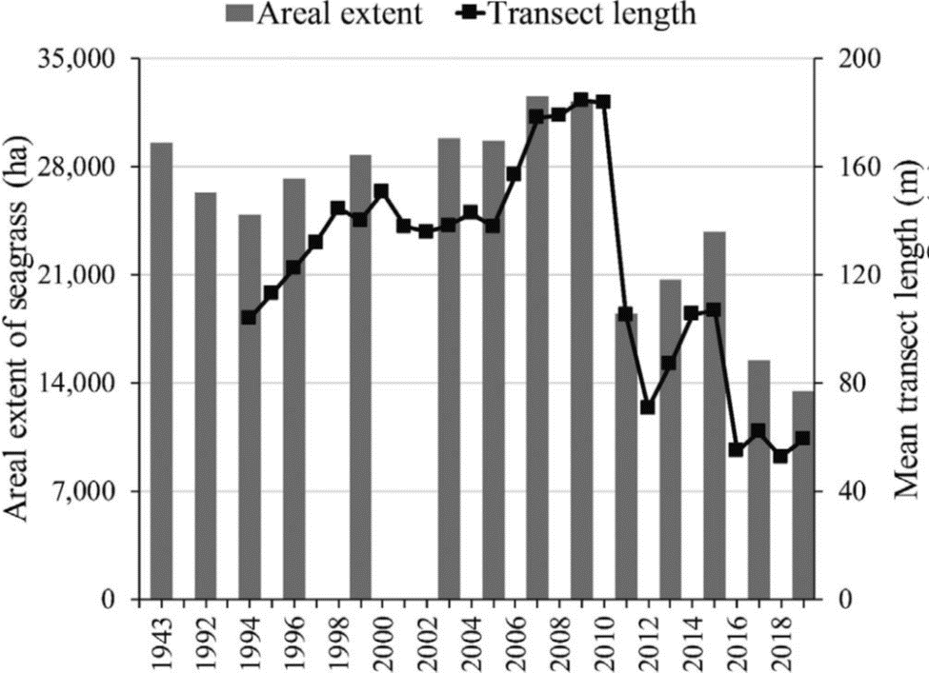
Note: From Morris et al., 2021.
Figure C-1: Mean Areal Extent of Seagrass and Mean Length of Transects
Figure C-1 Long Description
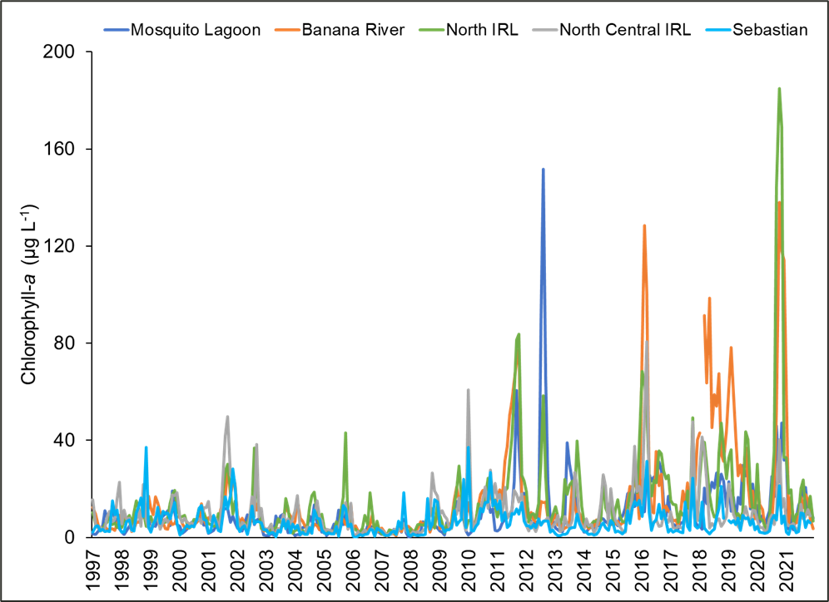
Figure C-2: Mean Chlorophyll-a Concentrations
Figure C-2 Long Description
Unfortunately, the IRL appears to be following a pattern described for systems that receive increased loads of nutrients (Duarte, 1995; Burkholder et al., 2007). The pattern involves a shift in the composition of the primary producer assemblage, with higher nutrient loads differentially promoting faster growing macroalgae and ultimately phytoplankton (Figure C-3). The macroalgae and phytoplankton can exacerbate loss of seagrasses, primarily through shading. Loss of seagrass and macroalgae makes more nutrients available to phytoplankton through decreased competition (Schmidt et al. 2012), and loss of seagrass means that the sediments may be more prone to resuspension, which also reduces light penetration. Overall, the change in the system becomes self-perpetuating. Reducing nutrient loads represents a critical first step in efforts to reverse the shift in primary producers. However, a return to the previous areal coverage of seagrass may take some time, especially if too few recruits are available and sediments are too destabilized for colonization.
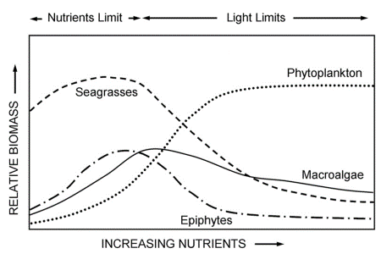
Note: Adapted from Burkholder et al. 2007
Figure C-3: Conceptual Model Illustrating a Shift in Biomass Among Major Primary Producers with Increasing Nutrient Enrichment

Nutrient Content of Seagrass
Halodule wrightii stores nutrients in its aboveground and belowground biological material, or biomass. The biomass of this and other seagrasses changes seasonally, with peak growth of aboveground shoots occurring in April and May and the greatest aboveground biomass recorded during summer. These seasonal changes introduce uncertainty into estimates of nutrient storage, but mean values will suffice for estimating return on investment in the long-term (Table C-1). For example, a single shoot of Halodule wrightii may contain up to five or more leaves in the summer, whereas in the winter this same shoot may contain only one leaf (Dunton 1996). For this estimate of nutrient content, we will assume that spring-summer growth and fall-winter senescence are equal. Thus, we will focus on our recent estimates of an average amount of aboveground and belowground biomass or standing stock of Halodule wrightii (Table C-1 and Table C-2).
Table C-1: Estimates of Biomass for Halodule Species
Location | Total Biomass (grams dry weight per square meter) | Reference
Texas (Laguna Madre) | 10–400 | Zieman and Zieman, 1989
North Carolina (multiple locations) | 22–208 | Zieman and Zieman, 1989
South Florida and Tampa Bay | 10–300 | Zieman and Zieman, 1989
IRL (Fort Pierce Inlet) | 124–198 | Hefferman and Gibson, 1983
IRL (Grand Harbor/Vero) | 45 | Hefferman and Gibson, 1983
IRL (Link Port) | 20–140 | Virnstein unpublished
IRL (Brevard County) | 53* | Morris, Chamberlain, and Jacoby unpublished
Texas (Laguna Madre) | 10–400 | Zieman and Zieman, 1989
* Mean aboveground biomass = 23 grams dry weight meters⁻² = [(mean percent cover × 30.533) × 0.019]; mean belowground biomass = 30 grams dry weight meters⁻² = 1.3 × aboveground biomass
Table C-2: Total Biomass in Seagrasses Along Brevard County
Sub-lagoon | Description | Total Biomass (grams dry weight per square meter)
Mosquito Lagoon | Brevard County line to southern end of sub-lagoon | 74
Banana River Lagoon | National Aeronautics and Space Administration restricted area | 64
Banana River Lagoon | Remainder of Banana River Lagoon | 44
IRL | North of State Road 405 | 51
IRL | State Road 405 to Pineda Causeway | 35
IRL | Pineda Causeway to Hog Point | 28
IRL | Hog Point to Brevard County line | 51
Mean | Not applicable | 50
Duarte (1990) compared nutrient contents of 27 species of seagrass, including Halodule wrightii. He determined that nitrogen and phosphorus represent about 2.2% and 0.2% of the dry weight of aboveground and belowground tissue of Halodule wrightii, respectively. These values are similar to those calculated during a recent study in the IRL (Table C-3). The values can be combined with estimates of biomass to calculate how much nitrogen and phosphorus are sequestered by 100 acres of Halodule wrightii on average (Table C-4).
Table C-3: Estimates of Nutrient Content for Halodule wrightii (percentage of dry weight)
Location | Carbon Above Ground | Nitrogen Above Ground | Phosphorus Above Ground | Carbon Below Ground | Nitrogen Below Ground | Phosphorus Below Ground
BRL-1 | 29.60 | 2.02 | 0.17 | 30.60 | 1.24 | 0.14
BRL-2 | 30.60 | 2.36 | 0.24 | 29.08 | 1.47 | 0.27
BRL-3 | 29.60 | 2.66 | 0.26 | 28.09 | 1.48 | 0.25
IRL-1 | 31.74 | 2.39 | 0.18 | 31.69 | 1.42 | 0.15
IRL-2 | 30.08 | 2.56 | 0.26 | 30.48 | 1.74 | 0.27
IRL-3 | 28.26 | 2.08 | 0.25 | 23.86 | 1.36 | 0.20
Mean | 29.98 | 2.35 | 0.23 | 28.97 | 1.45 | 0.21
BRL = Banana River Lagoon, IRL = Indian River Lagoon
Table C-4: Average Amount of Nutrients Contained in Seagrass from 1996–2009
Sub-lagoon | Acres | Seagrass (pounds per 100 acres) | Nitrogen (pounds per 100 acres) | Phosphorus (pounds per 100 acres)
Southern Mosquito Lagoon | 14,000 | 45,000 | 1,000 | 100
Banana River Lagoon | 21,000 | 45,000 | 1,000 | 100
North IRL | 19,000 | 37,000 | 900 | 90
Central IRL | 7,000 | 36,000 | 900 | 90

Draft Evaluation Criteria for Planting Seagrass
Part of the wisdom accumulated from past seagrass restoration projects is the importance of selecting sites that will support seagrass growth. Key information has been synthesized into an initial guide, with higher scores and more certainty indicating better sites for planting seagrass (Table C-5). Please note that the presence of seagrass leads to a lower score based on the premise that natural recruitment represents the most cost-effective option for restoring seagrass. In addition, a high level of uncertainty can suggest targets for further study. This guide can be refined following pilot studies to determine optimal methods for planting seagrass (e.g., type of planting units, use of chemicals to enhance growth, and density of initial planting) and protecting it from disturbance (e.g., grazing, waves, exposure, and low salinity) until it is established.

References
Burkholder, J.M., Tomasko, D.A., and Touchette, B.W. 2007. Seagrasses and eutrophication. Journal of Experimental Marine Biology and Ecology 350: 46–72.
Duarte, C.M. 1990. Seagrass nutrient content. Marine Ecology Progress Series 6: 201–207.
Duarte, C.M. 1995. Submerged aquatic vegetation in relation to different nutrient regimes. Ophelia 41: 87–112.
Dunton, K.H. 1990. Production ecology of Ruppia maritima and Halodule wrightii Aschers in two subtropical estuaries. Journal of Experimental Marine Biology and Ecology 143: 147–164.
Hefferman J.J. and Gibson, R.A. 1983. A comparison of primary production rates in Indian River, Florida seagrass systems. Florida Scientist 46: 295–306.
Morris, L.J, Hall, L.M., Miller, J.D., Lasi, M.A., Chamberlain, R.H., Virnstein, R.W., and Jacoby, C.A. 2021. Diversity and distribution of seagrasses as related to salinity, temperature, and availability of light in the Indian River Lagoon, Florida. Proceedings of Indian River Lagoon Symposium 2020.
Schmidt, A.L., Wysmyk, J.K.C., Craig, S.E., and Lotze, H.K. 2012. Regional-scale effects of eutrophication on ecosystem structure and services of seagrass beds. Limnology and Oceanography 57(5): 1389-1402.
Zieman, J.C. and Zieman, R.T. 1989. The ecology of seagrass meadows of the west coast of Florida: a community profile. United States Fish and Wildlife Service, Biological Report 85(7.25), September 1989.
Table C-5: Guide for Ranking Potential Seagrass Restoration Sites
Category | Metric | Timeframe | Attributes for Score = 0 | Attributes for Score = 2 | Attributes for Score = 4 | Attributes for Score = 6 | Score | Uncertainty (1 = low, 3 = high)
Critical Depth Zone 0.5-0.8 meters below mean sea level | Width of Critical Depth Zone (distance perpendicular to shore) | Recent | Very narrow: < 25 meters wide (< 82 feet) | Narrow: 25-50 meters (82-164 feet) | Moderately wide: 50-100 meters (164-328 feet) | Broad: > 100 meters (> 328 feet)
Critical Depth Zone 0.5-0.8 meters below mean sea level | Distance to seagrass (identified via the most recent map or targeted reconnaissance) | Recent | Continuous seagrass at site and within 1 kilometer (land use code = 9116): seagrass is a dominant feature (restoration not needed) | Isolated: no seagrass within 1 kilometers (0.6 miles) so conditions may be unfavorable | Discontinuous seagrass at site and within 1 kilometers (land use code = 9113): seagrass is patchy, so restoration may connect patches | Seagrass nearby: seagrass within 0.5-1.0 kilometers (0.3-0.6 miles)
Critical Depth Zone 0.5-0.8 meters below mean sea level | Percent cover in Critical Depth Zone (derived from the closest transect, paired considerations) | Past  (2000-2009) | High: > 30% | Low: 10-20% | Moderate: 20-30% | High: > 30%
Critical Depth Zone 0.5-0.8 meters below mean sea level | Percent cover in Critical Depth Zone (derived from the closest transect, paired considerations) | Last 3 Years | High: > 10% (restoration not needed) | Low: < 10% (restoration may not help) | Low: < 10% (restoration may help but ultimate gain is likely limited) | Low: < 10% (potentially optimum site for restoration)
Potential stressors | Water quality (salinity and light availability derived from the closest station) | Last 3 Years | Bad: salinity < 10 ppt anytime and < 18 ppt for > 3 consecutive months, or annual mean salinity -1 standard deviation < 17 ppt. Secchi depth < 0.5 m (1.6ft) anytime and < 0.65 m (2.1ft) for > 3 consecutive months, or annual mean Secchi depth -1 standard deviation < 0.65 m. | Poor: salinity < 18 ppt for 3 consecutive months but never < 12 ppt, or annual mean salinity -1 standard deviation < 17 ppt. Secchi depth < 0.65 m for < 3 consecutive months but never < 0.5 m, or annual mean Secchi depth -1 standard deviation < 0.65 m. | Supportive: salinity always > 18 Secchi depth always > 0.65 meters and may be 0.65-1.0 meters (2.1-3.3 feet) for 3 consecutive months | Good: salinity consistently > 23 Secchi depth consistently > 1.0 meters
Potential stressors | Sediment (assessed via visits to the site or other current information) | Present | Not supportive: anoxic and sulfidic near the surface or easily resuspended or moved | Minimally supportive: hard bottom (e.g., compact sand or shells), not conducive for growth of rhizomes and roots, porewater may lack nutrients | Generally supportive: unconsolidated sediment that holds plants with relatively little resuspension and movement observed, porewater nutrients not limiting | Fully supportive: loosely consolidated sediment with firmly anchored plants if present, anoxic and sulfidic layers located below the zone occupied by roots and rhizomes, porewater rich in nutrients
Potential stressors | Water movement (assessed via visits to the site or other current information) | Present | High currents - possible scouring: frequent and strong currents or waves that may cause ripples in the sediment and uproot new plants | Moderate to high currents: currents and waves bend plants, sweep fragments of seagrass away before they can gain a foothold, and cause some resuspension of sediment | Moderate currents: plants often stand upright, fragments of seagrass may be trapped, sediment typically not resuspended | Low currents: mild currents or waves, sediment not disturbed, no apparent negative effects on any seagrass that is present
Potential stressors | Shoreline characteristics (assessed via visits the site or other current information) | Present | Unnatural shoreline: Critical Depth Zone in close proximity to urban development, including canals, and a hardened shoreline (e.g., riprap or bulkhead) | Semi-natural shoreline: Critical Depth Zone near moderate development and some shoreline is vegetated | Mostly natural shoreline: Critical Depth Zone near low to moderate development, most of the shoreline is vegetated shoreline or the site is associated with living shoreline project | All natural shoreline: vegetated shoreline with very limited development
Potential stressors | Public use (assessed via visits to the site visits or other current information, including recent aerial photographs) | Present | High use: Critical Depth Zone adjacent to or within an area with frequent boating, swimming or fishing (e.g., aerial photographs show prop scars) | Near high use: Critical Depth Zone within 0.5 kilometers (0.3 miles) of a highly used area | Not near high use: Critical Depth Zone more than 0.5 kilometers from a highly used area | Low use: no public facilities nearby and limited signs of use
Potential stressors | Biota (assessed via visits to the site or other current information on grazing or physical disturbance) | Present | Heavy use: site adjacent to deep water or manatee zone, power plant within 10 kilometers (6.2 miles), freshwater nearby, manatees and rays observed frequently, disturbance or grazing evident in > 50% of the area on a weekly-monthly basis | Moderate use: power plant > 10 kilometers away, deep water and manatee zones > 0.5 kilometers away, no freshwater nearby, disturbance or grazing evident in < 50% of the area on a monthly basis | Intermittent use: disturbance or grazing evident in < 25% of the area on a quarterly basis | Rare use: disturbance or grazing hardly evident
Logistics | Enhancement or protection (assessed via visits to the site) | Present | Extensive need: dense planting required due to absence of seagrass, fencing or caging required due to grazing, other enhancement or protection required, including living shorelines, sediment barriers, wave baffles | Substantial need: moderately dense planting required because only 1-2% cover present, fencing or caging required, few additional enhancements or protections required | Moderate need: low density planting sufficient because at least 2% cover present, fencing or caging required for a limited time, other enhancements or protections beneficial but not critical | Limited need: minimal density planting or no planting required because  > 2% cover present and protection from grazing may result in spread of seagrass, no other enhancements or protections required
Logistics | Maintenance (assessed via visits to the site) | Anticipated | High maintenance: weekly cleaning | Moderate maintenance: monthly cleaning | Low maintenance: quarterly cleaning | Minimum maintenance: maintain as needed
Logistics | Staging and accessibility (assessed via visits to the site) | Present | Very difficult: substantial impediments that may include boat ramps > 10 kilometer away, soft sediment that is easily disturbed, permitting and access issues | Moderately difficult: boat ramp within 10 kilometers, somewhat firm sediment, tractable permitting and access issues | Relatively simple: boat ramp nearby and few other issues | No issues
Logistics | Monitoring (relevant past, current and future information on water quality and seagrasses available) | Present | No external support: no sampling of seagrass within 5 kilometers (3.1 miles), nearest water quality station not representative of conditions at the site | Minimal external support: seagrass surveyed within 3-5 kilometers (1.9-3.1 miles); water quality station is representative of conditions at the site | Moderate external support: seagrass and water quality sampled within 3 kilometers, so both are representative of conditions at the site | Considerable external support: seagrasses and water quality sampled at or adjacent to the site
Total
Notes:
Optimize potential for success by planting: a) within the Critical Depth Zone (e.g., at 0.6-0.8 meters below mean sea level) with due recognition of tides and annual changes in water levels; or b) during the spring (e.g., late March to May) when water clarity is best, water temperatures are warming, and grazing by fish is relatively low
Scoring: if conditions do not match the attributes provided, then assign a score between the two that are most applicable

Appendix D: Withdrawn Projects
Some of the projects submitted and approved as part of a plan update were determined to be less cost-effective and/or infeasible to implement after further investigation. Stormwater basin delineations were updated in 2019 with some basins merged or renamed in the 2020 Plan Update. Therefore, these projects were removed from the Save Our Indian River Lagoon Project Plan so that the funding could be used for other projects. Table D-1 lists the projects that have been removed from the plan at the request of the responsible entity.
Table D-1: Summary of Project Withdrawals from the Plan
Year Removed | Project Name | Responsible Entity | Sub-Lagoon | Total Nitrogen Reduction (pounds per year) | Total Phosphorus Reduction (pounds per year) | Plan Funding
2018 | Holman Road Baffle Box | City of Cape Canaveral | Banana | 71 | 2 | $6,248
2018 | Center Street Baffle Box | City of Cape Canaveral | Banana | 297 | 9 | $26,136
2018 | International Drive Baffle Box | City of Cape Canaveral | Banana | 443 | 4 | $34,700
2018 | Angel Isles Baffle Box | City of Cape Canaveral | Banana | 131 | 3 | $11,528
2018 | Cherie Down Park Swale | City of Cape Canaveral | Banana | 27 | 9 | $2,376
2018 | Norwood Baffle Box Retrofit | City of Palm Bay | Central IRL | 1,631 | 254 | $143,528
2018 | Victoria Pond | City of Palm Bay | Central IRL | 267 | 42 | $23,486
2018 | Goode Park | City of Palm Bay | Central IRL | 794 | 121 | $69,872
2018 | Florin Pond | City of Palm Bay | Central IRL | 75 | 11 | $6,600
2018 | Airport Boulevard Dry Retrofit | City of Melbourne | North IRL | 99 | 23 | $8,718
2018 | National Aeronautics and Space Administration Boulevard Pond Retrofit | City of Melbourne | Central IRL | 1,097 | 157 | $96,532
2018 | General Aviation Drive Retrofit | City of Melbourne | Central IRL | 158 | 10 | $13,937
2018 | L-1 Canal Bank Stabilization | Brevard County | North IRL | 995 | 383 | $87,560
2018 | Stormwater project in Basin 979 | Brevard County | Banana | 3,275 | 448 | $225,000
2018 | Stormwater project in Basin 1280 | Brevard County | Banana | 1,735 | 236 | $175,000
2018 | Stormwater project in Basin 1063 | Brevard County | Banana | 1,235 | 192 | $100,000
2018 | Stormwater project in Basin 970 | Brevard County | Banana | 1,092 | 185 | $100,000
2018 | Stormwater project in Basin 995 | Brevard County | Banana | 1,048 | 169 | $100,000
2018 | Stormwater project in Basin 754 | Brevard County | Banana | 734 | 95 | $100,000
2018 | Stormwater project in Basin 327 | Brevard County | North IRL | 1,999 | 283 | $125,000
2018 | Stormwater project in Basin 1582 | Brevard County | Central IRL | 2,402 | 443 | $200,000
2019 | Cocoa Beach Muck Dredging – Phase III Interstitial | City of Cocoa Beach | Banana | 2,942 | To be determined | $514,809
2019 | Indian River Drive Oyster Bar (reduction from 1,900 to 140 feet) | Brevard County | North IRL | 422 | 10 | $166,672
2019 | Indian River Drive Planted Shoreline (reduction from 1,900 to 140 feet) | Brevard County | North IRL | 118 | 41 | $20,620
2019 | Stormwater project in Basin 905 | Brevard County | Banana | 1,143 | 178 | $150,000
2019 | Stormwater project in Basin 492 | Brevard County | Banana | 1,020 | 117 | $100,000
2019 | Stormwater project in Basin 522 | Brevard County | Banana | 795 | 110 | $125,000
2019 | Stormwater project in Basin 705 | Brevard County | Banana | 650 | 95 | $100,000
2019 | Stormwater project in Basin 821 | Brevard County | Banana | 627 | 123 | $100,000
2019 | Stormwater project in Basin 820 | Brevard County | Banana | 597 | 112 | $100,000
2019 | Stormwater project in Basin 47 | Brevard County | North IRL | 1,348 | 139 | $125,000
2019 | Stormwater project in Basin 219 | Brevard County | North IRL | 956 | 113 | $125,000
2020 | Cape Canaveral Air Force Station Upgrade | Cape Canaveral Air Force Station | Banana | 25,627 | To be determined | $6,000,000
2020 | Malabar - Zone B | Brevard County | Central IRL | 1,929 | Not applicable | $2,135,808
2020 | Malabar - Zone A | Brevard County | Central IRL | 11,456 | Not applicable | $14,349,960
2020 | South Beaches - Zone F | Brevard County | Central IRL | 70 | Not applicable | $100,116
2020 | Carver Cove Swale | City of Cape Canaveral | Banana | 32 | 9 | $2,816
2020 | Cocoa Palms Low Impact Development | City of Cape Canaveral | Banana | 13 | 10 | $1,144
2020 | M1 Canal Biosorption Activated Media | Brevard County | Central IRL | 1,433 | 191 | $66,300
2020 | Oliver Oyster Bar | Brevard Zoo | North IRL | 116 | 39 | $51,620
2020 | Coconut Point/Environmentally Endangered Lands Oyster Bar (reduction from 27,125 square feet to 2,400 square feet) | Brevard Zoo | Central IRL | 989 | 367 | $464,830
2020 | Turkey Creek Shoreline Restoration – Oysters | City of Palm Bay | Central IRL | 309 | 8 | $122,055
2020 | Eden Isles Lane Oyster Bar | Brevard Zoo | Banana | 49 | 17 | $21,805
2020 | Turkey Creek Shoreline Restoration – Planted | City of Palm Bay | Central IRL | 104 | 36 | $24,960
2020 | Stormwater project in Basin 388 | Brevard County | Banana | 1,390 | 138 | $100,000
2020 | Stormwater project in Basin 451 | Brevard County | Banana | 1,168 | 121 | $100,000
2020 | Stormwater project in Basin 815 | Brevard County | Banana | 698 | 113 | $100,000
2020 | Stormwater project in Basin 829 | Brevard County | Banana | 630 | 145 | $100,000
2020 | Stormwater project in Basin 865 | Brevard County | Banana | 454 | 151 | $100,000
2020 | Stormwater project in Basin 889 | Brevard County | Banana | 539 | 85 | $100,000
2020 | Stormwater project in Basin 901 | Brevard County | Banana | 1,658 | 196 | $150,000
2020 | Stormwater project in Basin 912 | Brevard County | Banana | 1,025 | 34 | $100,000
2020 | Stormwater project in Basin 929 | Brevard County | Banana | 304 | 41 | $100,000
2020 | Stormwater project in Basin 933 | Brevard County | Banana | 302 | 38 | $100,000
2020 | Stormwater project in Basin 934 | Brevard County | Banana | 365 | 42 | $100,000
2020 | Stormwater project in Basin 938 | Brevard County | Banana | 424 | 160 | $100,000
2020 | Stormwater project in Basin 940 | Brevard County | Banana | 816 | 106 | $100,000
2020 | Stormwater project in Basin 943 | Brevard County | Banana | 708 | 90 | $100,000
2020 | Stormwater project in Basin 944 | Brevard County | Banana | 614 | 83 | $100,000
2020 | Stormwater project in Basin 955 | Brevard County | Banana | 522 | 60 | $100,000
2020 | Stormwater project in Basin 957 | Brevard County | Banana | 586 | 53 | $100,000
2020 | Stormwater project in Basin 958 | Brevard County | Banana | 164 | 26 | $100,000
2020 | Stormwater project in Basin 960 | Brevard County | Banana | 537 | 80 | $100,000
2020 | Stormwater project in Basin 961 | Brevard County | Banana | 431 | 57 | $100,000
2020 | Stormwater project in Basin 963 | Brevard County | Banana | 2,092 | 396 | $150,000
2020 | Stormwater project in Basin 969 | Brevard County | Banana | 528 | 78 | $100,000
2020 | Stormwater project in Basin 973 | Brevard County | Banana | 2,048 | 311 | $175,000
2020 | Stormwater project in Basin 975 | Brevard County | Banana | 521 | 75 | $100,000
2020 | Stormwater project in Basin 977 | Brevard County | Banana | 558 | 59 | $100,000
2020 | Stormwater project in Basin 980 | Brevard County | Banana | 836 | 127 | $100,000
2020 | Stormwater project in Basin 981 | Brevard County | Banana | 993 | 179 | $100,000
2020 | Stormwater project in Basin 982 | Brevard County | Banana | 642 | 68 | $100,000
2020 | Stormwater project in Basin 988 | Brevard County | Banana | 621 | 108 | $100,000
2020 | Stormwater project in Basin 989 | Brevard County | Banana | 1,030 | 110 | $100,000
2020 | Stormwater project in Basin 990 | Brevard County | Banana | 634 | 102 | $100,000
2020 | Stormwater project in Basin 992 | Brevard County | Banana | 1,244 | 195 | $100,000
2020 | Stormwater project in Basin 1000 | Brevard County | Banana | 277 | 40 | $100,000
2020 | Stormwater project in Basin 1001 | Brevard County | Banana | 401 | 54 | $100,000
2020 | Stormwater project in Basin 1010 | Brevard County | Banana | 374 | 55 | $100,000
2020 | Stormwater project in Basin 1014 | Brevard County | Banana | 333 | 50 | $100,000
2020 | Stormwater project in Basin 1016 | Brevard County | Banana | 920 | 136 | $100,000
2020 | Stormwater project in Basin 1018 | Brevard County | Banana | 389 | 54 | $100,000
2020 | Stormwater project in Basin 1026 | Brevard County | Banana | 1,073 | 180 | $100,000
2020 | Stormwater project in Basin 1033 | Brevard County | Banana | 1,113 | 152 | $100,000
2020 | Stormwater project in Basin 1038 | Brevard County | Banana | 157 | 25 | $100,000
2020 | Stormwater project in Basin 1039 | Brevard County | Banana | 708 | 104 | $100,000
2020 | Stormwater project in Basin 1041 | Brevard County | Banana | 273 | 47 | $100,000
2020 | Stormwater project in Basin 1048 | Brevard County | Banana | 107 | 20 | $100,000
2020 | Stormwater project in Basin 1070 | Brevard County | Banana | 113 | 12 | $100,000
2020 | Stormwater project in Basin 1071 | Brevard County | Banana | 1,082 | 144 | $100,000
2020 | Stormwater project in Basin 1082 | Brevard County | Banana | 264 | 39 | $100,000
2020 | Stormwater project in Basin 1098 | Brevard County | Banana | 341 | 53 | $100,000
2020 | Stormwater project in Basin 1104 | Brevard County | Banana | 701 | 106 | $100,000
2020 | Stormwater project in Basin 1117 | Brevard County | Banana | 282 | 43 | $100,000
2020 | Stormwater project in Basin 1120 | Brevard County | Banana | 313 | 50 | $100,000
2020 | Stormwater project in Basin 1121 | Brevard County | Banana | 186 | 27 | $100,000
2020 | Stormwater project in Basin 1125 | Brevard County | Banana | 307 | 51 | $100,000
2020 | Stormwater project in Basin 1133 | Brevard County | Banana | 562 | 90 | $100,000
2020 | Stormwater project in Basin 1142 | Brevard County | Banana | 534 | 73 | $100,000
2020 | Stormwater project in Basin 1152 | Brevard County | Banana | 245 | 30 | $100,000
2020 | Stormwater project in Basin 1159 | Brevard County | Banana | 134 | 20 | $100,000
2020 | Stormwater project in Basin 1167 | Brevard County | Banana | 180 | 28 | $100,000
2020 | Stormwater project in Basin 1175 | Brevard County | Banana | 394 | 42 | $100,000
2020 | Stormwater project in Basin 1183 | Brevard County | Banana | 272 | 39 | $100,000
2020 | Stormwater project in Basin 1188 | Brevard County | Banana | 166 | 29 | $100,000
2020 | Stormwater project in Basin 1198 | Brevard County | Banana | 365 | 62 | $100,000
2020 | Stormwater project in Basin 1220 | Brevard County | Banana | 396 | 61 | $100,000
2020 | Stormwater project in Basin 1223 | Brevard County | Banana | 561 | 86 | $100,000
2020 | Stormwater project in Basin 1225 | Brevard County | Banana | 122 | 19 | $100,000
2020 | Stormwater project in Basin 1231 | Brevard County | Banana | 300 | 58 | $100,000
2020 | Stormwater project in Basin 1248 | Brevard County | Banana | 306 | 46 | $100,000
2020 | Stormwater project in Basin 1250 | Brevard County | Banana | 188 | 26 | $100,000
2020 | Stormwater project in Basin 1251 | Brevard County | Banana | 448 | 66 | $100,000
2020 | Stormwater project in Basin 1262 | Brevard County | Banana | 443 | 80 | $100,000
2020 | Stormwater project in Basin 1265 | Brevard County | Banana | 743 | 98 | $100,000
2020 | Stormwater project in Basin 1270 | Brevard County | Banana | 187 | 28 | $100,000
2020 | Stormwater project in Basin 1296 | Brevard County | Banana | 241 | 48 | $100,000
2020 | Stormwater project in Basin 1302 | Brevard County | Banana | 172 | 25 | $100,000
2020 | Stormwater project in Basin 1303 | Brevard County | Banana | 166 | 24 | $100,000
2020 | Stormwater project in Basin 1305 | Brevard County | Banana | 119 | 25 | $100,000
2020 | Stormwater project in Basin 1310 | Brevard County | Banana | 583 | 106 | $100,000
2020 | Stormwater project in Basin 1311 | Brevard County | Banana | 104 | 15 | $100,000
2020 | Stormwater project in Basin 1314 | Brevard County | Banana | 170 | 26 | $100,000
2020 | Stormwater project in Basin 1317 | Brevard County | Banana | 1,679 | 143 | $125,000
2020 | Stormwater project in Basin 1319 | Brevard County | Banana | 117 | 16 | $100,000
2020 | Stormwater project in Basin 1327 | Brevard County | Banana | 352 | 52 | $100,000
2020 | Stormwater project in Basin 1328 | Brevard County | Banana | 617 | 89 | $100,000
2020 | Stormwater project in Basin 1332 | Brevard County | Banana | 303 | 47 | $100,000
2020 | Stormwater project in Basin 1334 | Brevard County | Banana | 795 | 130 | $100,000
2020 | Stormwater project in Basin 1336 | Brevard County | Banana | 470 | 68 | $100,000
2020 | Stormwater project in Basin 1337 | Brevard County | Banana | 1,121 | 186 | $100,000
2020 | Stormwater project in Basin 1338 | Brevard County | Banana | 256 | 37 | $100,000
2020 | Stormwater project in Basin 1343 | Brevard County | Banana | 1,388 | 142 | $100,000
2020 | Stormwater project in Basin 1346 | Brevard County | Banana | 189 | 28 | $100,000
2020 | Stormwater project in Basin 1350 | Brevard County | Banana | 1,049 | 165 | $100,000
2020 | Stormwater project in Basin 1351 | Brevard County | Banana | 129 | 19 | $100,000
2020 | Stormwater project in Basin 1357 | Brevard County | Banana | 338 | 56 | $100,000
2020 | Stormwater project in Basin 1362 | Brevard County | Banana | 476 | 71 | $100,000
2020 | Stormwater project in Basin 1366 | Brevard County | Banana | 1,483 | 242 | $100,000
2020 | Stormwater project in Basin 1371 | Brevard County | Banana | 273 | 39 | $100,000
2020 | Stormwater project in Basin 1372 | Brevard County | Banana | 720 | 113 | $100,000
2020 | Stormwater project in Basin 1378 | Brevard County | Banana | 744 | 104 | $100,000
2020 | Stormwater project in Basin 2421 | Brevard County | Banana | 343 | 49 | $100,000
2020 | Stormwater project in Basin 83 | Brevard County | North IRL | 452 | 61 | $100,000
2020 | Stormwater project in Basin 100 | Brevard County | North IRL | 888 | 115 | $100,000
2020 | Stormwater project in Basin 105 | Brevard County | North IRL | 549 | 72 | $100,000
2020 | Stormwater project in Basin 212 | Brevard County | North IRL | 693 | 89 | $100,000
2020 | Stormwater project in Basin 228 | Brevard County | North IRL | 684 | 131 | $100,000
2020 | Stormwater project in Basin 262 | Brevard County | North IRL | 794 | 126 | $100,000
2020 | Stormwater project in Basin 263 | Brevard County | North IRL | 469 | 65 | $100,000
2020 | Stormwater project in Basin 288 | Brevard County | North IRL | 732 | 78 | $100,000
2020 | Stormwater project in Basin 289 | Brevard County | North IRL | 1,112 | 223 | $100,000
2020 | Stormwater project in Basin 290 | Brevard County | North IRL | 1,116 | 193 | $100,000
2020 | Stormwater project in Basin 291 | Brevard County | North IRL | 485 | 82 | $100,000
2020 | Stormwater project in Basin 294 | Brevard County | North IRL | 551 | 84 | $100,000
2020 | Stormwater project in Basin 335 | Brevard County | North IRL | 1,187 | 206 | $100,000
2020 | Stormwater project in Basin 353 | Brevard County | North IRL | 497 | 86 | $100,000
2020 | Stormwater project in Basin 354 | Brevard County | North IRL | 555 | 115 | $100,000
2020 | Stormwater project in Basin 392 | Brevard County | North IRL | 840 | 155 | $100,000
2020 | Stormwater project in Basin 408 | Brevard County | North IRL | 1,179 | 170 | $125,000
2020 | Stormwater project in Basin 454 | Brevard County | North IRL | 1,996 | 302 | $150,000
2020 | Stormwater project in Basin 510 | Brevard County | North IRL | 586 | 92 | $100,000
2020 | Stormwater project in Basin 512 | Brevard County | North IRL | 364 | 53 | $100,000
2020 | Stormwater project in Basin 513 | Brevard County | North IRL | 1,137 | 183 | $100,000
2020 | Stormwater project in Basin 544 | Brevard County | North IRL | 624 | 98 | $100,000
2020 | Stormwater project in Basin 568 | Brevard County | North IRL | 534 | 85 | $100,000
2020 | Stormwater project in Basin 578 | Brevard County | North IRL | 430 | 68 | $100,000
2020 | Stormwater project in Basin 594 | Brevard County | North IRL | 833 | 135 | $100,000
2020 | Stormwater project in Basin 597 | Brevard County | North IRL | 800 | 142 | $100,000
2020 | Stormwater project in Basin 624 | Brevard County | North IRL | 860 | 134 | $100,000
2020 | Stormwater project in Basin 626 | Brevard County | North IRL | 1,602 | 193 | $150,000
2020 | Stormwater project in Basin 644 | Brevard County | North IRL | 686 | 94 | $100,000
2020 | Stormwater project in Basin 660 | Brevard County | North IRL | 844 | 212 | $100,000
2020 | Stormwater project in Basin 677 | Brevard County | North IRL | 709 | 136 | $100,000
2020 | Stormwater project in Basin 751 | Brevard County | North IRL | 532 | 121 | $100,000
2020 | Stormwater project in Basin 759 | Brevard County | North IRL | 614 | 98 | $100,000
2020 | Stormwater project in Basin 796 | Brevard County | North IRL | 639 | 98 | $100,000
2020 | Stormwater project in Basin 805 | Brevard County | North IRL | 645 | 94 | $100,000
2020 | Stormwater project in Basin 806 | Brevard County | North IRL | 622 | 100 | $100,000
2020 | Stormwater project in Basin 827 | Brevard County | North IRL | 639 | 96 | $100,000
2020 | Stormwater project in Basin 838 | Brevard County | North IRL | 658 | 135 | $100,000
2020 | Stormwater project in Basin 840 | Brevard County | North IRL | 619 | 84 | $100,000
2020 | Stormwater project in Basin 862 | Brevard County | North IRL | 416 | 72 | $100,000
2020 | Stormwater project in Basin 871 | Brevard County | North IRL | 366 | 53 | $100,000
2020 | Stormwater project in Basin 884 | Brevard County | North IRL | 437 | 68 | $100,000
2020 | Stormwater project in Basin 889 | Brevard County | North IRL | 539 | 85 | $100,000
2020 | Stormwater project in Basin 890 | Brevard County | North IRL | 533 | 110 | $100,000
2020 | Stormwater project in Basin 894 | Brevard County | North IRL | 794 | 116 | $100,000
2020 | Stormwater project in Basin 896 | Brevard County | North IRL | 581 | 123 | $100,000
2020 | Stormwater project in Basin 902 | Brevard County | North IRL | 276 | 35 | $100,000
2020 | Stormwater project in Basin 903 | Brevard County | North IRL | 631 | 88 | $100,000
2020 | Stormwater project in Basin 920 | Brevard County | North IRL | 511 | 87 | $100,000
2020 | Stormwater project in Basin 921 | Brevard County | North IRL | 743 | 96 | $100,000
2020 | Stormwater project in Basin 922 | Brevard County | North IRL | 601 | 107 | $100,000
2020 | Stormwater project in Basin 938 | Brevard County | North IRL | 424 | 160 | $100,000
2020 | Stormwater project in Basin 939 | Brevard County | North IRL | 502 | 71 | $100,000
2020 | Stormwater project in Basin 940 | Brevard County | North IRL | 816 | 106 | $100,000
2020 | Stormwater project in Basin 952 | Brevard County | North IRL | 1,251 | 212 | $100,000
2020 | Stormwater project in Basin 960 | Brevard County | North IRL | 537 | 80 | $100,000
2020 | Stormwater project in Basin 962 | Brevard County | North IRL | 527 | 75 | $100,000
2020 | Stormwater project in Basin 980 | Brevard County | North IRL | 836 | 127 | $100,000
2020 | Stormwater project in Basin 985 | Brevard County | North IRL | 687 | 99 | $100,000
2020 | Stormwater project in Basin 987 | Brevard County | North IRL | 1,099 | 172 | $100,000
2020 | Stormwater project in Basin 993 | Brevard County | North IRL | 611 | 93 | $100,000
2020 | Stormwater project in Basin 1002 | Brevard County | North IRL | 1,181 | 159 | $100,000
2020 | Stormwater project in Basin 1016 | Brevard County | North IRL | 920 | 136 | $100,000
2020 | Stormwater project in Basin 1027 | Brevard County | North IRL | 560 | 84 | $100,000
2020 | Stormwater project in Basin 1029 | Brevard County | North IRL | 685 | 93 | $100,000
2020 | Stormwater project in Basin 1032 | Brevard County | North IRL | 719 | 115 | $100,000
2020 | Stormwater project in Basin 1033 | Brevard County | North IRL | 1,113 | 152 | $100,000
2020 | Stormwater project in Basin 1034 | Brevard County | North IRL | 902 | 132 | $100,000
2020 | Stormwater project in Basin 1037 | Brevard County | North IRL | 533 | 105 | $100,000
2020 | Stormwater project in Basin 1039 | Brevard County | North IRL | 708 | 104 | $100,000
2020 | Stormwater project in Basin 1067 | Brevard County | North IRL | 463 | 67 | $100,000
2020 | Stormwater project in Basin 1071 | Brevard County | North IRL | 1,082 | 144 | $100,000
2020 | Stormwater project in Basin 1073 | Brevard County | North IRL | 428 | 61 | $100,000
2020 | Stormwater project in Basin 1076 | Brevard County | North IRL | 595 | 91 | $100,000
2020 | Stormwater project in Basin 1077 | Brevard County | North IRL | 1,687 | 289 | $150,000
2020 | Stormwater project in Basin 1080 | Brevard County | North IRL | 861 | 134 | $100,000
2020 | Stormwater project in Basin 1081 | Brevard County | North IRL | 1,281 | 210 | $100,000
2020 | Stormwater project in Basin 1112 | Brevard County | North IRL | 1,032 | 166 | $100,000
2020 | Stormwater project in Basin 1113 | Brevard County | North IRL | 416 | 93 | $100,000
2020 | Stormwater project in Basin 1124 | Brevard County | North IRL | 681 | 99 | $100,000
2020 | Stormwater project in Basin 1128 | Brevard County | North IRL | 279 | 77 | $100,000
2020 | Stormwater project in Basin 1150 | Brevard County | North IRL | 476 | 57 | $100,000
2020 | Stormwater project in Basin 1151 | Brevard County | North IRL | 1,057 | 141 | $125,000
2020 | Stormwater project in Basin 1172 | Brevard County | North IRL | 852 | 123 | $100,000
2020 | Stormwater project in Basin 1197 | Brevard County | North IRL | 609 | 82 | $100,000
2020 | Stormwater project in Basin 1213 | Brevard County | North IRL | 904 | 131 | $100,000
2020 | Stormwater project in Basin 1214 | Brevard County | North IRL | 727 | 84 | $100,000
2020 | Stormwater project in Basin 1215 | Brevard County | North IRL | 382 | 52 | $100,000
2020 | Stormwater project in Basin 1219 | Brevard County | North IRL | 512 | 60 | $100,000
2020 | Stormwater project in Basin 1220 | Brevard County | North IRL | 396 | 61 | $100,000
2020 | Stormwater project in Basin 1221 | Brevard County | North IRL | 545 | 85 | $100,000
2020 | Stormwater project in Basin 1222 | Brevard County | North IRL | 888 | 171 | $100,000
2020 | Stormwater project in Basin 1224 | Brevard County | North IRL | 401 | 111 | $100,000
2020 | Stormwater project in Basin 1228 | Brevard County | North IRL | 501 | 83 | $100,000
2020 | Stormwater project in Basin 1231 | Brevard County | North IRL | 300 | 58 | $100,000
2020 | Stormwater project in Basin 1233 | Brevard County | North IRL | 605 | 101 | $100,000
2020 | Stormwater project in Basin 1240 | Brevard County | North IRL | 638 | 100 | $100,000
2020 | Stormwater project in Basin 1241 | Brevard County | North IRL | 584 | 83 | $100,000
2020 | Stormwater project in Basin 1244 | Brevard County | North IRL | 576 | 78 | $100,000
2020 | Stormwater project in Basin 1245 | Brevard County | North IRL | 356 | 49 | $100,000
2020 | Stormwater project in Basin 1251 | Brevard County | North IRL | 448 | 66 | $100,000
2020 | Stormwater project in Basin 1253 | Brevard County | North IRL | 379 | 54 | $100,000
2020 | Stormwater project in Basin 1259 | Brevard County | North IRL | 450 | 106 | $100,000
2020 | Stormwater project in Basin 1262 | Brevard County | North IRL | 443 | 80 | $100,000
2020 | Stormwater project in Basin 1273 | Brevard County | North IRL | 1,964 | 288 | $175,000
2020 | Stormwater project in Basin 1291 | Brevard County | North IRL | 518 | 79 | $100,000
2020 | Stormwater project in Basin 1292 | Brevard County | North IRL | 386 | 60 | $100,000
2020 | Stormwater project in Basin 1293 | Brevard County | North IRL | 461 | 67 | $100,000
2020 | Stormwater project in Basin 1294 | Brevard County | North IRL | 628 | 94 | $100,000
2020 | Stormwater project in Basin 1295 | Brevard County | North IRL | 800 | 121 | $100,000
2020 | Stormwater project in Basin 1301 | Brevard County | North IRL | 1,025 | 154 | $125,000
2020 | Stormwater project in Basin 1307 | Brevard County | North IRL | 431 | 47 | $100,000
2020 | Stormwater project in Basin 1312 | Brevard County | North IRL | 549 | 120 | $100,000
2020 | Stormwater project in Basin 1313 | Brevard County | North IRL | 619 | 92 | $100,000
2020 | Stormwater project in Basin 1316 | Brevard County | North IRL | 557 | 68 | $100,000
2020 | Stormwater project in Basin 1318 | Brevard County | North IRL | 1,124 | 148 | $100,000
2020 | Stormwater project in Basin 1324 | Brevard County | North IRL | 1,422 | 176 | $150,000
2020 | Stormwater project in Basin 1330 | Brevard County | North IRL | 639 | 89 | $100,000
2020 | Stormwater project in Basin 1331 | Brevard County | North IRL | 1,000 | 159 | $100,000
2020 | Stormwater project in Basin 1339 | Brevard County | North IRL | 857 | 103 | $100,000
2020 | Stormwater project in Basin 1344 | Brevard County | North IRL | 459 | 61 | $100,000
2020 | Stormwater project in Basin 1348 | Brevard County | North IRL | 723 | 102 | $100,000
2020 | Stormwater project in Basin 1354 | Brevard County | North IRL | 597 | 86 | $100,000
2020 | Stormwater project in Basin 1359 | Brevard County | North IRL | 887 | 142 | $100,000
2020 | Stormwater project in Basin 1361 | Brevard County | North IRL | 524 | 79 | $100,000
2020 | Stormwater project in Basin 1363 | Brevard County | North IRL | 715 | 123 | $100,000
2020 | Stormwater project in Basin 1367 | Brevard County | North IRL | 1,042 | 146 | $100,000
2020 | Stormwater project in Basin 1372 | Brevard County | North IRL | 720 | 113 | $100,000
2020 | Stormwater project in Basin 1378 | Brevard County | North IRL | 744 | 104 | $100,000
2020 | Stormwater project in Basin 1380 | Brevard County | North IRL | 929 | 134 | $100,000
2020 | Stormwater project in Basin 1382 | Brevard County | North IRL | 622 | 88 | $100,000
2020 | Stormwater project in Basin 1384 | Brevard County | North IRL | 923 | 142 | $100,000
2020 | Stormwater project in Basin 1389 | Brevard County | North IRL | 822 | 134 | $100,000
2020 | Stormwater project in Basin 1390 | Brevard County | North IRL | 612 | 92 | $100,000
2020 | Stormwater project in Basin 1391 | Brevard County | North IRL | 887 | 142 | $100,000
2020 | Stormwater project in Basin 1395 | Brevard County | North IRL | 768 | 114 | $100,000
2020 | Stormwater project in Basin 1398 | Brevard County | North IRL | 449 | 74 | $100,000
2020 | Stormwater project in Basin 1401 | Brevard County | North IRL | 953 | 147 | $100,000
2020 | Stormwater project in Basin 1403 | Brevard County | North IRL | 558 | 88 | $100,000
2020 | Stormwater project in Basin 1413 | Brevard County | North IRL | 528 | 78 | $100,000
2020 | Stormwater project in Basin 1416 | Brevard County | North IRL | 1,799 | 229 | $150,000
2020 | Stormwater project in Basin 1417 | Brevard County | North IRL | 771 | 117 | $100,000
2020 | Stormwater project in Basin 1418 | Brevard County | North IRL | 832 | 111 | $100,000
2020 | Stormwater project in Basin 1423 | Brevard County | North IRL | 487 | 73 | $100,000
2020 | Stormwater project in Basin 1425 | Brevard County | North IRL | 690 | 113 | $100,000
2020 | Stormwater project in Basin 1426 | Brevard County | North IRL | 720 | 116 | $100,000
2020 | Stormwater project in Basin 1428 | Brevard County | North IRL | 440 | 65 | $100,000
2020 | Stormwater project in Basin 1429 | Brevard County | North IRL | 477 | 55 | $100,000
2020 | Stormwater project in Basin 1434 | Brevard County | North IRL | 932 | 112 | $125,000
2020 | Stormwater project in Basin 1435 | Brevard County | North IRL | 328 | 43 | $100,000
2020 | Stormwater project in Basin 1441 | Brevard County | North IRL | 1,034 | 149 | $100,000
2020 | Stormwater project in Basin 1459 | Brevard County | North IRL | 895 | 132 | $100,000
2020 | Stormwater project in Basin 1463 | Brevard County | North IRL | 1,321 | 195 | $100,000
2020 | Stormwater project in Basin 1491 | Brevard County | North IRL | 641 | 93 | $100,000
2020 | Stormwater project in Basin 1498 | Brevard County | North IRL | 483 | 74 | $100,000
2020 | Stormwater project in Basin 2419 | Brevard County | North IRL | 381 | 43 | $100,000
2020 | Stormwater project in Basin 2420 | Brevard County | North IRL | 450 | 121 | $100,000
2020 | Stormwater project in Basin 2421 | Brevard County | North IRL | 343 | 49 | $100,000
2020 | Stormwater project in Basin 1439 | Brevard County | Central IRL | 1,413 | 183 | $200,000
2020 | Stormwater project in Basin 1445 | Brevard County | Central IRL | 1,493 | 198 | $200,000
2020 | Stormwater project in Basin 1470 | Brevard County | Central IRL | 2,813 | 452 | $200,000
2020 | Stormwater project in Basin 1508 | Brevard County | Central IRL | 2,459 | 356 | $200,000
2020 | Stormwater project in Basin 1562 | Brevard County | Central IRL | 3,314 | 449 | $275,000
2020 | Stormwater project in Basin 1615 | Brevard County | Central IRL | 2,815 | 390 | $200,000
2020 | Stormwater project in Basin 1803 | Brevard County | Central IRL | 2,227 | 318 | $200,000
2020 | Stormwater project in Basin 1825 | Brevard County | Central IRL | 1,896 | 394 | $200,000
2021 | Cape Shores Swales | City of Cape Canaveral | Banana | 31 | 15 | $2,746
2021 | Justamere Road Swale | City of Cape Canaveral | Banana | 6 | 3 | $528
2021 | Hitching Post Berms | City of Cape Canaveral | Banana | 29 | 22 | $2,552
2021 | Oyster Bar | Brevard County | Banana | 120 | 3 | $47,350
2021 | Stewart Road Dry Retrofit | City of Melbourne | North IRL | 208 | 47 | $18,344
2021 | Stormwater project in Basin 1349 | Brevard County | North IRL | 1,747 | 268 | $354,400
2021 | Stormwater project in Basin 1409 | Brevard County | North IRL | 1,375 | 209 | $293,800
2021 | Indian River Drive Oyster Bar | Brevard County | North IRL | 34 | 1 | $13,258
2021 | Indian River Drive Planted Shoreline | Brevard County | North IRL | 9 | 3 | $2,240
2021 | Stormwater project in Basin 2191 | Brevard County | Central IRL | 1,925 | 185 | $326,500
2021 | Stormwater project in Basin 1511 | Brevard County | Central IRL | 2,409 | 378 | $410,300
2022 | Cape Canaveral Air Force Station Regional – Rapid Infiltration Basin | Brevard County | Banana | 4,625 | 1,226 | $5,227,200
2022 | Brevard Zoo Banana River Plant Project | Brevard Zoo | Banana | 13 | 4 | $3,120
2022 | Brevard Zoo Banana River Plant Project 2 | Brevard Zoo | Banana | 2 | 1 | $480
2022 | Newfound Harbor Drive | Marine Resources Council | Banana | 7 | 2 | $1,680
2022 | Port St. John Wastewater Treatment Plant – Rapid Infiltration Basin | Brevard County | North IRL | 4,116 | 915 | $980,100
2022 | Brevard Zoo North Indian River Lagoon Plant Project 3 | Brevard Zoo | North IRL | 4 | 1 | $960
2022 | Brevard Zoo Central IRL Plant Project | Brevard Zoo | Central IRL | 8 | 3 | $1,920
2022 | Canebreaker Condo – Sprayfield | Brevard County | North IRL | 61 | To be determined | $36,000

Appendix E: Long Descriptions of Figures

Figure 1-1: Decline of Commercial Fishing in Brevard County
The graph shows the declining value of the commercial fishery in Brevard County using Florida Fish and Wildlife Conservation Commission data from 1995 through 2019. The commercial fishery values drop over time while fish kill counts increase with the largest peaks in 2007 and 2016. The following table is an estimate of the values represented in the graph and are not the exact values.
Reporting Year | Value of Commercial Fishery
1995 | $21,808,095
1996 | $24,052,219
1997 | $15,027,821
1998 | $11,264,215
1999 | $14,765,165
2000 | $15,879,487
2001 | $13,096,088
2002 | $6,253,406
2003 | $7,155,669
2004 | $8,219,153
2005 | $6,314,361
2006 | $6,216,198
2007 | $5,127,527
2008 | $8,207,268
2009 | $6,166,197
2010 | $6,499,390
2011 | $8,354,718
2012 | $7,932,126
2013 | $7,278,107
2014 | $6,588,523
2015 | $7,960,368
2016 | $6,647,791
2017 | $8,444,720
2018 | $6,747,679
2019 | $7,925,947
Return to Figure 1-1.

Figure 2-2. Summary of the Save Our Indian River Lagoon Outputs and Outcomes
Graphic showing output of Public Education will result in years 0–5 early adopters lead, years 6–10 supporters join, and years 10+ lagoon friendly lifestyles are normal. Output of Reclaimed Water Upgrades, Sewer Later Rehabilitation, Septic System Removal and Upgrades, and Stormwater Treatment will result in years 0–5 cleaner ground and surface water, years 6–10 cleaner lagoon water, and years 10+ lush seagrass beds. Outputs of Muck Removal and Treatment of Muck Interstitial Water will result in years 0–5 exposed sandy sediments and tons of pollution removed, years 5–10 plentiful bottom dwelling marine life, and years 10+ abundant fishes. Output of Oyster Reefs and Living Shorelines will result in years 0–5 increased filtration, years 5–10 faster storm recovery, and years 10+ healthy stability. Outputs of Project Performance Monitoring and Plan Updates will result in years 0–5 increased efficiency and cost effectiveness, years 5–10 lagoon report card shows improvement, and years 10+ the Indian River Lagoon economy grows.
Return to Figure 2-2.

Figure 4-1: Grass Clippings Example for a Typical Lot
Example graphic showing the potential for grass clippings to get onto and be left on a road. For a 100 foot by 100 foot lot with a 2,500 square foot home and driveway, it will produce an estimated 3,000 pounds of grass clippings per year containing 75 pounds of total nitrogen and 10.4 pounds of total phosphorus. Grass clippings can be blown into the road from an approximately 2-foot-wide strip of lawn.
Return to Figure 4-1.

Figure 4-2: Septic System Removal Projects in Banana River Lagoon
Map showing the locations of the highest priority and high priority sewer locations within the northern portion of the Banana River Lagoon. The five areas with the highest loading, which include North Merritt Island Zone E, Sykes Creek Zone N, Merritt Island Zone C, Merritt Island Zone F, and Sykes Creek Zone M, are funded for septic removal. The map also shows the locations of all individual septic systems with loading estimates of 0–10 pounds, 10–30 pounds, and 30–50 pounds. Most are concentrated along the water in the west and southeast portions of Merritt Island with the areas closest to water being either 10–30 pounds or 30–50 pounds. The areas further from the water are 0–10 pounds. There are areas scattered across the north-central portion of Merritt Island. There is a line running north to south in the west that shows the drainage divide. The Bennett Causeway runs east to west through the middle of the map and North Courtenay Parkway runs north to south.
Return to Figure 4-2.

Figure 4-3: Septic System Removal Projects in Banana River Lagoon, continued
Map showing the locations of the highest priority and high priority sewer locations within the southern portion of the Banana River Lagoon. The six areas with the highest loading, which include Merritt Island Redevelopment Agency Phase 1, Merritt Island Redevelopment Agency Phase 2 Cone Road, Sykes Creek Zone R, Sykes Creek Zone G, South Banana Zone B, and Sykes Creek Zone T, are funded. The map also shows the locations of all septic systems with loading estimates of 0–10 pounds, 10–30 pounds, and 30–50 pounds. These cover most of the areas near the water with the areas closest to the water being either 10–30 pounds or 30–50 pounds. The areas further from the water, including the center of Merritt Island, are 0–10 pounds. There is a line running north to south in the west that shows the drainage divide. South Tropical Trail runs north to south through most of the septic areas on this map.
Return to Figure 4-3.

Figure 4-4: Septic System Removal Projects in Banana River Lagoon, continued
Map showing the locations of the highest priority and high priority sewer locations within the central portion of the Banana River Lagoon. None of the areas on the map are funded. The map also shows the locations of all septic systems with loading estimates of 0–10 pounds, 10–30 pounds, and 30–50 pounds. Most of Merritt Island is 10–30 pounds with a scattering of 30–50 pounds in the north portion. There are also a few areas of 0–10 pounds in the center north part of the island. There is a line running north to south in the west that shows the drainage divide. Pineda Causeway runs east to west and Rockledge Boulevard runs north to south in this area.
Return to Figure 4-4.

Figure 4-5: Septic System Removal Projects in North IRL
Map showing the locations of the highest priority and high priority sewer locations within the northern portion of the North Indian River Lagoon. The four areas with the highest loading, which include Titusville Zone A, Titusville Zone B, Titusville Zone C, and Titusville Zone H, are funded. The map also shows the locations of all septic systems with loading estimates of 0–10 pounds, 10–30 pounds, and 30–50 pounds. The zones previously mentioned have loading in the 10–30 pounds and 30–50 pounds range. There is a sparse scatter of 0–10 pound zones over the rest of the map with two dense concentrations in the northern half of the map. There is a line running north to south in the west that shows the drainage divide. Garden Street runs east to west in the northern portion of the map and Cheney Highway/Orlando Road runs east to west in the southern part of the map. South Street loops through the map area.
Return to Figure 4-5.

Figure 4-6: Septic System Removal Projects in North IRL, continued
Map showing the locations of the highest priority and high priority sewer locations within the north-central portion of the North Indian River Lagoon. The seven areas with the highest loading, which include Titusville Zone D, Titusville Zone E, Titusville Zone F, Titusville Zone G, Sharpes Zone A, Sharpes Zone B, and Cocoa Zone C, are funded. The map also shows the locations of all septic systems with loading estimates of 0–10 pounds, 10–30 pounds, and 30–50 pounds. These cover most of the areas near the water with the areas closest to the water being either 10–30 pounds or 30–50 pounds. The areas further from the water are 0–10 pounds. There is a line running north to south in the west that shows the drainage divide. National Aeronautics and Space Administration Causeway is at the top of the map and Indian River Drive/North Cocoa Boulevard runs north to south.
Return to Figure 4-6.

Figure 4-7: Septic System Removal Projects in North IRL, continued
Map showing the locations of the highest priority and high priority sewer locations within the central portion of the central North Indian River Lagoon. The five areas with the highest loading, which include Cocoa Zone C, Cocoa Zones J and K, City of Rockledge Breeze Swept, City of Rockledge, and Rockledge Zone B. All are funded. The map also shows the locations of all septic systems with loading estimates of 0–10 pounds, 10–30 pounds, and 30–50 pounds. These cover most of the areas near the water with the areas closest to the water being either 10–30 pounds or 30–50 pounds. The areas further from the water are 0–10 pounds. There is a line running north to south in the west that shows the drainage divide. Bennett Causeway runs east to west in the northern portion of the map and King Street/Hubert Humphrey Causeway/Merritt Island Causeway runs east to west in the southern portion of the map. Cocoa Boulevard runs north to south in the western portion of the map and North Courtenay Parkway runs north to south in the eastern portion of the map.
Return to Figure 4-7.

Figure 4-8: Septic System Removal Projects in North IRL, continued
Map showing the locations of the highest priority and high priority sewer locations within the south-central portion of the North Indian River Lagoon. The areas of City of Rockledge Breeze Swept, City of Rockledge, Rockledge Zone B, and South Central Zone A are funded. The map also shows the locations of all septic systems with loading estimates of 0-10 pounds, 10–30 pounds, and 30–50 pounds. These cover most of the areas near the water with the areas closest to the water being either 10–30 pounds or 30–50 pounds. The areas further from the water are 0–10 pounds. Rockledge Zone C is not along the water and has areas near the center that are 10–30 pounds or 30–50 pounds and the areas near the east and west sides are 0–10 pounds. There is a line running north to south in the west that shows the drainage divide. The Merritt Island Causeway runs east to west at the top of the map. Cocoa Boulevard/Rockledge Boulevard runs north to south in the western portion of the map and South Tropical Trail runs north to south in the eastern portion of the map.
Return to Figure 4-8.

Figure 4-9: Septic System Removal Projects in North IRL, continued
Map showing the locations of the highest priority and high priority sewer locations within the southern portion of the North Indian River Lagoon. The areas of South Central Zone C, South Central Zone D (Brevard), South Central Zone D (Melbourne), City of Melbourne Riverside, City of Melbourne Zone A, City of Melbourne Kent, and City of Melbourne Villa Espana are funded. The map also shows the locations of all septic systems with loading estimates of 0–10 pounds, 10–30 pounds, and 30–50 pounds. These cover most of the areas near the water with the areas closest to the water being either 10–30 pounds or 30–50 pounds. The areas further from the water are 0–10 pounds. There is a line running north to south in the west that shows the drainage divide. Pineda Causeway runs east to west in the middle of the map. Rockledge Drive runs north to south in the western portion of the map and South Tropical Trail runs north to south in the eastern portion.
Return to Figure 4-9.

Figure 4-10: Septic System Removal Projects in North IRL, continued
Map showing the locations of the highest priority and high priority sewer locations within the southern portion of the North Indian River Lagoon. The areas of City of Melbourne Riverside, City of Melbourne Zone A, City of Melbourne Kent, City of Melbourne Villa Espana, City of Melbourne Bowers, South Central Zone F, South Beaches Zone A, South Beaches Zone P, and South Beaches Zone O are funded. The map also shows the locations of all septic systems with loading estimates of 0–10 pounds, 10–30 pounds, and 30–50 pounds. These cover most of the areas near the water with the areas closest to the water being either 10–30 pounds or 30–50 pounds. The areas further from the water are 0–10 pounds. There are clusters of all three types of loading in the west-central and southwest part of the map. There is a line running north to south in the west that shows the drainage divide. Eau Gallie Boulevard runs east to west in the middle of the map. Dixie Highway runs north to south in the western portion of the map and Patrick Drive runs north to south in the eastern portion.
Return to Figure 4-10.

Figure 4-11: Septic System Removal Projects in Central IRL
Map showing the locations of the highest priority and high priority sewer locations within the northern portion of the Central Indian River Lagoon. The funded areas include City of West Melbourne Dundee Place and Manor Place, City of West Melbourne Lake Ashley Circle, City of West Melbourne Sylvan Estates, City of Melbourne Roxy, City of Melbourne Pennwood, City of Melbourne Hoag, and City of Melbourne Avenida del Rio are funded. The map also shows the locations of all septic systems with loading estimates of 0–10 pounds, 10–30 pounds, and 30–50 pounds. These cover some of the areas near the water with the areas closest to the water being 30–50 pounds. The areas further from the water are 0–10 pounds and 10–30 pounds mostly clustered in the center of the map just west of the Melbourne Causeway along U.S. 192 and approximately 4 miles west of U.S. 192 in West Melbourne. New Haven Avenue/Melbourne Causeway runs east to west through the middle of the map. Babcock Street runs north to south in the middle of the map and Dixie Highway runs north to south closer to the eastern portion of the map.
Return to Figure 4-11.

Figure 4-12: Septic System Removal Projects in Central IRL, continued
Map showing the locations of the highest priority and high priority sewer locations within the southern portion of the Central Indian River Lagoon. The funded areas include City of Palm Bay Zones A and B. The map also shows the locations of all septic systems with loading estimates of 0–10 pounds, 10–30 pounds, and 30–50 pounds. These cover about 30% of the map with a few areas closest to the water being either 10–30 pounds or 30–50 pounds. The areas further from the water are 0–10 pounds and tightly clustered in the western part of the map west of Babcock Street in the Malabar area. There are clusters of all three types of loading away from the water in the central and south central part of the map. Babcock Street runs north to south in the western portion of the map and Dixie Highway runs north to south in the western portion.
Return to Figure 4-12.

Figure 4-13: Septic System Removal Projects in Central IRL, continued
Map showing the locations of the highest priority and high priority sewer locations within the south central portion of the Central Indian River Lagoon. None of the areas on this map are funded. The map also shows the locations of all septic systems with loading estimates of 0–10 pounds, 10–30 pounds, and 30–50 pounds. These cover half of the areas near the water on the Barrier Island on the eastern portion of the map. There are isolated clusters of high loading areas along the waterfront on the mainland or western side of the map. There are clusters of all three types of loading away from the water in the west-central and south west part of the map. Highway A1A runs north to south in the middle of the map.
Return to Figure 4-13.

Figure 4-14: Septic System Removal Projects in Central IRL, continued
Map showing the locations of the highest priority and high priority sewer locations within the southern portion of the Central Indian River Lagoon. The funded areas include Micco Zones A and B. The map also shows the locations of all septic systems with loading estimates of 0–10 pounds, 10–30 pounds, and 30–50 pounds. These cover most of the areas near the water and along the Saint Sebastian River with the areas closest to the water being either 10–30 pounds or 30–50 pounds. The areas further from the water in the northwestern portion of the map are 30–50 pounds. There are clusters of all three types of loading in the northwestern and southern part of the map. Dixie Highway runs north to south in the middle of the map and Highway A1A runs north to south in the western portion of the map.
Return to Figure 4-14.

Figure 4-15: Quick Connection Septic System Removal Locations in North Brevard County
Map showing the locations of properties eligible to receive reimbursement to connect to a sewer system in the northern portion of the north Indian River Lagoon. Dots scattered along the map indicate whether the owner can connect to a force main or gravity type sewer and whether the parcel is a high priority. On this map, the dots are mostly near the water. Approximately half are for force main connections and half are for gravity sewer connections. There is a line running north to south in the west that shows the drainage divide. These sites are located north and south of the National Aeronautics and Space Administration Causeway on the western side of the lagoon.
Return to Figure 4-15.

Figure 4-16: Quick Connection Septic System Removal Locations in Central Brevard County
Map showing the locations of properties eligible to receive reimbursement to connect to a sewer system in the central Indian River Lagoon. Dots scattered along the map indicate whether the owner can connect to a force main or gravity type sewer and whether the parcel is a high priority. On this map, the dots are mostly near the water and tightly clustered in the northern portion of the map on Merritt Island. There are a few scattered near the water in the southern portion of the map south of the Pineda Causeway. Approximately half are for force main connections and half are for gravity sewer connections. There is a line running north to south in the west that shows the drainage divide. The sites are located near the Merritt Island Causeway to the northern portion of the map and Pineda Causeway to the southern portion of the map.
Return to Figure 4-16.

Figure 4-17: Quick Connection Septic System Removal Locations in South Brevard County
Map showing the locations of properties eligible to receive reimbursement to connect to a sewer system in the southern portion of the Indian River Lagoon in Brevard County. Dots scattered along the map indicate whether the owner can connect to a force main or gravity type sewer and whether the parcel is a high priority. On this map, the dots are mostly near the water and tightly clustered in the northern portion of the map near Melbourne and Eau Gallie. There are a few scattered near the water in the central portion of the map near Malabar. Approximately 20% are for force main connections and approximately 80% are for gravity sewer connections. There is a line running north to south in the west that shows the drainage divide.
Return to Figure 4-17.

Figure 4-18: Example In-Ground Nitrogen-Reducing Biofilter Septic System
This a diagram showing how an in-ground nitrogen reducing biofilter is constructed. It shows a septic tank to the left with a pipe leading out of it with an arrow showing the direction of water flow to the drainfield. The drainfield area is depicted as an 18-inch layer of soil above a 12-inch layer of woodchips or other denitrification media. There is a layer below these that shows an empty space which indicates native soil that should be at least six inches above the seasonal high water table.
Return to Figure 4-18.

Figure 4-19: Septic System Upgrades in North Brevard County
Map showing the locations of properties eligible to receive reimbursement to install an upgraded septic system in the northern portion of Brevard County along the Indian River Lagoon. Dots scattered along the map indicate whether the owner is eligible to receive reimbursement. On this map, the dots are mostly near the water and scattered from north to south. There is a line running north to south in the west that shows the drainage divide. The National Aeronautics and Space Administration Causeway runs east to west near the southern part of the map.
Return to Figure 4-19.

Figure 4-20: Septic System Upgrades in Central Brevard County
Map showing the locations of properties eligible to receive reimbursement to install an upgraded septic system in the central portion of Brevard County along the Indian River Lagoon. Dots scattered along the map indicate whether the owner is eligible to receive reimbursement. On this map, the dots are mostly near the water and scattered from north to south on Merritt Island. There is a line running north to south in the west that shows the drainage divide. The Bennett Causeway and Merritt Island Causeway run east to west in the northern portion of the map. Rockledge Parkway runs north to south on the western side and Courtenay Parkway runs north to south on the eastern side of the lagoon.
Return to Figure 4-20.

Figure 4-21: Septic System Upgrades in South Brevard County
Map showing the locations of properties eligible to receive reimbursement to install an upgraded septic system in the southern portion of Brevard County along the Indian River Lagoon. Dots scattered along the map indicate whether the owner is eligible to receive reimbursement. On this map, the dots are mostly near the water and scattered from north to south on along U.S. 1 and about one to three miles inland. There is a line running north to south in the west that shows the drainage divide. The Eau Gallie Causeway and 5th Avenue run east to west near the top of the map Babcock Street runs north to south in the middle of the map.
Return to Figure 4-21.

Figure 4-22: Stormwater Projects in North Brevard County
Map showing the selected basins for stormwater treatment in the northern portion of the Banana River Lagoon and North Indian River Lagoon in Brevard County. Project areas cover roughly 60% of the shoreline on the mainland and are all part of the North Indian River Lagoon. Project areas cover roughly 75% of North Merritt Island and half are part of the North Indian River Lagoon while the other half are part of the Banana River Lagoon. Project areas cover roughly 85% of the Barrier Island and all are part of the Banana River Lagoon.
Return to Figure 4-22.

Figure 4-23: Stormwater Projects in Central Brevard County
Map showing the selected basins for stormwater treatment in the southern portion of the Banana River Lagoon and North Indian River Lagoon in Brevard County. Project areas cover roughly 50% of the shoreline on the mainland and are all part of the North Indian River Lagoon. Project areas cover roughly 70% of South Merritt Island and half are part of the North Indian River Lagoon while the other half are part of the Banana River Lagoon. Project areas cover roughly 80% of the Barrier Island and all are part of the Banana River Lagoon.
Return to Figure 4-23.

Figure 4-24: Stormwater Projects in South Brevard County
Map showing the selected basins for stormwater treatment in the Central Indian River Lagoon for Brevard County. There is one project area on the Barrier Island on the north end of the map that is part of the Banana River Lagoon. Project areas for the Central Indian River Lagoon cover roughly 30% of the shoreline and are concentrated in the north half of the mainland with two sections also on the Barrier Island. Ten project areas are scattered inland from the shoreline in the southern half of the map.
Return to Figure 4-24.

Figure 4-25: Location of Muck Removal Projects in the Northern Banana River Lagoon
Map of the northern Banana River Lagoon in Brevard County showing the locations of the funded and unfunded muck removal projects. There are four unfunded projects in the very northern part of the Banana River Lagoon near the top of the map. Towards the bottom of the map, just south of State Highway 528, there are two funded projects: Canaveral South is along the Barrier Island shoreline and Merritt Island Phase I is along the Merritt Island shoreline. Additional unfunded projects are located at the bottom of the map, as well as the canals on Merritt Island.
Return to Figure 4-25.

Figure 4-26: Location of Muck Removal Projects in the Southern Banana River Lagoon
Map of the southern Banana River Lagoon in Brevard County showing the locations of the funded and unfunded muck removal projects. Towards the top of the map, just south of State Highway 528, are three funded projects. Canaveral South is along the Barrier Island shoreline. Merritt Island Phase I is just to the south and west along the Merritt Island shoreline. The Sykes Creek project is a little further south and west from that project. Further south, below State Highway 520, is the Cocoa Beach IIB project along the Barrier Island shoreline. South of that is the Cocoa Beach Phase III project. To the west of that is the Cocoa Beach Golf project. About six miles south along the Barrier Island is the Patrick Space Force Base project. To the west of that is the Pineda Banana River Lagoon project near the Merritt Island shoreline. South of that project, and south of State Highway 404 is the Grand Canal project on the Barrier Island. South of that project is the Satellite Beach project followed by the Indian Harbour Beach project.
Return of Figure 4-26.

Figure 4-27: Location of Muck Removal Projects in North IRL
Map of the North Indian River Lagoon in Brevard County showing the locations of the funded and unfunded muck removal projects. There are six funded projects. Titusville Railroad West is at the top of the map along the mainland shoreline. Just east of that on the Merritt Island shoreline is the Titusville Railroad East project. The National Aeronautics and Space Administration Causeway East project is about 10 miles south along the Merritt Island shoreline and just north of State Highway 405. The Rockledge A project is about 15 miles south along the Merritt Island shoreline. The Eau Gallie Northeast project is about 9 miles south near the Merritt Island shoreline. The Spring Creek project is located about two miles south and near the bottom of the map on the mainland.
Return to Figure 4-27.

Figure 4-28: Location of Muck Removal Projects in Central IRL
Map of the Central Indian River Lagoon in Brevard County showing the locations of the funded and unfunded muck removal projects. The only funded project is the Turkey Creek project, which is about three miles south of U.S. Highway 192 along the mainland shoreline.
Return to Figure 4-28.

Figure 4-29: Phase I Potential Enhanced Circulation Project Locations
Map of Brevard County showing a 40 square mile area where potential enhanced circulation projects could be located. The St. Johns River Water Management District identified potential projects the following areas: one in the southern part of the Mosquito Lagoon, one in the northern part of the Banana River Lagoon, two in Cape Canaveral, one at Patrick Air (Space) Force Base, and one at Malabar. They identified four internal projects with one at the north end of Merritt Island, two around Haulover Canal, and one in central Merritt Island. CDM Smith identified 23 additional potential project locations both internal and external spread throughout Brevard County with a heavy concentration around central Merritt Island.
Return to Figure 4-29.

Figure 4-30: Shoreline Survey to Identify Locations Appropriate for Oyster Bars and Planted Shorelines
Map of Brevard County showing the shoreline survey edge types including bulkhead and seawall, hardened slope and riprap, and no structures. No structures were found mainly in the northern portion of the county on the mainland and also around the central part of Merritt Island near Kennedy Space Center. There were also small concentrations on the southern part of Merritt Island in the Banana River Lagoon and on the southern portion of the Barrier Island. The rest of the shoreline was interspersed with both bulkhead and seawall types and hardened slope and riprap types. A large concentration of bulkhead and seawall was found on the western shore of Merritt Island, along Sykes Creek, in Cocoa Beach, and much of the west coast of the central Barrier Island.
Return to Figure 4-30.

Figure 4-31: Estimated Economic Value of Some Seagrass Services
Graphic showing the economic value provided by seagrass adapted from Dewsbury et. al. (2016). Seagrass provide direct grazing by turtles, manatees, fish, and snails, which has an unknown economic value. It is also nursery grounds for fish and crabs and benefit coral reefs, commercial fisheries, and recreation for a $4,600 per acre per year economic value. Additionally, it sequesters carbon, which reduces carbon dioxide for a $162 per acre per year economic value. It also reduces wave energy, which leads to sediment stability and improved water quality for an unknown economic benefit. Finally, it cycles and sequesters nutrients for an economic value of $7,695 per acre per year. Seagrasses provide a total economic benefit of $12,457 per acre per year. In 2007, there were 72,400 acres providing a total benefit of more than $902,000,000.
Return to Figure 4-31.

Figure 4-32: Completed Projects in North Brevard County
Map of North Brevard County showing locations of 16 completed projects. Near the top of the map, the Basin 10 County Line Road woodchip bioreactor is located at the north end on the west shore of the Indian River Lagoon. About two and a half miles southeast of that is the Basin 22 Huntington Road Serenity Park woodchip bioreactor. One mile southwest of that is the Basin 51 Johns Road pond biosorption activated media. About a half mile southeast of that is the County stormwater pond harvesting. Two miles south is Basin 100 Burkholm Road biosorption activated media. A half mile south of that is Basin 115 Carter Road biosorption activated media. One mile south of that is the Basin 141 Irwin Avenue woodchip bioreactor. One mile south of that is the Basin 193 Wiley Avenue biosorption activated media. A half mile south of that is Mims muck removal. About three miles south is Coleman Pond managed aquatic plant system. About a mile southeast is the Osprey Plant pond managed aquatic plant system. About a half mile southwest is the Draa Field vegetation harvesting and Draa Field pond managed aquatic plant systems. One mile southeast is the South Street baffle box. Two miles south of that is St. Theresa baffle box. A half mile south of that is the La Paloma baffle box.
Return to Figure 4-32.

Figure 4-33: Completed Projects in Central Brevard County
Map of Central Brevard County showing locations of 16 completed projects. Near the top of the map is the Basin 832 Broadway Pond biosorption activated media. Six miles south of that is the floating wetlands to existing stormwater ponds. Two miles south of that is the Church Street baffle box. Two miles south of that is the Breeze Swept septic removal. Eight miles south of that is the Basin 1298 bioreactor. Two miles south of that is the Sherwood Park stormwater quality project. One mile south of that is the Thrush Drive baffle box. One mile southeast of that is the Cliff Creek baffle box. In the southern part of Merritt Island is the Merritt Island Redevelopment Agency Septic Removal Phase 1 and Phase 2 septic removal projects. In the southern part of the Barrier Island is the Central Boulevard baffle box. About five miles south of that is the Cocoa Beach Water Reclamation Facility upgrade and Cocoa Beach muck dredging Phase III. Seven miles south of that is the Basin 1304 bioreactor. Two miles south of that is the Jackson Court stormwater treatment facility. Three miles south of that is the Big Muddy at Cynthia baffle box.
Return to Figure 4-33.

Figure 4-34: Completed Projects in South Brevard County
Map of south Brevard County showing locations of 10 completed projects. Near the top of the map is the Thrush Drive baffle box on the western shore of the lagoon. One mile southeast is the Cliff Creek baffle box. Six miles south of that is the Bayfront stormwater project and Turkey Creek muck removal. About six miles to the southwest is the Sylvan Estates septic-to-sewer conversion. About six miles southeast of that is the Basin 2134 Fleming Grant biosorption activated media. Near the top of the map on the Barrier Island is the Gleason Park reuse upgrade and the Big Muddy Cynthia baffle box. About three miles south of that is the Basin 5 dry retention. Twelve miles south of that is the Long Point package plant upgrade.
Return to Figure 4-34.

Figure 4-36. Distribution of Oyster Sizes, Age, and Average Number of Measured Oysters Per Unit
A bar chart showing the distribution of oyster sizes, as of most recent monitoring, for oyster sites located within the Banana River Lagoon, North Indian River Lagoon, and Central Indian River Lagoon. At each site, there are two bars for the number of oysters at the start of the bar creation and the number at the time of sampling. The number of settlers, subadults, adults, and large adults are shown. The following table summarizes the values shown in the bar graph.
Location | Oyster Age (Years) | Settler | Subadult | Adult | Large Adult
Bettinger | 0.00 | 0.00 | 2.40 | 22.60 | 0.00
Bettinger | 1.50 | 0.00 | 0.00 | 11.20 | 4.40
Gitlin | 0.00 | 1.00 | 11.88 | 22.88 | 1.25
Gitlin | 1.50 | 0.00 | 0.00 | 5.38 | 1.38
Marina Isles | 0.00 | 0.00 | 3.33 | 23.11 | 1.11
Marina Isles | 0.75 | 2.78 | 17.78 | 23.67 | 1.78
Bomalaski | 0.08 | 26.80 | 6.00 | 16.80 | 0.40
Bomalaski | 2.00 | 6.00 | 11.60 | 19.20 | 1.80
Ahmed/Niland | 0.00 | 0.00 | 0.43 | 23.50 | 1.07
Ahmed/Niland | 0.25 | 5.07 | 5.57 | 20.14 | 1.57
MacNiell/Pitner | 0.00 | 0.00 | 0.00 | 0.00 | 0.00
MacNiell/Pitner | 0.25 | 7.62 | 6.77 | 0.31 | 0.00
Coconut Point | 0.00 | 0.00 | 0.10 | 22.20 | 2.70
Coconut Point | 0.50 | 22.00 | 15.70 | 4.10 | 0.40
Hog Point | 0.00 | 0.00 | 0.00 | 21.60 | 3.40
Hog Point | 0.50 | 19.40 | 23.20 | 6.80 | 0.60
Maritime Hammock | 0.00 | 0.00 | 0.80 | 22.60 | 1.60
Maritime Hammock | 0.50 | 26.00 | 15.60 | 7.60 | 0.80
Riverview Senior | 0.00 | 0.40 | 3.07 | 21.80 | 0.13
Riverview Senior | 2.00 | 36.50 | 6.67 | 5.75 | 0.17
Return to Figure 4-36.

Figure 4-35. Countywide Groundwater Nutrient Concentrations for TN (top) and TP (bottom)
Bar graphs showing the total nitrogen (TN) and total phosphorus (TP) concentrations in groundwater for four areas: natural or undeveloped, septic system communities, sewer communities, and reclaimed water communities. The following table summarizes the values shown in the bar graphs.
Area | Total Nitrogen Concentration (milligrams per liter) | Total Phosphorus Concentration (milligrams per liter)
Natural, Undeveloped Area | 0.46 | 0.13
Septic Communities | 6.07 | 0.96
Sewer Communities | 1.99 | 0.19
Reclaimed Water Communities | 6.07 | 0.26
Return to Figure 4-35.

Figure 5-2: Evolution of Project Funding Allocations
Series of pie charts showing the percent distribution of funding from the original plan to each of the plan updates in 2017, 2018, 2019, 2020, 2021, and 2022. Public education makes up about 0% of the total funding in all years except 2022 when it is about 1%. Wastewater facility upgrades for reclaimed water were 3% of the costs in the original plan and 2017 Supplement, 4% in the 2018 Update, 7% in the 2019 Update, and 6% in the 2020, 2021, and 2022 Updates. Rapid infiltration basins/sprayfield upgrades were added in the 2019 Update as 1% of the cost, 2% in the 2020 and 2021 Updates, and 0% in the 2022 Update. Package plant connections were added in the 2021 Update and represent 1% of the costs, also in the 2022 Update. Sewer laterals were added in the 2019 Update and represent about 0% of the cost in all years. Septic system removal was 14% of the cost in the original plan and 2017 Supplement, 13% in the 2018 Update, 26% in the 2019 Update, 30% in the 2020 and 2021 Updates, and 31% in the 2022 Update. Septic system upgrades were 7% of the cost in the original plan and 2017 Supplement, 6% in the 2018 and 2019 Updates, and 7% in the 2020, 2021, and 2022 Updates. Stormwater projects were 4% of the costs in the original plan and 2017 and 2018 Updates, 11% in the 2019 Update, 12% in the 2020 Update, and 11% in the 2021 and 2022 Updates. Muck removal was 66% of the cost in the original plan and 2017 Supplement, 58% in the 2018 Update, 30% in the 2019 Update, 27% in the 2020 Update, and 26% in the 2021 and 2022 Updates. Treatment of interstitial water was added in the 2019 Update at 13% of the costs, 12% in the 2020 Update, and 11% in the 2021 and 2022 Updates. Oyster bars and living shorelines were 3% of the costs in the original plan through the 2019 Update, and 2% in the 2020, 2021, and 2022 Updates. Project monitoring was 3% of the costs in the original plan through the 2019 Update, and 2% in the 2020, 2021, and 2022 Updates.
Return to Figure 5-2.

Figure C-1: Mean Areal Extent of Seagrass and Mean Length of Transects
A line and bar graph comparing seagrass extent in hectares versus the mean transect length in meters. The date range is 1943 and then every other year from 1992 to 2019. In 1942, the seagrass extent was about 29,000 hectares. In 1992 the extent was about 26,000 hectares. The extent gradually climbed to a peak of around 32,000 hectares in 2008 and 2010, respectively. The extent then drastically dropped in 2012 to about 17,000 hectares. It slowly increased to about 23,000 hectares in 2016 and then dropped to about 13,500 hectares in 2019. The mean transect length followed a similar trend in years starting at about 100 meters in 1994 with a peak around 180 meters in 2016 and 2018. It dropped to around 70 meters in 2012 and increased to 100 in 2015. It then dropped to about 65 in 2019. The following table is an estimate of the numbers shown in the graph and does not represent the actual data.
Year | Seagrass extent (hectares) | Mean transect length (meters)
1943 | 29,537 | No data
1992 | 26,334 | No data
1994 | 24,893 | 104
1996 | 27,229 | 122
1999 | 28,699 | 140
2003 | 29,798 | 138
2005 | 29,798 | 138
2007 | 32,551 | 178
2009 | 32,209 | 184
2011 | 18,506 | 105
2013 | 20,702 | 87
2015 | 23,797 | 107
2017 | 15,463 | 62
2019 | 13,437 | 59
Return to Figure C-1.

Figure C-2: Mean Chlorophyll-a Concentrations
Line graph of mean chlorophyll a in micrograms per liter showing lines for the Mosquito Lagoon (ML), Banana River Lagoon (BRL), North Indian River Lagoon (NIRL), North Central Indian River Lagoon (NCIRL), and Sebastian (Seb). The time span is yearly from 1997 to 2021. 1997 had values ranging from 1.14 to 22.74 with the highest in NCIRL. 1998 ranged from 1.25 to 37.14 with the highest in Seb. 1999 ranged from 2.24 to 19.34 with the highest in NIRL. 2000 ranged from 1.06 to 14.00 with the highest in BRL. 2001 ranged from 1.68 to 49.70 with the highest in NCIRL. 2002 ranged from 0.98 to 38.2 with the highest in NCIRL. 2003 ranged from 0.30 to 15.97 with the highest in North IRL. 2004 ranged from 0.80 to 18.72 with the highest in NIRL. 2005 ranged from 0.45 to 42.98 with the highest in NIRL. 2006 ranged from 0.00 to 18.51 with the highest in NIRL. 2007 ranged from 0.34 to 18.55 with the highest in Seb. 2008 ranged from 0.57 to 26.68 with the highest in NCIRL. 2009 ranged from 1.02 to 29.40 with the highest in NIRL. 2010 ranged from 1.08 to 60.70 with the highest in NCIRL. 2011 ranged from 2.63 to 83.73 with the highest in NIRL. 2012 ranged from 2.22 to 151.58 with the highest in ML. 2013 ranged from 0.79 to 39.68 with the highest in NIRL. 2014 ranged from 0.89 to 25.97 with the highest in NIRL. 2015 ranged from 1.49 to 38.20 with the highest in NIRL. 2016 ranged from 2.21 to 128.36 with the highest in BRL. 2017 ranged from 1.86 to 49.28 with the highest in NIRL. 2018 ranged from 1.43 to 98.49 with the highest in BRL. 2019 ranged from 2.95 to 78.16 with the highest in BRL. 2020 ranged from 1.63 to 184.99 with the highest in NIRL. 2021 ranged from 1.32 to 60.36 with the highest in BRL.
Return to Figure C-2.

