Contents
What is Accela Mobile View 1
How to Use Accela Mobile View 1
How to Schedule an Inspection 5
How to Reschedule an Inspection 11
How to Cancel an Inspection 15
How to View Conditions 18
How to View More Record Details 20
How to View Related Records 21
How to View the Process Status 22

What is Accela Mobile View
Accela Mobile is a mobile application for iOS and Android. To simply search and view records, a registered user account is not required. Not all configuration is supported in this release of Accela Mobile such as the pay feature but will be available in a future release.
As a registered Accela mobile view user you can schedule inspections on issued records (permits) , reschedule inspections, cancel inspections, view conditions, view record details, view related records, and view the processing status (workflow) of the record

How to Use Accela Mobile View
- Log into Accela Mobile View at https://acaweb.brevardcounty.us/citizenaccess/
- Enter your BASS Username
- Enter your BASS Password
- Click the Login button

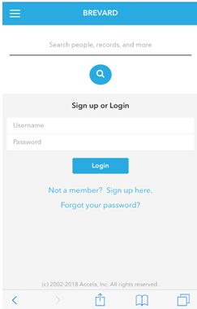
Figure 1 Accela Mobile View Sign up or Login screen
- The main Accela Mobile view page will be displayed. The Pay feature is not configured and it is unavailable at this time. From this page you can:
- Search for people, records, addresses, etc. by entering a piece of the information and clicking the magnifying glass to begin the search or;
- Clicking the Permit/record number if displayed.
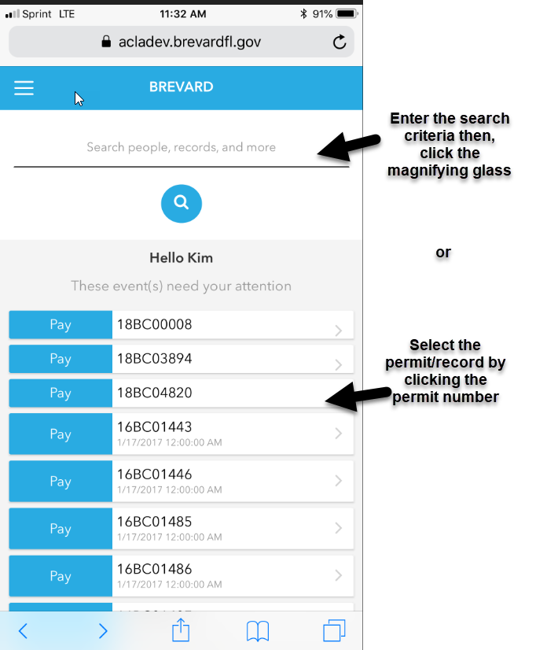
Figure 2 Accela Mobile view search field
Figure 3 Accela Mobile View search field

- For this example there are 100+ Records returned for 2725 Judge Fran
- Click Records
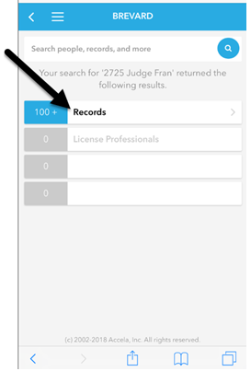
Figure 4 Search results 100+ retuned for the address entered.
- Select the record for your inquiry
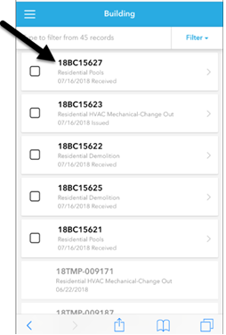
Figure 5 Records returned from the Search criteria entered

- The following information will be shown:
- Record Number /Permit number will be displayed in the banner
- Type of permit
- Add to Collections link, if applicable
- Status – Permit Status
- Work Location – Site Address
- Licensed Professional(s) – Licensed Professional Name, License Number (County or State), and Contractor type. To display additional Licensed Professionals associated to the permit/record, click the View All link.
- Inspections
- Conditions
- More Record Details
- Related Records
- Process Status – The application workflow status.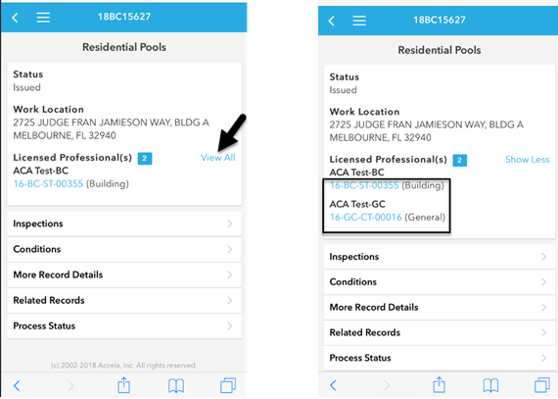
Figure 6 Licensed Professional “View All” link. The Licensed Professional field was expanded to display all Licensed Professionals associated to this record.

How to Schedule an Inspection
This section will explain how to schedule an inspection using Accela Mobile.
Inspections must be scheduled by 4:00 p.m. for the next business day (M-F). All fees must be paid prior to scheduling a Pre-Power or Final Inspection. Scheduling an incorrect inspection will result in a failed inspection and will incur additional fees. Note: The permit must be issued to schedule an inspection.
- Click Inspections
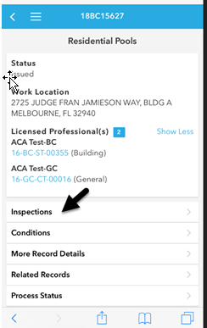
Figure 7 Inspections field
- Click Schedule an Inspection
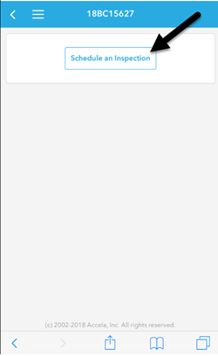
Figure 8 Schedule an Inspection button
- Available Inspection Types for this record will be displayed (Pool Steel and Ground, Pool Deck, Pool Final, and Pool Other).
- Click the inspection type to schedule the inspection.
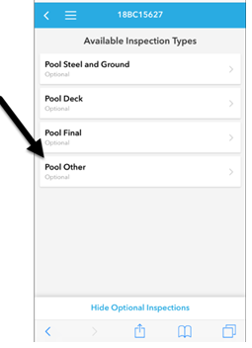
Figure 9 Available Inspection Types associated to the record
- Schedule Inspection screen will be displayed. This screen provides the following information:
- Record Number (Permit Number)
- Inspection Type
- Location (Site Address)
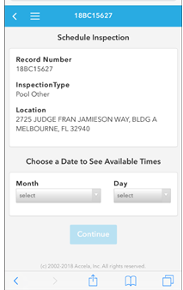
Figure 10 Schedule Inspection screen displaying the Record Number, Inspection Type, and Location. Choose a Date of the inspection using the dropdown fields
- Choose a Date to See Available Times by clicking the Month dropdown and the Day dropdown. Select the Month and Day of the inspection.
- Choose a Time – Select All Day as this is the only option available at this time.
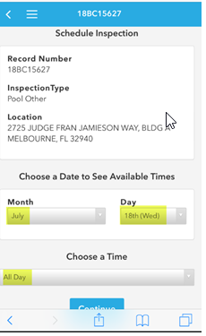
Figure 11 Select the inspection date by clicking the dropdowns for the Month, Day, and Time (All Day only option.
- Click the Continue button.
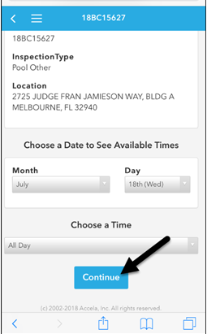
Figure 12 Inspection information selected. Click the Continue button.
- Enter the Contact Information, Phone Number, and a Comment (optional). Note: Do not add confidential information in the Comment section as this information is displayable to the public.
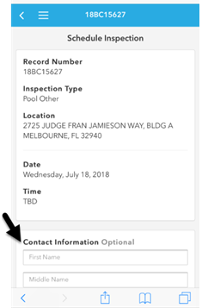
Figure 13 Enter Contact Information to be associated to the inspection.
- Click Schedule Inspection.

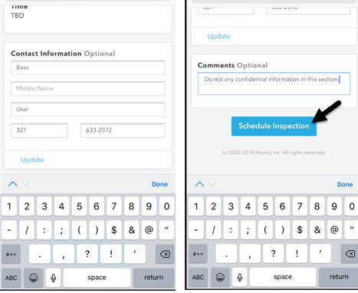
Figure 14 Contact Information and Inspection comments (notes to the inspector). Click the Schedule Inspection button to continue the inspection scheduling. Do not enter Confidential Information in this section.

- Schedule Confirmation will be displayed.
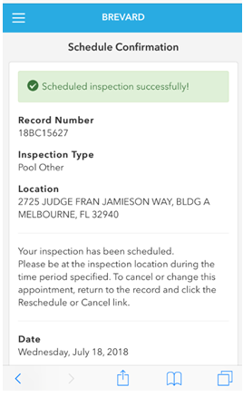
Figure 15 Inspection Schedule Confirmation
- Click Back to Record Summary.
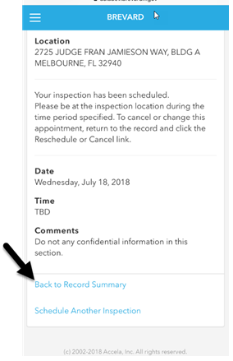
Figure 16 "Back to Record Summary" link
- To view the Inspector’s name and the details of the inspection, click Inspections.
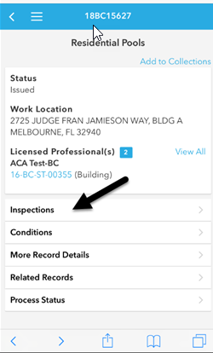
Figure 17 Inspections tab associated to the record
- The inspection overview will be displayed.
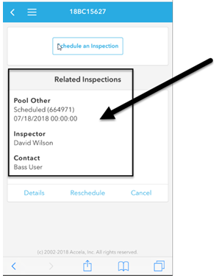
Figure 18 The scheduled inspection associated to the record provides the Inspection Type, Scheduled Date, Inspector's name, and Contact.

How to Reschedule an Inspection
This section will provide the instructions to reschedule an inspection. Reschedule must be made before 4:00 p.m. 1 day prior to the inspection date.
- Search and select the record
- From the record’s main page, select Inspections
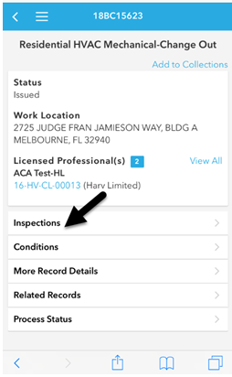
Figure 19 Inspections tab
- The Inspections page will be displayed
- Click the Reschedule link
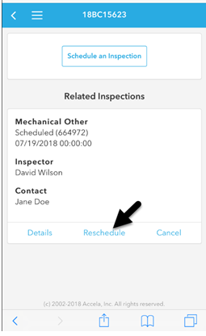
Figure 20 Related Inspections "Reschedule" link
- The Inspection Details page will be displayed.
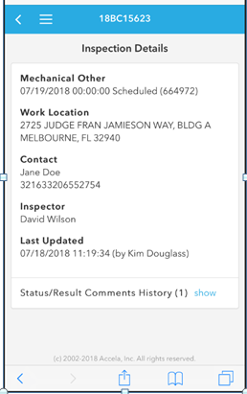
Figure 21 Inspection Details associated to the record – Inspection Type, Work Location, Contact, Inspector, and Last Updated.
- Choose a Date to See Available Times by clicking the Month dropdown and the Day dropdown to select the Month and Day of the inspection.
- Choose a Time – Select All Day as this is the only option available at this time.

- Click the Continue button.
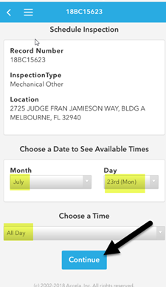
Figure 22 Select the Month, Day, and Time then click the Continue button
- The Schedule Inspection page will display.
- If needed, modify the Contact Information and the Comments sections.
- Then, click the Schedule Inspection button.
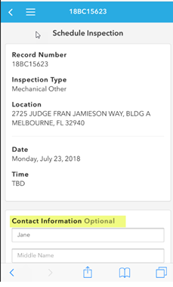
Figure 23 I Contact Information for this inspection

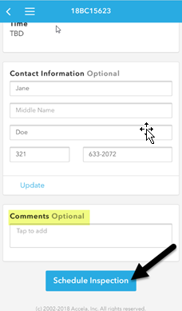
Figure 24 Comment section and the Schedule Inspection button.

- The Schedule Confirmation page will be displayed stating Scheduled inspection successfully!
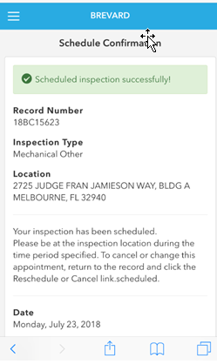
Figure 25 Schedule Confirmation

How to Cancel an Inspection
This section provides how to cancel an inspection. Cancellations must be made before 4:00 p.m. 1 day prior to the inspection date.
- Search and select the record
- From the record’s main page, select Inspections
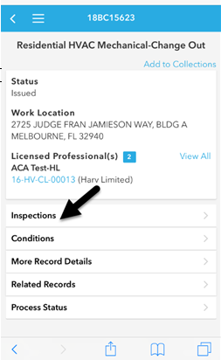
Figure 26 Record Inspection tab
- The Related Inspections page will display.
- Click the Cancel link
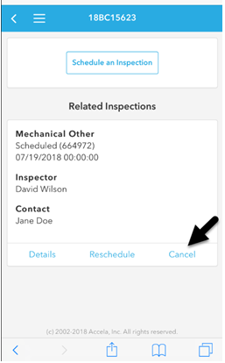
Figure 27 Related Inspections Cancel link
- A Cancel Inspection? pop-up window (dialog box) providing the Record Number, Inspection Type, Status, and Inspection Date & Time will display.
- Click the Yes, Cancel link.
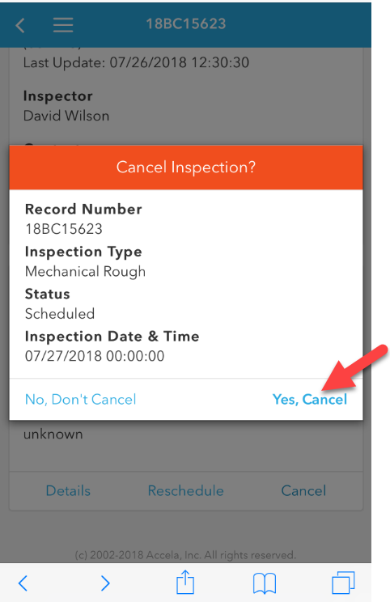
Figure 28 Cancel - Inspection pop-up window.
- A pop-up window (dialog box) confirming the inspection was cancelled will be displayed stating “Success Inspection was cancelled successfully. Closing this dialog will refresh the page.”

- Click the Close link.
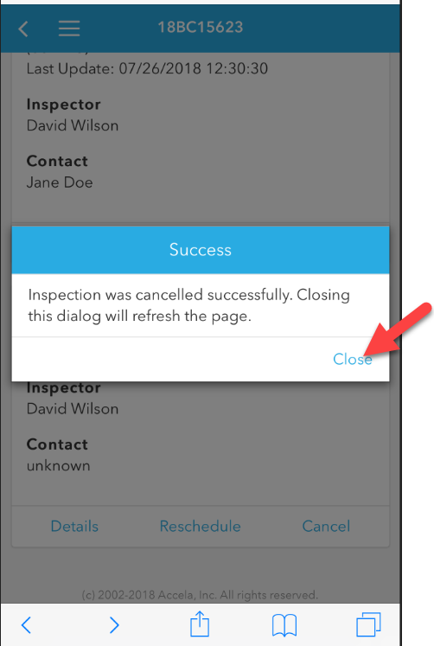
Figure 29 Inspection was cancelled successfully.
- When the inspection details page is refreshed. The inspection details will show the inspection was cancelled and will provide the date and time of the cancellation.
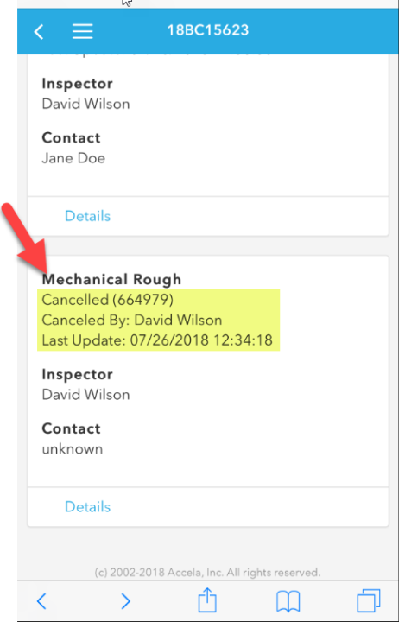
Figure 30 The cancelled inspection displays showing who the inspection was cancelled by and the date and time of the cancellation.

How to View Conditions
This section provides instruction to View Conditions. Standard conditions are requirements by the County. A standard condition can be added to the application prior to the permit issuance or after a revision is summited. Depending on the Condition severity a Notice, Hold, or Lock may be placed on the record requiring information submitted prior to the first inspection up to a stop work order issued.
- Click Conditions
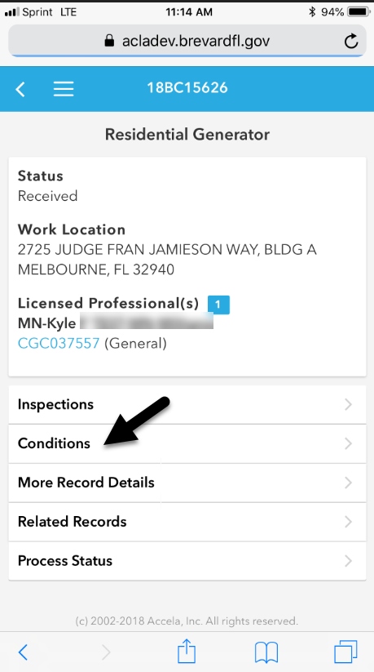
Figure 31 The Conditions link associated to the record.

- Conditions associated to the record will be displayed and will provide the following information:
- Group – Condition type such as a Notice, Hold, Lock, etc.
- Description – A description of the Condition
- Type – Department requiring the information
- Status – Condition Status
- Severity
- Applied Date – The date the condition was applied
- Expiration Date – The date the condition will expire
- Effective Date – The effective date of the condition
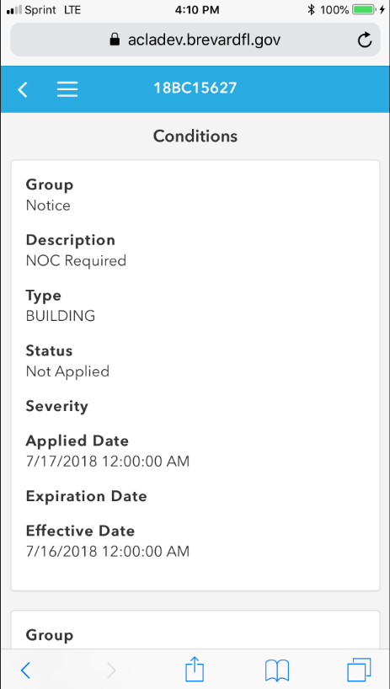
Figure 32 Conditions associated to this record.

How to View More Record Details
The More Record Details provides the high level details of the record/permit: Type, Status, Date and time the record was created, the address, the applicant’s name, and a description of the record.
- Click More Record Details
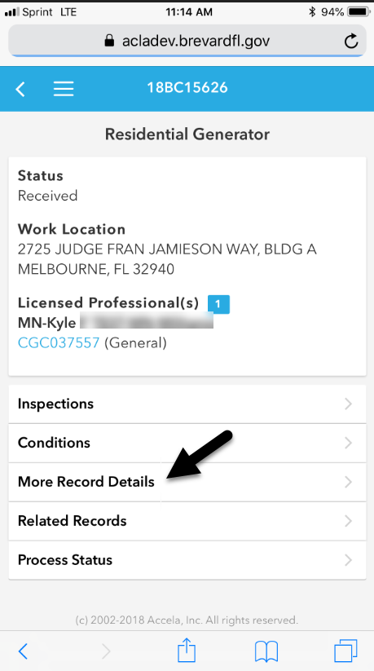
Figure 33 More Record Details tab.
- The following information will be displayed in the More Record Details section:
- Type – The type of record/permit
- Status of the record
- Date - The date and time the record was created
- Address – Site location
- Applicant
- Description – The record description
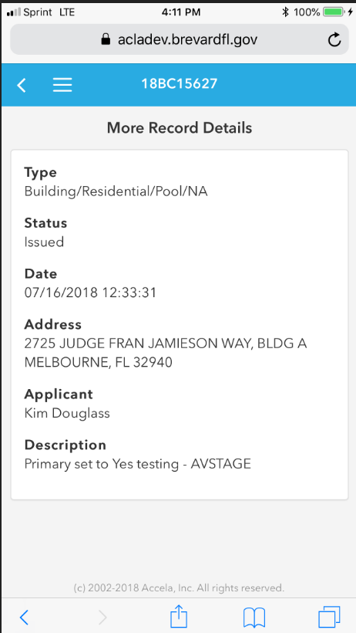
Figure 34 More Record Details assocaited to this record.

How to View Related Records
Related Records are Records/permits associated to a record. Not all permits have related records and in most cases there will not be a related record.
- Click Related Records
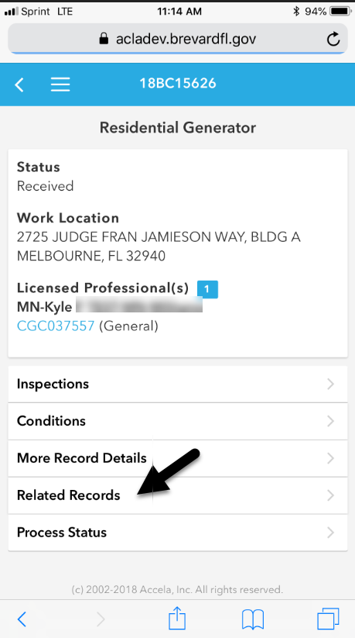
Figure 35 Related Records Tab.
- If there are Related Record associated to this permit, the records will be listed in this section
Figure 36 No matches were found under the Related Record

How to View the Process Status
The Process Status (workflow status) will be listed in this section. The active step of the workflow or Process Step will be identified by a highlighted checkmark. The workflow steps that are not highlighted are completed or are steps that will be active in the future.
- Click Process Status
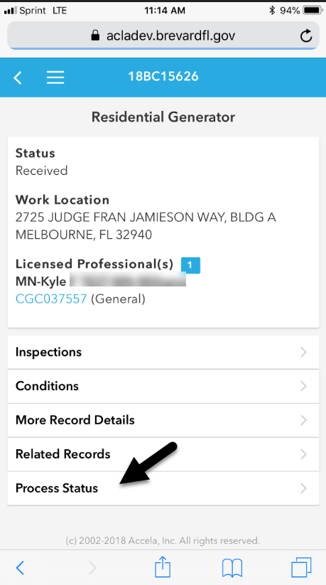
Figure 37 Process Status Tab
This example shows Inspections is the active step within the workflow.
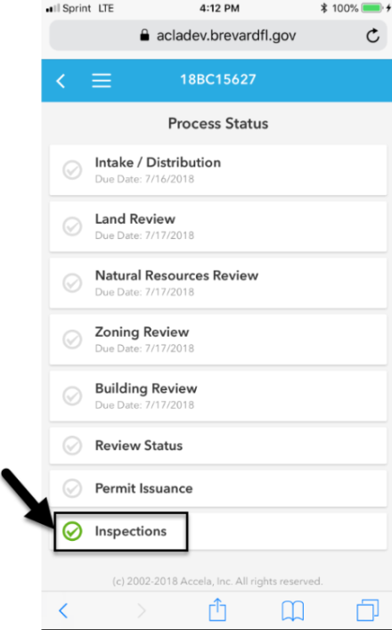
Figure 38 Active step of the Process Status (workflow) is Inspections.

