Pine Island Conservation Area Trail Map
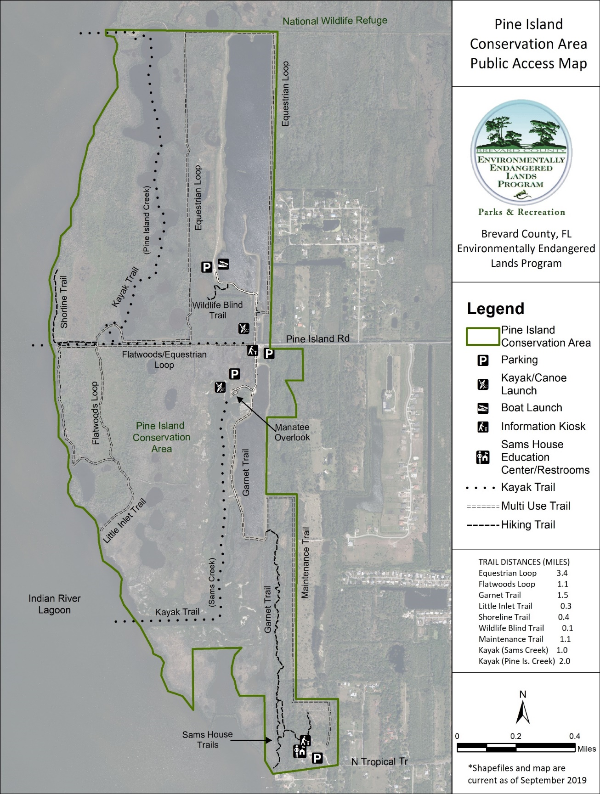
Pine Island Conservation Area trail map long description

Pine Island Conservation Area Trail Map
This aerial view of Pine Island Conservation Area displays the locations of the site boundaries, hiking trails, multi-use trails, kayak trails, kiosks, parking areas, Sams House Education Center/restrooms, Sams House trails, and overlooks. This property is part of the Brevard County Florida Environmentally Endangered Lands Program. These features are overlaid on a 2018 aerial image photograph. The site is bordered by the Indian River Lagoon to the west, the Merritt Island National Wildlife Refuge to the north, Pine Island Road and private property to the east, and North Tropical Trail to the south.
Hiking trails represented are: Wildlife Blind Trail (0.1 miles) in the central portion of the site, Shoreline Trail (0.4 miles) in the west-central portion of the site, and the Garnet Trail (1.5 miles) in the east-central portion of the site connecting to Sams House trails in the south-central portion of the site.
Multi-Use trails represented are: Flatwoods Loop (1.1 miles) in the west-central portion of the site, Equestrian Loop (3.4 miles) in the central and northeast portions of the site, Little Inlet trail (0.3 miles) to the south of the Flatwoods Loop, and the Maintenance Trail (not yet complete) in the southeast portion of the site.
Kayak trails represented are: Pine Island Creek trail (2 miles) in the central and north portions of the site, and Sams Creek trail (1 mile) in the south-central portion of the site.
A parking area, kiosk and kayak launch is represented at the west end of Pine Island Road. A parking area and a boat launch is represented north of the west end of Pine Island Road A parking area, manatee overlook, and kayak launch is represented south of the west end of Pine Island Road. A parking area, Sams House Education Center and restrooms are represented off of North Tropical Trail at the south end of the site.

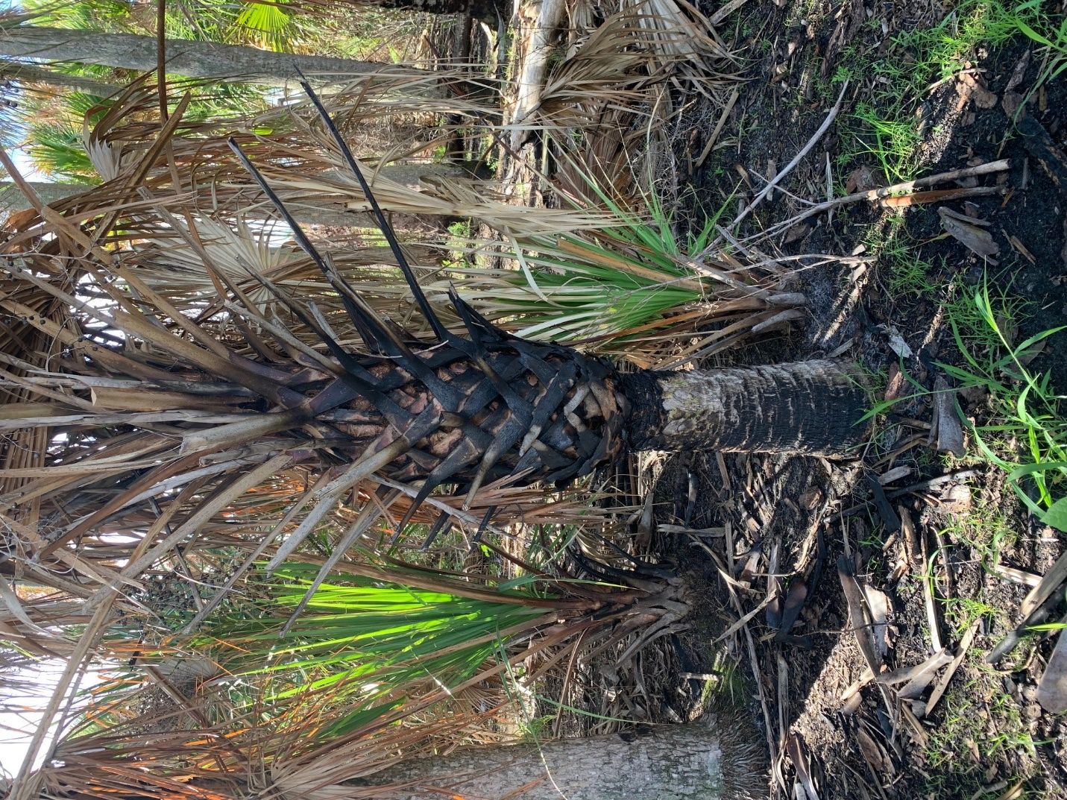

Pine Island Conservation Area Coin Hunt Photo 1
Image of a burned palm tree viewed from a trail.

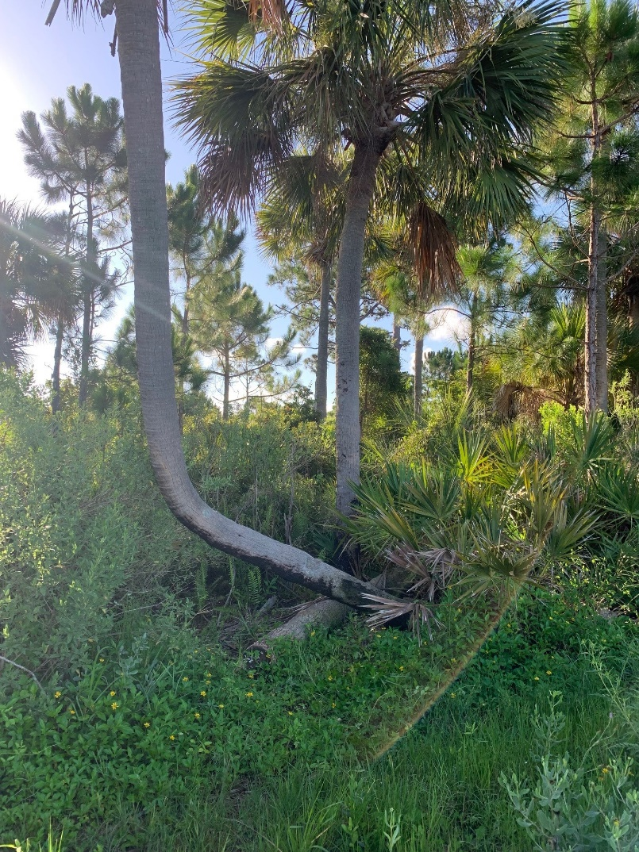

Pine Island Conservation Area Coin Hunt Photo 2
Image of palm trees, ferns and palmettos viewed from a trail.

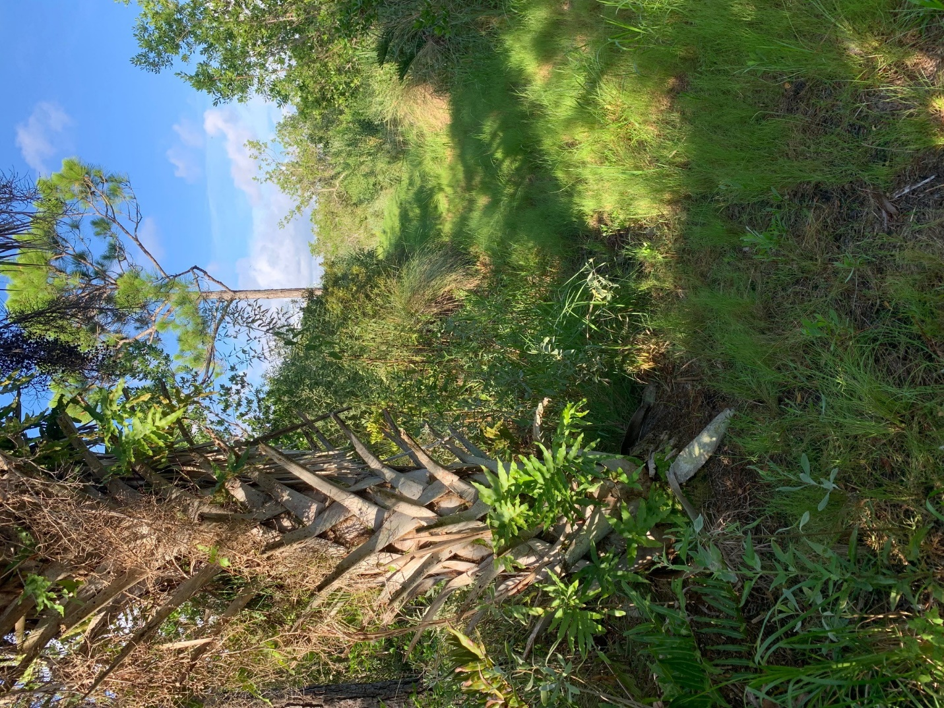

Pine Island Conservation Area Coin Hunt Photo 3
Image of palm trees with ferns and vines viewed from a trail.

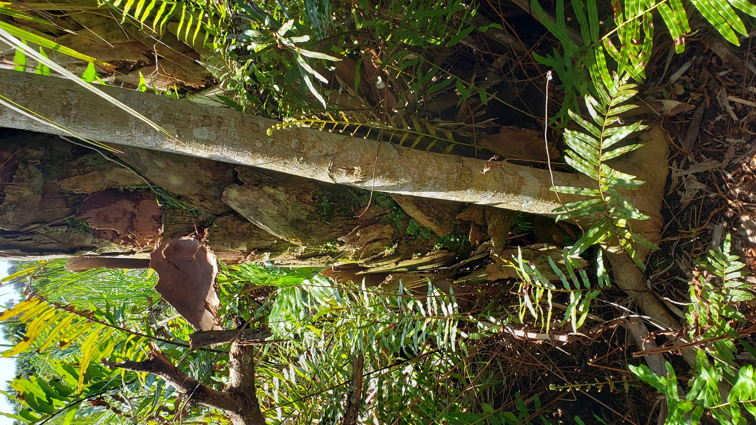

Pine Island Conservation Area Coin Hunt Photo 4
Image of a palm tree, strangler fig and ferns viewed from a trail.

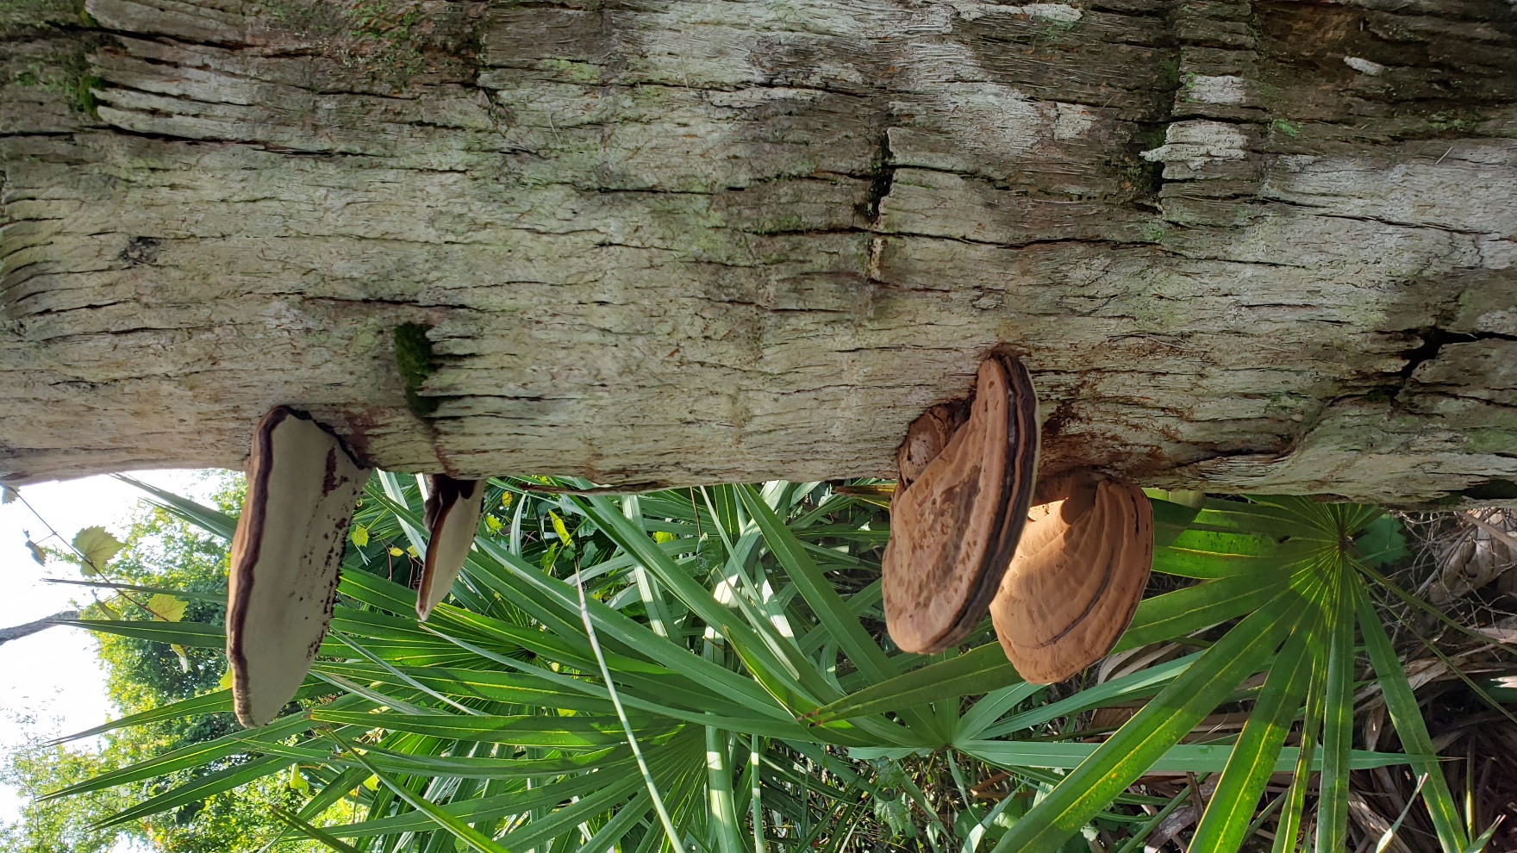

Pine Island Conservation Area Coin Hunt Photo 5
Image of a palm tree and mushrooms viewed from a trail.

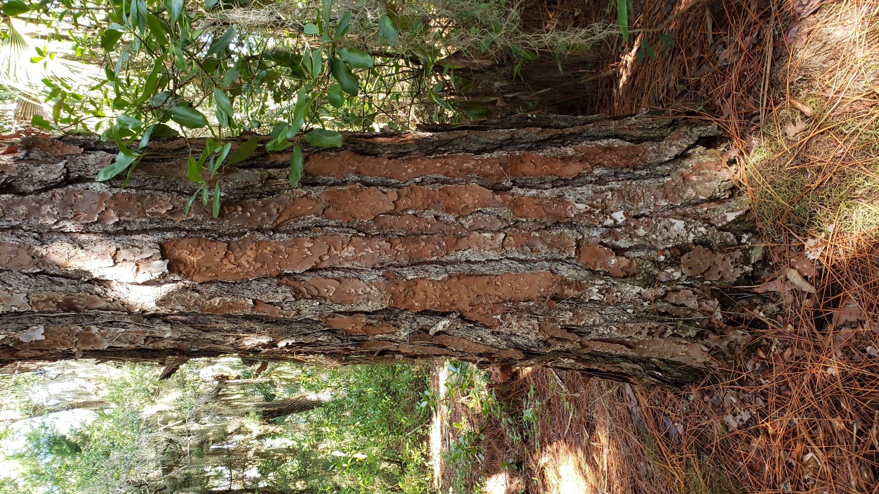

Pine Island Conservation Area Coin Hunt Photo 6
Image of a large pine tree viewed from a trail.

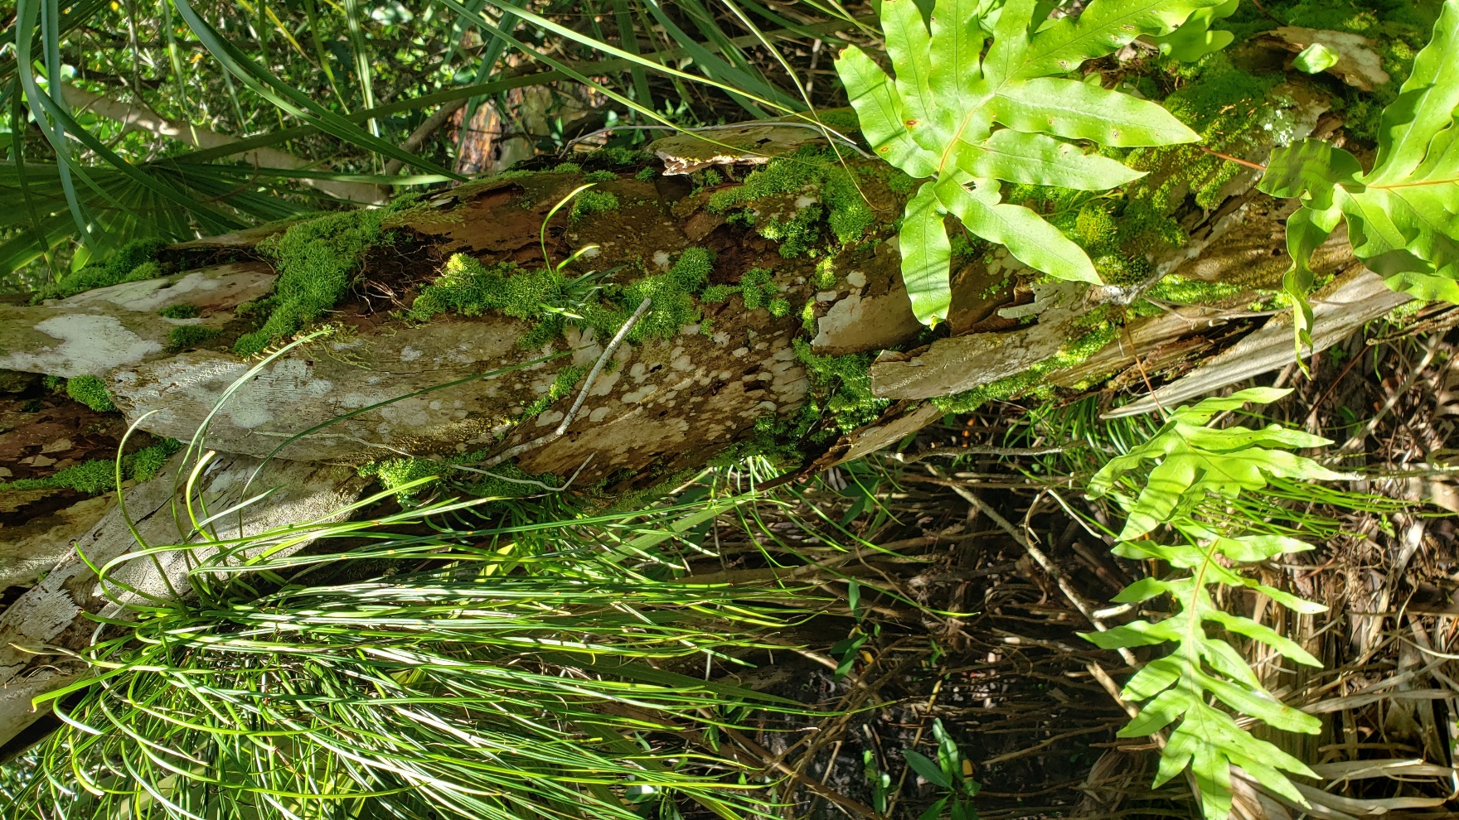

Pine Island Conservation Area Coin Hunt Photo 7
Image of a palm tree with shoestring and rabbits foot ferns viewed from a trail.

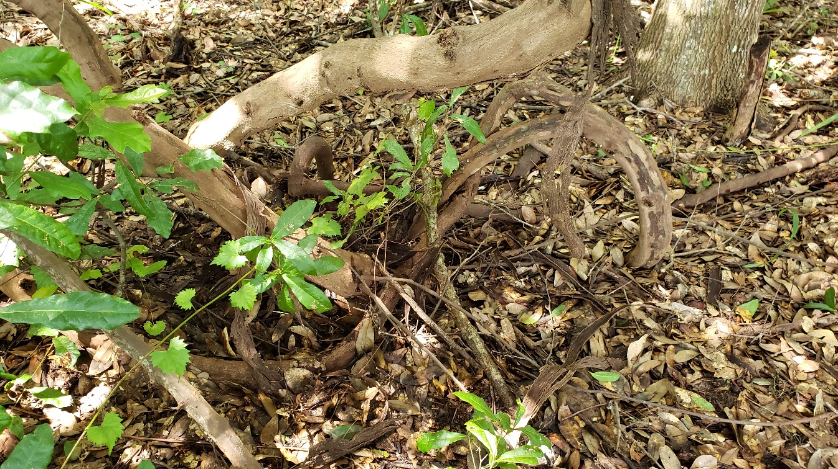

Pine Island Conservation Area Coin Hunt Photo 8
Image of a thick, twisted vine viewed from a trail.

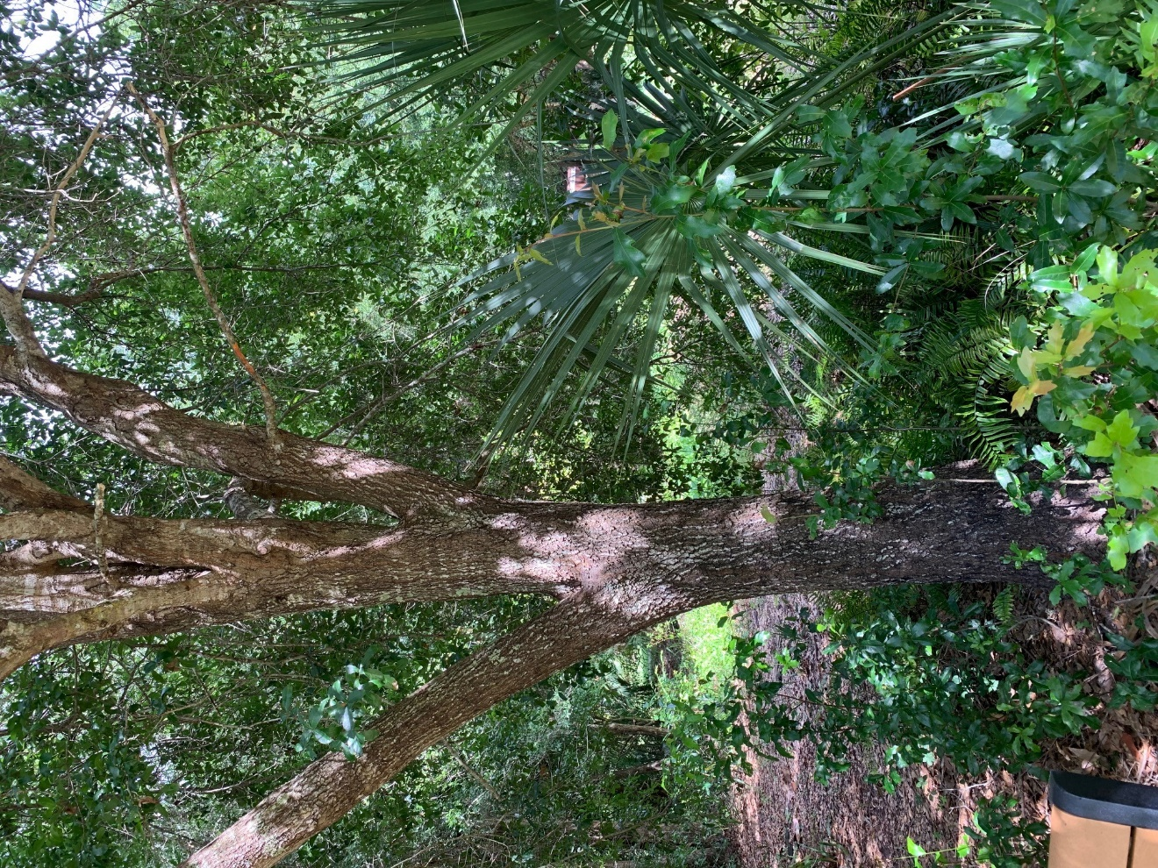

Pine Island Conservation Area Coin Hunt Photo 9
Image of a large oak tree viewed from a trail.

