South Lake Conservation Area Draft Public Access Plan

Site Summary
The sanctuary is a 207-acre site located west of I-95 in Titusville, Brevard County, Florida. South Lake Conservation Area is directly adjacent to Salt Lake Wildlife Management Area to the south and is located in the vicinity of a number of other conservation properties that offer similar recreational opportunities. The sanctuary can be accessed from a trailhead on Lancaster Lane. The site is bordered by private property to the north, west, and east. The majority of the sanctuary consists of oak-saw palmetto scrub, scrubby flatwoods, and depression marsh. The remainder consists primarily of hardwood hammock adjacent to South Lake. This is a “Category 2 site” within the Environmentally Endangered Lands Program and as such, minimal capital improvements will be allowed.

Passive Recreation Definition
To the extent they do not interfere with biological management goals, Environmentally Endangered Lands (EEL) sanctuaries provide a range of passive recreation opportunities for the public. As a general guideline for EEL Program management decisions, passive recreation is defined as, “a recreational type of use, level and combination of uses that do not individually, or collectively, degrade the resource values, biological diversity, and aesthetic or environmental qualities of a site.”
Before developing a site public access plan, staff conducts a Public Access Site Assessment. From this assessment, the types and extent of activities can be determined with the goal to balance human use with the protection of natural resources. Items considered during the assessment include environmental, cultural, recreational and educational resources, stakeholder interests, potential conflicts, universal access, connections to other recreational resources, and potential management and/or maintenance conflicts and constraints.
Activities that allow for the quiet enjoyment of nature are conducive to EEL Program goals. Common activities on EEL sanctuaries are hiking, biking, kayaking, fishing, and equestrian use. Activities and uses that are generally not allowed on EEL sanctuaries without permit include, but are not limited to: motorized vehicles, smoking, overnight use, commercial use, hunting/shooting sports, removal of plants or animals, relocating plants or animals, and pets.

Public Access Site Assessment
During the Public Access Site Assessment, existing trails, site topography, South Lake, and scrub and wetland habitats were identified as resources on site. Similar or complimentary recreational resources are the adjacent Salt Lake Wildlife Management Area, and nearby Indian Mound Station Sanctuary, Enchanted Forest Sanctuary, Dicerandra Scrub Sanctuary, Fox Lake Sanctuary, and Buck Lake Conservation Area. The relatively small size of the site and planned trail, and the sandy and wet soils support hiking and nature observation as permitted activities, but do not support bicycling or equestrian. The shoreline of South Lake is not conducive to support fishing or paddling as activities. A parking location, trailhead, kiosk and directional signage will be required. Providing Americans with Disabilities Act access would require an accessible parking area and trail stabilization.

Recreational Uses and Amenities
The parking area on Lancaster Lane will serve as a trailhead. There are no restrooms on site. A kiosk near a walk-through gate provides a map and information for visitors. A 1.4-mile unimproved single-track trail (Figure 1) has been developed, incorporating portions of existing trails on the site. The trail layout was designed in conjunction with fire and environmental management plans, so as to minimize conflicts and maintenance constraints. The relatively short trail traverses sandy scrub and wetland areas that are conducive to hiking, but not bicycling or equestrian use. The small size of the sanctuary and proximity to homes and roads make it unsuitable for youth group camping. No Americans with Disabilities Act access is planned at this time due to the considerable resources required and the environmental impacts to the site. The trail is planned to connect to existing and proposed trails at Salt Lake Wildlife Management Area, providing for a larger interconnected trail system.

Environmental Education Opportunities
Access to scrub and forested woodlands, close proximity to Salt Lake Wildlife Management Area, and a relatively short trail offer opportunities for educational hikes and interpretive trail signage. Interpretive trail signage topics could include habitat restoration, fire management, threatened species, and natural history.
Figure 1: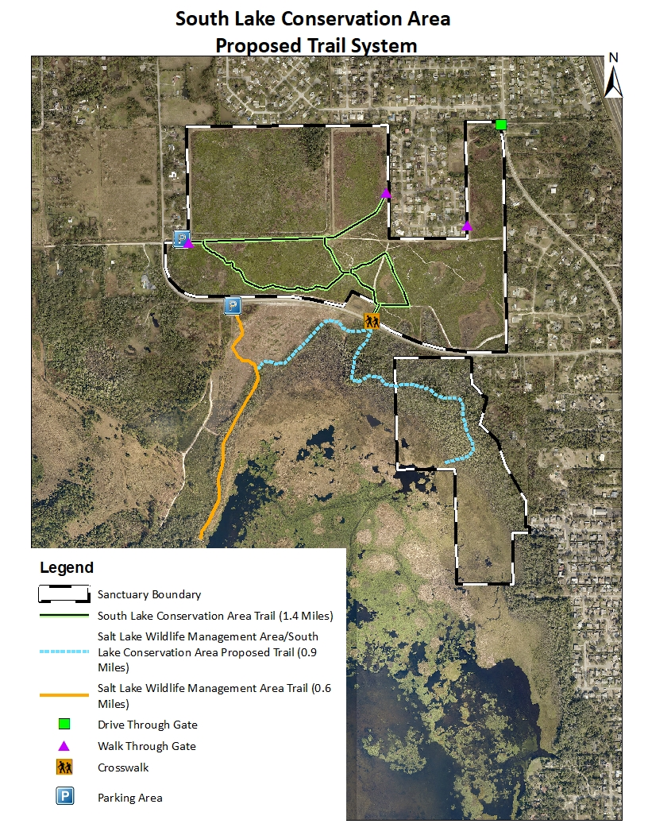Link back to Recreational Uses and Amenities

