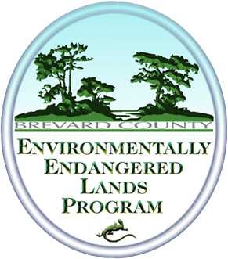
ENVIRONMENTALLY ENDANGERED LANDS PROGRAM
THOUSAND ISLANDS PUBLIC ACCESS PLAN MEETING
June 25, 2019 Minutes
ENVIRONMENTALLY ENDANGERED LANDS PROGRAM STAFF
Laura Clark
David DeMeyer
GUESTS
None
Protecting and Preserving Biological Diversity
Through Responsible Stewardship of Brevard County’s Natural Resources

MEETING MINUTES
CALL TO ORDER AND ROLL CALL
Meeting called to order at 6:25 PM.
PUBLIC COMMENT
None
ADMINISTRATIVE REVIEW
David DeMeyer, Land Management Superintendent for the Central Region, facilitated and stated the purpose of this meeting is to gather public input on the proposed public access plan for the Thousand Islands Conservation Area. The input gathered at this meeting will be presented to the Selection and Management and Recreation and Education Advisory Committees. He provided an overview of the Environmentally Endangered Lands (EEL) Program, discussed public access, and passive recreation opportunities at the Thousand Islands Conservation Area including hiking, kayaking, and bird watching. Hunting is not permitted; however, fishing is permitted and all Florida Fish and Wildlife (FFW) rules apply for licenses and size limits. Public parking and public access were covered. No members of the public attended this meeting; however, the information was presented to remain in compliance procedurally.
ADJOURNED
Meeting adjourned at 7:00 PM.
ACTION ITEMS
Provide the minutes of this public meeting to the Recreation and Education Advisory Committee in the meeting to be held September 2019.

