Citizen Oversight Committee Bio: Terrence L. (Terry) Casto, Lagoon Advocacy/Alternate
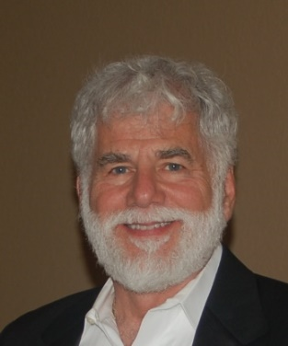
Mr. Casto has been a resident of Brevard County since 1969. He retired from Harris Corporation in 2008, having served as a director in Engineering, Program Management and Business Development. He is currently the principal of Strategic Growth Consulting LLC, providing guidance and training to companies doing business with the US Government. He holds a BSEE from the University of Akron and post-graduate courses from University of Florida, Duke and Kellogg.
He has been a volunteer with the Marine Resources Council since 2013. Activities include oyster reef restoration, shoreline restoration (pepper tree removal; mangrove transplanting), and muck and water quality sample collection. He is an NEP-certified Lagoon Lifesaver presenter and was featured as an IRL volunteer in Brevard Business News (April 2016).

