Citizen Oversight Committee Bio: John Windsor, Lagoon Advocacy/Member
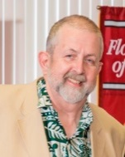
- Resident - 35 years
- Served on IRL restoration committees for over 3 decades: Governor’s task force on IRL, SWIM Plan Development, IRLCCMP, and served as TAC Chair for the IRL NEP Technical Advisory Committee (1992-2013).
- Facilitated 8 working groups of BC citizens to develop the CM3P.
- MA and Ph.D. from the College of William and Mary, Marine Science
- Expertise: water quality
- Professor, Oceanography and Environmental Science, Florida Tech, 34 years; currently Professor Emeritus
- Reviewed SOIRL Plan and presented it to the BOCC. This plan is important and we need to ensure that restoration efforts are the most effective.

